**Q1)**   
Just one layer. Input xmu = [xmu_1 … xmu_i … xmu_N] arrives and every for each cluster k we compute: y_k = sum(w_ik * xmu_i for i=1..N). The output layer contains the y_k which are the output neurons which map the input data xmu into a the output neuronal space.

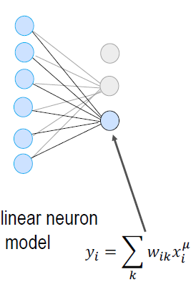

**Q2)**

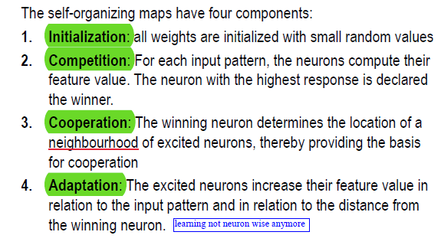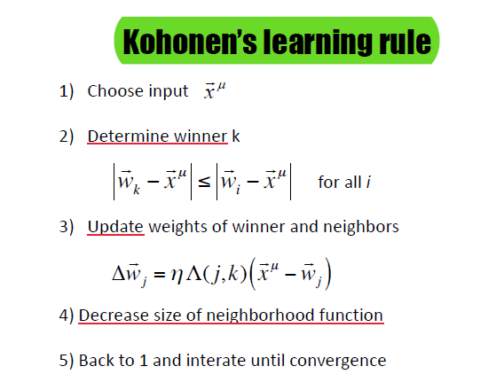

**Q3)**

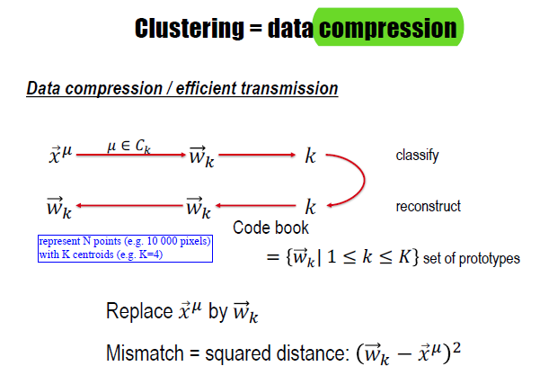

**Q4)**

Topographic map: input are signals (auditory, visual etc.) and are mapped into a cortical (neuronal) space w.r.t their features (frequency, orientation etc.).

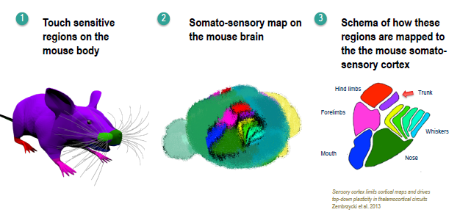

**Q5)**

almost direct using Oja’s rule which is a modification of the standard Hebb's Rule

