**Camadas do Lake – Ingestão de Dados**

**Visão Camadas – Mount Azure BlobStorage – Projeto Climatico**

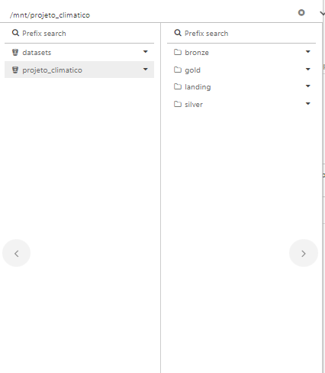

**Camada Landing – Storage nasa_solar_flux_temperature**

**(CSVs recebidos via API e desformformatados)**

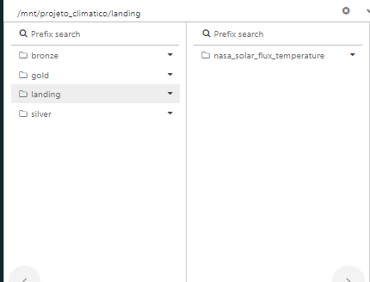

**Camada Landing – Storage nasa_solar_flux_temperature**

**2023 – CSVs desformatados extraídos via API e utilizados para carga mensal**

**historico – CSVs desformformatados extraídos ano-a-ano via API e utilizados para carga histórica**

**colab – CSV gerado para utilizado no colab. Apoio ao time para exploração e Ciência de Dados**

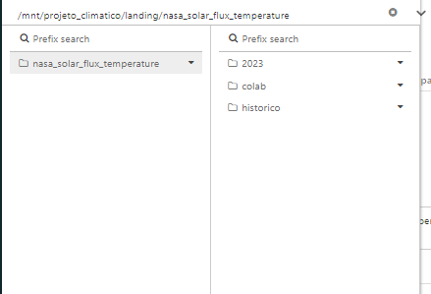

**2023 – Evidências Cargas**

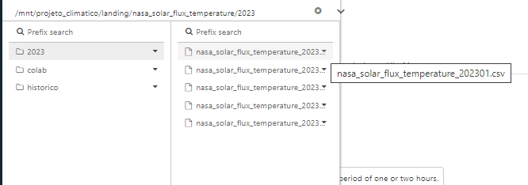

**colab – Evidências Cargas**

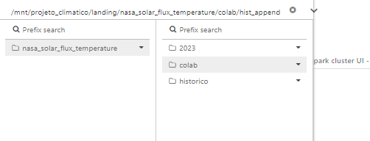

**colab – hist_append**

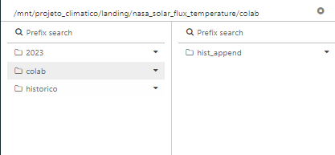

**colab – hist_append – Evidência Carga**

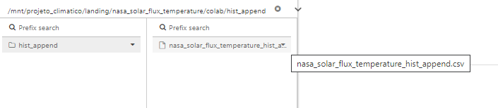

**histórico – Evidência Cargas**

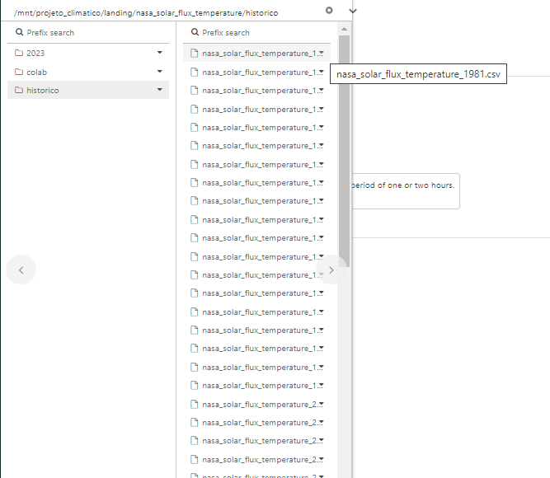

**Camada Bronze – Evidência Carga**

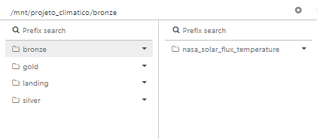

**Bronze – tabela nasa_solar_flux_temperature – Evidência Carga**

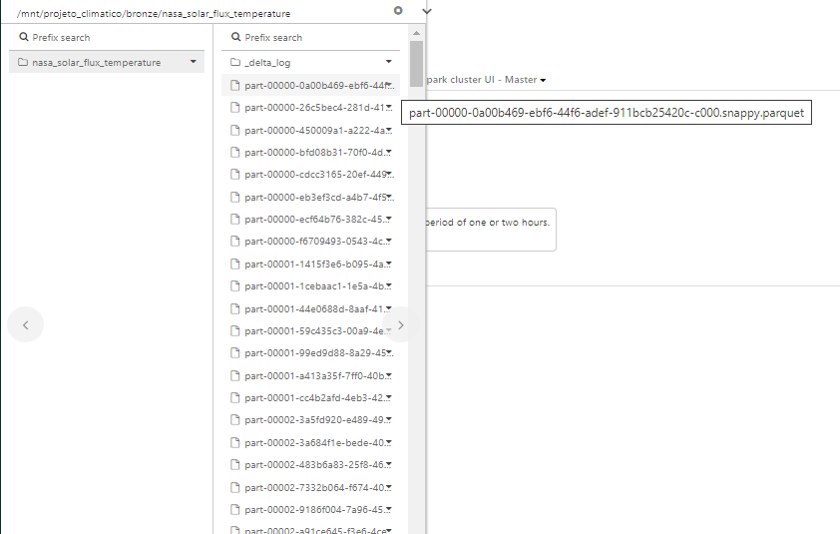

**Camada Silver – Evidências Cargas**

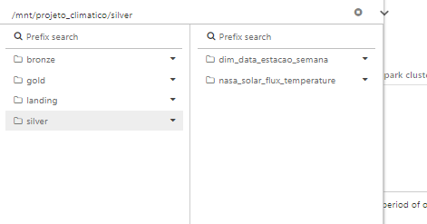

**Silver – Tabela dim_data_estacao_semana – Evidência Cargas**

**(Utilizada na transformação da tabela nasa_solar_flux_temperature)**

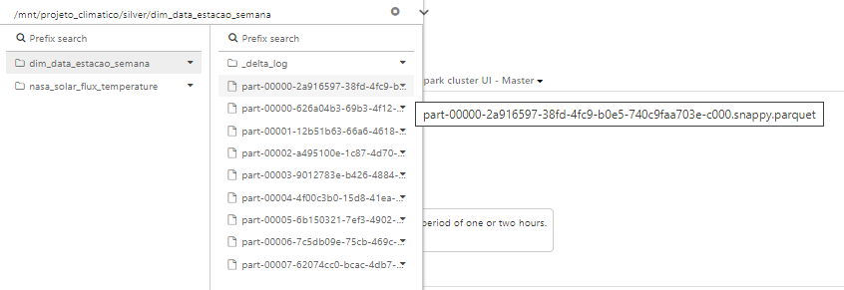

**Camada Silver – Tabela nasa_solar_flux_temperature**

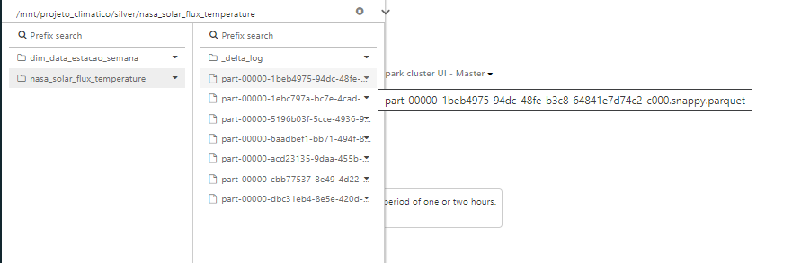

Lista:

**Camada Bronze**

bronze

**bronze – Tabela nasa_solar_flux_temperature**

bronze/nasa_solar_flux_temperature

bronze/nasa_solar_flux_temperature/_delta_log

bronze/nasa_solar_flux_temperature/_delta_log/.s3-optimization-0

bronze/nasa_solar_flux_temperature/_delta_log/.s3-optimization-1

bronze/nasa_solar_flux_temperature/_delta_log/.s3-optimization-2

bronze/nasa_solar_flux_temperature/_delta_log/00000000000000000000.crc

bronze/nasa_solar_flux_temperature/_delta_log/00000000000000000000.json

bronze/nasa_solar_flux_temperature/_delta_log/00000000000000000001.crc

bronze/nasa_solar_flux_temperature/_delta_log/00000000000000000001.json

bronze/nasa_solar_flux_temperature/_delta_log/00000000000000000002.crc

bronze/nasa_solar_flux_temperature/_delta_log/00000000000000000002.json

bronze/nasa_solar_flux_temperature/_delta_log/00000000000000000003.crc

bronze/nasa_solar_flux_temperature/_delta_log/00000000000000000003.json

bronze/nasa_solar_flux_temperature/_delta_log/00000000000000000004.crc

bronze/nasa_solar_flux_temperature/_delta_log/00000000000000000004.json

bronze/nasa_solar_flux_temperature/_delta_log/00000000000000000005.crc

bronze/nasa_solar_flux_temperature/_delta_log/00000000000000000005.json

bronze/nasa_solar_flux_temperature/_delta_log/00000000000000000006.crc

bronze/nasa_solar_flux_temperature/_delta_log/00000000000000000006.json

bronze/nasa_solar_flux_temperature/_delta_log/00000000000000000007.crc

bronze/nasa_solar_flux_temperature/_delta_log/00000000000000000007.json

bronze/nasa_solar_flux_temperature/_delta_log/00000000000000000008.crc

bronze/nasa_solar_flux_temperature/_delta_log/00000000000000000008.json

bronze/nasa_solar_flux_temperature/_delta_log/00000000000000000009.crc

bronze/nasa_solar_flux_temperature/_delta_log/00000000000000000009.json

bronze/nasa_solar_flux_temperature/_delta_log/00000000000000000010.checkpoint.parquet

bronze/nasa_solar_flux_temperature/_delta_log/00000000000000000010.crc

bronze/nasa_solar_flux_temperature/_delta_log/00000000000000000010.json

bronze/nasa_solar_flux_temperature/_delta_log/_last_checkpoint

bronze/nasa_solar_flux_temperature/part-00000-0a00b469-ebf6-44f6-adef-911bcb25420c-c000.snappy.parquet

bronze/nasa_solar_flux_temperature/part-00000-26c5bec4-281d-41a5-8df1-180c4b48a6be-c000.snappy.parquet

bronze/nasa_solar_flux_temperature/part-00000-450009a1-a222-4a89-9935-8e990b34adff-c000.snappy.parquet

bronze/nasa_solar_flux_temperature/part-00000-bfd08b31-70f0-4d48-b519-e795c896f930-c000.snappy.parquet

bronze/nasa_solar_flux_temperature/part-00000-cdcc3165-20ef-449a-80af-4fdad31a3940-c000.snappy.parquet

bronze/nasa_solar_flux_temperature/part-00000-eb3ef3cd-a4b7-4f56-b9f4-293018b4b147-c000.snappy.parquet

bronze/nasa_solar_flux_temperature/part-00000-ecf64b76-382c-4557-bb05-430da82c88cb-c000.snappy.parquet

bronze/nasa_solar_flux_temperature/part-00000-f6709493-0543-4c69-8226-d6de2d77fb02-c000.snappy.parquet

bronze/nasa_solar_flux_temperature/part-00001-1415f3e6-b095-4a57-ae47-8d46d5d3ae8e-c000.snappy.parquet

bronze/nasa_solar_flux_temperature/part-00001-1cebaac1-1e5a-4b4b-b8e1-134f7ce447a8-c000.snappy.parquet

bronze/nasa_solar_flux_temperature/part-00001-44e0688d-8aaf-416b-b76f-57700f79200f-c000.snappy.parquet

bronze/nasa_solar_flux_temperature/part-00001-59c435c3-00a9-4e0f-8b82-9265503b5d1d-c000.snappy.parquet

bronze/nasa_solar_flux_temperature/part-00001-99ed9d88-8a29-45e8-9588-0706097bc95a-c000.snappy.parquet

bronze/nasa_solar_flux_temperature/part-00001-a413a35f-7ff0-40b8-b19f-912b5459b4f3-c000.snappy.parquet

bronze/nasa_solar_flux_temperature/part-00001-cc4b2afd-4eb3-42e0-a067-cecb2e2298c9-c000.snappy.parquet

bronze/nasa_solar_flux_temperature/part-00002-3a5fd920-e489-499c-8cb9-fb3a385cc268-c000.snappy.parquet

bronze/nasa_solar_flux_temperature/part-00002-3a684f1e-bede-407a-bafd-f3d385b68c8b-c000.snappy.parquet

bronze/nasa_solar_flux_temperature/part-00002-483b6a83-25f8-461b-b8f5-ca0b9c09bff7-c000.snappy.parquet

bronze/nasa_solar_flux_temperature/part-00002-7332b064-f674-40eb-a423-1029678d8657-c000.snappy.parquet

bronze/nasa_solar_flux_temperature/part-00002-9186f004-7a96-45ac-ae7a-449cf05de08c-c000.snappy.parquet

bronze/nasa_solar_flux_temperature/part-00002-a91ce645-f3e6-4cec-bd60-4fc490180ec4-c000.snappy.parquet

bronze/nasa_solar_flux_temperature/part-00002-e6d6ae26-c806-4fa7-ac15-b9b27eb19ce5-c000.snappy.parquet

bronze/nasa_solar_flux_temperature/part-00003-06798ec3-6cc1-4c5a-8a08-238c9f798e28-c000.snappy.parquet

bronze/nasa_solar_flux_temperature/part-00003-1287b8c0-8e89-433f-8626-9e9e92964c88-c000.snappy.parquet

bronze/nasa_solar_flux_temperature/part-00003-39d00e0b-d79b-4343-b873-d48fbe021758-c000.snappy.parquet

bronze/nasa_solar_flux_temperature/part-00003-7349f011-3bbe-413b-b614-42dfb764a6c8-c000.snappy.parquet

bronze/nasa_solar_flux_temperature/part-00003-b43a4468-e771-4b21-8e07-de92072b4069-c000.snappy.parquet

bronze/nasa_solar_flux_temperature/part-00003-cac1c48c-c1be-47ed-9cb4-53e4dbaff87e-c000.snappy.parquet

bronze/nasa_solar_flux_temperature/part-00003-e3d26f2a-7fc9-446a-a7f5-30922f4ce39f-c000.snappy.parquet

bronze/nasa_solar_flux_temperature/part-00004-4880414a-a944-437c-bbf1-9aafe45c513e-c000.snappy.parquet

bronze/nasa_solar_flux_temperature/part-00004-880d77ef-2299-4cb6-b565-cf3c380c68a9-c000.snappy.parquet

bronze/nasa_solar_flux_temperature/part-00004-8ceec5de-0a36-42ed-beed-b379f2d4f2fc-c000.snappy.parquet

bronze/nasa_solar_flux_temperature/part-00004-c8bfecfe-d731-4b8f-8bc9-d22147a4148c-c000.snappy.parquet

bronze/nasa_solar_flux_temperature/part-00004-d00575cd-f002-490f-8cda-d0f0b476e572-c000.snappy.parquet

bronze/nasa_solar_flux_temperature/part-00004-f6ada8da-3a01-4a43-9df6-24f029666cb5-c000.snappy.parquet

bronze/nasa_solar_flux_temperature/part-00004-f966f7f0-0a9c-4a0c-919f-ca7a460522eb-c000.snappy.parquet

bronze/nasa_solar_flux_temperature/part-00005-4feee232-2d99-4f38-a2e4-2e380f77c57d-c000.snappy.parquet

bronze/nasa_solar_flux_temperature/part-00005-56f1f670-0ee4-46ea-87f2-567a1a29d581-c000.snappy.parquet

bronze/nasa_solar_flux_temperature/part-00005-87d470ed-8408-42e4-8762-d0192a777bd1-c000.snappy.parquet

bronze/nasa_solar_flux_temperature/part-00005-a2ecbf83-3e5e-4b50-95ca-50051fcbf834-c000.snappy.parquet

bronze/nasa_solar_flux_temperature/part-00005-d36c6963-f973-432e-a4af-24a8b2f94e27-c000.snappy.parquet

bronze/nasa_solar_flux_temperature/part-00005-f74e1761-5cdf-48fb-9509-0d3a9c71daf1-c000.snappy.parquet

bronze/nasa_solar_flux_temperature/part-00005-f90ec649-0bfc-4f55-8068-4c3fe3298006-c000.snappy.parquet

bronze/nasa_solar_flux_temperature/part-00006-1342cec7-4bd0-49f4-b4e3-2111fac8bfd0-c000.snappy.parquet

bronze/nasa_solar_flux_temperature/part-00006-4106e528-d510-4f77-89bb-6a20f9a4642a-c000.snappy.parquet

bronze/nasa_solar_flux_temperature/part-00006-50027da7-8682-48d6-bcc8-1b7380f9e7dd-c000.snappy.parquet

bronze/nasa_solar_flux_temperature/part-00006-5ded002a-1385-4abf-8b20-68ffdfa4a941-c000.snappy.parquet

bronze/nasa_solar_flux_temperature/part-00006-67274b01-2ab2-4982-a120-afba9e5588c9-c000.snappy.parquet

bronze/nasa_solar_flux_temperature/part-00006-86efb9b2-fc4c-4b11-a9df-33eb22e6c6be-c000.snappy.parquet

bronze/nasa_solar_flux_temperature/part-00006-b1f40422-a514-470a-b6ff-de0461fa62f7-c000.snappy.parquet

bronze/nasa_solar_flux_temperature/part-00007-37e67ae6-bb2f-462c-b8fb-47c01058ea0d-c000.snappy.parquet

bronze/nasa_solar_flux_temperature/part-00007-39668dea-1884-46ce-a508-b51c4d3716c2-c000.snappy.parquet

bronze/nasa_solar_flux_temperature/part-00007-5a1763fe-5acb-45a2-858a-fb5d21761d7a-c000.snappy.parquet

bronze/nasa_solar_flux_temperature/part-00007-98f986e3-0f93-4421-a951-755db8fb5abd-c000.snappy.parquet

bronze/nasa_solar_flux_temperature/part-00007-9c910e8c-2411-41f9-a5c7-0c75ba2a9f9d-c000.snappy.parquet

bronze/nasa_solar_flux_temperature/part-00007-9fa3c854-d723-45ff-91c2-287fec01a0d1-c000.snappy.parquet

bronze/nasa_solar_flux_temperature/part-00007-f4b4f9c0-b181-4f2b-8365-2d734af4bdf4-c000.snappy.parquet

bronze/nasa_solar_flux_temperature/part-00008-ac8d213d-9bc0-4052-8e91-2126ae971a2d-c000.snappy.parquet

bronze/nasa_solar_flux_temperature/part-00009-4116719e-7386-4822-8fda-db4a67d3bf37-c000.snappy.parquet

bronze/nasa_solar_flux_temperature/part-00010-4e307a17-475e-404d-9e9d-2e1a7b7e9aaa-c000.snappy.parquet

bronze/nasa_solar_flux_temperature/part-00011-46661d9a-03d4-4176-b6b0-508e41e55bfb-c000.snappy.parquet

bronze/nasa_solar_flux_temperature/part-00012-9b6ff43f-4f73-4a1a-8e4e-d48c50e9c20f-c000.snappy.parquet

bronze/nasa_solar_flux_temperature/part-00013-f9f928a1-f78b-4798-9bd7-4e5fd93e755c-c000.snappy.parquet

bronze/nasa_solar_flux_temperature/part-00014-3f81977b-fcac-450c-8fe7-4011601bb44e-c000.snappy.parquet

bronze/nasa_solar_flux_temperature/part-00015-e7c78d27-0b53-424b-abbf-08f32507e595-c000.snappy.parquet

bronze/nasa_solar_flux_temperature/part-00016-57e20e23-a793-4847-88af-d48d74615d66-c000.snappy.parquet

bronze/nasa_solar_flux_temperature/part-00017-24f8e85d-9d0d-440c-b062-051f62cf4612-c000.snappy.parquet

bronze/nasa_solar_flux_temperature/part-00018-72254572-23ac-4cf6-9e65-0231bb3b580f-c000.snappy.parquet

bronze/nasa_solar_flux_temperature/part-00019-f0427c17-7f62-44ff-9c62-deadce9c6612-c000.snappy.parquet

bronze/nasa_solar_flux_temperature/part-00020-71c8be79-0964-4cc8-aaba-1546b97d0648-c000.snappy.parquet

bronze/nasa_solar_flux_temperature/part-00021-c51b8e9c-4f00-4543-8ae7-64bd9343d081-c000.snappy.parquet

bronze/nasa_solar_flux_temperature/part-00022-cf99ca19-6e03-47ae-963f-001f9c446f53-c000.snappy.parquet

bronze/nasa_solar_flux_temperature/part-00023-e24ecf0f-0410-44aa-9691-c0c59fe8f1cf-c000.snappy.parquet

bronze/nasa_solar_flux_temperature/part-00024-a9051cd8-d046-4d63-94cc-7b87aac93727-c000.snappy.parquet

bronze/nasa_solar_flux_temperature/part-00025-f6888b99-a33a-49d7-803f-312284a94297-c000.snappy.parquet

bronze/nasa_solar_flux_temperature/part-00026-c76af2ea-2235-4c83-9317-6404adf69777-c000.snappy.parquet

bronze/nasa_solar_flux_temperature/part-00027-3f1f46b3-c1f7-4331-b622-e057aa28f78e-c000.snappy.parquet

bronze/nasa_solar_flux_temperature/part-00028-64fe7309-0c1a-4d4b-97f4-4f3add2b440a-c000.snappy.parquet

bronze/nasa_solar_flux_temperature/part-00029-972bcdc9-3d55-4079-be83-af5aee636004-c000.snappy.parquet

bronze/nasa_solar_flux_temperature/part-00030-fd49905b-dcaf-4697-85e3-fcaec81f2ddd-c000.snappy.parquet

bronze/nasa_solar_flux_temperature/part-00031-b8b0e4ec-169e-48f4-bf0d-80caf46a613b-c000.snappy.parquet

bronze/nasa_solar_flux_temperature/part-00032-d29199ed-6586-499d-b94c-e7ed10801f9c-c000.snappy.parquet

bronze/nasa_solar_flux_temperature/part-00033-554278e6-9f06-43e9-a3eb-e44efb83efd0-c000.snappy.parquet

bronze/nasa_solar_flux_temperature/part-00034-e73f0c70-1b2b-48d3-8594-c40272ce2bf0-c000.snappy.parquet

bronze/nasa_solar_flux_temperature/part-00035-abea77aa-480d-439c-bf2b-32fd835ca41f-c000.snappy.parquet

bronze/nasa_solar_flux_temperature/part-00036-c22abe6f-b8fd-410d-95f1-6e531537036c-c000.snappy.parquet

bronze/nasa_solar_flux_temperature/part-00037-2c1ec0c1-08d9-46d0-a743-9f0f35c20bce-c000.snappy.parquet

bronze/nasa_solar_flux_temperature/part-00038-6a1237b6-8aa2-49e2-85bd-5545cfba3d5f-c000.snappy.parquet

bronze/nasa_solar_flux_temperature/part-00039-fe7ed793-139e-4585-a250-2c002cdfa561-c000.snappy.parquet

bronze/nasa_solar_flux_temperature/part-00040-8b27b281-6d32-4eaf-8449-2118234d3114-c000.snappy.parquet

bronze/nasa_solar_flux_temperature/part-00041-0c0ff57b-d200-4397-b127-d8e69cc7d823-c000.snappy.parquet

bronze/nasa_solar_flux_temperature/part-00042-94bc5d3c-ef9e-43a5-8193-5d98a3eef4f5-c000.snappy.parquet

bronze/nasa_solar_flux_temperature/part-00043-3579c802-1aab-4879-a8cf-99b87115fab8-c000.snappy.parquet

bronze/nasa_solar_flux_temperature/part-00044-ad6f08c3-2b9c-4cff-a135-ee189109385d-c000.snappy.parquet

bronze/nasa_solar_flux_temperature/part-00045-fa13e7b4-57db-4227-bfae-e9e8b95bb541-c000.snappy.parquet

bronze/nasa_solar_flux_temperature/part-00046-17343280-742e-4143-b006-0cc55b3df17f-c000.snappy.parquet

bronze/nasa_solar_flux_temperature/part-00047-06136553-c0c2-478f-a02c-909f7e0ebe58-c000.snappy.parquet

bronze/nasa_solar_flux_temperature/part-00048-f855b682-92ed-4f5b-a70e-dfd64740c54b-c000.snappy.parquet

bronze/nasa_solar_flux_temperature/part-00049-536c709a-f784-4d8c-8429-687363fd7e93-c000.snappy.parquet

bronze/nasa_solar_flux_temperature/part-00050-043649ad-b8b2-443a-92ee-3623274c0b8b-c000.snappy.parquet

bronze/nasa_solar_flux_temperature/part-00051-12094737-2426-4afe-bb9b-9258d219044c-c000.snappy.parquet

bronze/nasa_solar_flux_temperature/part-00052-2f2a6f55-03cd-4292-9d55-02c84caa3b54-c000.snappy.parquet

bronze/nasa_solar_flux_temperature/part-00053-2dcdddda-6a84-470b-83bf-838eb56ddae0-c000.snappy.parquet

bronze/nasa_solar_flux_temperature/part-00054-97471cbf-c560-4acd-ac98-57edae0a7478-c000.snappy.parquet

bronze/nasa_solar_flux_temperature/part-00055-aad85d39-9c9b-4343-b251-c48f8d36a14f-c000.snappy.parquet

bronze/nasa_solar_flux_temperature/part-00056-83f7ef2a-72dd-4ca6-8e18-4a914b486817-c000.snappy.parquet

bronze/nasa_solar_flux_temperature/part-00057-85814cfe-fd27-4243-9abe-dc020fa3b4ac-c000.snappy.parquet

bronze/nasa_solar_flux_temperature/part-00058-5aaa78fc-e44c-4452-b84f-97eda4e319df-c000.snappy.parquet

bronze/nasa_solar_flux_temperature/part-00059-770a19ee-4530-4d65-a769-645fc618d17c-c000.snappy.parquet

bronze/nasa_solar_flux_temperature/part-00060-e3184c9c-2723-4d94-ac09-09224c00bc22-c000.snappy.parquet

bronze/nasa_solar_flux_temperature/part-00061-9126baa5-8444-4e4a-bc52-7133f1fd063c-c000.snappy.parquet

bronze/nasa_solar_flux_temperature/part-00062-1d4dfb3d-7927-4ac2-8398-5ee6b77293f6-c000.snappy.parquet

bronze/nasa_solar_flux_temperature/part-00063-74ef6d19-32ba-4a43-b394-889d15ebc392-c000.snappy.parquet

bronze/nasa_solar_flux_temperature/part-00064-f169f4d9-8404-49e8-a89c-c71612412823-c000.snappy.parquet

bronze/nasa_solar_flux_temperature/part-00065-839af83d-6dd1-47a2-9701-44db55abbc02-c000.snappy.parquet

bronze/nasa_solar_flux_temperature/part-00066-f3147897-4029-4d4b-80f7-6f8afd9cc48c-c000.snappy.parquet

bronze/nasa_solar_flux_temperature/part-00067-0e464381-a824-4241-8362-2a325782273d-c000.snappy.parquet

bronze/nasa_solar_flux_temperature/part-00068-e48b2b9a-c288-41e9-b66a-cd09afd1d731-c000.snappy.parquet

bronze/nasa_solar_flux_temperature/part-00069-d8457a40-50e6-4298-bbe8-c032c9869c92-c000.snappy.parquet

bronze/nasa_solar_flux_temperature/part-00070-668f3a71-e5b8-47e7-bbb8-235a63d721ad-c000.snappy.parquet

bronze/nasa_solar_flux_temperature/part-00071-7b005529-71eb-4dbd-b038-2345aa3af8b6-c000.snappy.parquet

bronze/nasa_solar_flux_temperature/part-00072-37a70f3a-b2b3-46cf-9cc3-152dce830d8c-c000.snappy.parquet

bronze/nasa_solar_flux_temperature/part-00073-2b1e55db-6a6c-4931-85eb-585e876f6d11-c000.snappy.parquet

bronze/nasa_solar_flux_temperature/part-00074-09b8b2d5-ba0c-4077-ae5b-8675ac4d497e-c000.snappy.parquet

bronze/nasa_solar_flux_temperature/part-00075-63774655-3135-49d7-9d8d-3af193c9b822-c000.snappy.parquet

bronze/nasa_solar_flux_temperature/part-00076-40ee2a6f-759d-42e2-8d69-d5bdf85b3585-c000.snappy.parquet

bronze/nasa_solar_flux_temperature/part-00077-d4eb6d18-0faa-4496-a658-6f190e6bde6e-c000.snappy.parquet

bronze/nasa_solar_flux_temperature/part-00078-36aeff8e-0fd5-49de-b027-5e9aab1d8152-c000.snappy.parquet

bronze/nasa_solar_flux_temperature/part-00079-d060b81e-246d-4c9f-aca9-7a81b677fa31-c000.snappy.parquet

bronze/nasa_solar_flux_temperature/part-00080-df2f596d-5aaa-406c-bf1b-3df63d4950f0-c000.snappy.parquet

bronze/nasa_solar_flux_temperature/part-00081-a942fea9-166c-4ba4-9b1f-18f63fafe115-c000.snappy.parquet

bronze/nasa_solar_flux_temperature/part-00082-8747e78a-ceea-42ea-98b9-9c386258cb53-c000.snappy.parquet

bronze/nasa_solar_flux_temperature/part-00083-478716a4-fba3-49f6-b952-edd7fe5b2b40-c000.snappy.parquet

bronze/nasa_solar_flux_temperature/part-00084-24afcb75-9f8f-4fdc-bd9b-0e714f35980b-c000.snappy.parquet

bronze/nasa_solar_flux_temperature/part-00085-e9665cf9-5ac5-4519-8aa3-65182d75fe01-c000.snappy.parquet

bronze/nasa_solar_flux_temperature/part-00086-1bdf979b-5fa3-4810-ba14-59534a6d2cf4-c000.snappy.parquet

bronze/nasa_solar_flux_temperature/part-00087-2c6c4bc3-607d-4482-a92d-f6d28cd5594c-c000.snappy.parquet

bronze/nasa_solar_flux_temperature/part-00088-65f3ebe4-384c-489b-a5e2-4b0d7e161731-c000.snappy.parquet

bronze/nasa_solar_flux_temperature/part-00089-81dc6735-de5a-4819-9812-c4d09ccde12c-c000.snappy.parquet

bronze/nasa_solar_flux_temperature/part-00090-a84360c9-309e-42c8-9ec6-1a993c7de5cd-c000.snappy.parquet

bronze/nasa_solar_flux_temperature/part-00091-6adaa0db-1b8e-4ab4-a60e-38dd84d9cedf-c000.snappy.parquet

bronze/nasa_solar_flux_temperature/part-00092-63470de0-5b07-4778-b25a-3430052319a5-c000.snappy.parquet

bronze/nasa_solar_flux_temperature/part-00093-790b0044-8e79-4300-a1ae-f18f3865ec50-c000.snappy.parquet

bronze/nasa_solar_flux_temperature/part-00094-7531b67e-a8cb-457f-95e1-8f2474c993e2-c000.snappy.parquet

bronze/nasa_solar_flux_temperature/part-00095-9dc4fca0-5223-4725-9b54-f1de378724ff-c000.snappy.parquet

bronze/nasa_solar_flux_temperature/part-00096-85b598d4-5d48-4502-88f2-b5d600ff2bdd-c000.snappy.parquet

bronze/nasa_solar_flux_temperature/part-00097-d3a82ff0-7032-4647-8400-c7f769b6b886-c000.snappy.parquet

bronze/nasa_solar_flux_temperature/part-00098-81c94d6b-7222-49ef-93ac-97589c7846df-c000.snappy.parquet

bronze/nasa_solar_flux_temperature/part-00099-aa861740-f629-437b-93b4-7ca6415293d1-c000.snappy.parquet

bronze/nasa_solar_flux_temperature/part-00100-029122d4-e193-4142-838a-e1c0074a05b9-c000.snappy.parquet

bronze/nasa_solar_flux_temperature/part-00101-c5e69ce9-02b9-4e7f-841b-2e3a7139a396-c000.snappy.parquet

bronze/nasa_solar_flux_temperature/part-00102-97ac923a-9fe6-4617-9922-252169fc76dc-c000.snappy.parquet

bronze/nasa_solar_flux_temperature/part-00103-63a53281-10f6-4541-a85e-43d46faf1186-c000.snappy.parquet

bronze/nasa_solar_flux_temperature/part-00104-5ebc28d8-83c9-4186-8b99-983423790c06-c000.snappy.parquet

bronze/nasa_solar_flux_temperature/part-00105-3bf92c2f-a32f-455e-a57c-e26702a2c9dc-c000.snappy.parquet

bronze/nasa_solar_flux_temperature/part-00106-b7106fc4-0d40-4e4f-8133-768f90a1e9cd-c000.snappy.parquet

bronze/nasa_solar_flux_temperature/part-00107-ebc497df-27f2-445a-9f2c-706365fd0f6a-c000.snappy.parquet

bronze/nasa_solar_flux_temperature/part-00108-e60da42b-fb27-4673-ad11-61ed9642af33-c000.snappy.parquet

bronze/nasa_solar_flux_temperature/part-00109-365d8375-3044-47fe-8544-b93f95752c94-c000.snappy.parquet

bronze/nasa_solar_flux_temperature/part-00110-2b20e0f0-4c96-4c43-964e-6f0cae100dec-c000.snappy.parquet

bronze/nasa_solar_flux_temperature/part-00111-6bbdc4b2-1488-4d70-824c-8f0cdd172409-c000.snappy.parquet

bronze/nasa_solar_flux_temperature/part-00112-426a0ee1-3468-4215-aea9-084dcb599ec3-c000.snappy.parquet

bronze/nasa_solar_flux_temperature/part-00113-3fdc3dbb-bb23-45b2-bf84-4b7906f756d5-c000.snappy.parquet

bronze/nasa_solar_flux_temperature/part-00114-40de50cf-302d-49cc-bf3a-b9779b7b3789-c000.snappy.parquet

bronze/nasa_solar_flux_temperature/part-00115-5f9ee2eb-87fd-44c8-9adc-3a303250df90-c000.snappy.parquet

bronze/nasa_solar_flux_temperature/part-00116-1e3f61b8-6ca1-4718-ad67-c2d196981988-c000.snappy.parquet

bronze/nasa_solar_flux_temperature/part-00117-60a20a82-0c7c-417b-ae42-918b3b4c7cc8-c000.snappy.parquet

bronze/nasa_solar_flux_temperature/part-00118-d2fa83d6-36a8-439d-8cc2-6170ca7a8ae4-c000.snappy.parquet

bronze/nasa_solar_flux_temperature/part-00119-c16a90f6-320b-4cc2-81c7-4c2993485f80-c000.snappy.parquet

bronze/nasa_solar_flux_temperature/part-00120-21dc3a57-4993-409a-8a18-7643d84dd202-c000.snappy.parquet

bronze/nasa_solar_flux_temperature/part-00121-43f14de2-ecc9-4a99-af5b-a54c656c90dd-c000.snappy.parquet

bronze/nasa_solar_flux_temperature/part-00122-d55c27ba-a125-4fdc-8515-944be3d953a3-c000.snappy.parquet

bronze/nasa_solar_flux_temperature/part-00123-f57cee05-0918-4dd6-a848-b64bb6c07d44-c000.snappy.parquet

bronze/nasa_solar_flux_temperature/part-00124-0b27751b-db5c-44da-a083-372d0e875f28-c000.snappy.parquet

bronze/nasa_solar_flux_temperature/part-00125-1051116f-35b9-4a53-aed2-d09935051d80-c000.snappy.parquet

bronze/nasa_solar_flux_temperature/part-00126-dcf0c62f-105f-40c2-8014-2f9fb248c619-c000.snappy.parquet

bronze/nasa_solar_flux_temperature/part-00127-26c39c80-91bc-44b4-862a-b0864a8e5608-c000.snappy.parquet

bronze/nasa_solar_flux_temperature/part-00128-81958f90-544d-490a-bf00-3e3534b5a76e-c000.snappy.parquet

bronze/nasa_solar_flux_temperature/part-00129-af290780-cbe3-4453-9289-7cfed6e3d846-c000.snappy.parquet

bronze/nasa_solar_flux_temperature/part-00130-8f865f1a-046c-41b4-b17a-bbb001418f90-c000.snappy.parquet

bronze/nasa_solar_flux_temperature/part-00131-e40e850e-3463-476f-b584-4b8d20040e05-c000.snappy.parquet

bronze/nasa_solar_flux_temperature/part-00132-88296341-381c-43f1-b87e-2b8c91e36e71-c000.snappy.parquet

bronze/nasa_solar_flux_temperature/part-00133-7a739cc2-2993-4c2e-a037-7551cb2a6c46-c000.snappy.parquet

bronze/nasa_solar_flux_temperature/part-00134-5ad12f6c-412a-4eea-aa40-9484b8008b57-c000.snappy.parquet

bronze/nasa_solar_flux_temperature/part-00135-634bb741-c8dd-4c04-b9ac-cc7db54fcef1-c000.snappy.parquet

bronze/nasa_solar_flux_temperature/part-00136-82e791bf-4b69-4844-8a37-9c83c52849be-c000.snappy.parquet

bronze/nasa_solar_flux_temperature/part-00137-a0624d92-78c1-4b98-8e90-28bb194eca7d-c000.snappy.parquet

bronze/nasa_solar_flux_temperature/part-00138-a3959011-c69e-4c89-834c-a371a52b8a7a-c000.snappy.parquet

bronze/nasa_solar_flux_temperature/part-00139-39079da1-61d2-406e-8cb8-b0b56ac37b11-c000.snappy.parquet

bronze/nasa_solar_flux_temperature/part-00140-9d1a2078-3a65-48bf-83c3-b98d5a206cc5-c000.snappy.parquet

bronze/nasa_solar_flux_temperature/part-00141-6226a214-4b93-40ff-9c1e-ad0c88eae1f6-c000.snappy.parquet

bronze/nasa_solar_flux_temperature/part-00142-d00bb596-b354-491a-b689-6015c1273dac-c000.snappy.parquet

bronze/nasa_solar_flux_temperature/part-00143-c25bf845-8a90-47da-b66b-3d6c5d14ab16-c000.snappy.parquet

bronze/nasa_solar_flux_temperature/part-00144-83febe78-13fa-49d4-9946-4997d5fe8c99-c000.snappy.parquet

bronze/nasa_solar_flux_temperature/part-00145-099cfb0a-8087-4ae5-9aea-75c6f749fd79-c000.snappy.parquet

bronze/nasa_solar_flux_temperature/part-00146-65bb3687-0132-44b7-993a-fddeae1406f7-c000.snappy.parquet

bronze/nasa_solar_flux_temperature/part-00147-f114627b-8b5f-4188-801f-8f2827eb906c-c000.snappy.parquet

bronze/nasa_solar_flux_temperature/part-00148-b84db743-810f-4c57-b8f9-4f7f8c56291e-c000.snappy.parquet

bronze/nasa_solar_flux_temperature/part-00149-f46ec003-028d-429d-989c-71831a7dd3b3-c000.snappy.parquet

bronze/nasa_solar_flux_temperature/part-00150-8039ccfc-a1fd-44ae-a43b-1e57175e349b-c000.snappy.parquet

bronze/nasa_solar_flux_temperature/part-00151-73c50ec6-5d9f-4dd5-9993-d5b1e675f9f9-c000.snappy.parquet

bronze/nasa_solar_flux_temperature/part-00152-15650a04-1e95-4d9f-bb7d-a15f653bedaa-c000.snappy.parquet

bronze/nasa_solar_flux_temperature/part-00153-d6039c36-d769-4fca-a765-cca0a4662d4a-c000.snappy.parquet

bronze/nasa_solar_flux_temperature/part-00154-9911524e-b4b8-49fd-a24e-c58e4371f15f-c000.snappy.parquet

bronze/nasa_solar_flux_temperature/part-00155-7415309c-db38-42d9-9d07-b49cfe3051f5-c000.snappy.parquet

bronze/nasa_solar_flux_temperature/part-00156-aed332bf-9bfc-4c37-9626-e2b4d75afbbb-c000.snappy.parquet

bronze/nasa_solar_flux_temperature/part-00157-52a053a5-9f5e-4be2-8c59-aa2e4ecfe81e-c000.snappy.parquet

bronze/nasa_solar_flux_temperature/part-00158-c86ef3f6-208b-4be4-9639-9e3d7d3efc81-c000.snappy.parquet

bronze/nasa_solar_flux_temperature/part-00159-fdb84c7a-86ea-4f4e-9863-913000c14f8e-c000.snappy.parquet

bronze/nasa_solar_flux_temperature/part-00160-b0b6b3f5-38d3-4ee7-b6fd-389be9ec9550-c000.snappy.parquet

bronze/nasa_solar_flux_temperature/part-00161-61b4b398-fde5-4998-95db-ec75d292551d-c000.snappy.parquet

bronze/nasa_solar_flux_temperature/part-00162-0ed6fded-629e-4c0e-abfb-e1f94773d540-c000.snappy.parquet

bronze/nasa_solar_flux_temperature/part-00163-a5cc3817-3708-4c1a-8e85-8a38339d199e-c000.snappy.parquet

bronze/nasa_solar_flux_temperature/part-00164-3bd4f388-2eb7-4902-8da0-e1994fa3b213-c000.snappy.parquet

bronze/nasa_solar_flux_temperature/part-00165-00f25e41-2223-4162-aedd-a23d8ed66307-c000.snappy.parquet

bronze/nasa_solar_flux_temperature/part-00166-77baa5d2-3b65-4a0b-834b-9867b47a54fe-c000.snappy.parquet

bronze/nasa_solar_flux_temperature/part-00167-a1d55077-5ea2-409c-81ce-df5763b11fae-c000.snappy.parquet

bronze/nasa_solar_flux_temperature/part-00168-8afdcad8-8dc0-4c29-b3b0-a5e3beee9f08-c000.snappy.parquet

bronze/nasa_solar_flux_temperature/part-00169-d7285aeb-7af2-4c93-baa5-2effab2d3961-c000.snappy.parquet

bronze/nasa_solar_flux_temperature/part-00170-189af818-1ddc-490c-8aff-23dcc1853356-c000.snappy.parquet

bronze/nasa_solar_flux_temperature/part-00171-d17f0770-8ce5-4053-9112-f6a46c89b329-c000.snappy.parquet

bronze/nasa_solar_flux_temperature/part-00172-65bd3fca-bc5d-4ac8-883d-77941bed95c8-c000.snappy.parquet

bronze/nasa_solar_flux_temperature/part-00173-809745b8-0b1a-4614-820d-92bf73a124b5-c000.snappy.parquet

bronze/nasa_solar_flux_temperature/part-00174-96c40ba8-14af-4b1b-9d7e-94d393529e09-c000.snappy.parquet

bronze/nasa_solar_flux_temperature/part-00175-bf6fa8f2-bf71-4bdd-8e72-3b958a8276f2-c000.snappy.parquet

bronze/nasa_solar_flux_temperature/part-00176-4d6d5eae-e0b6-4b8a-b51d-9fce4584bc01-c000.snappy.parquet

bronze/nasa_solar_flux_temperature/part-00177-cd599620-353d-4c8f-a4f3-a4e4f32069b0-c000.snappy.parquet

bronze/nasa_solar_flux_temperature/part-00178-1c94c7b0-b05b-4bf5-bb63-32aae84e3e7c-c000.snappy.parquet

bronze/nasa_solar_flux_temperature/part-00179-b1c88e45-ee94-4d68-9030-551f8097e45d-c000.snappy.parquet

bronze/nasa_solar_flux_temperature/part-00180-4efc74a7-a8d3-4d85-9001-76af844bc8c8-c000.snappy.parquet

bronze/nasa_solar_flux_temperature/part-00181-7c3333e9-6480-4cff-97e7-527c830accc0-c000.snappy.parquet

bronze/nasa_solar_flux_temperature/part-00182-f7a8ed29-ee61-48ff-b3fb-7eaa83030d01-c000.snappy.parquet

bronze/nasa_solar_flux_temperature/part-00183-ec631991-c201-4720-b24d-7ee9fdc91a6a-c000.snappy.parquet

bronze/nasa_solar_flux_temperature/part-00184-bd4734b2-c675-4a41-88cc-d6235abca51f-c000.snappy.parquet

bronze/nasa_solar_flux_temperature/part-00185-86dc1dee-5885-4c50-bf1b-fa0138cd5194-c000.snappy.parquet

bronze/nasa_solar_flux_temperature/part-00186-941f6206-39b5-4318-a0dc-64080c24b2aa-c000.snappy.parquet

bronze/nasa_solar_flux_temperature/part-00187-464eeafb-c253-4019-9be9-ce8f73897869-c000.snappy.parquet

bronze/nasa_solar_flux_temperature/part-00188-2b9b1d56-c411-4159-be90-04081d954bcb-c000.snappy.parquet

bronze/nasa_solar_flux_temperature/part-00189-5e5b8b43-9c84-4287-b9df-4fcf93b6d5d0-c000.snappy.parquet

bronze/nasa_solar_flux_temperature/part-00190-2b7c793f-0591-41d4-af39-dd22acbe4cbd-c000.snappy.parquet

bronze/nasa_solar_flux_temperature/part-00191-0a575e51-177f-4e6c-b33b-1728977cd534-c000.snappy.parquet

bronze/nasa_solar_flux_temperature/part-00192-57b18eea-0ca2-497b-acc5-a359bc7d0c94-c000.snappy.parquet

bronze/nasa_solar_flux_temperature/part-00193-a44e9e64-0c84-4d58-9ff4-2dc4ff6b9f95-c000.snappy.parquet

bronze/nasa_solar_flux_temperature/part-00194-4fa4fc01-c4c6-4f9c-89fa-48028bca82fb-c000.snappy.parquet

bronze/nasa_solar_flux_temperature/part-00195-e21f2401-f611-4992-9a9d-f9044e36b13f-c000.snappy.parquet

bronze/nasa_solar_flux_temperature/part-00196-1ee8a75d-12a2-483e-a5a8-29832c8cfd5e-c000.snappy.parquet

bronze/nasa_solar_flux_temperature/part-00197-03d78c95-1835-443c-9b3d-bcd39fd586aa-c000.snappy.parquet

bronze/nasa_solar_flux_temperature/part-00198-35eb28fb-2156-4665-a297-074e95f08ee9-c000.snappy.parquet

bronze/nasa_solar_flux_temperature/part-00199-b11abdd8-5c06-415e-8d5d-9573d6582280-c000.snappy.parquet

bronze/nasa_solar_flux_temperature/part-00200-939b4c48-9de8-4df8-9736-5a77fff143f0-c000.snappy.parquet

bronze/nasa_solar_flux_temperature/part-00201-ca168473-cfc2-4939-8c29-ac1fc6a9e5be-c000.snappy.parquet

bronze/nasa_solar_flux_temperature/part-00202-ea4d9772-cf6e-4ea4-b4ee-dc96add334ad-c000.snappy.parquet

bronze/nasa_solar_flux_temperature/part-00203-b116215f-2b91-4101-8b73-ad9d3991ad37-c000.snappy.parquet

bronze/nasa_solar_flux_temperature/part-00204-d4a8f559-2c3c-4843-bc9e-86e1d0985dea-c000.snappy.parquet

bronze/nasa_solar_flux_temperature/part-00205-0478ae6b-70d9-430b-84b3-24b8883db4f5-c000.snappy.parquet

bronze/nasa_solar_flux_temperature/part-00206-0d876436-90cc-4688-96ed-160c201ad2c9-c000.snappy.parquet

bronze/nasa_solar_flux_temperature/part-00207-472bd645-154e-4363-9b77-e7317aa72ecf-c000.snappy.parquet

bronze/nasa_solar_flux_temperature/part-00208-b2bed88d-3466-4b71-a60e-5e58a93c7f91-c000.snappy.parquet

bronze/nasa_solar_flux_temperature/part-00209-cbf67905-848a-45d6-a496-83ae7a593527-c000.snappy.parquet

bronze/nasa_solar_flux_temperature/part-00210-754f3972-2fb7-4d21-893a-5ac57a023ffb-c000.snappy.parquet

bronze/nasa_solar_flux_temperature/part-00211-426d5ce9-44c0-4ecb-a472-7a45dd5fe4e4-c000.snappy.parquet

bronze/nasa_solar_flux_temperature/part-00212-4d7a8dfa-3cba-48a3-849c-a9c18c25f5cc-c000.snappy.parquet

bronze/nasa_solar_flux_temperature/part-00213-23490ae1-0a63-4f05-a86e-36493d33bb52-c000.snappy.parquet

bronze/nasa_solar_flux_temperature/part-00214-0f72ee0b-a3ad-4fdd-a9ac-6102664623ef-c000.snappy.parquet

bronze/nasa_solar_flux_temperature/part-00215-2cb0580a-08dd-4f73-b278-731392ed6d73-c000.snappy.parquet

bronze/nasa_solar_flux_temperature/part-00216-f763d410-f9a4-44bc-b09d-e411733fadb9-c000.snappy.parquet

bronze/nasa_solar_flux_temperature/part-00217-f61f9f43-ada1-4836-8910-5fffac2b1f1b-c000.snappy.parquet

bronze/nasa_solar_flux_temperature/part-00218-8a476c78-6fcd-4181-8212-c4b31b37ccd3-c000.snappy.parquet

bronze/nasa_solar_flux_temperature/part-00219-8cc90bc1-5ff2-43ad-aefc-97bee9f8c9e9-c000.snappy.parquet

bronze/nasa_solar_flux_temperature/part-00220-49be8b3b-82d3-42c0-b171-a88c38f44f31-c000.snappy.parquet

bronze/nasa_solar_flux_temperature/part-00221-24f84286-2ad2-479f-a1fd-c1039b257af2-c000.snappy.parquet

bronze/nasa_solar_flux_temperature/part-00222-80386a9c-8a47-462f-9a58-b327c11121dc-c000.snappy.parquet

bronze/nasa_solar_flux_temperature/part-00223-9871c2f4-6c33-4e7f-9217-6fd23e2795e6-c000.snappy.parquet

bronze/nasa_solar_flux_temperature/part-00224-6a3fa457-43cd-4c0a-ad40-cdc124f4706d-c000.snappy.parquet

bronze/nasa_solar_flux_temperature/part-00225-47b438fd-953f-4005-bf5a-99b5ecb965a5-c000.snappy.parquet

bronze/nasa_solar_flux_temperature/part-00226-50d3360e-b6fb-4528-b2b4-ffda78c71e40-c000.snappy.parquet

bronze/nasa_solar_flux_temperature/part-00227-21ddedcc-1d79-4b11-ba7e-63ee96b32971-c000.snappy.parquet

bronze/nasa_solar_flux_temperature/part-00228-96b8129e-b35f-4d99-81d3-87f07ef0afa9-c000.snappy.parquet

bronze/nasa_solar_flux_temperature/part-00229-efd83f8c-5ace-4bb7-ab45-a2f0801dc769-c000.snappy.parquet

bronze/nasa_solar_flux_temperature/part-00230-df637075-1b9f-44e7-b818-73ae767ca9cc-c000.snappy.parquet

bronze/nasa_solar_flux_temperature/part-00231-96fc2dc1-49da-489f-8173-54f56d93120b-c000.snappy.parquet

bronze/nasa_solar_flux_temperature/part-00232-48430f0e-67cd-4bfb-8635-16242eb414ef-c000.snappy.parquet

bronze/nasa_solar_flux_temperature/part-00233-d7b84eee-6feb-47b6-b890-5b9c51511ba7-c000.snappy.parquet

bronze/nasa_solar_flux_temperature/part-00234-c091338a-8838-4da2-9645-da5eb8982a76-c000.snappy.parquet

bronze/nasa_solar_flux_temperature/part-00235-b9044469-078c-4f81-bb1c-63630d49c669-c000.snappy.parquet

bronze/nasa_solar_flux_temperature/part-00236-0b9ddc40-256b-4c45-855f-0b7e50ddef43-c000.snappy.parquet

bronze/nasa_solar_flux_temperature/part-00237-f572282b-2e32-43d3-b15e-1b1d7a92c3cb-c000.snappy.parquet

bronze/nasa_solar_flux_temperature/part-00238-6d79e755-9607-448d-8498-b68f0902f009-c000.snappy.parquet

bronze/nasa_solar_flux_temperature/part-00239-47538774-7318-4306-b932-5a28ffa0ea44-c000.snappy.parquet

bronze/nasa_solar_flux_temperature/part-00240-404e631b-26fc-426e-a4bd-439011f9faa6-c000.snappy.parquet

bronze/nasa_solar_flux_temperature/part-00241-76426dce-369b-42fc-b4cb-a7c2961bbbbc-c000.snappy.parquet

bronze/nasa_solar_flux_temperature/part-00242-ba1ec23d-f13b-46ba-b6fd-8bab29a69d23-c000.snappy.parquet

bronze/nasa_solar_flux_temperature/part-00243-7de202bf-9d12-41bb-a42e-cb41862cf104-c000.snappy.parquet

bronze/nasa_solar_flux_temperature/part-00244-1351c8ed-601f-4bf7-9260-c2beb08f2bfa-c000.snappy.parquet

bronze/nasa_solar_flux_temperature/part-00245-2545b70b-c2e3-433c-bda0-b1dfa1f56257-c000.snappy.parquet

bronze/nasa_solar_flux_temperature/part-00246-1c55cdb5-4517-4c6b-bbef-f6bdc1893200-c000.snappy.parquet

bronze/nasa_solar_flux_temperature/part-00247-04b15b45-e2b7-4c4b-b90f-2370fbd376b8-c000.snappy.parquet

bronze/nasa_solar_flux_temperature/part-00248-4dccb6fd-f797-4489-b8ff-640b9866a784-c000.snappy.parquet

bronze/nasa_solar_flux_temperature/part-00249-b17f53d1-ff11-42a5-83b4-e0d9dfd7a736-c000.snappy.parquet

bronze/nasa_solar_flux_temperature/part-00250-8e10521f-0571-4327-9c9f-90a150db3af5-c000.snappy.parquet

bronze/nasa_solar_flux_temperature/part-00251-bb33117a-f408-4ab7-a2fc-4e757b721248-c000.snappy.parquet

bronze/nasa_solar_flux_temperature/part-00252-7f494643-975c-4fc4-9258-cbd5a704c325-c000.snappy.parquet

bronze/nasa_solar_flux_temperature/part-00253-0de3ee80-c80d-47b5-b227-ca1e0ab6256c-c000.snappy.parquet

bronze/nasa_solar_flux_temperature/part-00254-27887613-7c2c-4fce-a031-4ad24bf447af-c000.snappy.parquet

bronze/nasa_solar_flux_temperature/part-00255-96a58ddf-9b18-474d-9ae1-96673cc52e61-c000.snappy.parquet

bronze/nasa_solar_flux_temperature/part-00256-576b9873-1869-4846-a9c7-bb339df9f591-c000.snappy.parquet

bronze/nasa_solar_flux_temperature/part-00257-d9dcf6a4-d08b-405d-92f1-d6667a3408e6-c000.snappy.parquet

bronze/nasa_solar_flux_temperature/part-00258-16bc8c22-623a-47b2-bb56-139ae2f87baf-c000.snappy.parquet

bronze/nasa_solar_flux_temperature/part-00259-29978b3d-308e-4b4a-b1de-c15c6e66313e-c000.snappy.parquet

bronze/nasa_solar_flux_temperature/part-00260-4862dffa-44ae-4b9f-a514-7d0f945b9903-c000.snappy.parquet

bronze/nasa_solar_flux_temperature/part-00261-0614a8b4-d2c2-4915-a23c-266308a467f3-c000.snappy.parquet

bronze/nasa_solar_flux_temperature/part-00262-a43945a4-9564-4187-91a8-73b0a17e512e-c000.snappy.parquet

bronze/nasa_solar_flux_temperature/part-00263-9afbd937-6133-48a5-9d77-025256cba5f7-c000.snappy.parquet

bronze/nasa_solar_flux_temperature/part-00264-479ff97e-5be7-420b-a9af-647b291c0ae0-c000.snappy.parquet

bronze/nasa_solar_flux_temperature/part-00265-32dc6620-a493-4269-899b-0003b69c376d-c000.snappy.parquet

bronze/nasa_solar_flux_temperature/part-00266-44239cea-69a7-4977-828d-3151138b67ab-c000.snappy.parquet

bronze/nasa_solar_flux_temperature/part-00267-156aedce-5073-4907-900c-469e7e084b51-c000.snappy.parquet

bronze/nasa_solar_flux_temperature/part-00268-86832e3d-414a-4ac3-9e5a-70c9481909a5-c000.snappy.parquet

bronze/nasa_solar_flux_temperature/part-00269-08de316c-a849-402f-830e-fea17c724ea3-c000.snappy.parquet

bronze/nasa_solar_flux_temperature/part-00270-fb33ca1f-c9c3-4056-8a58-8cc679519fa4-c000.snappy.parquet

bronze/nasa_solar_flux_temperature/part-00271-77c70b91-fc78-4bbe-ab25-230c90550362-c000.snappy.parquet

bronze/nasa_solar_flux_temperature/part-00272-06ddd733-2452-42d4-b848-6d9cd4408281-c000.snappy.parquet

bronze/nasa_solar_flux_temperature/part-00273-1362ab70-1872-4d04-868d-85c311a12052-c000.snappy.parquet

bronze/nasa_solar_flux_temperature/part-00274-bce8b6dd-1fc7-48cd-a11a-976028890750-c000.snappy.parquet

bronze/nasa_solar_flux_temperature/part-00275-68b71ee0-d4ce-44b5-9875-2d981f8a4e84-c000.snappy.parquet

bronze/nasa_solar_flux_temperature/part-00276-ba6adab5-4da9-44c6-8a04-be266b80d83b-c000.snappy.parquet

bronze/nasa_solar_flux_temperature/part-00277-a9939594-c5ab-4a01-b309-d15824e733c1-c000.snappy.parquet

bronze/nasa_solar_flux_temperature/part-00278-d4037226-dc76-4b00-9910-2e11975a5cd7-c000.snappy.parquet

bronze/nasa_solar_flux_temperature/part-00279-2c67841f-a03d-43b7-aef9-38fbfd877f08-c000.snappy.parquet

bronze/nasa_solar_flux_temperature/part-00280-ceef203f-1d0e-4726-b6c3-36d670785eb2-c000.snappy.parquet

bronze/nasa_solar_flux_temperature/part-00281-d0ed4601-e6cf-4d54-b1ce-2d9faec68e54-c000.snappy.parquet

bronze/nasa_solar_flux_temperature/part-00282-0b4abdfc-5744-4463-8914-5f573f8377f0-c000.snappy.parquet

bronze/nasa_solar_flux_temperature/part-00283-a194049d-ff41-435e-b223-70257d408324-c000.snappy.parquet

bronze/nasa_solar_flux_temperature/part-00284-c8c6b177-b7a5-4bbd-abb7-85e8ac23e34a-c000.snappy.parquet

bronze/nasa_solar_flux_temperature/part-00285-601b1cd9-5b97-4813-afec-b4ae3a71b01c-c000.snappy.parquet

bronze/nasa_solar_flux_temperature/part-00286-152d561f-0978-4adb-94af-65a7eea8c32e-c000.snappy.parquet

bronze/nasa_solar_flux_temperature/part-00287-14682302-f529-43de-9644-5fc6ce16a1e0-c000.snappy.parquet

bronze/nasa_solar_flux_temperature/part-00288-c9bd5153-2283-46c5-933b-5554b89cf0ed-c000.snappy.parquet

bronze/nasa_solar_flux_temperature/part-00289-200d6980-9c0a-4a15-a1f1-d45bbbc9e253-c000.snappy.parquet

bronze/nasa_solar_flux_temperature/part-00290-f5dd7255-588b-4949-9222-2e26f615070a-c000.snappy.parquet

bronze/nasa_solar_flux_temperature/part-00291-4348507f-d311-44f5-927d-6b1fae2f1a5c-c000.snappy.parquet

bronze/nasa_solar_flux_temperature/part-00292-c34246e3-64bd-4055-a0bc-f594d6a277f2-c000.snappy.parquet

bronze/nasa_solar_flux_temperature/part-00293-9abb09a4-c192-4709-887c-493d05b5cc78-c000.snappy.parquet

bronze/nasa_solar_flux_temperature/part-00294-829c6844-4d85-4b4a-a8e5-0c7ef4afd73d-c000.snappy.parquet

bronze/nasa_solar_flux_temperature/part-00295-b70beab9-66b5-422f-8157-ec79ad8bda5a-c000.snappy.parquet

bronze/nasa_solar_flux_temperature/part-00296-551c310e-f7f0-44eb-9975-caf3f6bfa25b-c000.snappy.parquet

bronze/nasa_solar_flux_temperature/part-00297-49835bb0-3b8e-44a8-a49c-4a1576f5cc61-c000.snappy.parquet

bronze/nasa_solar_flux_temperature/part-00298-bbc35446-4e49-4df0-9119-00d425eba3cb-c000.snappy.parquet

bronze/nasa_solar_flux_temperature/part-00299-048bd5de-1e7a-4f65-8cc6-ea379ca495bb-c000.snappy.parquet

bronze/nasa_solar_flux_temperature/part-00300-ea819c5b-97df-4885-82b2-aa531d77dc11-c000.snappy.parquet

bronze/nasa_solar_flux_temperature/part-00301-c3243655-3d84-45ef-b0f7-fd3056dcc0e0-c000.snappy.parquet

bronze/nasa_solar_flux_temperature/part-00302-d826f220-63c0-4a1a-93f6-e4ea8208715e-c000.snappy.parquet

bronze/nasa_solar_flux_temperature/part-00303-0420fc7d-12ae-40e3-af83-e38101c5cf0d-c000.snappy.parquet

bronze/nasa_solar_flux_temperature/part-00304-6cfee472-9d82-4292-afe4-01df9c21a776-c000.snappy.parquet

bronze/nasa_solar_flux_temperature/part-00305-b6239d27-a41b-4ebc-9f54-d121cc07985b-c000.snappy.parquet

bronze/nasa_solar_flux_temperature/part-00306-d4cc21d0-b0b5-4769-8aac-ad1a22e9e179-c000.snappy.parquet

bronze/nasa_solar_flux_temperature/part-00307-fbff91f1-77c8-49db-a01b-df1711155ad5-c000.snappy.parquet

bronze/nasa_solar_flux_temperature/part-00308-7b1d8441-dabf-4e8e-b50f-09d3e54b8ae1-c000.snappy.parquet

bronze/nasa_solar_flux_temperature/part-00309-0b0a4323-2680-4ae9-800a-3079d1f2a305-c000.snappy.parquet

bronze/nasa_solar_flux_temperature/part-00310-86a58fdd-cb1d-4c34-b438-805763579477-c000.snappy.parquet

bronze/nasa_solar_flux_temperature/part-00311-294aa49f-e6cc-46f5-849a-8a92ad456cad-c000.snappy.parquet

bronze/nasa_solar_flux_temperature/part-00312-5e65d4a3-1dfb-4ec6-83af-98dfeebacd0f-c000.snappy.parquet

bronze/nasa_solar_flux_temperature/part-00313-7aa5c72d-61fc-46f3-b98d-54aed1670190-c000.snappy.parquet

bronze/nasa_solar_flux_temperature/part-00314-ac61e8a0-f9a9-4a05-8b78-096ffd342c2e-c000.snappy.parquet

bronze/nasa_solar_flux_temperature/part-00315-0ac687a7-0bdb-46ca-afa8-44807524d62b-c000.snappy.parquet

bronze/nasa_solar_flux_temperature/part-00316-0e7b77ae-35d3-477f-8d26-92dee4082867-c000.snappy.parquet

bronze/nasa_solar_flux_temperature/part-00317-ce804437-c88b-47dd-ba6e-1259650f43c3-c000.snappy.parquet

bronze/nasa_solar_flux_temperature/part-00318-2ddd82a0-a8b4-4b56-9861-c36897fe79f0-c000.snappy.parquet

bronze/nasa_solar_flux_temperature/part-00319-cfc41410-56ea-4c8d-8b9b-6f0f1793592c-c000.snappy.parquet

bronze/nasa_solar_flux_temperature/part-00320-ec0c1209-345b-4430-9ba8-9288833e1f60-c000.snappy.parquet

bronze/nasa_solar_flux_temperature/part-00321-95b4fd6f-715e-4b7e-8585-fabf8cb9e55b-c000.snappy.parquet

bronze/nasa_solar_flux_temperature/part-00322-738fbb5f-4b53-44d4-9d7e-b3f5e8976ef7-c000.snappy.parquet

bronze/nasa_solar_flux_temperature/part-00323-32906afd-892c-438d-954a-406422a59eb5-c000.snappy.parquet

bronze/nasa_solar_flux_temperature/part-00324-24bcd791-dd54-4720-bb04-42d0d05e117e-c000.snappy.parquet

bronze/nasa_solar_flux_temperature/part-00325-b2c44baa-bc12-42db-b3d3-042c87f31bdb-c000.snappy.parquet

bronze/nasa_solar_flux_temperature/part-00326-dfc15a77-1d23-438c-a9a0-d242d1353da0-c000.snappy.parquet

bronze/nasa_solar_flux_temperature/part-00327-19050138-9636-480c-a9dd-8107154b7995-c000.snappy.parquet

bronze/nasa_solar_flux_temperature/part-00328-57955ec7-dcd5-46b7-8829-446833d5fc47-c000.snappy.parquet

bronze/nasa_solar_flux_temperature/part-00329-6ca1aeee-ac87-4994-aca1-4118d4cbe581-c000.snappy.parquet

bronze/nasa_solar_flux_temperature/part-00330-ada90f89-68e3-4b51-b208-f32b3b476308-c000.snappy.parquet

bronze/nasa_solar_flux_temperature/part-00331-970ef69c-a83f-4c50-a02f-f26ceb4e084e-c000.snappy.parquet

bronze/nasa_solar_flux_temperature/part-00332-30335c27-b5a5-4be8-95c0-060e2a6aa043-c000.snappy.parquet

bronze/nasa_solar_flux_temperature/part-00333-b469f970-4c10-45cf-8d1c-fc7f66025013-c000.snappy.parquet

bronze/nasa_solar_flux_temperature/part-00334-37cfb2b6-a118-459e-830f-fb1bee76e193-c000.snappy.parquet

bronze/nasa_solar_flux_temperature/part-00335-61821d6f-6f05-4600-a549-a50a81591387-c000.snappy.parquet

**Camada Gold**

**gold**

**Camada Landing**

Landing

**landing – Arquivo Mensal CSV nasa_solar_flux_temperature_AAAAMM.csv**

landing/nasa_solar_flux_temperature

landing/nasa_solar_flux_temperature/2023

landing/nasa_solar_flux_temperature/2023/nasa_solar_flux_temperature_202301.csv

landing/nasa_solar_flux_temperature/2023/nasa_solar_flux_temperature_202302.csv

landing/nasa_solar_flux_temperature/2023/nasa_solar_flux_temperature_202303.csv

landing/nasa_solar_flux_temperature/2023/nasa_solar_flux_temperature_202304.csv

landing/nasa_solar_flux_temperature/2023/nasa_solar_flux_temperature_202305.csv

**landing – Arquivo Mensal CSV nasa_solar_flux_temperature_hist_append.csv (Apoio DS)**

landing/nasa_solar_flux_temperature/colab

landing/nasa_solar_flux_temperature/colab/hist_append

landing/nasa_solar_flux_temperature/colab/hist_append/nasa_solar_flux_temperature_hist_append.csv

**landing – Arquivo Mensal CSV nasa_solar_flux_temperature_hist_append.csv (Apoio DS)**

landing/nasa_solar_flux_temperature/historico

landing/nasa_solar_flux_temperature/historico/nasa_solar_flux_temperature_1981.csv

landing/nasa_solar_flux_temperature/historico/nasa_solar_flux_temperature_1982.csv

landing/nasa_solar_flux_temperature/historico/nasa_solar_flux_temperature_1983.csv

landing/nasa_solar_flux_temperature/historico/nasa_solar_flux_temperature_1984.csv

landing/nasa_solar_flux_temperature/historico/nasa_solar_flux_temperature_1985.csv

landing/nasa_solar_flux_temperature/historico/nasa_solar_flux_temperature_1986.csv

landing/nasa_solar_flux_temperature/historico/nasa_solar_flux_temperature_1987.csv

landing/nasa_solar_flux_temperature/historico/nasa_solar_flux_temperature_1988.csv

landing/nasa_solar_flux_temperature/historico/nasa_solar_flux_temperature_1989.csv

landing/nasa_solar_flux_temperature/historico/nasa_solar_flux_temperature_1990.csv

landing/nasa_solar_flux_temperature/historico/nasa_solar_flux_temperature_1991.csv

landing/nasa_solar_flux_temperature/historico/nasa_solar_flux_temperature_1992.csv

landing/nasa_solar_flux_temperature/historico/nasa_solar_flux_temperature_1993.csv

landing/nasa_solar_flux_temperature/historico/nasa_solar_flux_temperature_1994.csv

landing/nasa_solar_flux_temperature/historico/nasa_solar_flux_temperature_1995.csv

landing/nasa_solar_flux_temperature/historico/nasa_solar_flux_temperature_1996.csv

landing/nasa_solar_flux_temperature/historico/nasa_solar_flux_temperature_1997.csv

landing/nasa_solar_flux_temperature/historico/nasa_solar_flux_temperature_1998.csv

landing/nasa_solar_flux_temperature/historico/nasa_solar_flux_temperature_1999.csv

landing/nasa_solar_flux_temperature/historico/nasa_solar_flux_temperature_2000.csv

landing/nasa_solar_flux_temperature/historico/nasa_solar_flux_temperature_2001.csv

landing/nasa_solar_flux_temperature/historico/nasa_solar_flux_temperature_2002.csv

landing/nasa_solar_flux_temperature/historico/nasa_solar_flux_temperature_2003.csv

landing/nasa_solar_flux_temperature/historico/nasa_solar_flux_temperature_2004.csv

landing/nasa_solar_flux_temperature/historico/nasa_solar_flux_temperature_2005.csv

landing/nasa_solar_flux_temperature/historico/nasa_solar_flux_temperature_2006.csv

landing/nasa_solar_flux_temperature/historico/nasa_solar_flux_temperature_2007.csv

landing/nasa_solar_flux_temperature/historico/nasa_solar_flux_temperature_2008.csv

landing/nasa_solar_flux_temperature/historico/nasa_solar_flux_temperature_2009.csv

landing/nasa_solar_flux_temperature/historico/nasa_solar_flux_temperature_2010.csv

landing/nasa_solar_flux_temperature/historico/nasa_solar_flux_temperature_2011.csv

landing/nasa_solar_flux_temperature/historico/nasa_solar_flux_temperature_2012.csv

landing/nasa_solar_flux_temperature/historico/nasa_solar_flux_temperature_2013.csv

landing/nasa_solar_flux_temperature/historico/nasa_solar_flux_temperature_2014.csv

landing/nasa_solar_flux_temperature/historico/nasa_solar_flux_temperature_2015.csv

landing/nasa_solar_flux_temperature/historico/nasa_solar_flux_temperature_2016.csv

landing/nasa_solar_flux_temperature/historico/nasa_solar_flux_temperature_2017.csv

landing/nasa_solar_flux_temperature/historico/nasa_solar_flux_temperature_2018.csv

landing/nasa_solar_flux_temperature/historico/nasa_solar_flux_temperature_2019.csv

landing/nasa_solar_flux_temperature/historico/nasa_solar_flux_temperature_2020.csv

landing/nasa_solar_flux_temperature/historico/nasa_solar_flux_temperature_2021.csv

landing/nasa_solar_flux_temperature/historico/nasa_solar_flux_temperature_2022.csv

**Camada Silver**

silver

**silver – Tabela DIM_DATA**

silver/dim_data_estacao_semana

silver/dim_data_estacao_semana/_delta_log

silver/dim_data_estacao_semana/_delta_log/.s3-optimization-0

silver/dim_data_estacao_semana/_delta_log/.s3-optimization-1

silver/dim_data_estacao_semana/_delta_log/.s3-optimization-2

silver/dim_data_estacao_semana/_delta_log/00000000000000000000.crc

silver/dim_data_estacao_semana/_delta_log/00000000000000000000.json

silver/dim_data_estacao_semana/_delta_log/00000000000000000001.crc

silver/dim_data_estacao_semana/_delta_log/00000000000000000001.json

silver/dim_data_estacao_semana/part-00000-2a916597-38fd-4fc9-b0e5-740c9faa703e-c000.snappy.parquet

silver/dim_data_estacao_semana/part-00000-626a04b3-69b3-4f12-adf8-14a98971228f-c000.snappy.parquet

silver/dim_data_estacao_semana/part-00001-12b51b63-66a6-4618-93b3-7864552ba627-c000.snappy.parquet

silver/dim_data_estacao_semana/part-00002-a495100e-1c87-4d70-b97c-56632ac517f6-c000.snappy.parquet

silver/dim_data_estacao_semana/part-00003-9012783e-b426-4884-8e92-a7c3d4f67b5d-c000.snappy.parquet

silver/dim_data_estacao_semana/part-00004-4f00c3b0-15d8-41ea-b29e-a0451b86b7fb-c000.snappy.parquet

silver/dim_data_estacao_semana/part-00005-6b150321-7ef3-4902-a573-3c7915e1043b-c000.snappy.parquet

silver/dim_data_estacao_semana/part-00006-7c5db09e-75cb-469c-a5c4-dbc6f548e388-c000.snappy.parquet

silver/dim_data_estacao_semana/part-00007-62074cc0-bcac-4db7-a4dc-6b40c0bb5db5-c000.snappy.parquet

**silver – Tabela nasa_solar_flux_temperature**

silver/nasa_solar_flux_temperature

silver/nasa_solar_flux_temperature/_delta_log

silver/nasa_solar_flux_temperature/_delta_log/.s3-optimization-0

silver/nasa_solar_flux_temperature/_delta_log/.s3-optimization-1

silver/nasa_solar_flux_temperature/_delta_log/.s3-optimization-2

silver/nasa_solar_flux_temperature/_delta_log/00000000000000000000.crc

silver/nasa_solar_flux_temperature/_delta_log/00000000000000000000.json

silver/nasa_solar_flux_temperature/_delta_log/00000000000000000001.crc

silver/nasa_solar_flux_temperature/_delta_log/00000000000000000001.json

silver/nasa_solar_flux_temperature/_delta_log/00000000000000000002.crc

silver/nasa_solar_flux_temperature/_delta_log/00000000000000000002.json

silver/nasa_solar_flux_temperature/_delta_log/00000000000000000003.crc

silver/nasa_solar_flux_temperature/_delta_log/00000000000000000003.json

silver/nasa_solar_flux_temperature/_delta_log/00000000000000000004.crc

silver/nasa_solar_flux_temperature/_delta_log/00000000000000000004.json

silver/nasa_solar_flux_temperature/_delta_log/00000000000000000005.crc

silver/nasa_solar_flux_temperature/_delta_log/00000000000000000005.json

silver/nasa_solar_flux_temperature/_delta_log/00000000000000000006.crc

silver/nasa_solar_flux_temperature/_delta_log/00000000000000000006.json

silver/nasa_solar_flux_temperature/_delta_log/00000000000000000007.crc

silver/nasa_solar_flux_temperature/_delta_log/00000000000000000007.json

silver/nasa_solar_flux_temperature/part-00000-1beb4975-94dc-48fe-b3c8-64841e7d74c2-c000.snappy.parquet

silver/nasa_solar_flux_temperature/part-00000-1ebc797a-bc7e-4cad-8e56-06efe1e82298-c000.snappy.parquet

silver/nasa_solar_flux_temperature/part-00000-5196b03f-5cce-4936-9774-a9e804a9b3eb-c000.snappy.parquet

silver/nasa_solar_flux_temperature/part-00000-6aadbef1-bb71-494f-8231-b8b5a1ac7662-c000.snappy.parquet

silver/nasa_solar_flux_temperature/part-00000-acd23135-9daa-455b-a6a9-da3171a29578-c000.snappy.parquet

silver/nasa_solar_flux_temperature/part-00000-cbb77537-8e49-4d22-9457-424430211483-c000.snappy.parquet

silver/nasa_solar_flux_temperature/part-00000-dbc31eb4-8e5e-420d-baf9-9ceae5ddc7a1-c000.snappy.parquet