Google Analytics - Analysis

Flávio Brito

15 de julho de 2016

DATA: **18 de julho de 2016**

## Google Analytics - Analysis

This document shows deep analysis about Servidor Portal behaviour

### Texto

## [1] "Sessions: 7.946.731"

## [1] "Users: 6.281.728"

## [1] "Pageviews: 52.894.831"

## [1] "Pages / Sessions: 6,656175"

## [1] "Bouce Rate: 0,1333652"

## [1] "Sessions AVG: 14.825,99"

## month.date. Freq  
## 1 1 705999  
## 2 2 751813  
## 3 3 1219187  
## 4 4 1000043  
## 5 5 696373  
## 6 6 723868  
## 7 7 714255  
## 8 8 441133  
## 9 9 421347  
## 10 10 394074  
## 11 11 420863  
## 12 12 454731

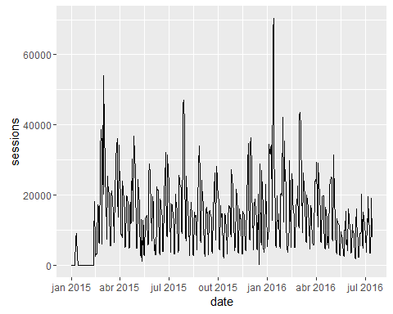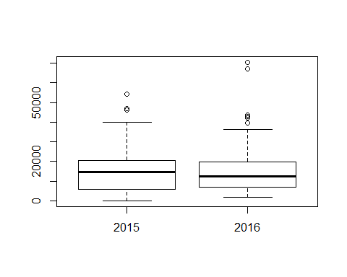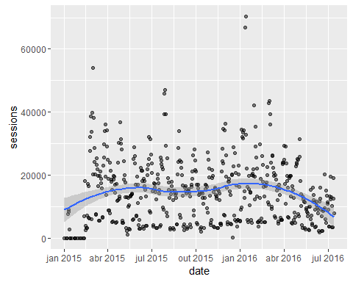

## `stat_bin()` using `bins = 30`. Pick better value with `binwidth`.

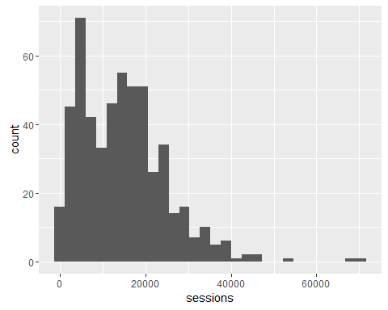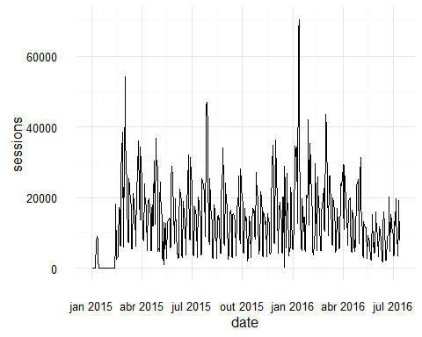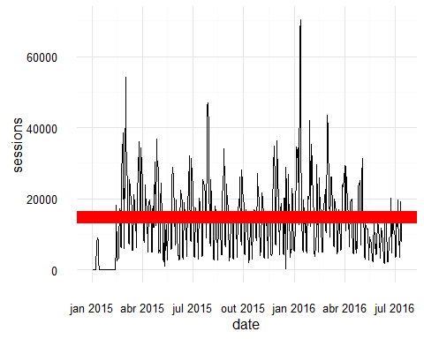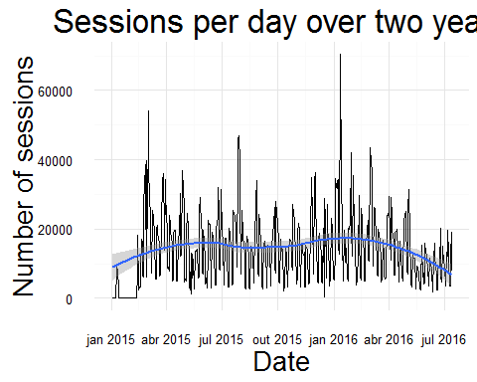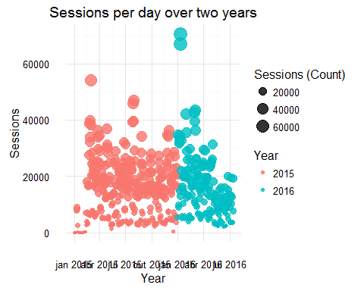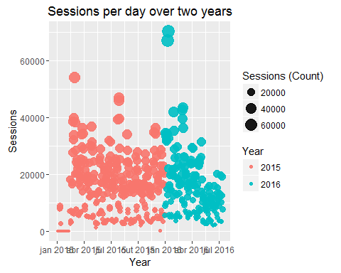

## Loading required package: zoo

##   
## Attaching package: 'zoo'

## The following objects are masked from 'package:base':  
##   
## as.Date, as.Date.numeric

## Loading required package: timeDate

## This is forecast 7.1

