**Bench4Q Tool 1.3 – USP Extension**

Workload Model

***USER’S MANUAL***

Revision Sheet

|  |  |  |  |
| --- | --- | --- | --- |
| Release No. | Date | Revision Description | |
| Rev. 1.0 | 09/24/2009 | | For Bench4Q Tool 1.0.0 |
| Rev. 1.1 | 11/26/2009 | | For Bench4Q Tool 1.1.0 |
| Rev. 1.2 | 05/10/2010 | | For Bench4Q Tool 1.2.X |
| Rev. 1.3 | 07/11/2010 | | For Server-side Resourcer Monitoring |
| Rev. 1.3 - USP | 07/11/2015 | | For Workload Model |

# Introduction

## Basic information

The Bench4Q, is a benchmarking using an e-commerce oriented QoS, provided features that allow the simulation of a controllable and flexible environment. Furthermore, the Bench4Q can be used to evaluate system performance scalability.

The Bench4Q is an extension of TPC-W, and aims to tuning servers ecommerce oriented to provide QoS to their customers. The main features of Bench4Q include: supporting the analysis of session-based metrics that simulates sensitive cargo QoS for a capacity analysis.

The Bench4Q benchmark, is distributed under the Lesser General Public License (GNU), and free software, it can be redistributed and / or modified under the terms of public license by the Free Software Foundation. Following many directives of the TPC-W specification, Bench4Q mainly uses in his simulation metrics QoS guarantee

USP by the need of some academic work, need to extend the Bench4Q for the execution and completion of some work, the version used in extension was 1.3. This pape is extation the Bench4Q’s paper original.

Bench4Q is available on the Internet at http://forge.ow2.org/projects/jaspte. You can find latest version there. Bench4Q is distributed the zip file Which you shouldnt expand using unzip, WinZip (http://www.winzip.com/) or similar.

## Targeted Audience

This document is targeting two types of audience:

* People who just want to use right away the Bench4Q Tool. This is for those who will use the Bench4Q Tool to benchmarking the middleware.
* People who would like to modify Bench4Q Tool to fit their particular needs. You may want to change a little bit our Bench4Q Tool to add some functionality or replace a component with another one.
* People wishing to undertake study and transient analysis or a modulated load

## Structure of the document

This document will guide you on:

* A brief introduction to Bench4Q in section 2, and must justify the extension done.
* A brief introduction to Bench4Q tool in Section 3, followed by som practical examples of the extension.

# Bench4Q: Workload Model

## Overview

Bench4Q is available on the Internet at http://forge.ow2.org/projects/jaspte. You can find latest version there. Bench4Q is distributed the zip file Which you shouldnt expand using unzip, WinZip (http://www.winzip.com/) or similar. All necessary information on this benchmarking can be found in its original documentation distributed with the tool.

## USP Extension

The main challenge of the new benchmarks is to make the results presented, provide relevant information to these different services with different capacities and guarantees these services.

Most aplicaçõesWeb are designed as Multi-tiers systems, due to the flexibility and software reusability, however it is difficult to model the Web application behavior multi-tiers, due to the fact that the workload stimulates the dynamics of system in different levels of the layer.

As part of performance analysis in computer systems, we set the benchmark as the act of measuring and evaluating performance computing, networking protocols, devices and networks, under reference conditions relative to a reference evaluation.

However, despite the existence of various benchmarks and tools for the study, none of them stimulate the transient dynamics of the system and allow an evaluation in transient

The proposed and implemented extension in Bench4Q aims to meet the requirements of MEDC model, which restricts the modulation magnitude of the workload generated by the benchmark. Craving analysis of dynamic systems and that enables the transient analysis of sitema SUT

# Bench4Q Tool

## QUICK Introductions

Bench4Q Tool is designed for Bench4Q benchmarking. Bench4Q Tool offers a convenient way to configure the test and analysis the test result. Now, it is possible Workload Modeling

## Bench4Q Tool Design

Bench4Q tool composed of three parts, console, agent and SUT(system under test), this had no modification.

### Cosole

The console configures the test, collate and display result. The main frame of console windows has a new tab "Load Frequency" is Showed Following in the picture.

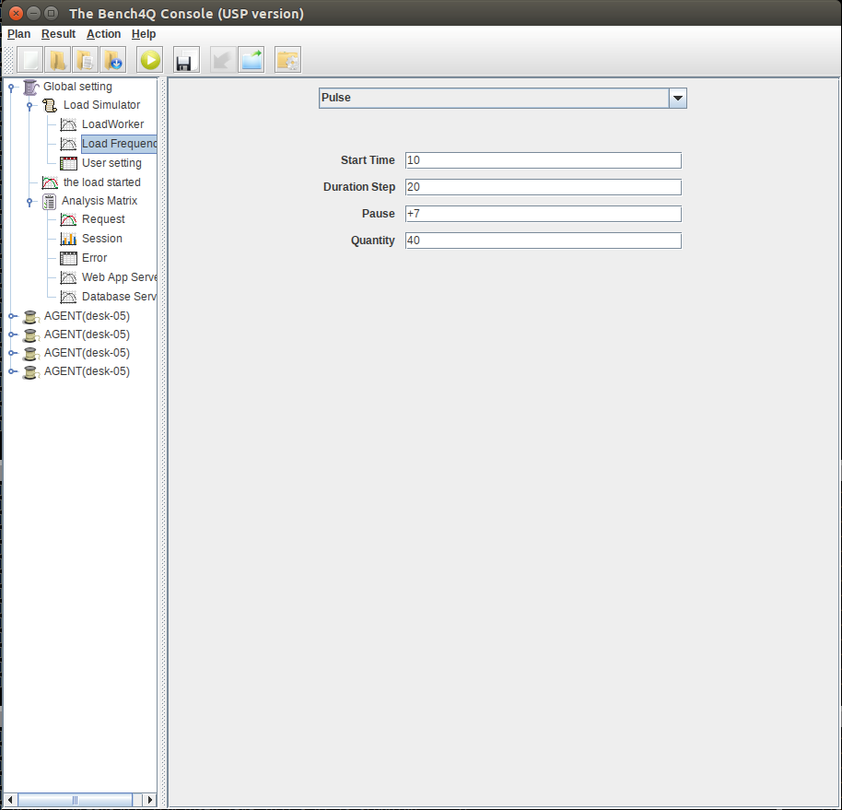

The new tab, which configures the running of the experiment relating to the parameters of the extent of generation of the modulated load. For this option, you must fill in the fields (Start Time, Duration Step, Pause and Quantity) that will generate the modulated load as planned.

* **Start Time:** A period of time that the workload is modulated, characterizing the behavior of the change requests programmed manner;
* **Step Duration:** as shown in Chapter 2, the modulation will be displayed on Degray way;
* **Pause:** Period of interruption / pause after the load planning time;
* **Quantity:** book a number of EBs customers in case of Bench4Q) that are dedicated exclusively to the load modulation.

# Getting Started

In order to run a Bench4Q test, you will need to get some basic information of the Bench4Q Tool.

## Execution workload model

Load Work the tab, enter the following values:

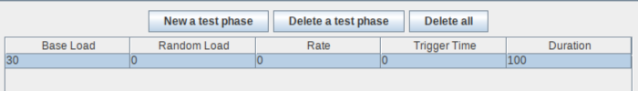

Na nova tab, Load Frequency, insirá os parâmetros utilizado para fazer o teste conforme a figura a seguir:

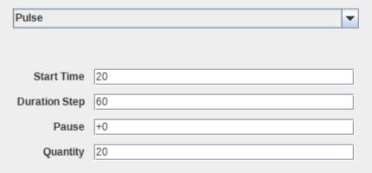

The result can be analyzed by the next figure, this graph is native Bench4Q itself, which shows the load behavior over time. Although stochasticity of the load is modulated as programmed, that is characteristic of stochasticity Bench4Q, in order to maintain a more realistic behavior with clients accessing a stochasticity e-commerce.

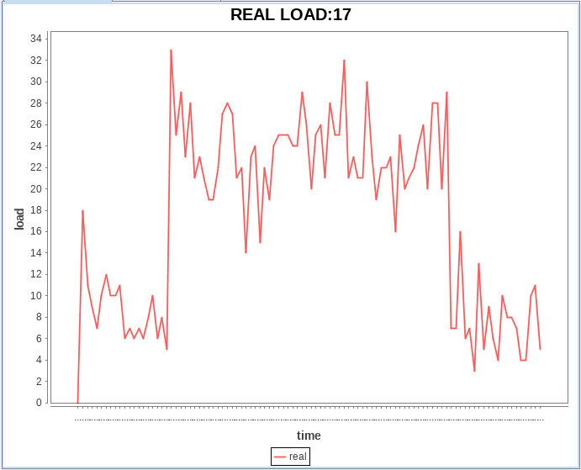

## Other examples

