Wrap-It: Wrapping text around figures & content
Until is resolved, typst doesn’t natively support wrapping text around figures or other content. However, you can use wrap-it to mimic much of this functionality:

- Wrapping images left or right of their text

- Specifying margins

- And more

Detailed descriptions of each parameter are available in the [wrap-it documentation](https://github.com/ntjess/wrap-it/blob/main/docs/manual.pdf).

Installation
The easiest method is to import wrap-it: wrap-content from the @preview package:

#import "@preview/wrap-it:0.1.1": wrap-content

Sample use:

Vanilla
#let fig = figure(

rect(fill: teal, radius: 0.5em, width: 8em),

caption: [A figure],

)

#let body = lorem(30)

#wrap-content(fig, body)

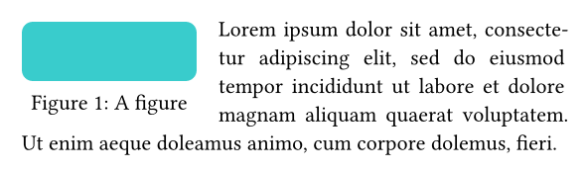

Changing alignment and margin
#wrap-content(

fig,

body,

align: bottom + right,

column-gutter: 2em

)

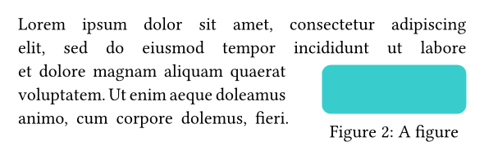

Uniform margin around the image
The easiest way to get a uniform, highly-customizable margin is through boxing your image:

#let boxed = box(fig, inset: 0.25em)

#wrap-content(boxed)[

#lorem(30)

]

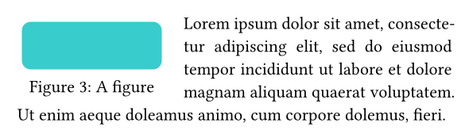

Wrapping two images in the same paragraph
Note that for longer captions (as is the case in the bottom figure below), providing an explicit columns parameter is necessary to inform caption text of where to wrap.

#let fig2 = figure(

rect(fill: lime, radius: 0.5em),

caption: [#lorem(10)],

)

#wrap-top-bottom(

bottom-kwargs: (columns: (1fr, 2fr)),

box(fig, inset: 0.25em),

fig2,

lorem(50),

)

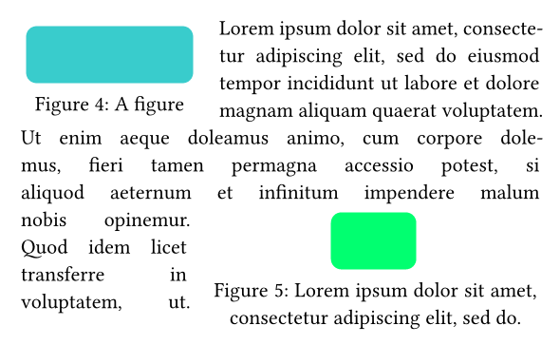

Adding a label to a wrapped figure
Typst can only append labels to figures in content mode. So, when wrapping text around a figure that needs a label, you must first place your figure in a content block with its label, then wrap it:

#show ref: it => underline(text(blue, it))

#let fig = [

#figure(

rect(fill: red, radius: 0.5em, width: 8em),

caption:[Labeled]

)<fig:lbl>

]

#wrap-content(fig, [Fortunately, @fig:lbl's label can be referenced within the wrapped text. #lorem(15)])

