****Documentation-FOTL Changes****

****Elysian Studios to Pro Image Experts** images and text-**

**Header Menu,Invoice File and Mail Template in** different files and locations, follow these steps along with documentation:

1. ****Header Menu - Elysian Studios to Pro Image Experts:****

* File Path: **var/www/git.fotl/templates/frontend/header_menu_FOTL.tpl**
* Locate the logo or text referring to "Elysian Studios" in the header menu template.
* Replace "Elysian Studios" with "Pro Image Experts" in the appropriate HTML/CSS OR PHP code.
* Open the **header_menu_FOTL.tpl** file.
* Search for instances of "Elysian Studios" and replace them with "Pro Image Experts".
* Save the file after making the changes.

1. ****Invoice File - Elysian Studios Logo to Pro Image Experts:****

* File Path: **/var/www/git.fotl/general/general.funcs.php and f**unction name is **exportRecieptUsingDOMPDF().**
* Update the logo used in invoices from "Elysian Studios" to "Pro Image Experts".
* Locate the section of code responsible for inserting the logo into invoices.
* Replace the reference to the "Elysian Studios" logo with the "Pro Image Experts" logo.
* Save the changes and ensure the updated logo appears correctly in generated invoices.

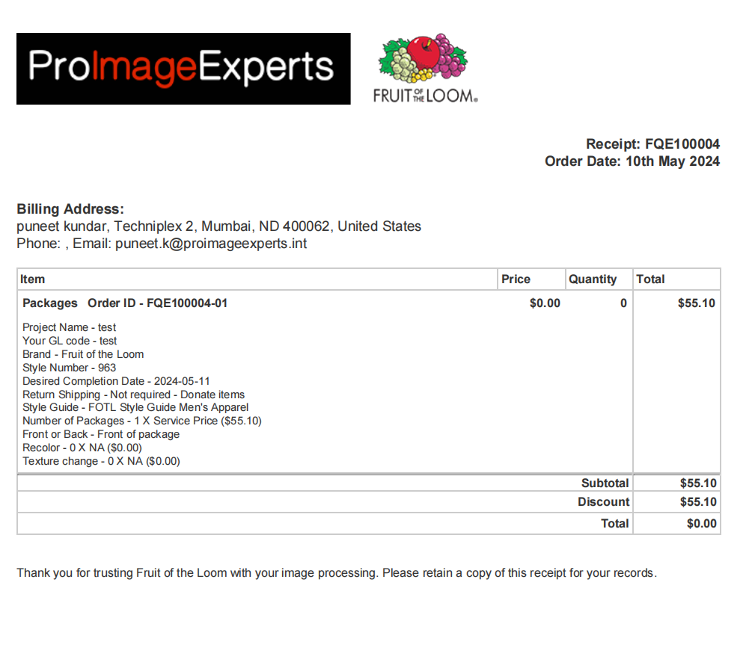

****Database Update for Reseller Logo in Invoice:****

* Access the Database Table: **resellers**.
* Locate the Column Name: **reseller_logo** where the logo information is stored.
* Update the logo data from "Elysian Studios" to "Pro Image Experts" in the "resellers" table.
* Save the changes in the database.

1. ****Mail Template - Change Text from Elysian Studios to Pro Image Experts:****

* File Path: **site.config.php** within the **git.fotl** directory, i.e /var/www/git.fotl/**site.config.php.**
* Open the **site.config.php** file and search for occurrences of "Elysian Studios".
* Replace all instances of "Elysian Studios" with "Pro Image Experts" in the appropriate locations wherever necessary.
* Save the file after making the changes.