BABEŞ-BOLYAI UNIVERSITY CLUJ-NAPOCA

FACULTY OF MATHEMATICS AND COMPUTER SCIENCE SPECIALIZATION COMPUTER SCIENCE IN ROMANIAN

DIPLOMA THESIS

DATABASE MIGRATION:
RDBMS TO NOSQL

Supervisor
Assoc. Prof. PhD. Simona Motogna

Author
Flaviu Mateș

2017
Table of Contents
1. Introduction 3
1.1 Objectives and short description 3
1.2 Theme 4
1.3 Personal Contributions 5
2. Comparative study (SQL and NoSQL) 6
2.1 Overview of Relational Databases 6
2.1.1 Keys Concept 7
2.1.2 Normalization 8
2.1.3 ACID Properties of Databases 9
2.1.4 Structured Query Language (SQL) 10
2.1.5 MySQL 12
2.2 Overview of NoSQL (non relational) Databases 14
2.2.1 NoSQL Databases Data Models 15
2.2.2 Map Reduce Framework 19
2.2.3 The CAP Theorem 20
2.2.4 MongoDB 21
3. Data Migration 25
3.1 Study of problems and solutions 25
3.2 Choosing the Databases 25
3.2.1 Choosing the RDBMS 25
3.2.2 Choosing the NoSQL Database 26
3.2.3 MongoDB vs MySQL Syntax comparison 27
3.3 The Data Migration Process 29
3.4 Mongify 30

Chapter 1

1. Introduction

1.1 Objectives and short description

Large businesses that have great numbers of customers and very big amounts of data are surely going to experience performance problems when handling their Big Data. When businesses need to run queries for fetching their data either for commercial, marketing or analytical purposes, their systems tend to slow down tremendously.

Databases are among the most important pieces of enterprise applications. They store meaningful information which is used for further decision making. This involves processing and analyzing large volumes of data, which leads to growth of databases day by day [4]. Nowadays, big companies and social network organizations need to handle huge amounts of data in their every-day operations. For example, Facebook has five new profiles created every second and WhatsApp says they've processed 7 billion messages in the last day of 2013.

If we take a closer look, some of the big companies that handle massive amounts of data have already switched to using NoSQL databases for storing their Big Data. This is a new type of database and its popularity is ascending among large businesses nowadays. NoSQL provides simple scalability and improved performance relative to traditional relational databases. It also supports dynamic provisioning, horizontal scaling, significantly increased database performance, distributed architecture and developer agility benefits [2] . NoSQL is most valuable when using data structures that are changing rapidly unlike the traditional rigid SQL where developers would have to be very careful when designing their database which shouldn't change much over time.

So most of the existing enterprise databases are, or have been at a certain point in time, implemented using Relational Database Management Systems (RDBMSs). The objective of this thesis is to investigate possible ways to migrate data from the old and performance heavy database to a new generation of NoSQL databases.

Chapter 2 will handle basic concepts of both the RDBMS and NoSQL databases alongside examples of such systems, followed by a comparative study between the two of them.

Chapter 3 will contain a detailed overview regarding the proposed process of migration which consists of choosing two databases, one for each type, a RDBMS as a source and a NoSQL database as a destination. It will also highlight a suggested tool for a test case and implemetation using the said tool.

Chapter 4 provides an implementation of a Graphical User Interface for an existing migration tool, along with experimental benchmarks when trying to migrate different relational databases to non-relational ones.

Chapter 5 is composed of related work and the conclusion of this thesis, while also containing suggestions for future investigations in this area.

1.2 Theme

This thesis will describe the process of migrating old RDBMSs to newer and better NoSQL databases emphasizing on the differences between the two, the technology used for migration, principles that the whole process is based on, issues that might occur when trying to change database types and also consistency matters that are very important when migrating.

The experimental databases that will be used are MySQL as a RDBMS and MongoDB as a NoSQL database. The tool used for migrating the MySQL database will be Mongify as it's by far the easiest way to move data from any SQL database to MongoDB

1.3 Personal Contributions
Chapter 2

2. Comparative study (SQL and NoSQL)

2.1 Overview of Relational Databases

Database management system is a methodology used by different organizations for managing and handling their data in efficient way with the help of different data model [14]. Among different data models including hierarchical model, network mode, object-oriented model, relational model and associative model, relational is highly efficient, most successful and adoptable by professionals [14]. The idea of the relational model was introduced and presented by E.F. Codd in 1970 [3]. In a relational model data is stored in different tables through relationships which can be then accessible using these relationships. This relationship is called ‘Entity Relationship’ which can be logically in the form of one-to-one, one-to-many or many-to-many. Fig 2.1 shows the sales and service activities among different entities by an Entity-Relationship diagram.
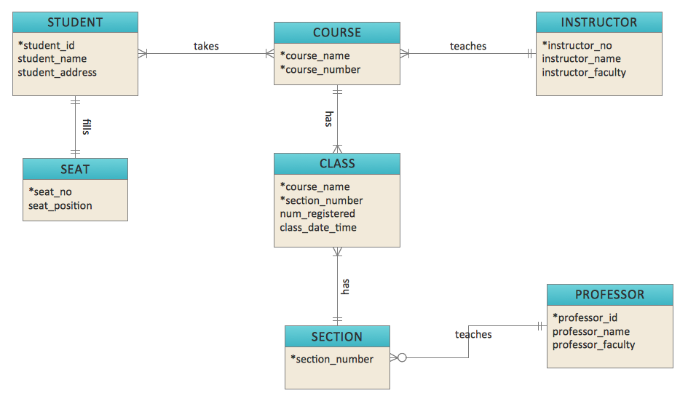
Fig2.1: ERD for Course Management
Source:http://www.conceptdraw.com/solution-park/resource/images/solutions/entity-relationship-diagram-(erd)/Diagramming-Crow%27s-Foot-ERD-Sample60.png
The data structure in the relational model is defined by some of the components which are known as entity or table, row, column or domain, attribute or field and relation. Relational view of data is defined by some of the following properties [3]:
    - Each row in a table represents a record.
    - All the values of attributes recorded in a table are atomic
    - All rows are unique.
    - The ordering of rows is not significant.
    - The ordering of columns is not significant.

This led to defining specific concepts for RDBMSs:

2.1.1 Keys Concept

In RDBMS keys concept are very important as they are used to identify records and make relationship between tables. One of the important properties of relational model is uniqueness of rows or records which are also established using the concept of ‘Key’. There are mainly three types of keys. They are as follows:
- Candidate Key - A candidate key [3] is a key which can be used to uniquely identify any record in a table without referring to any other data. A candidate key can represent a single column or a combination of multiple columns. A table can have more than one candidate key. As for example in a professor table, one candidate key can represent only the 'pofessor_id' column and another candidate key can be the combination of 'professor_id' and 'professor_name'.
- Primary Key - A primary key [3] is a key by which any record can uniquely be identified from a table. A table can have multiple candidate keys. But only one from those keys can be considered or chosen as a primary key. Primary keys ensure the uniqueness of record in a table and reduce data redundancy. It can be defined as a single column or a combination of multiple columns. Fig.2.2 shows ‘order_id’ and ‘cust_id’ as the primary keys of the ‘orders’ table and ‘customer’ table respectively.
- Foreign Key - A foreign key represents a column or set of columns in a table which refers to the primary key of another table in order to uniquely identify a record of that table. In Fig.2.2, ‘order_cust_id’ in the ‘orders’ table represents the foreign key that refers to the primary key ‘cust_id’ which is defined in the ‘customer’ table. Using this foreign key, customer details for any order can be retrieved from the ‘customer’ table.
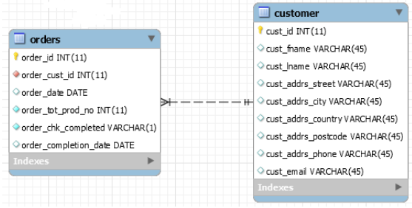
Fig.2.2: Example of using Primary Key and Foreign Key

2.1.2 Normalization

Normalization is a set of rules by which tables or entities in the relational model are designed to be connected through relationships using Primary Keys and Foreign Keys in order to overcome the problem of complex domains described by E.F. Codd [3]. Normalization refers to the process of dividing tables into sub tables as a part of making database management operations easy and simple. The benefits of normalization are as follows:
- Avoid anomalies from updating.
- Optimize queries.
- Provide data integrity.
- Increase speed and flexibility of queries, sorts and summaries.

Three types of normalization were introduced which are termed as First Normal Form (1NF), Second Normal Form (2NF) and Third Normal Form (3NF) [20]. The three forms of normalization are described as:
- First Normal Form (1NF) - In the First Norma Form there should not be any repeating groups. If different columns of a table contain same types of information like Item1, Item2, Item3 then it is not in 1NF. Data must be broken up into smallest possible unit. A table is 1NF if and only if each of the values is atomic.
- Second Normal Form (2NF) - A table is 2NF if and only if it first fulfills all of the requirements of 1NF. Then in the Second Normal Form all non-key columns must entirely be functionally dependent on the primary key.
- Third Normal Form (3NF) - A table is 3NF if it fulfills all the requirements of 2NF. In the third normal form non-primary key fields should be dependent on the primary key rather than non-key field.

2.1.3 ACID Properties of Databases

An important concept for database that ensures safe and reliable transaction process is known as ACID properties [5]. A single logical unit of work which is performed through a sequence of operations refers to as a transaction. In order to qualify a safe, reliable and consistent transaction, the logical unit of work must follows four properties – Atomicity, Consistency, Isolation and Durability (ACID). ACID properties are defined as follows:
- Atomicity - “Transactions are atomic (all or nothing)” [5] In a transaction either all of its operations must be accomplished or nothing will be changed.
- Consistency - After the completion of a transaction all data must be in consistent state which means database will be updated only with valid data. This property ensures that any transaction will transform the database from one consistent state to another consistent state following the databases consistency rules.
- Isolation - “Transactions are isolated from one another” [5]. The intermediate state of a transaction cannot be accessed or seen by any other transactions. Isolation is required to maintain consistency between transactions. Modifications done by concurrent transactions must be isolated from one another.
- Durability - After the completion of a successful transaction the modified works or final state must permanently be saved in the system even in the case of system failure.

2.1.4 Structured Query Language (SQL)

Relational databases use a well-structured language to get access to the database and retrieve the information which is known as Structured Query Language (SQL) [17].

SQL gained popularity within a very short period of time and major RDBMS integrated SQL with their systems. The prime reason behind the increased popularity was 16 development facility. SQL reduces developers’ involvement for their coding as they do not need to write additional code for data query which ultimately reduces the development cost. Considering the popularity and wide spread implementation of SQL, the American National Standards Institute (ANSI) developed a standard for SQL which is known as ANSI SQL. Based on the industry standard ANSI SQL there are different forms of SQL used by different relational database vendors. Fig.2.3 shows how different relational databases use different forms of SQL.
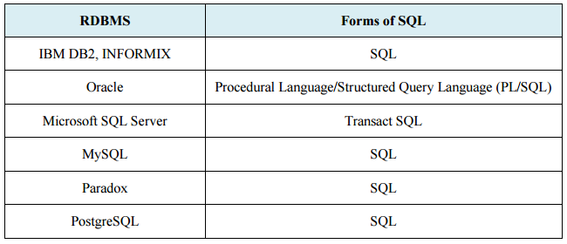
Fig.2.3: Different Forms of SQL used by Various RDBMSs

2.1.5 MySQL

For the purpose of this thesis, the relational database that has been chose in MySQL. MySQL is the most popular Open Source RDBMS developed, distributed, and supported by Oracle Corporation [11]. MySQL databases are relational, which means it stores data in separate tables rather than putting all data in a single store room.The database is organised into multiple physical files which optimized for speed. The entire logical model, with objects such as databases, tables, views, rows, and columns, offers a programming environment that is flexible. You only have to set up rules for the relationships between different data fields, such as one-to-one, one-to-many, unique, required or optional, and “pointers” between different tables. The database applies these rules, so that with a well-designed database, your application never deals with inconsistent, duplicate, out-of-date, or missing data [19].

MySQL software is Open Source, so anyone is free to use and modify the software. It also means that it's free for use and everyone can study the source code and change it according to their needs.
The Database Server that comes with MySQL is very fast, reliable, scalable and easy to use. MySQL Server can run on a desktop or laptop, alongside any of your your other applications, web servers, and so on, requiring close to no maintenance. If you reserve an entire machine to MySQL, you can adjust the settings of it to take advantage of all the memory, CPU power, and I/O capacity available. MySQL can also scale up to clusters of machines, binded together by a network. MySQL Server was originally developed to handle large databases much faster than solutions that were existent and has been successfully used in high performance production environments for years [19]. Although under continuous development, MySQL Server today offers a vast and useful set of functions. Its connectivity, speed, and security make MySQL Server really suited for accessing any of the databases on the Internet.

MySQL is an important component of the LAMP open-source web applications software stack (and other "AMP" stacks). LAMP stands for "Linux, Apache, MySQL, Perl/PHP/Python" [19]. Applications that use the MySQL database include: TYPO3, MODx, Joomla, WordPress, phpBB, MyBB, and Drupal. MySQL is also used in many high-profile, large-scale websites, including Google(though not for searches), Facebook, Twitter, Flickr, and YouTube.

2.2 Overview of NoSQL (non relational) Databases

Designed for distributed data store NoSQL is termed as ‘Not Only SQL’. NoSQL databases have been formed in response to limitations of RDBMSs in storing and processing big data particularly for large scale and high concurrency applications [18]. NoSQL databases are mainly designed to comply with the requirements of Web 2.0 applications where they need large data storage with flexible schema for storing different kinds of attributes like picture, videos, text, comments and other information [13]. They are compatible with cloud scale solutions where distributed data stores can meet the requirements of large user base in terms of reliability and availability. Key features of NoSQL databases include [16]:
- Ability to scale horizontally.
- Ability to partition or distribute over many servers.
- Comparably weaker concurrency than ACID.
- Compared to SQL binding, simple call level protocol.
- Ability to add new attributes to data records dynamically.
- Capable use of RAM and distributed indexes for data storage.

Horizontal scaling, replication and distribution of data over various servers make data reading and writing operations more quickly. But at the same time NoSQL does not support ACID properties which are required for data consistency from concurrent transactions. The web based applications mainly run on the distributed environment where the main requirement is system scalability. And for a distributed system it is not possible to ensure simultaneous Consistency, Availability and Partition tolerance at the same which is stated as the CAP theorem that articulates two of them can be achieved [8]. A weaker model BASE (Basically Available, Soft state, Eventual consistency) replaces ACID in order to keep NoSQL data consistent and reliable. Invented by Eric Brewer, BASE properties are described as [8] :
- Basic availability: Any request will be responded with successful or failed execution.
- Soft state: The state of the system is ‘soft’ which may change over time. So due to eventual consistency changes even may be going on without any input.
- Eventual consistency: Eventually the database will be consistent even though it could be inconsistent momentarily.

The data structures of NoSQL databases are in different form compared to Relational data model. The following section classifies the different types of data models for NoSQL databases.

2.2.1 NoSQL Databases Data Models

According to their data storing techniques, NoSQL databases are classified into following major data models:
- Column-oriented Data Store - Though data organization for both relational databases and column-oriented data stores are done based on rows and columns concept, but it is not necessary for column data stores to define their columns [15]. In contrast with the RDBMS where data sets are stored as rows in a table, column-oriented data store provides provisions for storing data sets as columns. Each of the rows in a RDBMS that provides a complete data set that includes information about Record no., Name, Address, City and State correspond to same data sets, organized in different columns of the column-oriented data store.
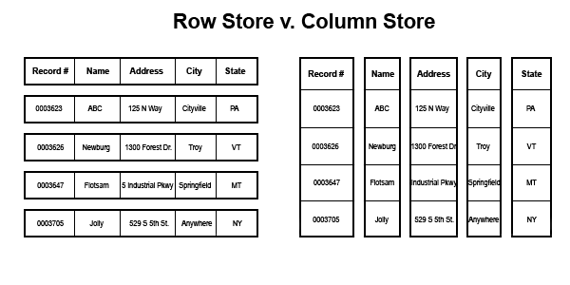
Fig.2.4: Data Storing Way of RDBMS and Column-oriented Data Store
Source: http://www.davewentzel.com/sites/default/files/rscs.gif
- Document-oriented Data Store - Document-oriented data store is designed for managing and storing data in the form of documents that includes inserting, retrieving and manipulating of semi-structured data [8]. In order to make it convenient for the developer’s work, the several different documents accommodated in the document data store are independent and free from a defined schema. The following example shows three different documents stored in a document data store to get a picture about the document data store:
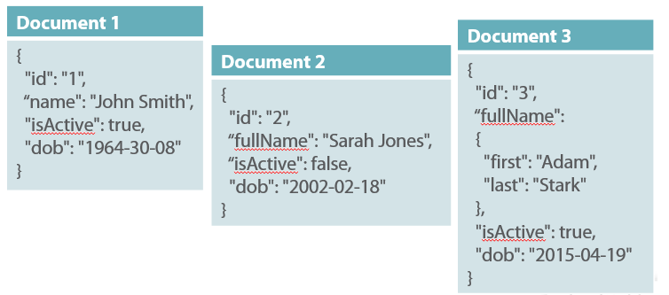
Fig.2.5: Example for the structure of Document Data Store
Source: https://lennilobel.files.wordpress.com/2015/07/i4.png?w=780
In Document data store XML, JSON, BSON (Binary JSON) [12] formats are used to store data in each and every document. Fig.2.5 shows two JSON-format documents where ‘Document 1’ and 'Document 2' are simple structured documents and ‘Document 3’ is nested with another sub document ‘fullName’. But none of them represents document ID which is required in order to get access to the document databases. In Document-Oriented data store a system generated or developer defined identifier is used which is uniquely allocated for each of the documents to identify them [6]. The document data model is mainly useful for web based applications [12] as a part of managing and processing large scale data distributed in a network including text documents, email messages and XML documents. MongoDB, CouchDB, Jackrabbit, Lotus Notes, Apache Cassandra, Terrastore, BaseX are the popular examples of Document Oriented data store [8].
- Key Value Data Store - Key Value data store provides provisioning for storing data in a standalone schema free table which is also referred as a typical Hash Table against an identifier. The identifiers or keys are alphanumeric which can be system generated or developer defined [6] like document ID of Document data model. Fig.2.6 shows data that represent Cars’ attributes are stored against respective numeric keys in a Key Value store model.
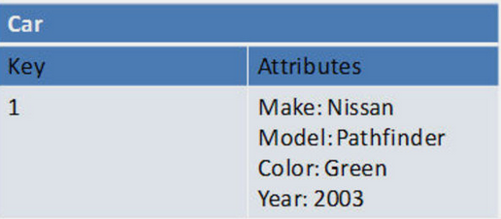
Fig.2.6: Data Stored against a Key in Key Value Store
Source: http://1.bp.blogspot.com/-OeutecOk8X8/VcZYgv4IQhI/AAAAAAAAIsQ/SAzi0A5GNoY/s1600/iiii.PNG

Key Value data stores are primarily useful for in-memory distributed cache [8] to facilitate retrieving data quickly. As “Key-value stores are optimized for querying against keys” [8], they are used for retrieving data from user profiles, look-up information for shopping cart system etc. Examples of Most popular Key Value data stores include Memcached (in-memory), MemcacheDB (built on Memcached), Redis (in-memory, with dump or command-log persistence), Berkley DB, Voldemort and Riak [8].
- Graph Databases - The graph databases store and represent data using graphical structures that include nodes, edges and properties as shown in Fig.2.7. Nodes represent conceptual objects that are connected by lines called edges. Edges are also used to make connections among nodes and properties. Like relational model graph databases handle relationships by traversing through edges. Using a graph algorithm, Graph Databases store data scalable over several servers with nodes and edges. Nodes and relationships are the basic parts of the graph databases where nodes are organized by properties associated with relationships and related data is stored in the nodes those also have properties. The graph databases are primarily useful where relationships to data are more important [12]. Social networking web sites like Facebook and Twitter can be referred as the best example in this scenario as they need to store graph data as a part of making relationships among their users. FlockDB (used by Twitter), AllegroGraph, InfiniteGraph, Sones GraphDB are the examples of some of the Graph databases.
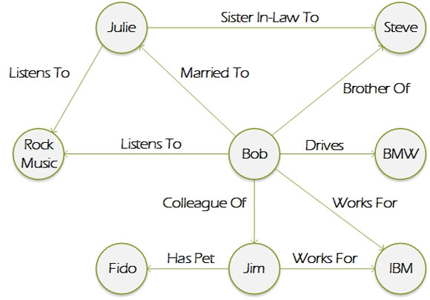
Fig.2.7: Graphical Representation of Graph Database
Source: http://cdn.ttgtmedia.com/rms/editorial/Graph-database-sketch-580px.jpg

2.2.2 Map Reduce Framework

When talking about NoSQL and Big Data, Map Reduce is one of the most frequently used computational models. In 2004 Google introduced a software framework known as MapReduce in order to process huge amounts of data distributed in a clustered environment [4]. As a programming model, MapReduce uses two functions Map and Reduce to facilitate parallel implementation that processes terabytes or petabytes of data distributed across several servers within the desired amount of time. Map function generates intermediate key-value pair data by processing key-value pair input data and then finally all intermediate value are combined against respective intermediate key using Reduce function. For getting a clear conception the MapReduce process has been represented in the Fig.2.8 where two-step functions ‘Map’ and ‘Reduce’ is used. In the ‘Map’ step, input data is distributed over different worker nodes (Node1, Node2, Node3) from the master node where it is divided into smaller sub-problems. The worker nodes work on the sub problem and get back with the answers to the master node. After collecting all of the answers from different worker nodes, master node then merges all of the sub-problems answers in order to form output in ‘Reduce’ step using reduce function.
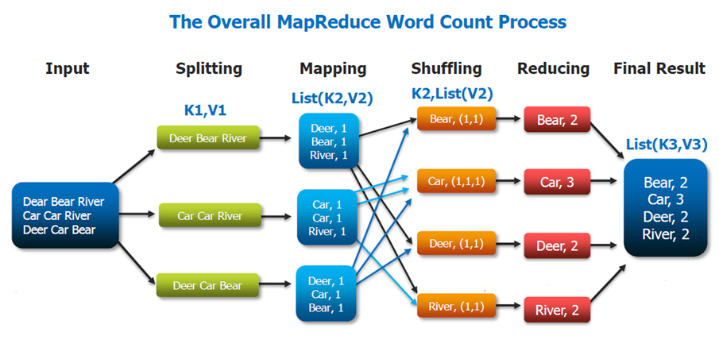
Fig.2.8: Map Reduce Process using Two-Step Function
Source: https://wikis.nyu.edu/download/attachments/74681720/WordCount%20MapReduce%20Paradigm.PNG?version=1&modificationDate=1462902481180&api=v2

2.2.3 The CAP Theorem

The CAP Theorem was introduced by Eric Brewer in 2000. The idea of the CAP stated as “there is a fundamental trade-off between consistency, availability, and partition tolerance” [21]. It is most necessary for every system to achieve all of the three components of the CAP Theorem but it is impossible to achieve Consistency, Availability and Partitioning Tolerance at the same time [21]. The three components of the CAP Theorem can be explained as:
- Consistency: A consistent systems guarantees same data is available to all of the servers in a clustered environment even at the event of any concurrent modification.
- Availability: Some version of data in a cluster must be accessible to all database clients even at the event of shutdown of a node in the cluster.
- Partition Tolerance: Even at the event of network and machine failure the system must keep working fine.

Data consistency is easily achievable in relational database systems as it supports ACID properties. At the same time horizontal scalability is a great challenge for RDBMS system. On the other hand though it is easier for NoSQL data store to achieve horizontal scalability but it can ensure lesser data consistency level due to its weaker BASE properties compare to ACID. Web based applications require horizontal scalability as they deal with data distributed in many servers. It is not easy to achieve all of the three properties of the CAP Theorem. The distributed web based applications mainly ensures higher availability and partition tolerance at the cost of data consistency eventually.

2.2.4 MongoDB

MongoDB is an open-source document database and leading NoSQL database. MongoDB is written in C++ and it's a cross-platform, document oriented database that provides high performance, high availability, and easy scalability. MongoDB works using the concepts of collections and documents. The Database is actually a physical container for collections [10]. Each database gets its own set of files on the file system. A MongoDB server usually has multiple databases.

A group of MongoDB documents is reffered to as a. It is the equivalent of an RDBMS table. A collection exists within a single database. Collections do not enforce a schema. Documents within a collection can have different fields. Typically, all documents in a collection are of similar or related purpose. A document is a set of key-value pairs. Documents have dynamic schema, meaning that documents in the same collection do not need to have the same fields or structure, and common fields in a collection's documents may contain different types of data [9]. The following figure shows the relationship of RDBMS terminology with MongoDB.
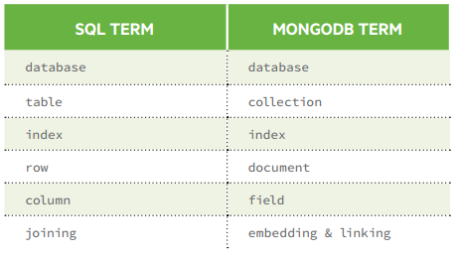
Fig.2.9: Terminology comparation of RDMBS and MongoDB
Source: http://s3.amazonaws.com/info-mongodb-com/sql_to_mongo.pdf

A record in MongoDB is called a document, which is a data structure composed of field -value pairs [9]. MongoDB documents are very similar to the more common JSON objects. The values of fields may include arrays, other documents, and even arrays of documents. Following example shows the document structure of a blog site, which is simply a comma separated key value pair.
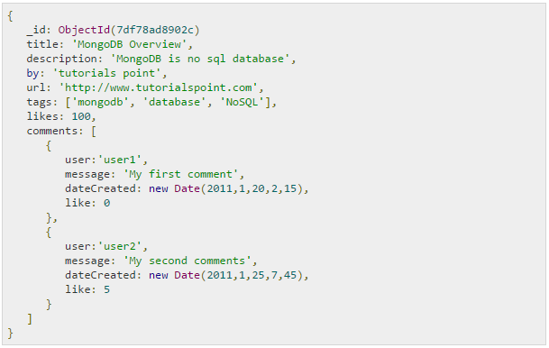
Fig.2.10: Example of a MongoDB Document
Source: https://www.tutorialspoint.com/mongodb/mongodb_overview.htm

The _id field is a 12 bytes hexadecimal number which assures the uniqueness of every document. The user can provide _id while inserting the document. If the user doesn’t provide the _id then MongoDB provides a unique id for every document. The distribution of these 12 bytes is: first 4 bytes for the current timestamp, next 3 bytes for machine id, next 2 bytes for process id of MongoDB server and remaining 3 bytes are simple incremental values [10].
The advantages of using documents are [9]:
- Documents (i.e. objects) correspond to native data types in many programming languages.
- Embedded documents and arrays reduce need for expensive joins.
- Dynamic schema supports fluent polymorphism.
The key features of MongoDB are [9]:
- High Performance: MongoDB provides high performance data persistence. In particular, support for embedded data models reduces I/O activity on database system and Indexes support faster queries and can include keys from embedded documents and arrays.
- Rich Query Language: MongoDB integrates a rich query language to support read and write operations (CRUD) as well as Data Aggregation, Text Search and Geospatial Queries.
- High Availability: MongoDB's replication facility, called “replica set”, provides automatic failover and data redundancy. The replica set is a group of MongoDB servers that maintain the same data set, providing redundancy and increasing data availability.
- Horizontal Scalability: MongoDB provides horizontal scalability as part of its core functionality: sharding distributes data across a cluster of machines, and it supports creating zones of data based on the shard key. In a balanced cluster, MongoDB directs certain reads and writes covered by a zone only to those shards inside the zone.
- Support for multiple storage engines: MongoDB supports multiple storage engines as: WiredTiger Storage Engine and MMAPv1 Storage Engine. In addition, MongoDB provides a pluggable storage engine API that allows third parties to develop storage engines for MongoDB.
Chapter 3

3. Data Migration

3.1 Study of problems and solutions

Most of the current enterprise applications are using relational data models that do not support improved performance relative to NoSQL in terms of analyzing large volumes of data. Data migration is required as a part of performing enterprises’ statistical data analysis when their data set can be categorized as Big Data. With the reference of section 2 where a comparative analysis is discussed between RDBMSs and NoSQL databases, we can conclude that the NoSQL data model is different from Relational model according to their structure and to the way in which they store information. Compared with the NoSQL databases, the structure of the relational databases is more complex in terms of their concept of normalization. According to the rules of normalization they split their information into different tables with join relationship. On the other hand NoSQL databases store their information in a de-normalized way which is unstructured or semi structured. Therefore the successful migration with data accuracy and reliability from RDMS to NoSQL would not be an easy task to accomplish. This chapter proposes a method for data migration process followed by an implementation.

3.2 Choosing the Databases

3.2.1 Choosing the RDBMS

From the available RDMS choices, MySQL will be selected as the source database. MySQL is an open source database which has all the features of relational data models. According to the Oracle Corporation “MySQL is the world’s most popular open source database, enabling the cost-effective delivery of reliable, high-performance and scalable web-based and embedded database applications”. MySQL is very popular to all developers as it is freely available from Oracle Corporation as an open source database [11].

3.2.2 Choosing the NoSQL Database

If we take a look at the Google Trends as shown in Fig.3.1, the search-term MongoDB has been entered more often than some other NoSQL databases like CouchDB, Cassandra, Redis and HBase. This search trends reflects how MogoDB is getting more popularity day by day. Considering the characteristics that include simplicity, agility and developer-friendly features available with the MongoDB, it would be good selection for meeting the purposes of the thesis.
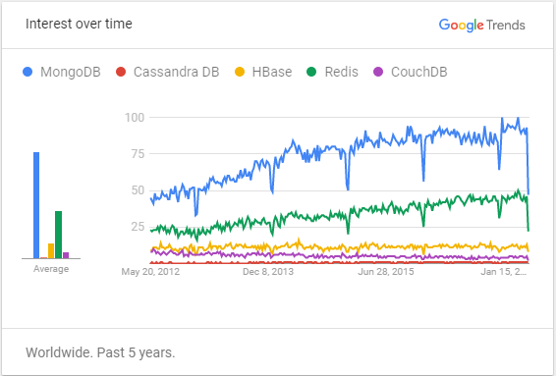
Fig.3.1: Popularity comparison of different NoSQL engines according to Google Search Trends
Source: https://trends.google.com/trends/explore?q=MongoDB,Cassandra%20DB,HBase,Redis,CouchDB

When choosing between different NoSQL Databases, MongoDB will always win because it's written in C++, which is doing things fast, and the open source JSON based document database MongoDB is the most popular NoSQL database among the existing options. Available in many platforms it has a leverage on standards, meaning it supports most of the popular languages like C#, Python, Ruby or Java either on Windows, Mac or Linux. The features of MongoDB include JSON based documents for storing data, flexibility, replication that leads to high availability, support indexing, auto sharding for horizontal scalability, data query and MapReduce [10].

The way MongoDB is implemented allows it to use memory mapped files where it uses as much memory as possible to put its indexes and collections in the RAM as a part of optimizing its performance. MongoDB supports distribution of data over multiple machines which is called ‘Sharding’ and which is also the part of scaling out data. Each of the machines where data is distributed can be replicated in order to avoid losing data. Query processing done by MongoDB is a very simple way that includes choosing indexes, finding documents and finally sending output as BSON (Binary JSON) documents to the socket [9].

The attractive features that include easy data model and data query with high performance make it more popular to the developer community [1].

3.2.3 MongoDB vs MySQL Syntax comparison

For data manipulation, MySQL databases use SQL, a language that provides functionalities like INSERT, UPDATE, DELETE and SELECT statement. On the other hand MongoDB uses functions available in JavaScript APIs (Application Programming Interfaces) for its data manipulation. This section represents some syntax differences between MySQL and 35 MongoDB databases for the same operation. Fig.3.1 includes some of query commands used by MySQL and MongoDB for same operation.

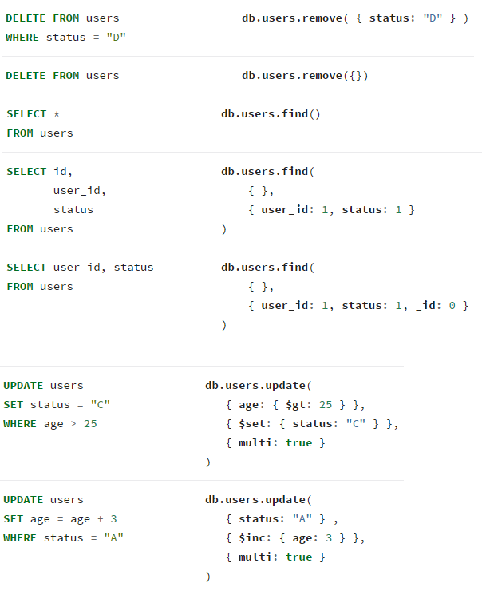
Fig.3.2: Syntax comparison between MySQL and MongoDB
Source: https://docs.mongodb.com/v3.0/reference/sql-comparison/

3.3 The Data Migration Process

Considering the data structure and storage technique, NoSQL databases are obviously different than RDBMSs. Relational models are highly structured and their data is normalized into different tables according to their relations whereas NoSQL data stores are semi structured or unstructured and store the data in de-normalized way. Therefore the data migration process would not be an easy trip. The Fig.3.3 illustrates how data to be migrated from relational SQL database to NoSQL document database. This figure shows that data in the SQL model is normalized into different tables through relationship and same data set to be stored into JSON-style document nested with different other related documents through a migration process.
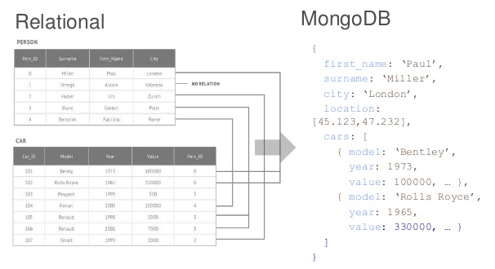
Fig.3.3: A basic scenarion of Data Migration
Source: https://image.slidesharecdn.com/managingdatabasecomplexity-160115113307/95/mongodb-and-the-internet-of-things-3-638.jpg?cb=1452857664

For the migration process as shown in the above Fig.3.3, this thesis proposes an approach not based on traditional data migration procedure, which is called ETL (Extract, Transform and Load), but based on a modern tool called “Mongify”, which is a high performance data translator from traditional RDBMS to MongoDB.

3.4 Mongify

Mongify is a data translator system which helps migrating Relational Databases to MongoDB. Mongify moves data without users having to worry about any of the relational constraints such as Ids and foreign Ids. It allows embedding data into documents, including polymorphic associations all these after simply installing Mongify using a command similar to “gem install mongify” [7].

Before “Mongifying” a database, two important things are required [7]:
- A database configuration file which is used by Mongify to locate the connections to the RDMS and a MogoDB database. This file must always be called “database.config”. Fig.3.4 shows an example of such file
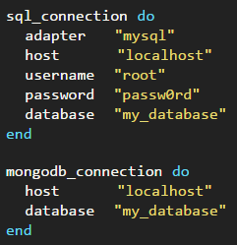
Fig.3.4: Example of a database.config file
Source: http://mongify.com/getting_started.html
- A translation file which is used to identify the data that has to be translated and specify certain things that Mongify will do to the data. This file should always be called “translation.rb”. Fig.3.5 illustrates how such a file should look.
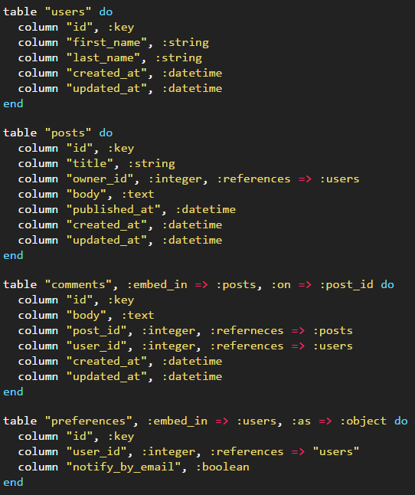
Fig.3.5 Example of a translation.rb file
Source: http://mongify.com/getting_started.html
The entire process of using Mongify is comprised of 4 commands [7]:
- “check” - all this command does is check if the database.config file is correctly constructed and if the specified databases connections work. Example: “mongify check database.confg”.
- “translation” - this command auto-generates a translation from the SQL database. Example: “mongify translation database.config”, or, if a translation.rb file should be generated automatically: “mongify translation database.config > translation.rb”.
- “process” - once the translation.rb file is written or generated the way the user wants, Mongify can be told to actually migrate the data by issuing this command. Example: “mogify process database.config translation.rb”.
- “sync” - it does the same thing as “process”, but instead of moving all the data from scratch, it only syncs (inserts/updates) the new or updated records. Example: “”mongify sync database.config translation.rb”.
Mongify was considered for this thesis because it is an open-source software product, free of any charge for every user, and was created by Andrew Kalek during 2011-2013 [7].
Bibliography
[1] Tauro, C. J. M., Patil, B. R., Prashanth, K.R., "A Comparative Analysis of Different NoSQL Databases on Data Model, Query Model and Replication Model", 2013, , International Conference on ”Emerging Research in Computing, Information, Communication and Applications” ERCICA, retrieved from https://pdfs.semanticscholar.org/c080/1f287bf3d410632207add7aee79193c14b1b.pdf
[2] Han, J., Song, M., Song, J., "A Novel Solution of Distributed Memory NoSQLDatabase for Cloud Computing", 2011, 10th IEEE/ACIS International Conference onComputer and Information Science, p.351-355, retrieved from https://www.slideshare.net/jgabriellima/a-novel-solution-of-distributed-memory-no-sql-database-for-cloud-computing
[3] Codd, E. F., "A relational model of data for large shared data banks", 1970, Communications of the ACM, p.377-387, retrieved from http://users.dcc.uchile.cl/~cgutierr/cursos/BD/A_Relational_Model_of_Data_for_Large_Shared_Data_Banks.pdf
[4] Patel, A. B., Birla M., Nair, U., "Addressing Big Data Problem Using Hadoop and Map Reduce", 2012, 2012 Nirma University International Conferenceon Engineering, p.1-5
[5] Date, C.J., "An Introduction to Database Systems“, 2003, Pearson Education, Inc.
[6] Mughees, M., "Data Migration FROM Standard SQL TO NoSQL", 2013, retrieved from https://ecommons.usask.ca/handle/10388/ETD-2013-11-1342
[7] , "Getting started - transforming your data from SQL to MongoDB in a few simple steps", retrieved from http://mongify.com/getting_started.html
[8] Vaish, G., "Getting Started with NoSQL", 2013, retrieved from Google Books
[9] "Introduction to MongoDB", retrieved from https://docs.mongodb.com/manual/introduction/
[10] "MongoDB Overview", retrieved from https://www.tutorialspoint.com/mongodb/mongodb_overview.htm
[11] "MySQL The World's Most Popular Open Source Database", retrieved from http://www.oracle.com/us/products/mysql/overview/index.html, February2015
[12] Moniruzzaman, A B M, Hossain, s. A., "NoSQL Database: New Era of Databases for Big data Analytics - Classification, Characteristics and Comparison", 2013, International Journal of Database Theory and Application, retrieved from http://www.sersc.org/journals/IJDTA/vol6_no4/1.pdf
[13] Hecht, R., Jablonski, S., "NoSQL Evaluation A Use Case Oriented Survey", 2011, Cloud and Service Computing (CSC), p.336-341, retrieved from https://pdfs.semanticscholar.org/b316/2e0faf4ed736da6b7c043d5a4b8549d10772.pdf
[14] Ganiee, N., Bhargava R., "NOSQL for Interactive Applications", International Journal of Allied Practice, Research and Review
[15] , "Rules of Engagement – NoSQL Column Data Stores", retrieved from http://www.ingenioussql.com/2013/02/
[16] Cattell, R., "Scalable SQL and NoSQL Data Stores", 2010, Newsletter - ACM SIGMOD Record archive, retrieved from http://www.cattell.net/datastores/Datastores.pdf
[17] Chamberlin, D. D., Boyce, R. F., "SEQUEL: A Structured English Query Language", 1974, Proceedings of the 1974 ACM SIGFIDET (now SIGMOD) workshop on Datadescription, access and control, p.249-264, retrieved from http://www.joakimdalby.dk/HTM/sequel.pdf
[18] Han, J., Haihong, E., Le G., Du, J., "Survey on NoSQL Database", 2011, Pervasive Computing and Applications (ICPCA), p.363-366
[19] "What is MySQL?", retrieved from https://dev.mysql.com/doc/refman/5.7/en/what-is-mysql.html
[20] Fagin R., “Multivalued Dependencies and a New Normal Form for Relational Databases”, 1977, ACM Transactions on Database Systems (TODS), p.262-278, retrieved from https://www.comp.nus.edu.sg/~lingtw/papers/fagin.pdf
[21] Gilbert, S., Lynch, N. A., “Perspectives on the CAP Theorem”, 2012, IEEE Computer, retrieved from https://groups.csail.mit.edu/tds/papers/Gilbert/Brewer2.pdf

