- SELECT *
FROM Livros
WHERE PrecoUnitario BETWEEN 50.00 AND 100.00;

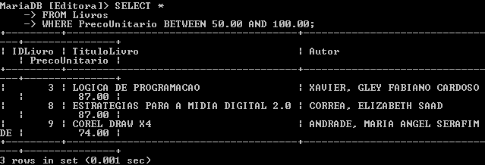

- SELECT *
FROM Livrarias
WHERE NomeLivraria BETWEEN ‘C’ AND ‘J’;
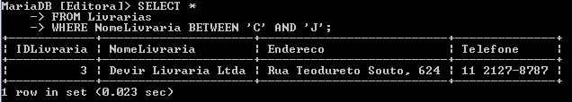

- SELECT *
FROM Livros
ORDER BY IDLivro
LIMIT 5;
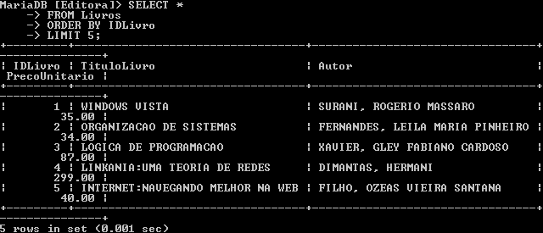

- SELECT MIN(PrecoUnitario)
FROM Livros;
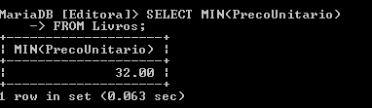

- SELECT MAX(PrecoUnitario)
FROM Livros;
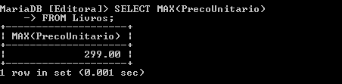

- SELECT MIN(Autor)
FROM Livros;

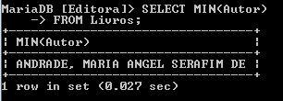

- SELECT MAX(TituloLivro)
FROM Livros;

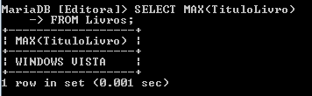

- SELECT COUNT(IDLivro)
FROM Livros;
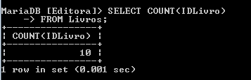

- SELECT AVG(IDLivro)
FROM Livros;
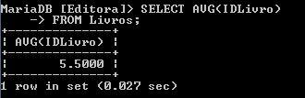

- SELECT SUM(QtdeVendida)
FROM ItensNF;
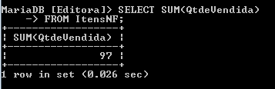

- SELECT nf.IDVenda AS Venda,
nf.DataVenda AS Data,
la.NomeLivraria AS Nome,
la.Telefone AS Contato
FROM NotasFiscais AS nf INNER JOIN Livrarias AS la
ORDER BY nf.IDVenda;

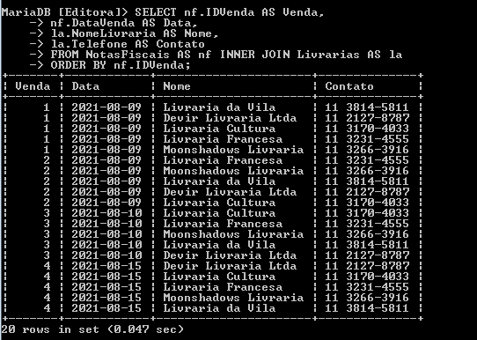

- SELECT inf.IDVenda AS Venda,
lo.TituloLivro AS Titulo,
inf.QtdeVendida AS Qtde,
lo.PrecoUnitario AS Valor
FROM ItensNF AS inf INNER JOIN Livros AS lo
ORDER BY inf.IDVenda;

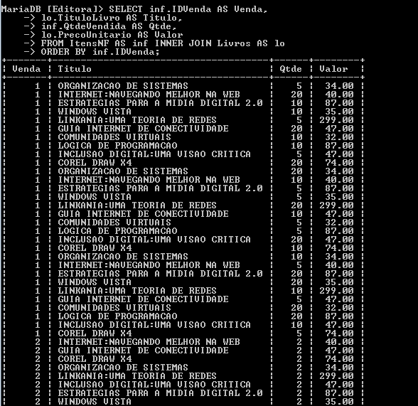
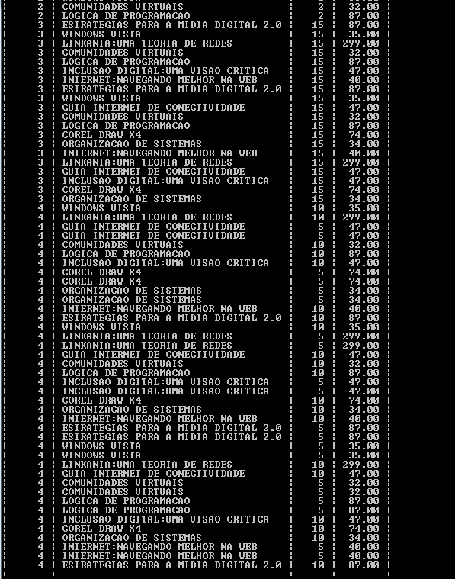

- SELECT inf.IDVenda AS Venda,
lo.TituloLivro AS Titulo,
inf.QtdeVendida AS Qtde,
lo.PrecoUnitario AS Valor
FROM ItensNF AS inf INNER JOIN Livros AS lo
ORDER BY inf.IDVenda;

