OOP Coursework

~ Siddhant Misra, ID: 230319473

Part 1

Importance of encapsulation

Encapsulation is used to prevent unauthorized access/modification of the properties of the Horse class. In this case it is useful as we will be forcing the rest of the code to be going through a function for reading/writing it, we can add further functionality to the getter/setter functions to log all these, this way we can know that no one cheated in the race by changing the attributes in between the races.

Testing encapsulation

Test 1: Trying to read from/write to a private field:



As we can see, the horse’s private properties cannot be read from/written to, since they are private.

Test 2: Using methods to read from/write to private fields:

Now, let us change the direct reads/writes to using the access/mutator (getters/setters).

Here we can see that the build completed successfully, and that there were no errors when the program was run, and it was able to edit the name without any problems.

Improving the Race class

The race class does not show the winner when the race ends, we can make it show the winner by adding an indication of which horse won the race by adding the text for it next to the winning horse’s lane. We can use the `raceWonBy()` method that is already present in the race class:

Edge cases:

1. There are times where more than one horse can win the race, for example:

Here, since both b and c finished the race at the same time, it says that both won. This would make sense but we want to show the user that there was no clear win, rather that two (or more possibly) horses tied.

Changing the code for the print race, I added an array list for the horses that have won.

I then changed the message on the side of the lane from “Race Won” to “Finished”, as we will be listing who won or tied afterwards. I also added the horses that wont to the horsesThatWon array list

I then added a check to see if one or more horses tied, and made it display the appropriate message.

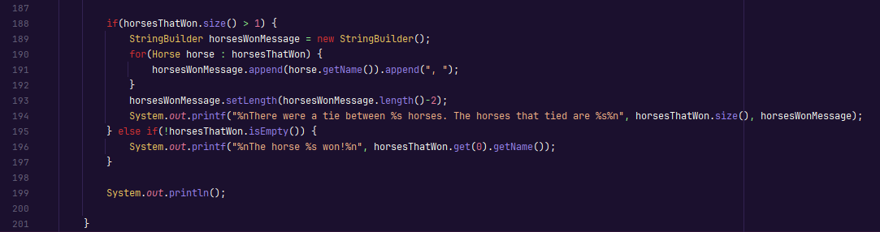

Now when 2 or more horses win, the user is shown a proper message signifying a tie.

1. There are times where a fallen horse can win. This should not happen as a horse falling means the horse is eliminated from the race. An eliminated horse cannot win. This is a simple fix.

We modify our raceWonBy() code to do a check to ensure the horse has not fallen.

With this change, a fallen horse can no longer win.

Here we can see even though the first horse reached the end, it was not counted as having finished the race.

1. Another issue is when all the horses fall. This would end up in an endless loop, which we can fix by doing a check to see if all the horses have fallen or not at the end of the main game loop.

1. The horse characters are printed in the lanes, but it can sometimes be a bit confusing to remember which horse had which symbol. To fix this problem, I added the following code to the print lane method.

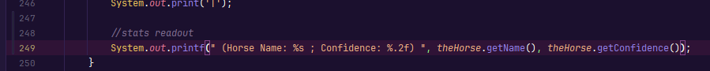

It results in the races looking like this:

This makes it clear which horse is which.

1. Horse confidences do not decrease when the horses fall. To fix this I made a small change to the horse class’s fall() function:

This will reduce the confidence automatically when a horse falls:

1. Horse confidence does not increase when a horse wins. This can be fixed by updating the horse confidence before printing the line. For this I can just edit the print lane function to add the update:

Now the confidence readout updates at the end:

Final code for task 1 can be found on <https://github.com/flaxeneel2/HorseRaceSimulator> (private repository)