Type I IFN signaling promotes stress erythropoiesis by promoting erythroblast/macrophage interaction via atypical chemokine receptor 3 signaling

Authors:
Florian Deckert^{1,2,*}, Riem Gawish^{1,*}, Anna-Dorothea Gorki¹, Federica Quattrone¹, Asma Farhat^{1,2}, Karin Lakovits¹, Anastasiya Hladik¹, Sylvia Knapp^{1,**}

* equal contribution
** corresponding author

¹ Department of Medicine I, Laboratory of Infection Biology, Medical University Vienna, Austria, ² Ce-M-M-, Research Center for Molecular Medicine of the Austrian Academy of Sciences, Vienna, Austria

Running title: Type I IFN regulates stress erythropoiesis

Text word count: x

Abstract word count: x

Corresponding Author:
Sylvia Knapp, MD, PhD,
Laboratory of Infection Biology, Dept. of Medicine 1, Medical University Vienna
Waehringer Guertel 18-20, 1090 Vienna, Austria
Phone: +43-1-40400-51390, Fax: +43-1-40400-51670
ORCID ID: 0000-0001-9016-5244
E-mail: sylvia.knapp@meduniwien.ac.at

Summary
3 sentence summary

Abstract
150 words abstract

Key words

Stress erythropoiesis, terminal differentiation, macrophages, interferon, Ackr3, Ccl2

Introduction
Folgende Punkte müssen rein (&bitte refs immer gleich verlinken mit endnote)
- RBC generation and turnover under steady state conditions
erythropoiesis in humans mainly in the bone marrow but in mice there is a substantial amount of extramedullary hematopoiesis already under steady state conditions in the spleen
- What happens under hematopoietic stress?
infections/irradiation/cytotoxic agents cause BM failure
compensatory stress erythropoiesis: how is this different from steady state?
- Viral infections and stress erythropoiesis – the role of IFN in EMH what is known?
- What was the aim of our study and how did we approach it
Hematopoietic stem cells (HSCs) can differentiate into all types of blood cells. Recent evidence refined our understanding of hematopoiesis towards a dynamic model []. In this system, cell lineages react differently through development [] and in response to external stimulus []. Thereby adjusting the output of immune cells in homeostasis and according to a context specific demand.
Under steady-state condition red blood cells (RBCs) need to be constantly replenished. The center of erythropoiesis resides in the bone marrow (BM) and balances the erythrophagocytosis of senescent RBCs in the spleen and liver. Red pulp macrophages (RPMs) facilitate both the development of RBC progenitors in erythroblastic islands (EBIs) and their phagocytosis []. The molecular signal to enhance erythropoiesis is the kidney derived hormone erythropoietin (EPO) which promotes survival, proliferation, and differentiation of RBC progenitors [].
Stress erythropoiesis is a response to conditions in which the steady-state erythropoiesis is not sufficient to supply RBCs. Treatment with EPO induces stress erythropoiesis by enhancing steady-state erythropoiesis []. It has been shown that EPO skews the BM multipotential progenitor (MPP) pool towards erythropoiesis [Singh 2018, Tusi 2018]. During infection and inflammation however the steady-state BM hematopoiesis is compromised by anemia of inflammation (AI) and the skewing of BM MPPs towards myelopoiesis. In this situation an alternative pathway to the hypoxia induced EPO-stress response is needed to avoid tissue anemia.
Paulson et al. 2011 and 2020 reviews his and others work on the discovery of a bone morphogenetic protein 4 (BMP4) dependent stress erythropoiesis progenitor (SEP). In murine models SEPs originate from BM short reconstituting HSC which specify within the spleen []. Upon infection RPM erythrophagocytosis leads to heme-dependent increase of RPM SpiC and BMP4 expression. Together with pro-inflammatory cytokines TNFa and IL-1b those signals promote SEP proliferation in vitro. Simultaneously monocytes are recruited into the spleen and develop into pre-RPM and RPM. Monocytes and RPM interact with SEPs and promote the formation of stress EBIs which drive differentiation of SEPs. While the early expansion of SEPs is independent of hypoxia the later differentiation is boosted by EPO. Within seven days the extramedullary stress erythropoiesis (ESE) reaches its maximum output marked by splenomegaly.
Our aim is to further refine the model of splenic stress erythropoiesis in infectious disease. We use a sterile inflammation model of viral infection by injecting mouse with TLR9 antagonist CpG. This induces inflammation and splenomegaly after seven days which indicates the peak of ESE. We then used an IFNAR/IFNBR double knock-out mice to identify cell types that react to the viral stimulus and are crucial for ESE. We conclude that monocytes and macrophage are driving ESE but not lymphocytes or granulocytes. Next, we designed a FACS sorting strategy to purify HSC, MPP, erythroblasts (progenitor sort) and monocytes, dendritic cells, macrophages (myeloid sort) from the mouse spleen. To compare splenic steady-state and stress erythropoiesis in an unbiased manner we perform 10x single cell 3’ RNA sequencing (scRNA-seq) of untreated (NaCl) and treated (CpG) mouse. We use the FACS strategy outlined above and pooled the cells of two mice per sample and two biological replicates per group.
Results
Myeloid IFNAR signaling is critical for terminal differentiation during stress erythropoiesis
Infections are a frequent trigger of splenomegaly. Aside from clonal expansion of T and B cells, the spleen under stress conditions is a niche of compensatory hematopoiesis in situations of hematopoietic stress. Infections are typically associated with elevated expression levels of a plethora of inflammatory mediators and during viral infections, Type I IFNs in particular are key drivers of antiviral resistance. However, as the deficiency in Type I IFN typically results in excessive viral replication and, as a consequence, enhanced hematopoietic stress, it is difficult to dissect the direct impact of Type I IFN on stress erythropoiesis. CpG oligonucleotide injection induces massive splenomegaly and stress erythropoiesis under sterile conditions, which is why we used this model to test the contribution of myeloid IFN signaling on erythrocyte maturation in the absence of a replicating stimulus.
Ifnar^{fl/fl} CD169cre, which lack the type I IFN receptor in the myeloid compartment, and Ifnar^{fl/fl} control animals were injected with CpG and xxxx

Single cell sequencing of splenic myeloid and erythroid cells as an unbiased approach to identifiy novel drivers of stress erythropoiesis
To compare the cellular changes in the myeloid and erythroid compartment in the spleen under steady state and stress conditions, we injected wild type mice with either PBS or CpG and collected their spleens on day 6, the peak of splenomegaly. To enrich for small cell populations of interest from each spleen 2 cell fractions were sorted for subsequent single cell sequencing. Fraction I is enriched for macrophages, monocytes and dendritic cells and fraction II for erythroblasts and hematopoietic stem cells. After single cell sequencing cells were integrated across treatment conditions using the Seurat SCT integration workflow with 2000, 4000, 6000 or 8000 highly variable genes (HVGs). The same set of HVGs was then used for Scanorama graph-based harmonization and outputs were evaluated based on marker gene expression. We arbitrarily selected the Seurat integration workflow with 8000 HVGs for downstream analysis. Clusters were determined with the Louvain algorithm (resolution 1). We used the first ten dimension of the PCA build on the integrated SCT assay and k set to 20 for the neighborhood graph. After subclustering of three clusters on the same graph (resolution 0.25), 28 cell populations were visualized using UMAP (Figure 1A) (15 dimension of the PCA with k set to 100).

Cell type annotation based on Louvain cluster
According to Dahlin et al., 2018, we identified small clusters of HSC, granulocyte and monocyte progenitors which confirms the accuracy of the integration process (Figure 1C). As expected, the gene expression patterns of the erythroid lineage clusters, MEP (1-3), Pro-Erythroblast (1-4) and late Erythroblasts (1-5) reflects a smooth continuum. Importantly, only MEP (1) and to a lesser extent MEP (2) still show expression of Megakaryocyte genes, while the transition from MEP (3) to Pro-Erythroblast (1) is marked by the expression of Car1 and Epor, indicative of a clear commitment to the erythroid lineage (Figure 1C). Terminal differentiating erythroblasts (1-5) show elevated transcription of late-stage erythropoiesis genes such as Car2, Gata1, Tfrc, Hba-a1, Hba-a2, with the highest levels of hemoglobin in the last erythroblast cluster(5) which is characteristic for orthochromatic erythroblasts shortly before enucleation and transition to the reticulocyte stage (Figure 1C).

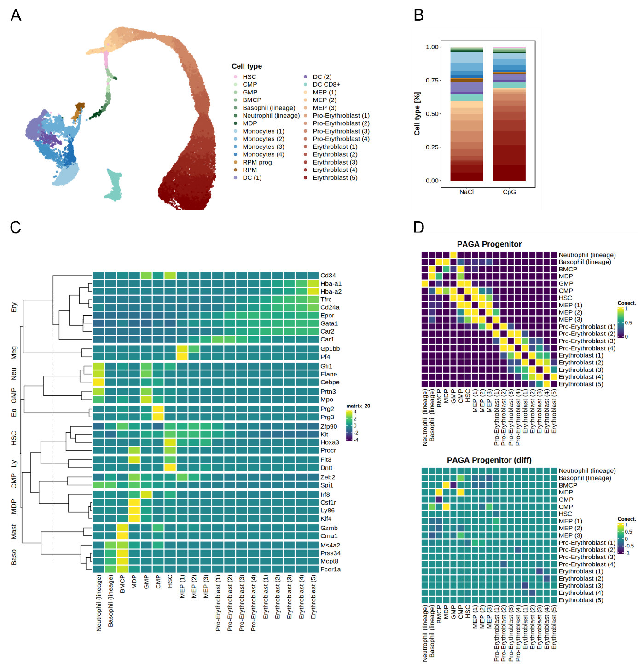
Figure 1A: Mice were injected with either PBS or CpG and presorted splenocytes were analysed using single cell sequencing on day 6 post injection. (A) depicts the UMAP cell clusters found in both treatment groups and in (B) the differential abundance of identified clusters is shown under steady state and upon stress conditions. In (C) key marker genes which were used to identify progenitors are shown and in (D) PAGA connectivity matrix xxx

Erythropoiesis is known to be a linear process without branching. We confirm this by diffusion map and pseudotime analysis (Figure 2 A). In addition, we construct an PAGA graph of all progenitor cells to measure the probability that cells of a cluster transition into another cluster state (Figure 1 D). The analysis concludes that early progenitor (MEP (1-3)) retain the capacity to convert towards each other transcriptional state. With the first pro-erythroblast (1) stage this plasticity is lost and based on the PAGA connectivity the cells do only transition towards the next cluster. The direction of the process from progenitor to erythroblast stage is confirmed by RNA-velocity analysis (Figure 3). We conclude that we have faithfully captured the complete erythroid lineage on single cell resolution.
We also detect a cluster of HSC with the potential to progress towards MEP, CMP, and GMP. The identity of the HSC cells was further confirmed by correlating the transcriptome profile with the ImmGen data bank (not shown). The HSC represent a potential source of BMP4 stress progenitors which is further investigated by RNA-velocity analysis.
The myeloid cell annotation is based on marker gene expression (not shown yet).

CpG treatment exacerbates extramedullary erythropoiesis
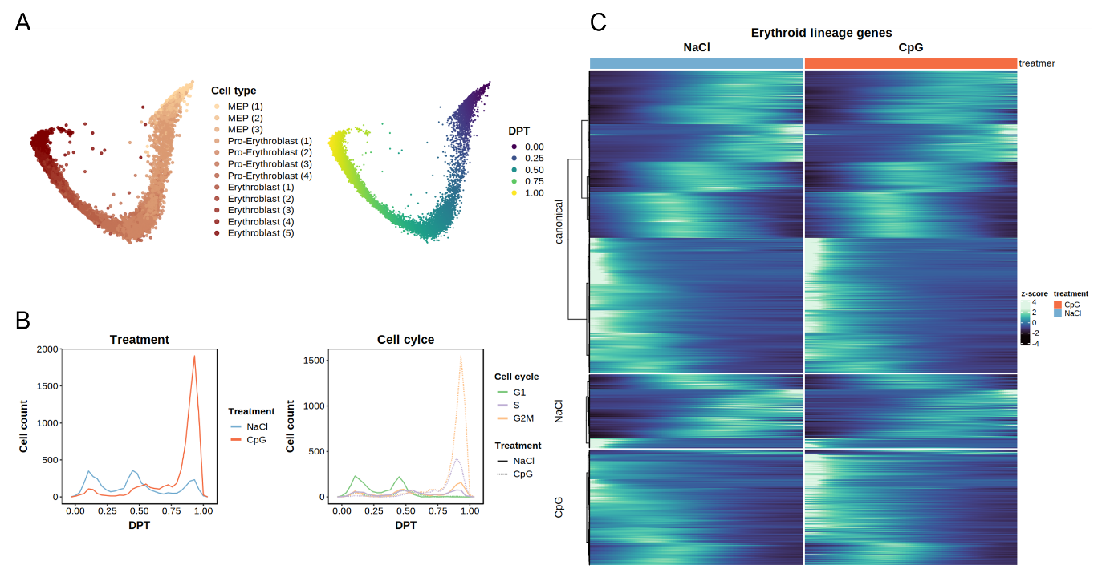
Figure 1 B shows the cell type composition of treated and untreated samples. The most pronounced effect is the expansion of erythroblasts in the CpG group while most cells of the NaCl erythroid lineage halt at the MEP and pro-erythroblast stage. When plotting the cell counts along the diffusion pseudotime (Figure 2 B left) we identify a trimodal distribution in both samples for both conditions. We can show that the peaks correlate to MEPs, pro-erythroblasts, and erythroblast clusters respectively. The first and second peak of the distribution are predominantly cells in G1 phase (Figure 2 B right) while the later peak represents proliferating cells. That is in accordance with the development of erythrocytes from the literature. In the CpG group the erythroid lineage shifts towards proliferating erythroblasts.
Figure 2

Extramedullary stress hematopoiesis is transcriptional distinct at progenitor states
We identified erythroid lineage marker along the diffusion pseudotime with tradeSeq. We identified 1094 genes which are differential expressed along the trajectory in both treatment groups (Figure 2 C). Those include the known marker genes Gata2, Car1, Car2, Epor, Tfrc, Cd25a, Hba-a1, Hbba-a2. Conditioning the model on the treatment group yields 254 steady state erythropoiesis lineage genes and 399 stress erythropoiesis lineage genes. Interestingly, while the steady state genes are distributed along the whole trajectory the stress specific genes accumulate at the beginning of the trajectory, suggesting what? We further investigate the differential lineage genes by pathway analysis (not done yet).

RNA-velocity identifies different dynamics of stress erythropoiesis
RNA-velocity correctly identifies the direction, root, and end points of erythropoiesis (Figure 3). The late-stage erythroblast stage transition quickly in both groups which is in accordance with the cell cycle analysis. Differences between the treatment groups occur at the early stages. In the CpG group the MEP are more likely to transition towards the pro-erythroblast stage. We also observe a shift in root cells. In the CpG group the HSC are likely to develop into MEPs and the MEP (1) cluster is likely to harbor a subset of cells activated to proliferate. The later subset might be the stress erythrocyte progenitors described by Paulson et al.
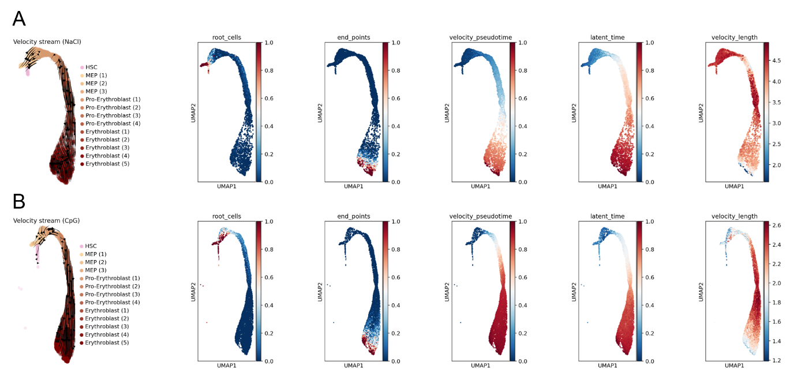
Figure 3 A RNA-velocity NaCl. B RNA-velocity CpG. I identified root and end points of the process. Velocity and latent pseudo time which are not too important right now. And the velocity length as well.

Spleen myeloid cells show IFNAR activation signature
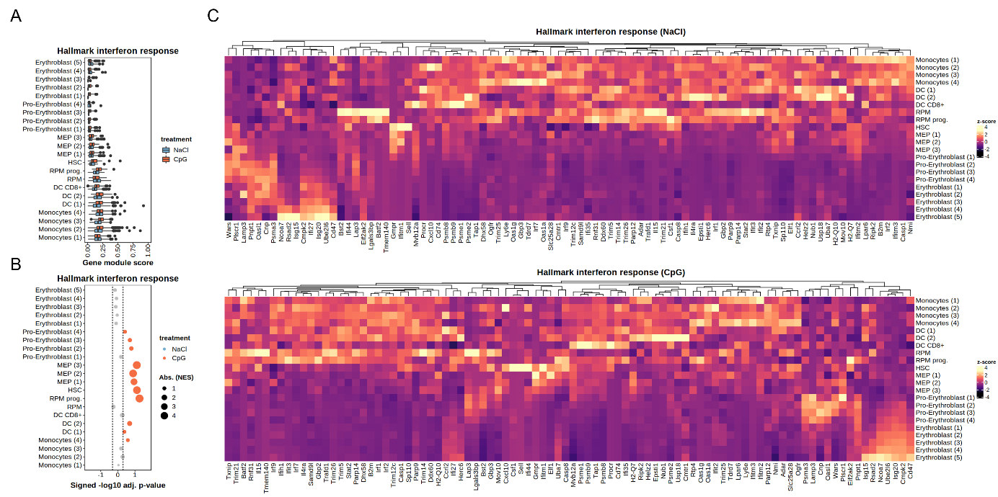
To confirm the IFNAR knock out experiments we expect myeloid cells to express a IFNAR activation signature. We used the MSIGDB gene hallmark interferon response gene set as a reference
Figure 4 A module score for interferon alpha response per cell. B GSEA of interferon response. If the dots are red the response is significant in the CpG group. Gray means no significance. And blue would be significant in the NaCl group. C Average interferon response gene expression per cell type. Top NaCl bottom CpG.
to compute a module score per cell (Figure 4 A) and to perform gene set enrichment analysis (Figure 4 B). The interferon response signature is on average stronger in the CpG treated group compared to the NaCl group (Figure 4 A). The GSEA shows that only CpG treated cells show a significant ifna response signature (Figure 4 B). Interestingly, the RPM progenitor but not RPM show a strong signature for interferon response in the CPG group (Figure 4B). The RPM progenitor GSEA is also the top hit by adjusted p-value. In addition, we find that HSC, MEP (1-3) show a strong activation signature in the CpG group. To a lesser extend Monocytes and DC. Figure 4 C shows the interferon response gene and average expression per cell type separated by treatment groups.

Stress erythropoiesis needs cell communication rewiring
Next, we want to investigate which signals are required for stress erythropoiesis (Figure 5). I need to deeper analysis this but so far, I can tell that CpG treated RPM communicate with erythroblast (1-5) through Cxcl2-Ackr1 and Clc2-Ackr1. That is already interesting, but I need to have a closer look if the RPM progenitors interact with MEPs or earlier stages of erythropoiesis.
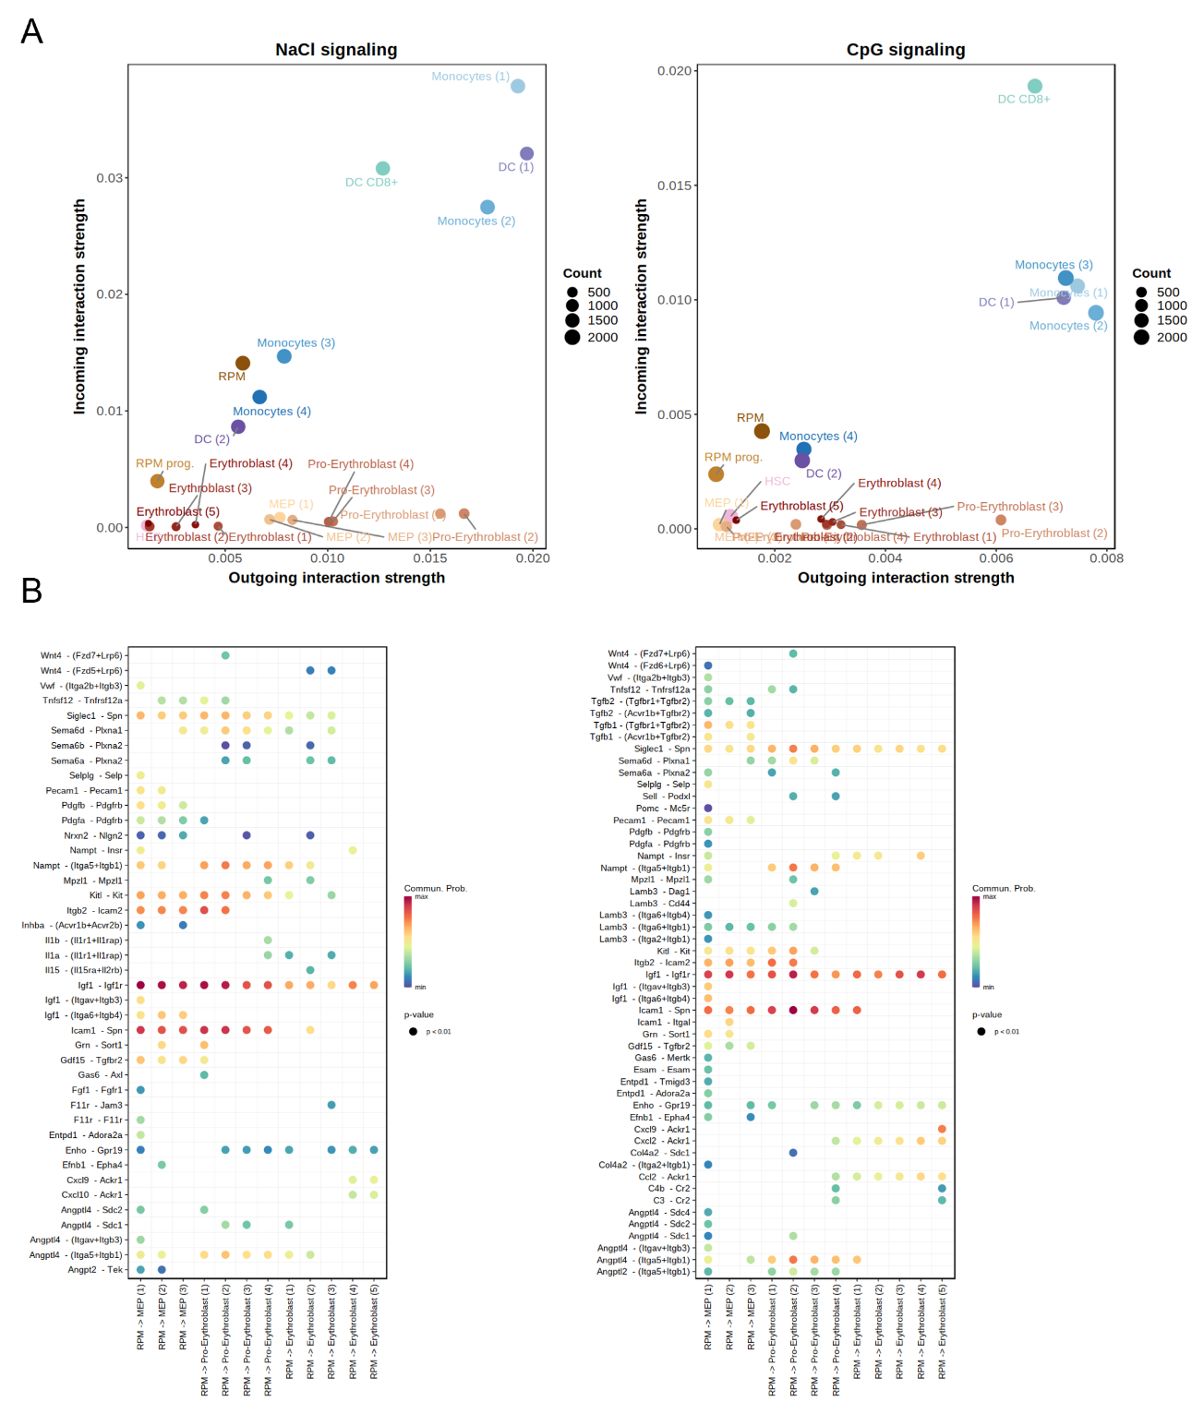
Figure 5 A Differences in the incoming/outgoing interaction strength between cell types and treatment groups. B shows the ligand receptor interaction between RPM and the erythroid lineage. On the left NaCl and on the right hand CpG

Source
Singh et al., 2018 https://doi.org/10.1016/j.stemcr.2018.04.012
Tusi et al., 2018 https://doi.org/10.1038%2Fnature25741
Paulson et al., 2020 https://doi.org/10.3390/cells9030634
Paulson et al., 2020 https://doi.org/10.1016/j.exphem.2020.07.011
Paulson et al., 2011 https://doi.org/10.1097%2FMOH.0b013e32834521c8
Dahlin et al., 2018 https://doi.org/10.1182/blood-2017-12-821413

