Encapsulating means enclosing a piece of code’s behavior, and consequently hiding their details from other classes. All of the data and functions that should pertain to only one class, will only stay with that class. Encapsulation is important because it reduces the complexity of the code, improves readability, and debugging. If anything breaks in a program, if the code Is properly encapsulated, only one area will have to change.

In my program, for example, the class Word has a variable called _value.

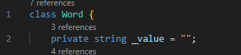

The value of this variable is set by the Constructor of the class, because it must be set when right when it is created.

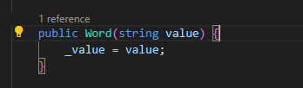

Because of the purpose of this program, I don’t want any other class to have access to the _value variable, therefore, I must set it as private. Otherwise, anyone could just access it and change the value, and it would be very complex. Because it is private, the value can only be set once on the constructor, and that’s it.