**Inheritance**

Inheritance is when one or more classes have the ability of obtaining the characteristics of another class, such as attributes and functions. The class that gives the characteristics is called a parent class, and the one who receives is called a child class.

This principle is important because it saves lots of time by sharing behaviors in between different classes, so you don’t need to write the same method or attribute for every single class that has a similar functionality. It also helps to maintain the code and fix bugs, because if one piece of code breaks, you just have to fix it in one place, which is the parent class.

For example, in this week’s assignment, it was required to write a program that shows 3 types of activities, that have different functionalities overall, but still have the same behavior at some parts. That’s why I wrote an Activity class to act as the parent, and 3 other classes, BreathingActivity, ListingActivity, and ReflectionActivity, to act as child classes.

The Activity class has some methods that are shared with all the child classes, such as DisplayStartingMessage, DisplayEndingMessage and ShowSpinner:

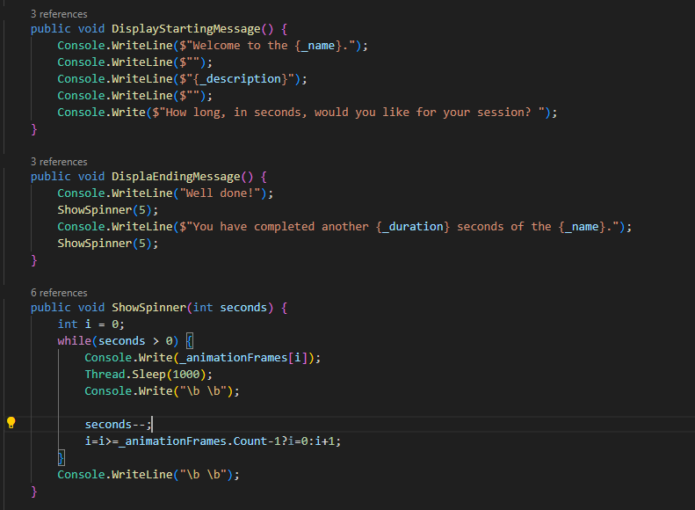

Therefore, these classes can be used in all of the child classes.

Some of the child classes have particular methods that are only used in their scope, and are not necessary in the other classes, like the GetRandomPrompt and the GetRandomQuestion methods in the ReflectionActivity class:

