**Nombre:** Fabián Lecaros

Método GET http://localhost:8080/api/v1/pacientes

Método POST http://localhost:8080/api/v1/pacientes

**BUSCAR PACIENTE** Método: **GET** URL: http://localhost:8080/api/v1/pacientes/{id}

**ACTUALIZAR PACIENTE** Método: **PUT** URL: http://localhost:8080/api/v1/pacientes/{id}

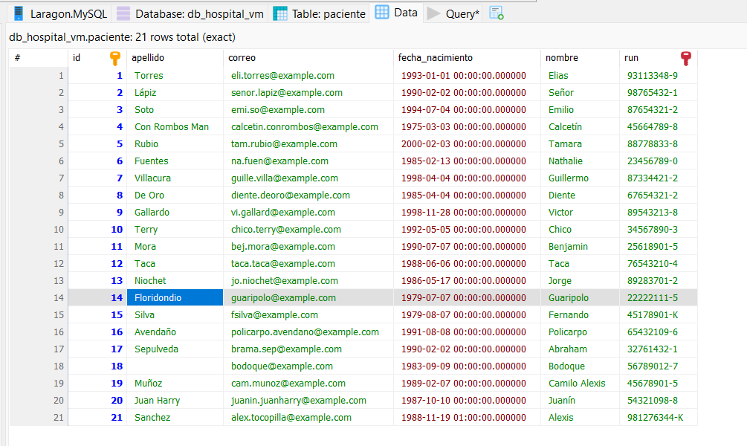

**ELIMINAR PACIENTE Método: DELETEURL: http://localhost:8080/api/v1/pacientes/{id}**



