Contents
Using TSRoute user’s guide 3
Installing TSRoute 4
Copying TSRoute files 4
Installing TSRoute 4
TSRoute: Parsing Transport Stream files 6
Parsing a MPEG2 TS file 6
Parsing programs of a MPEG2 TS file 7
Parsing of MPEG2 TS files with packet filter 8
Parsing of MPEG2 TS files with PID and packet filters 9
Parsing of MPEG2 TS files with timestamp and packet filter 10
TSRoute: Capturing Transport Stream files 11
Capturing a MPEG2 TS file 11
TSRoute: Streaming Transport Stream files 14
Streaming a MPEG2 TS file in command mode 14
Input XML file format 15
Streaming a MPEG2 TS file 17
Streaming a MPEG2 TS file continuously 17
Streaming several MPEG2 TS files simultaneously 18
Streaming several MPEG2 TS files simultaneously in service mode 18
Defining the list of transport stream files to stream 18
Installing TSRoute service 20
Starting TSRoute service 20
Stopping TSRoute service 20
Uninstalling TSRoute service 20
TSRoute: Converting Transport Stream files 21
Converting a MPEG2 TS file in command mode 21
TSRoute: Filtering Transport Stream files 22
Filtering a MPEG2 TS file in command mode 22
TSRoute: Routing Streams over UDP 23
Routing a MPEG2 TS stream in command mode 23

Using TSRoute user’s guide
TSROUTE application has been developed to stream MPEG2-TS transport stream files towards the video components. With this tool running on Windows, it’s now possible to show:
- MPEG2-TS spooled Live TV channels over Internet,

TSROUTE is not only a MPEG2-TS streamer, with TSROUTE you can:
- Capture MPEG2 Transport Stream on network
- Parse MPEG2 Transport Stream files
- Route MPEG2 Transport Stream streams

Installing TSRoute

Copying TSRoute files
Copy all the files listed below to the destination folder on your machine running Windows.
Description | DVD Folder | Internet link | Destination
Latest TSRoute build without TS files | \IPTV_Edition_Tools\TSRoute | https://github.com/flecoqui/Win32/blob/master/TSRoute/Releases/ReleasesWithTSFiles.zip | C:\TSROUTE
Latest TSRoute build with TS files. | \IPTV_Edition_Tools\TSRoute\TS | https://github.com/flecoqui/Win32/blob/master/TSRoute/Releases/Releases.zip | C:\TSROUTE

Installing TSRoute
- TSRoute is a command line application which can run on Windows. This tool supports two modes:
- Command mode: TSROUTE runs in a Command Shell window
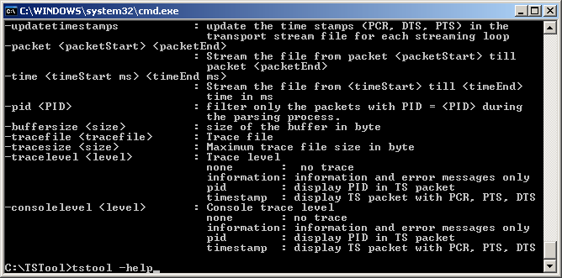
- Service mode: TSROUTE run as Windows Service to stream Transport Stream files
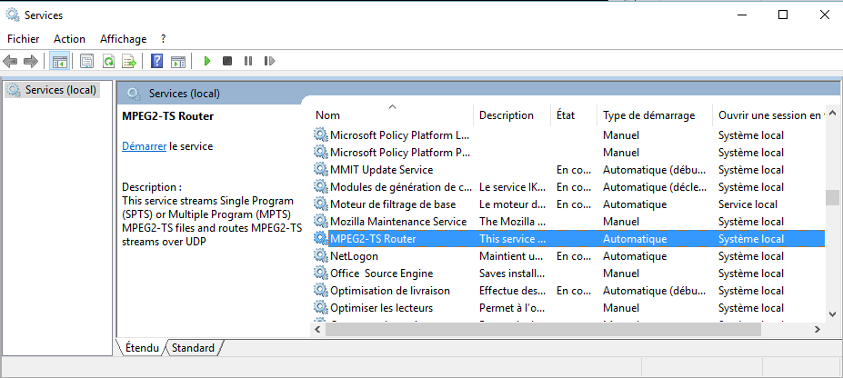
- When the file TSROUTE.EXE is copied on your machine, the application is ready to be used in command mode. To use TSROUTE application, selectthe menu Start -> Run , the dialog box Run appears enter cmd in the Open field and click on the OK button.
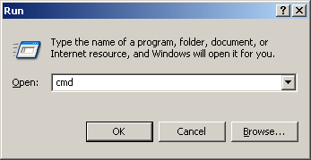
- The Command Shell window appears, enter the command: cd c:\TSROUTE to change directory
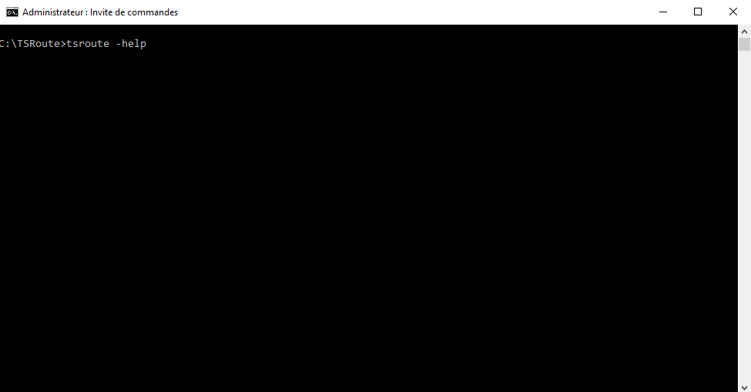
- TSROUTE is ready to use: enter TSROUTE –help
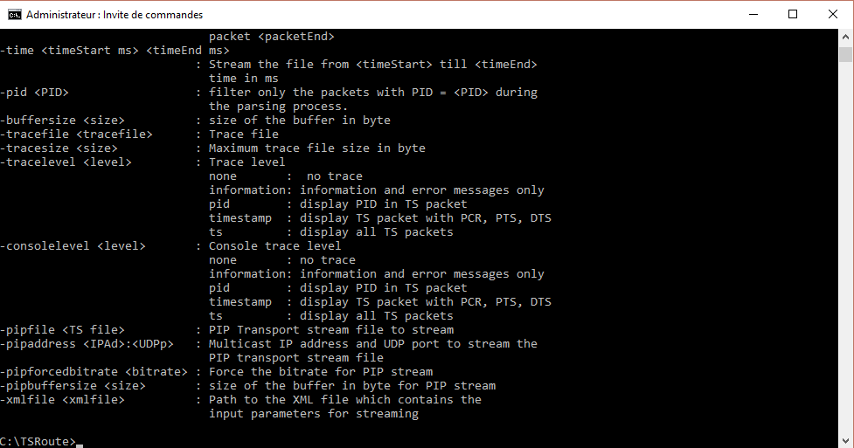

TSRoute: Parsing Transport Stream files
TSROUTE supports a mini-parser to analyze the Transport Stream files before a broadcast.

Parsing a MPEG2 TS file
- Select the menu Start -> Run , the dialog box Run appears enter cmd in the Open field and click on the OK button.
- The Command Shell window appears, enter the command: cd c:\TSROUTE to change directory. Enter the following command line:
TSROUTE –parse –file <file> [option]
The options are described in the table below:
Parse option | Mandatory | Description
-parse | Yes | Activate Parsing
-file <TS file> | Yes | Path of the transport stream file to parse
-packet <first> <last> | No | Define the range of packets to parse  For instance:  -packet 12 14 : parse from packet 12 till 14  -packet 12 : parse from packet 12 till the last packet of the file
-pid <PID> | No | Parse only the packets with pid = <PID>
-consolelevel <level> | No | Define the trace level on the screen:  <level> = none : No trace  <level> = information : Information  <level> = pid : Display packet with the PID filter  <level> = timestamp : Display packet with the timestamp filter  <level> = ts : Display all the packet
-tracefile <file> | No | Path of the trace file
-tracesize <size> | No | Maximum size of the trace file.
-tracelevel <level> | No | Define the trace level in the trace file:  <level> = none : No trace  <level> = information : Information  <level> = pid : Display packet with the PID filter  <level> = timestamp : Display packet with the timestamp filter  <level> = ts : Display all the packet
-buffersize <size> | No | Define the size of the memory buffer used to read the transport stream file.  Default value: 4194304 (4096*1024)  if size = 0, the file is completely loaded in memory

Parsing programs of a MPEG2 TS file
- Select the menu Start -> Run , the dialog box Run appears enter cmd in the Open field and click on the OK button.
- The Command Shell window appears, enter the command: cd c:\TSROUTE to change directory. Enter the following command line:
TSROUTE –parse –file TEST1.TS
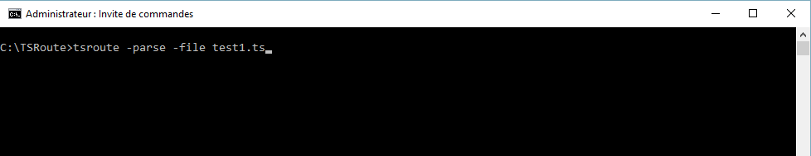
- The result of the parsing is immediately displayed, and provide the following information regarding the Transport Stream file:
  - the number of packets
  - the PCR_PID present in the transport stream file
one PCR_PID for Single program Transport Stream (SPTS)
two PCR_PID for Multiple program Transport Stream (MPTS)
  - the program_map_pid
  - the program_number
  - the pid and the stream type for each component of the program
  - the expected bitrate of the stream
  - the expected duration of the stream

Sample:
Parsing of a Multiple Program Transport Stream file:
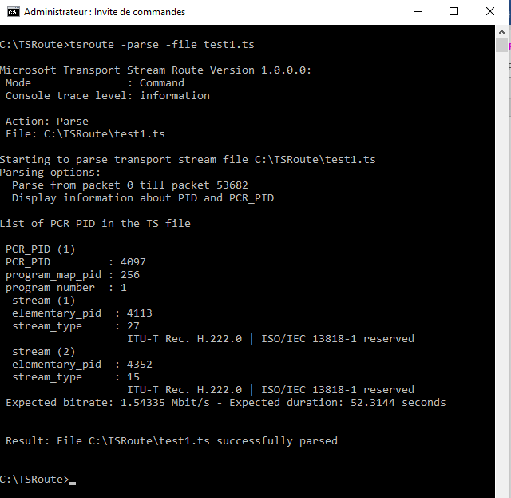

Parsing of MPEG2 TS files with packet filter
- Select the menu Start -> Run , the dialog box Run appears enter cmd in the Open field and click on the OK button.
- The Command Shell window appears, enter the command: cd c:\TSROUTE to change directory. Enter the following command line:
TSRoute -file TS\TEST1.TS -parse -consolelevel ts -packet 0 100
TSROUTE parses the packets from 0 till 100 and display the packet in hexadecimal format.
- The result of the parsing is immediately displayed, and provide the following information regarding the Transport Stream file:
  - the number of packets
  - the PCR_PID present in the transport stream file
one PCR_PID for Single program Transport Stream (SPTS)
two PCR_PID for Multiple program Transport Stream (MPTS)
  - the program_map_pid
  - the program_number
  - the pid and the stream type for each component of the program
  - the expected bitrate of the stream
  - the expected duration of the stream (from packet 0 till 100)
  - the packets from packet 0 till 100

Parsing of MPEG2 TS files with PID and packet filters
- Select the menu Start -> Run , the dialog box Run appears enter cmd in the Open field and click on the OK button.
- The Command Shell window appears, enter the command: cd c:\TSROUTE to change directory. Enter the following command line:
TSRoute -file TS\TEST1.TS -parse -consolelevel ts -pid 2048 -packet 0 100
TSROUTE parses the packets from 0 till 100 with PID = 2048 and display the packet in hexadecimal format.
- The result of the parsing is immediately displayed, and provide the following information regarding the Transport Stream file:
  - the number of packets
  - the PCR_PID present in the transport stream file
one PCR_PID for Single program Transport Stream (SPTS)
two PCR_PID for Multiple program Transport Stream (MPTS)
  - the program_map_pid
  - the program_number
  - the pid and the stream type for each component of the program
  - the expected bitrate of the stream
  - the expected duration of the stream (from packet 0 till 100)
  - the packets associated with the specific PID

Parsing of MPEG2 TS files with timestamp and packet filter

- Select the menu Start -> Run , the dialog box Run appears enter cmd in the Open field and click on the OK button.
- The Command Shell window appears, enter the command: cd c:\TSROUTE to change directory. Enter the following command line:
TSRoute -file TEST1.TS -parse -consolelevel timestamp -packet 0 100
TSROUTE parses the packets from 0 till 100 containing PCR, DTS or PTS information.
- The result of the parsing is immediately displayed, and provide the following information regarding the Transport Stream file:
  - the number of packets
  - the PCR_PID present in the transport stream file
one PCR_PID for Single program Transport Stream (SPTS)
two PCR_PID for Multiple program Transport Stream (MPTS)
  - the program_map_pid
  - the program_number
  - the pid and the stream type for each component of the program
  - the expected bitrate of the stream
  - the expected duration of the stream (from packet 0 till 100)
  - the packets containing timestamps

TSRoute: Capturing Transport Stream files
You can use TSROUTE to capture Transport Stream “multicasted” on a network.

Capturing a MPEG2 TS file
- Select the menu Start -> Run , the dialog box Run appears enter cmd in the Open field and click on the OK button.
- The Command Shell window appears, enter the command: cd c:\TSROUTE to change directory. Enter the following command line:
TSROUTE –receive –file <file> [option]
The options are described in the table below:
Receive option | Mandatory | Description
-receive | Yes | Activate Capture
-file <TS file> | Yes | Path of the transport stream file to capture
-address <IP Address>:<UDP port> | Yes | Define the multicast IP address and UDP port to listen to capture the transport stream file.
[-interfaceaddress <IP Address>] | Yes | Define the IP address of the Ethernet card connected to the network where the transport stream is multicasted.
-consolelevel <level> | No | Define the trace level on the screen:  <level> = none : No trace  <level> = information : Information  <level> = pid : Display packet with the PID filter  <level> = timestamp : Display packet with the timestamp filter  <level> = ts : Display all the packet
-tracefile <file> | No | Path of the trace file
-tracesize <size> | No | Maximum size of the trace file.
-tracelevel <level> | No | Define the trace level in the trace file:  <level> = none : No trace  <level> = information : Information  <level> = pid : Display packet with the PID filter  <level> = timestamp : Display packet with the timestamp filter  <level> = ts : Display all the packet
For instance enter the following command line:
TSROUTE –receive –file RECV.TS –address 239.1.1.1:2501 –interfaceaddress 192.168.10.1
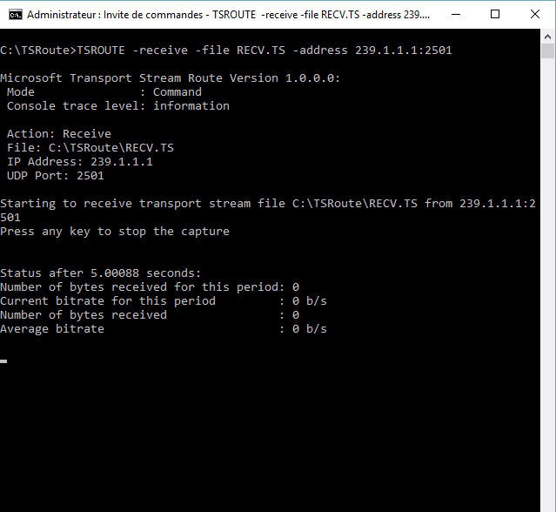
- TSROUTE is capturing the transport stream, press on any key on the PC keyboard to stop the capture. TSROUTE automatically parses the captured file and displays the program information.
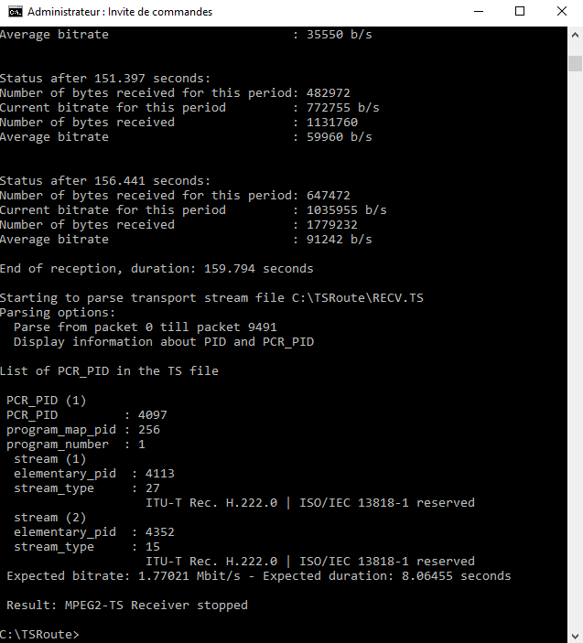

TSRoute: Streaming Transport Stream files
With TSROUTE you can stream Transport Stream file either in command mode or service mode.
In command mode, the input parameters are the arguments of a command line.
In service mode, the input parameters are defined in a XML file.

Streaming a MPEG2 TS file in command mode
- Select the menu Start -> Run , the dialog box Run appears enter cmd in the Open field and click on the OK button.
- The Command Shell window appears, enter the command: cd c:\TSROUTE to change directory. Enter the following command line:
TSROUTE –stream –file <file> [option]
The options are described in the table below:
Parse option | Mandatory | Description
-stream | Yes | Activate Streaming
-file <TS file> | Yes | Path of the transport stream file to stream
-address <IP Address>:<UDP port> | Yes | Define the multicast IP address and UDP port used to stream the transport stream file.
-interfaceaddress <IP Address> | Yes | Define the IP address of the Ethernet card connected to the network where the transport stream will be streamed.
-loop [<number>] | No | Define the number of loop  Default value -1, infinite loop
-updatetimestamps | No | When this option is set, TSROUTE will update the following timestamps in the transport stream PCR, DTS and PTS to avoid any time discontinuity in the stream.
-packet <first> <last> | No | Define the range of packets to stream  For instance:  -packet 100 20000 : parse from packet 100 till 20000  -packet 100 : parse from packet 100 till the last packet of the file
-time <start> <end> | No | Define the part of the transport stream file to stream in milliseconds  For instance:  -packet 100 20000 : stream from 100 ms till 20000 ms  -packet 100 : stream from 100 ms till the last packet of the file
-forcedbitrate <bitrate> | No | With this parameter it’s possible to force the bitrate of this transport stream file. The bitrate unit is bit/second.
-ttl <n> | No | Time To Live parameter
-consolelevel <level> | No | Define the trace level on the screen:  <level> = none : No trace  <level> = information : Information
-tracefile <file> | No | Path of the trace file
-tracesize <size> | No | Maximum size of the trace file (byte).
-tracelevel <level> | No | Define the trace level in the trace file:  <level> = none : No trace  <level> = information : Information
-buffersize <size> | No | Define the size of the memory buffer to read the transport stream file.  Default value: 4194304 (4096*1024)  if size = 0, the file is completely loaded in memory
-pipfile <TS file> | Yes | Path of the PIP transport stream file to stream
-pipaddress <IP Address>:<UDP port> | Yes | Define the PIP multicast IP address and PIP UDP port used to stream the PIP transport stream file.
-pipbuffersize <size> | No | Define the size of the memory buffer to read the PIP transport stream file.  Default value: 4194304 (4096*1024)  if size = 0, the file is completely loaded in memory
-pipforcedbitrate <bitrate> | No | With this parameter it’s possible to force the bitrate of the PIP transport stream file. The bitrate unit is bit/second.
-xmlfile <xmlfile> | No | Path to the xml file which contains all the input parameters for streaming.  The content of the xml file is described in the subsequent chapter.

Input XML file format
The input XML file allows TSROUTE to stream several streams simultaneously either in command mode or in service mode. The content of the XML file is defined below
Path | Field | Range/  Size | Description | Examples
TSROUTE.InputParameters | TraceFile | Char | Path of the trace file | TSROUTE.LOG
TSROUTE.InputParameters | TraceSize | DWORD | Maximum size of the trace file (byte). | 300000
TSROUTE.InputParameters | TraceLevel | ENUM  none  information | Define the trace level in the trace file:  <level> = none : No trace  <level> = information : Information | information
TSROUTE.InputParameters | ConsoleLevel | ENUM  none  information | Define the trace level on the screen:  <level> = none : No trace  <level> = information : Information | none
TSROUTE.InputParameters/Stream | Name | Char | Name of the stream | Stream1
TSROUTE.InputParameters/Stream | OutputFile | Char | Path of the Output XML file  This file contains the counters associated with the stream of the transport stream file. The content of this XML file is refreshed periodically.  For instance  <TSROUTE.Counters>  <Name>Stream7</Name>  <File>D:\\TSROUTE\TS\TS.VC1.PAL.SPTS.2.TS</File>  <Date>15/12/2006 08:23:19 475</Date>  <PacketTransmit>5696</PacketTransmit>  <Duration>25.9925</Duration>  <Bitrate>2.24453e+006</Bitrate>  <ExpectedDuration>37.6341</ExpectedDuration>  <ExpectedBitrate>2.25e+006</ExpectedBitrate>  <PIPFile>D:\TSROUTE\TS\TS.VC1.PIP.SPTS.2.TS</PIPFile>  <PIPPacketTransmit>777</PIPPacketTransmit>  <PIPDuration>25.1562</PIPDuration>  <PIPBitrate>366724</PIPBitrate>  <PIPExpectedDuration>46.4012</PIPExpectedDuration>  <PIPExpectedBitrate>270000</PIPExpectedBitrate>  </TSROUTE.Counters> | Stream1.xml
TSROUTE.InputParameters/Stream | RefreshPeriod | DWORD | Refresh period of the Output XML file in second | 5
TSROUTE.InputParameters/Stream | TSFile | Char | Path of the transport stream file to stream | MPEG2.TS
TSROUTE.InputParameters/Stream | UdpIpAddress | Char | Define the multicast IP address used to stream the transport stream file. | 239.1.1.1
TSROUTE.InputParameters/Stream | UdpPort | WORD | Define the UDP port used to stream the transport stream file. | 2501
TSROUTE.InputParameters/Stream | UdpIpAddressInterface | Char | Define the IP address of the Ethernet card connected to the network where the transport stream will be streamed. | 192.168.10.1
TSROUTE.InputParameters/Stream | ForcedBitrate | DWORD | With this parameter it’s possible to force the bitrate of this transport stream file. The bitrate unit is bit/second | 2300000
TSROUTE.InputParameters/Stream | BufferSize | DWORD | Define the size of the memory buffer to read the transport stream file.  Default value: 4194304 (4096*1024)  if size = 0, the file is completely loaded in memory | 4194304
TSROUTE.InputParameters/Stream | PIPTSFile | Char | Path of the PIP transport stream file to stream | MPEG2..PIP.TS
TSROUTE.InputParameters/Stream | PIPUdpIpAddress | Char | Define the multicast IP address used to stream the PIP transport stream file. | 239.1.1.2
TSROUTE.InputParameters/Stream | PIPUdpPort | WORD | Define the UDP port used to stream the PIP transport stream file. | 2502
TSROUTE.InputParameters/Stream | PIPForcedBitrate | DWORD | With this parameter it’s possible to force the bitrate of the PIP transport stream file. The bitrate unit is bit/second | 230000
TSROUTE.InputParameters/Stream | PIPBufferSize | DWORD | Define the size of the memory buffer to read the PIP transport stream file.  Default value: 4194304 (4096*1024)  if size = 0, the file is completely loaded in memory | 4194304
TSROUTE.InputParameters/Stream | TTL | WORD | Time To Live parameter | 2
TSROUTE.InputParameters/Stream | Loop | Integer | Define the number of loop  Default value -1, infinite loop | -1
TSROUTE.InputParameters/Stream | UpdateTimeStamp | ENUM  1  0 | When the value of this field is 1, TSROUTE will update the following timestamps in the transport stream PCR, DTS and PTS to avoid any time discontinuity in the stream. | 1
TSROUTE.InputParameters/Stream | PacketStart | DWORD | Define the range of the first packet in the transport stream file to stream  Default value: 0 | 100
TSROUTE.InputParameters/Stream | PacketEnd | DWORD | Define the range of the last packet in the transport stream file to stream. If the value is 4294967295 (-1), TSROUTE stream the transport stream file till the end  Default value: 4294967295 (-1) | 1345
TSROUTE.InputParameters/Stream | TimeStart | DWORD | Define the timecode in millisecond of the first packet in the transport stream file to stream (unit: millisecond)  Default value: 0 | 1000
TSROUTE.InputParameters/Stream | TimeEnd | DWORD | Define the timecode in millisecond of the last packet in the transport stream file to stream. If the value is 4294967295 (-1), TSROUTE stream the transport stream file till the end  Default value: 4294967295 (-1) | 13000

Streaming a MPEG2 TS file
- Select the menu Start -> Run , the dialog box Run appears enter cmd in the Open field and click on the OK button.
- The Command Shell window appears, enter the command: cd c:\TSROUTE to change directory. Enter the following command line:
TSRoute -file TEST1.TS -stream -address 239.1.1.1:2501 –interfaceaddress 192.168.10.1
- TSROUTE stream the transport stream file towards the IP address 239.1.1.1 UDP port 2501.

Streaming a MPEG2 TS file continuously
- Select the menu Start -> Run , the dialog box Run appears enter cmd in the Open field and click on the OK button.
- The Command Shell window appears, enter the command: cd c:\TSROUTE to change directory. Enter the following command line:
TSRoute -file TEST1.TS -stream -address 239.1.1.1:2501 –interfaceaddress 192.168.10.1 -loop –updatetimestamps
After each loop, TSROUTE updates the value of PCR, DTS and PTS fields.
- TSROUTE stream continuously the transport stream file towards the IP address 239.1.1.1 UDP port 2501.

Streaming several MPEG2 TS files simultaneously
- Select the menu Start -> Run , the dialog box Run appears enter cmd in the Open field and click on the OK button.
- The Command Shell window appears, enter the command: cd c:\TSROUTE to change directory. Enter the following command line:
TSRoute -stream –xmlfile TSROUTE.SAMPLE.XML
- TSROUTE streams the list of transport stream files defined in the xml file. With the XML file TSROUTE can stream several streams simultaneously.
Sample of xml file:
<TSROUTE.InputParameters>
<!-- Global parameters -->
<TraceFile>TSROUTE.log</TraceFile>
<TraceMaxSize>300000</TraceMaxSize>
<TraceLevel>information</TraceLevel>
<ConsoleTraceLevel>information</ConsoleTraceLevel>
<!-- Stream 1 parameters -->
<!-- MPEG4 SPTS -->
<Stream>
<Name>Stream1</Name>
<OutputFile>Stream1.xml</OutputFile>
<RefreshPeriod>5</RefreshPeriod>
<TSFile>TEST1.TS</TSFile>
<UdpIpAddress>239.1.1.1</UdpIpAddress>
<UdpPort>2501</UdpPort>
<TTL>2</TTL>
<Loop>-1</Loop>
<UpdateTimeStamp>1</UpdateTimeStamp>
</Stream>
<!-- Stream 2 parameters -->
<!-- VC1 SPTS -->
<Stream>
<Name>Stream2</Name>
<OutputFile>Stream2.xml</OutputFile>
<RefreshPeriod>5</RefreshPeriod>
<TSFile>TEST2.TS</TSFile>
<UdpIpAddress>239.1.1.2</UdpIpAddress>
<UdpPort>2506</UdpPort>
<TTL>2</TTL>
<Loop>-1</Loop>
</Stream>
</TSROUTE.InputParameters>

Streaming several MPEG2 TS files simultaneously in service mode
Before streaming several files simultaneously in service mode, you need to :
- Define the list of files to stream
- Install TSROUTE as a Win32 service

Defining the list of transport stream files to stream
Edit the XML file you want to use as input parameters. Add the definition of each streams and save the XML file.
Sample of xml file:
<TSROUTE.InputParameters>
<!-- Global parameters -->
<TraceFile>TSROUTE.log</TraceFile>
<TraceMaxSize>300000</TraceMaxSize>
<TraceLevel>information</TraceLevel>
<ConsoleTraceLevel>information</ConsoleTraceLevel>
<!-- Stream 1 parameters -->
<!-- MPEG4 SPTS -->
<Stream>
<Name>Stream1</Name>
<OutputFile>Stream1.xml</OutputFile>
<RefreshPeriod>5</RefreshPeriod>
<TSFile>TEST1.TS</TSFile>
<UdpIpAddress>239.1.1.1</UdpIpAddress>
<UdpPort>2501</UdpPort>
<TTL>2</TTL>
<Loop>-1</Loop>
<UpdateTimeStamp>1</UpdateTimeStamp>
</Stream>
<!-- Stream 2 parameters -->
<!-- VC1 SPTS -->
<Stream>
<Name>Stream2</Name>
<OutputFile>Stream2.xml</OutputFile>
<RefreshPeriod>5</RefreshPeriod>
<TSFile>TEST2.TS</TSFile>
<UdpIpAddress>239.1.1.2</UdpIpAddress>
<UdpPort>2506</UdpPort>
<TTL>2</TTL>
<Loop>-1</Loop>
</Stream>
</TSROUTE.InputParameters>

Installing TSRoute service
- Select the menu Start -> Run , the dialog box Run appears enter cmd in the Open field and click on the OK button.
- The Command Shell window appears, enter the command: cd c:\TSROUTE to change directory
- Enter the command line: TSROUTE –install –xmlfile <path of the XML file>
TSROUTE is now installed as a WIN32 service on your machine.
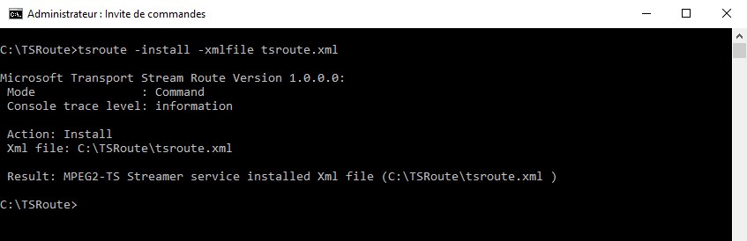
- You can check that the IPTV Edition MPEG2-TS Streamer has been installed as a WIN32 service.
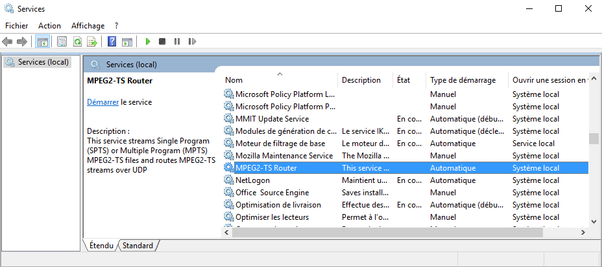

Starting TSRoute service
- To start the WIN32 Service, Enter the command line: TSROUTE –start

Stopping TSRoute service
- To stop the WIN32 Service, Enter the command line: TSROUTE –stop

Uninstalling TSRoute service
- To uninstall the WIN32 Service, Enter the command line: TSROUTE –uninstall

TSRoute: Converting Transport Stream files
With TSROUTE you can convert Transport Stream files which contain 204 bytes packets into Transport Stream files which contain 188 bytes packets.

Converting a MPEG2 TS file in command mode
- Select the menu Start -> Run , the dialog box Run appears enter cmd in the Open field and click on the OK button.
- The Command Shell window appears, enter the command: cd c:\TSROUTE to change directory. Enter the following command line:
TSROUTE –convert <input_file> <output_file>
The options are described in the table below:
Parse option | Mandatory | Description
-convert | Yes | Activate Convert
<input_file> | Yes | Path of the transport stream file to convert
<output_file> | Yes | Path of the transport stream file which contains 188 bytes packets

TSRoute: Filtering Transport Stream files
With TSROUTE you can filter a Transport Stream file and select only the packets associated with a program number.
Warning:
By default the filter remove the null packets from the final transport file.

Filtering a MPEG2 TS file in command mode
- Select the menu Start -> Run , the dialog box Run appears enter cmd in the Open field and click on the OK button.
- The Command Shell window appears, enter the command: cd c:\TSROUTE to change directory. Enter the following command line:
TSROUTE –filter <input_file> <output_file> <program_number>
The options are described in the table below:
Parse option | Mandatory | Description
-filter | Yes | Activate Convert
<input_file> | Yes | Path of the transport stream file to filter
<output_file> | Yes | Path of the result transport stream file
<program_number> | Yes | The program number you want to keep in the transport stream file.

TSRoute: Routing Streams over UDP
With TSROUTE you can route Transport Stream streams over UDP.

Routing a MPEG2 TS stream in command mode
- Select the menu Start -> Run , the dialog box Run appears enter cmd in the Open field and click on the OK button.
- The Command Shell window appears, enter the command: cd c:\TSROUTE to change directory. Enter the following command line:
TSROUTE –stream -inputaddress <IPAddress>:<UDP Port> [options]
The options are described in the table below:
Parse option | Mandatory | Description
-stream | Yes | Activate Streaming/Routing
-inputaddress <IP Address>:<UDP port> | Yes | Define the input IP Address (unicast or multicast) and UDP port
-address <IP Address>:<UDP port> | Yes | Define the IP address (unicast or multicast) and UDP port used to stream the transport stream file.
-interfaceaddress <IP Address> | Yes | Define the IP address of the Ethernet card connected to the network where the transport stream will be streamed.
-ttl <n> | No | Time To Live parameter
-consolelevel <level> | No | Define the trace level on the screen:  <level> = none : No trace  <level> = information : Information
-tracefile <file> | No | Path of the trace file
-tracesize <size> | No | Maximum size of the trace file (byte).
-tracelevel <level> | No | Define the trace level in the trace file:  <level> = none : No trace  <level> = information : Information
-buffersize <size> | No | Define the size of the memory buffer to read the transport stream file.  Default value: 4194304 (4096*1024)  if size = 0, the file is completely loaded in memory

