We get a cleansing warning in EDW within EDW_EMPLOYEE saying that this value does not exist:



The following records exist for TSJC for orgn code 112323 in FTVORGN:

SELECT *FROM ftvorgn WHERE ftvorgn_orgn_code = '132323' AND ftvorgn_vpdi_code = 'TSJC';

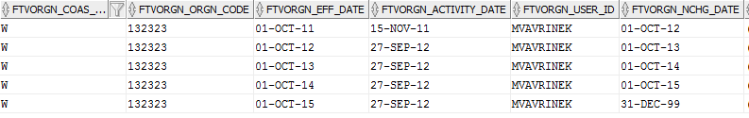

The cleansing rule for HOME_ORGANIZATION is as follows;

SELECT DISTINCT 'HOME_ORGANIZATION' DATA_ELEMENT, FTVORGN_vpdi_CODE W_PREFIX, FTVORGN_ORGN_CODE W_VALUE, FTVORGN_ORGN_CODE ||' - ' ||FTVORGN_TITLE LONG_DESC, FTVORGN_TITLE SHORT_DESC FROM FTVORGN ORIG WHERE FTVORGN_EFF_DATE = (SELECT MAX(VAL.FTVORGN_EFF_DATE) FROM FTVORGN VAL WHERE VAL.FTVORGN_COAS_CODE = RIG.FTVORGN_COAS_CODE AND VAL.FTVORGN_ORGN_CODE = ORIG.FTVORGN_ORGN_CODE AND orig.ftvorgn_vpdi_code = val.ftvorgn_vpdi_code AND orig.FTVORGN_EFF_DATE <= SYSDATE AND orig.FTVORGN_NCHG_DATE > SYSDATE )

The 4th row from FTVORGN above should be a valid home org code to appear in the cleansing values. The ORIG value in the prevents this from showing up. The comparisons on the sysdate should be to the VAL alias of ftvorgn rather than ORIG. This fixed our problem.