We received a refresh error in the post_secondary star. Our nightly refresh of SRP is done by way of the wide refresh product. The entire control report is attached (control_report.pdf), but the following is the important part:

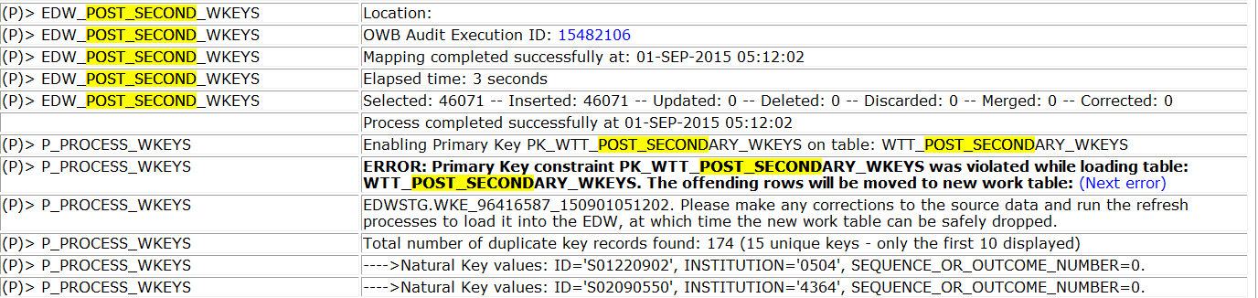

*Note: The other errors in the control report regarding chg_student_progress are not relevant to this; those are for a separate issue we had been working with Eric Morneault on last year.*

So we can see in the control report the error table is EDWSTG.WKE_96416587_150901051202. I have attached the entire output of that WKE table (wke_table.xlsx). Upon querying that error table, it is obvious the records are for the post_secondary star, however, they are stamped with “TEST” in the system_load_process field for some reason.

The WKE table is built by way of the P_PROCESS_WKEYS procedure in EDWSTG, however, that only generates dynamic SQL that pulls from the wkeys table. So we can deduct that “TEST” exists in the system_load_process for the WKEYS table as well.

If you look at the mapping (EDW_POST_SECONDARY_WKEYS), within the joiner (the code is attached as “joiner_code.sql”) you’ll see that line 23 of the code displays the sytem_load_process origin:

"WDT_MULTI_SOURCE"."SYSTEM_LOAD_PROCESS" "SYSTEM_LOAD_PROCESS",

Look in the control report for a timeline of things:

Post secondary star finished updating the wdt_multi_source dimension at 5:07:57

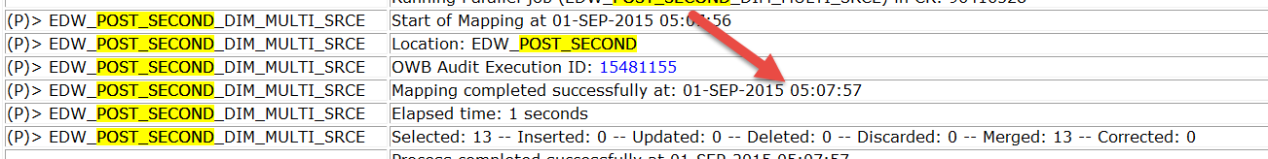

TEST star finished updating wdt_multi_source dimension at 5:11:28

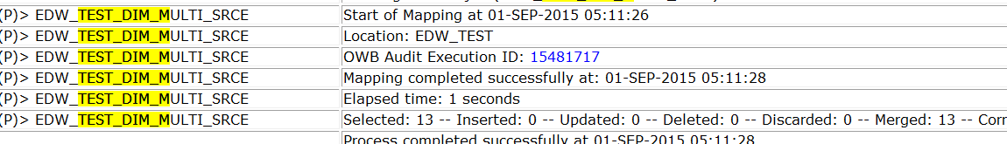

So at 5:11:28, the value in wdt_multi_source.system_load_process was “TEST”.

The post_secondary WKEYS didn’t start until 5:11:59 (as it was busy populating other dimensions’ data):



So when the WKE_* table was built for the bad records, it used the value in WDT_MULTI_SOURCE, which was “TEST”, even though the star with the erroneous records was POST_SECONDARY. Additionally, all fact records in WFT_POST_SECONDARY_SCHOOL will be labeled as “TEST”. This is incorrect.

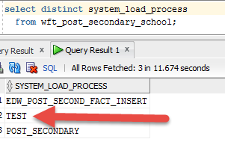

We can clearly see that the TEST star never touches the table WFT_POST_SECONDARY_SCHOOL:

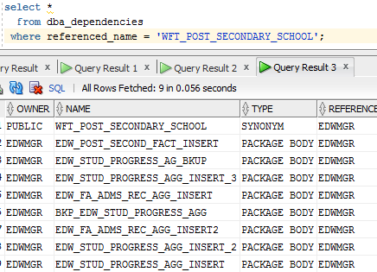

There needs to be a method to populate the system_load_process within the WKEYS mappings that derives from the star it’s populating, not simply pulling the field in from whatever star last updated WDT_MULTI_SOURCE, else, the parallel (wide) refresh/load method should not be used.