**PROBLEM #1: Hardly any addresses are showing in EDW, while nearly everyone in ODS has an address**

/* Example #1: Records for FRCC for 201410 */

/* Returns 69K records */

select count(*) from wat_student_progress

where multi_source_key = 6 --FRCC

and academic_time_key = 54; --201410

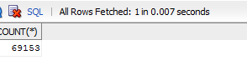

/* Example #2: Same as #1 only where we have a street address */

/* Returns only 29 records*/

select count(*) from wat_student_progress

where multi_source_key = 6 --FRCC

and academic_time_key = 54 --201410

and street_line_key <> 0;

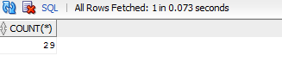

/* Meaning, only 29/69000 people have a street address in EDW */

/* Example #3: How many of those from Example 1 have an address in ODS? */

/* Returns 69K records */

select count(distinct(person_uid))

from person_address

where person_uid IN

--subquery to get banner pidm for those in Exampe #1 above

(select we.banner_pidm

from wat_student_progress sp,

wdt_warehouse_entity we

where sp.person_uid = we.warehouse_entity_uid

and sp.multi_source_key = 6 --FRCC

and sp.academic_time_key = 54);

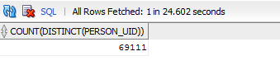

/* Conclusion: Not all addresses are getting loaded to EDW for some reason, why? */

**PROBLEM #2 – which address is this picking when it does populate an address?**

EDW Query for a particular individual returns 8300 Sheridan Blvd address:



select address_seq_no, address_type, street_line1 from mst_address where entity_uid = odsmgr.f_get_pidm('SXXXXXXXX');

