EDW 8.5. Mapping for EDW_ADVISOR_DIM_PERSON

Trying to MEP this mapping and running into extreme issues. In all other person dimension mappings, we simply switch the merge join to display as such on user_attribute_01:

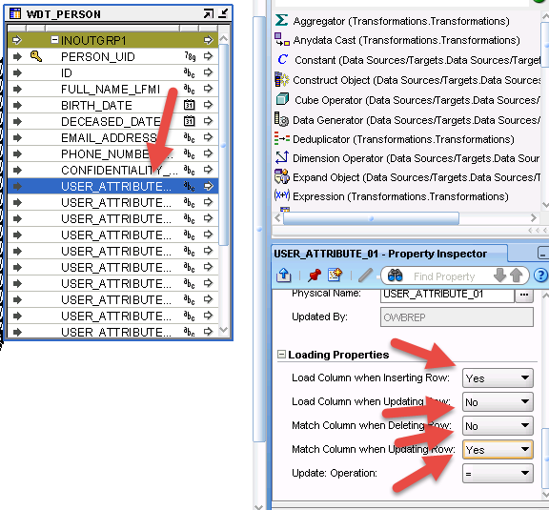

So we have done this in 8.4.3 and everything is fine, it gets our MERGE able to obtain a stable set of rows, however, in 8.5 you have added a pivot & set operator to this mapping and we are running into issues.