**Cleaning up Cleansing Errors in Control Reports for EDW:**

Find the cleansing error:





Now we need to find the data that is causing this problem. This can be done by checking the extract package that gets the data for EDW. Snapshot stars each have their own extract package, operational stars have 1 extract package per business area. Since this is an operational star in the student area, we will seek out EDW_STUDENT_EXTR package in EDWSTG schema.

Within this package there is a function or procedure call for each star load. Simple logic will point you to the proper function for the load. In this case, it is “p_get_student” procedure. There will be a select statement in there. Find where the field is sourced from. So we are looking for “ACADEMIC_PROGRAM”. In this case, we find it in the code:



….

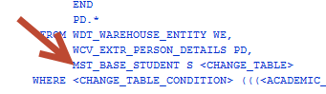

The “S” alias is “MST_BASE_STUDENT”

select program from mst_base_student where program='U_CER_DET';

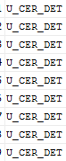

So those are our problem rows.

Determine, through a project manager, if this is a data error or if we need a translation. In this case we needed a translation:

Diesel Mechanics Tech/Techn Cert