Cccs set up cleansing process

1. Modify the area of the extract package to set the user attribute = to your custom value:





1. Need to link a cleansing rule to this new value
   1. Admin UI -> Options -> Set up and maintain Cleansing Processes -> Set up and maintain cleansing rules (skip this step if the rule is already set up for this value, ie, a multi_source one)
   2. Set up the rule (obviously, Bryan, you need to put instructions for this in here sometime)
2. Need to link the rule to the dimension table
   1. Admin UI -> Options -> Set up and maintain Cleansing Processes -> Set up and maintain data cleansing elements:

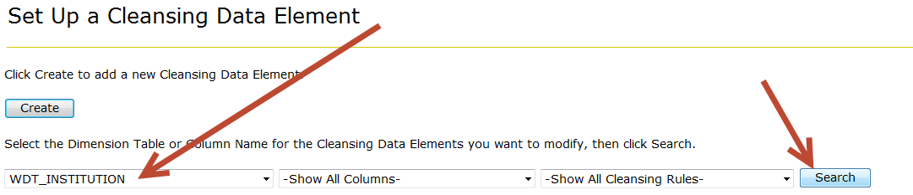

* 1. Click on your user defined field you customized  
     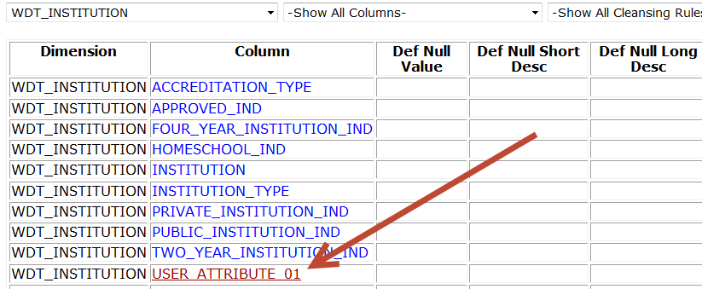
  2. Modify your cleansing rule to the rule you either created in step 2, or the one that already existed (ie, multi_source)  
     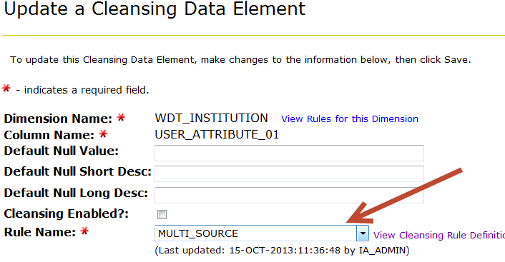

1. Note: if this is being done to MEP something, you will need to modify the mappings to point mep values to one-another, such that merge statements will work ok.