**Troubleshoot “stable set of rows” errors**

**Bryan Mack – 5/6/2014**

**Load job:**



**Error job:**



**Oracle error description:**

Cause: A stable set of rows could not be got because of large dml activity or a non-deterministic where clause.  
Action: Remove any non-deterministic where clauses and reissue the dml.  
<http://download.oracle.com/docs/cd/B19306_01/server.102/b14219/e29250.htm#sthref8601>

**So, what do we do?**

Find the package which is loading the error-laden dimension, it will be in the EDWMGR schema:



This is loading the wdt_institution table. This is evidenced from either sifting through the package:

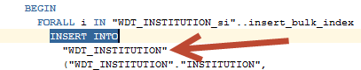

…or checking out the mapping itself in OWB:

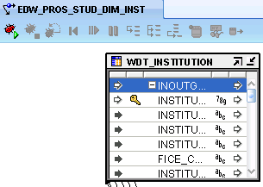

Check your indexes on that table – what is being duplicated?

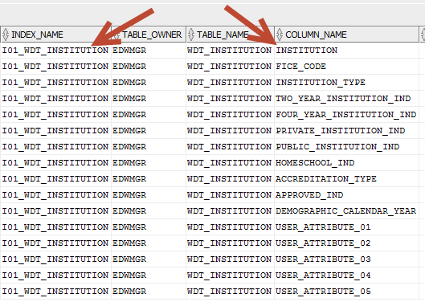

This package will be using cursors which call rows from the CLEAN table, which sadly, will have been deleted already. I use the following trick to generate the data in SQL Developer which would be placed in the input table:

select * from table(edw_student_extr.f_get_prosp_students('L',sysdate,null));

Using the Oracle TABLE function to call our EDW “table function” in the extract parameter will essentially display what would go into the input table without having to run the load job, or pick the code out of the extract package itself. The result of that TABLE function will show the data we are working with; our erroneous data will exist in this data set.

So we are going to look for duplicates of the above unique index. Note: the user_attributes are NULL by default, and not named that way in the table function, so you can comment out those 5 user attribute fields unless you’ve already customized your extract package to populate those for your institution.

***select INSTITUTION,FICE_CODE,INSTITUTION_TYPE,TWO_YEAR_INSTITUTION_IND,FOUR_YEAR_INSTITUTION_IND,PRIVATE_INSTITUTION_IND,  
PUBLIC_INSTITUTION_IND,HOMESCHOOL_IND,ACCREDITATION_TYPE,APPROVED_IND,DEMOGRAPHIC_CALENDAR_YEAR  
from  
(select * from table(edw_student_extr.f_get_prosp_students('L',sysdate,null)))  
group by INSTITUTION,FICE_CODE,INSTITUTION_TYPE,TWO_YEAR_INSTITUTION_IND,FOUR_YEAR_INSTITUTION_IND,PRIVATE_INSTITUTION_IND,  
PUBLIC_INSTITUTION_IND,HOMESCHOOL_IND,ACCREDITATION_TYPE,APPROVED_IND,DEMOGRAPHIC_CALENDAR_YEAR   
having count(*) > 0;***

in our case – this is obvious. Our USING statement doesn’t have the multi-source values. Need to place the multi_source into the user-attribute 01 field. This is done via the table function in the extract package. So – edw_student_extr.f_get_prosp_stud:

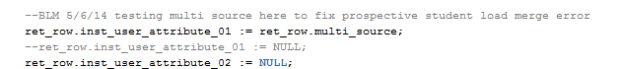

Next we have to set the cleansing rule on the dimension table so that it can populate the short & long description, else you will get an error when loading. Log into the Admin UI. If you don’t yet have a cleansing rule, create one via “Set up and Maintain Cleansing Rules”. If you can use one already (as we can here, multi-source), go to “Set up & Maintain Cleansing Data Elements”.

Select the dimension table, then select the field you set equal to multi_source (user attribute 01). Click into user-attribute one, then set the rule to “Multi Source”. Save.

Modify the mapping so that the merge statement will use the custom MIF value in the ON statement (not wise to modify the package itself, rather should adjust the mapping within OWB):

Find the mapping:

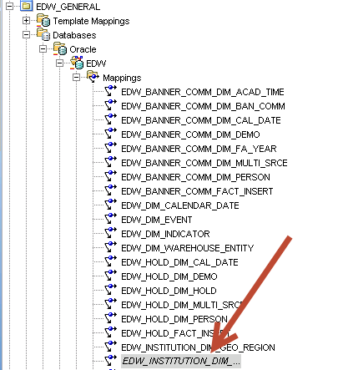

Open the mapping – then go to the dimension table on the right side of the deduplicator:

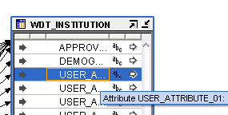

Highlight the field you need added to the ON statement (user attribute 01, where we are holding MIF). Then update the loading properties as such:

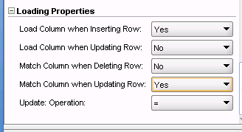

Validate, save, & deploy the mapping.

In this case, we did this to 2 mappings:

General -> EDW_INSTITUTION_DIM_INST

Student -> EDW_PROS_STUD_DIM_INST

Now – try your loads again.