Proving out that this join is illogical and is causing records to be deleted from the table wft_student_course_attribute, and those records are NOT re-added.

My suspected illogical joins within the refresh statement of edw_student_extr.f_get_student_course_attr (the purple joins directly contradict the fact that in the red OR clause, we have proven that person_uid can be null)

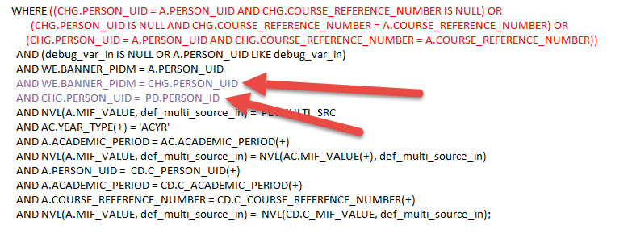

**Truncated Fact table:**

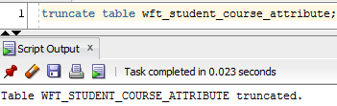

**Loaded up the student course attribute star:**

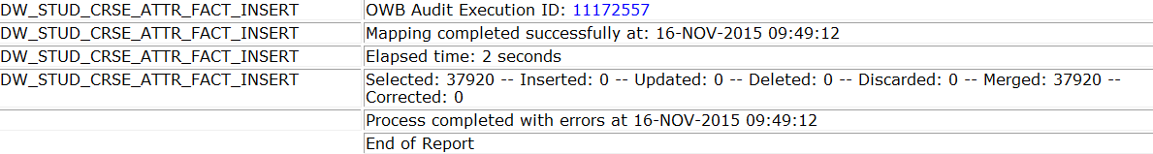

**Proving out that records with NULL person_uid exist in the change table:**

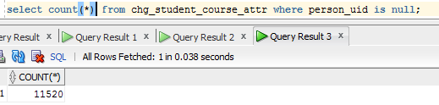

**We’ll pick on one of these records which have an entry in the fact table, first we’ll identify one:**

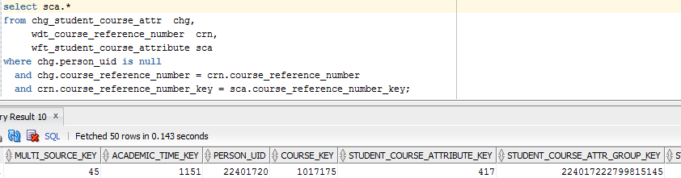

**Now I kick off the student course attribute refresh.**

**The process is currently doing an insert to the INPUT table, but the deletes have already happened, we know this as we added custom counts to the control report:**

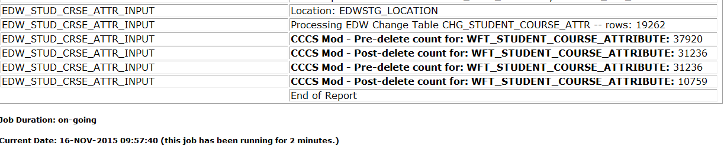

**While this step was running, I searched for the record posted above to confirm it was deleted:**

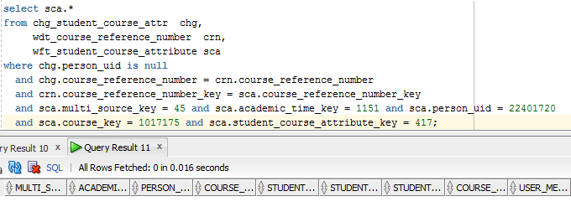

**Ok, we’ve confirmed it’s gone. Let’s confirm that that record would still be returned if we did a load by modifying the LOAD’s table function for this single record:**

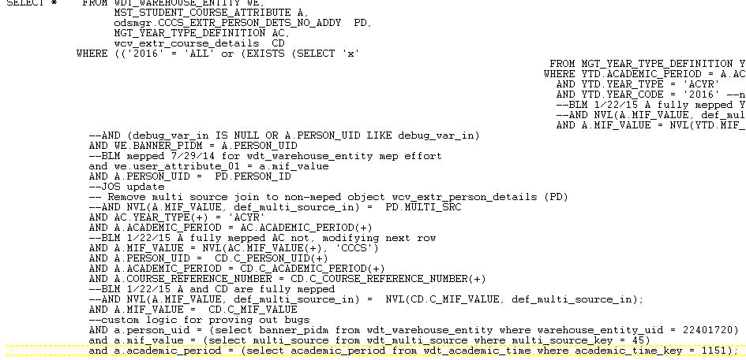



**Now that we’ve proven the record exists in the ODS, should be in the EDW, and has a course reference number with a change table record with a NULL person UID, we know logically the refresh should insert the record again. With the refresh mapping completed, we’ll look for the record again to see if it inserted:**

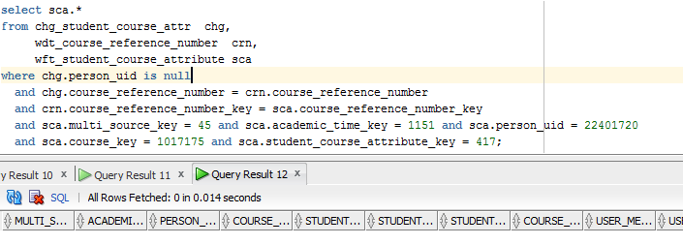

**Nope, it’s gone.**

**NOW – I commented out those 2 joins (which were in red atop this doc) in the refresh logic and tried the entire process again.**

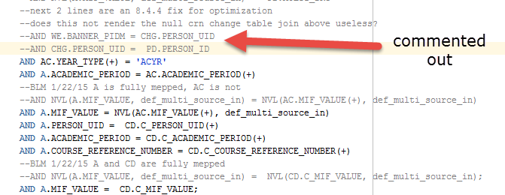

**Loaded the entire star – is that record there now?:**

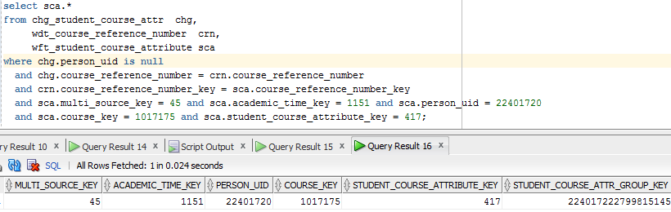

**Ok – it’s there. Made sure that record was in the change table again (I manually put it back in there):**

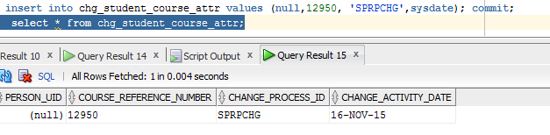

**Ran the refresh – the record should be deleted and re-added to the change table this time around, did it delete?**

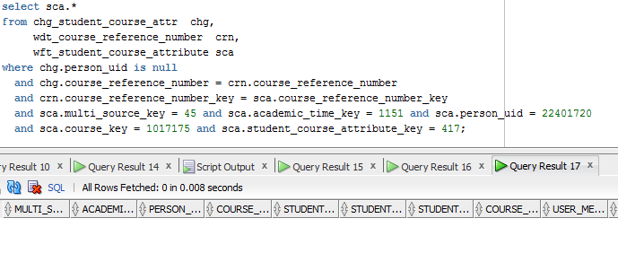

**Yes, it deleted. Now the insert should add it back since we removed the illogical joins:**

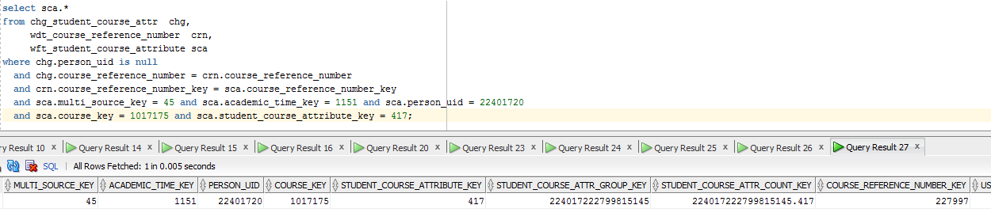

**Yup! It’s back. Those joins are bad.**

Bottom line: Those joins are illogical and are causing multiple fact records to be deleted and they are not re-added. I believe this was done to improve efficiency of the refresh. Rather than add an illogical join that causes you to lose data, my suggestion if people have poor performance here would be to add the academic period to the change table chg_student_course_attribute. We did this to the student course star and it worked flawlessly; doesn’t take much effort, you just:

1. Add academic_period varchar2(6) to chg_student_course_attribute
2. Modify odsmgr.maintain_edw_change_records to change all references on said change table to insert a term, and add the correct joins
3. Modify the change table condition in edw_student_extr.f_get_student_course_attr to join on term
4. Modify edwstg.maintain_edw_error_records procedure, add a CASE block for this specific change table to adjust the join logic
5. Modify edw_general_extr.p_delete_fact_records, add a block to the CASE statement to join on term for this change table