**Run these sequentially:**

select count(*) from wft_race;

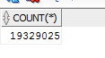

select * from table(edw_general_extr.f_get_race('R',sysdate));

<allow this to finish>

select count(*) from wft_race;



select * from table(edw_general_extr.f_get_race('L',sysdate));

<allow this to finish>

select count(*) from wft_race;

