We have duplicate rows in our wdt_academic_time table. This is our fault, it is because we ran a load at a time when mgt_year_type_definition was empty – so it populated “new” rows for each term, the only difference being that the start & end dates are null (as that is what comes from mgt_year_type_definition from within the COURSE INSTRUCTOR load).

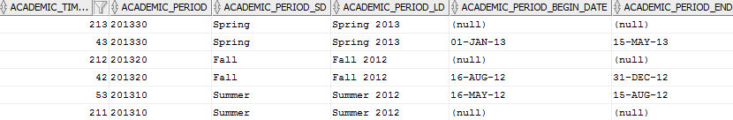

Again – this is our fault. I realize that.

The problem is, the prompts in Cognos are pointing our academic periods to the academic time keys such as 213, 212, and 211 above. However, all the data in wat_student_progress use the keys 43, 42, 53 for these terms.

The bottom line is, I really need to be able to get rid of certain values within wdt_academic_time (while re-pointing values in other stars, should it exist, to the other key with the same academic_period), as well as getting the Cognos delivered reports’ prompts to point to the new values.

I’m wondering if I can:

-Simply delete the rows and somehow Cognos will find itself?

-Potentially refresh the dimension table and it would populate the NULL values in the 2 fields seen above, as well as merge the two rows?

-Hopefully not have to reload everything.

Tips?