BEVOAC
Runbook V5.2 Production Ready - Edition complete B2B
Installation, exploitation, onboarding Azure securise, API SaaS B2B, worker, billing, PDF, APIM, alerting, retention, DLQ, backup/restore et validation client/admin
Champ | Valeur
Version | V5.2.0-pilot-hardening - edition complete consolidee
Date de consolidation | 2026-05-31
Sources comparees | Runbook V4.2, Runbook V5.1 Production Ready, Runbook V5.2 fourni, tests admin/client confirmes
Statut documentaire | Runbook client-ready pour demonstration/pilote B2B sous reserve de la checklist Go/No-Go
Positionnement | Azure-first, API B2B d audit continu; ne pas revendiquer AWS/GCP livre ni production sans reserve avant preuves formelles
Important: ce runbook restaure la granularite V4.2/V5.1, reintegre les schemas Mermaid et met a jour les procedures selon V5.2. Toute cle ou secret visible dans des terminaux de recette doit etre regenere avant usage client.

Sommaire fonctionnel
Chapitre | Titre
0 | Controle documentaire et comparaison V4.2 / V5.1 / V5.2
1 | Resume executif et positionnement client
2 | Architecture cible et schemas
3 | Prerequis poste admin et conventions
4 | Variables, nommage et configuration
5 | Microsoft Entra App Registration et OIDC admin
6 | Deploiement Terraform from scratch
7 | Build, push et mise a jour des images
8 | PostgreSQL, migrations versionnees et controles schema
9 | Gestion des tenants, plans et API keys
10 | Onboarding Azure securise
11 | Autorisation de cibles et anti cross-customer abuse
12 | Catalogue complet des URLs API
13 | Commandes client / integrateur
14 | Commandes administrateur Bevoac
15 | Billing, quotas, backpressure et limites ressources
16 | Rapport PDF
17 | Catalogue modules et ressources scannees
18 | Worker, Service Bus sessions, DLQ et KEDA
19 | Securite code et ecosysteme Azure
20 | Observabilite, alertes et supervision
21 | Troubleshooting structure
22 | Maintenance Azure, ACR et Docker
23 | Scenario de validation from scratch
24 | Annexes staging-only et elements obsoletes
25 | Fonctionnalites non incluses et roadmap
26 | Checklist readiness production B2B
27 | Tests de charge, pentest et Go/No-Go
28 | Retention, RGPD et backup/restore
29 | Annexe SQL operateur utile
30 | Matrice alignement code / documentation
31 | Annexes Mermaid et sources
32 | Conclusion

0. Controle documentaire et comparaison V4.2 / V5.1 / V5.2
Constat principal: la version V5.2 fournie etait plus courte visuellement que V4.2/V5.1 et ne conservait pas toute la valeur graphique. Cette edition complete restaure les schemas, le niveau operatoire, les commandes et les criteres de preuve client/admin.
Sujet | V4.2 | V5.1 | V5.2 fourni | V5.2 edition complete
Nombre de pages | 31 pages | 35 pages | 25 pages | Edition complete generee pour restaurer la profondeur V4.2/V5.1
Images/schemas | 4 images architecture/onboarding/isolation/scan | Annexe Mermaid textuelle, pas d images | Annexe Mermaid textuelle, pas d images | Schemas Graphviz integres + sources Mermaid livrees
Positionnement | Pre-production B2B / recette client | Production Ready documente / validation avant vente | V5.2.0-pilot-hardening | Discours precise: production-oriented et pilot-ready, production sans reserve apres checklist
Idempotence | Header recommande | Header optionnel + generation serveur | V5.2 confirme | Conserve et documente avec commandes de test
Outbox | Non centrale | Hardening V5 | V5.2 confirme | Detaille transaction, publisher, controles SQL
Billing | Quota/ledger/snapshot | Backpressure + resultats | reserved/consumed/refunded | Cycle complet avec preuves SQL
APIM | Non central | Mention WAF/APIM | APIM optionnel ajoute | Mode APIM key documente + tests
Alerting | General | Dashboard minimum | Azure Monitor et alertes | Alertes et corrections connues documentees
Backup/restore | Avant production | Chapitre dedie | Present mais court | Procedure detaillee avec preuves attendues

0.1 Ecarts critiques corriges dans cette edition
Theme | Risque observe | Correction documentaire
Schemas Mermaid et architecture | V4.2 comportait des schemas visuels; V5.2 fourni etait majoritairement textuel | Reintegration de 7 schemas visuels + sources Mermaid
Page count et granularite | V5.2 plus court que V5.1/V4.2 | Ajout de sections detaillees APIM, DLQ, backup, tests client/admin, erreurs rencontrees
APIM | La configuration necessitait operations proxy et gestion subscription key | Chapitre APIM avec deux modes et commandes de test
Service Bus namespace | Erreur recurrente entre FQDN et nom court | Variables SB_NAMESPACE_SHORT et SB_NAMESPACE_FQDN documentees
Key Vault prive | Terraform local peut echouer ForbiddenByConnection | Procedure POC temporaire + production runner VNet
BillingState | Root vs nested billingState peut confondre | Contrat de reponse et recommandation de DTO unifie

1. Resume executif et positionnement client
Bevoac est un control plane SaaS B2B d audit securite cloud et web. L API recoit les demandes de scan, authentifie le client par API key, derive le tenant Bevoac cote serveur, verifie que le perimetre demande appartient bien au tenant, reserve le billing, enregistre l idempotence, ecrit un evenement outbox et declenche un traitement asynchrone via Service Bus et worker. Les resultats sont persistés en JSON, consultables par API, synthétisés dans un PDF finding/remediation/evidence et visibles dans le billing mensuel.
Axe | Implementation V5.2 | Valeur B2B
Multi-tenant | Tenant derive de la cle API; rejet tenantId/customerId body | Evite le cross-customer abuse
Idempotence | Idempotency-Key client ou generation serveur | Retries reseau plus simples pour integrateurs
Outbox | scan.requested persiste avant publication Service Bus | Reduit le risque de scans PENDING orphelins
Worker | Service Bus sessions, scan_attempts, DONE/FAILED idempotent | Traitement robuste et traçable
Billing | scan_reserved -> scan_consumed ou scan_refunded | Facturation defendable en B2B
APIM | Gateway optionnelle devant l API | URL pro, logs gateway, controle edge
Retention/backup | Job retention + backup/restore a tester | Confiance RGPD/exploitation
Discours client recommande: Bevoac V5.2 est Azure-first, production-oriented et pret pour un pilote B2B cadre apres validation de la checklist. Ne pas revendiquer une production enterprise sans reserve tant que les preuves charge, pentest, backup/restore et runbook incident ne sont pas signees.

2. Architecture cible et schemas
Les schemas ci-dessous remplacent et etendent les schemas visuels de V4.2. Les sources Mermaid correspondantes sont livrees dans docs/mermaid afin de pouvoir les maintenir dans le depot.
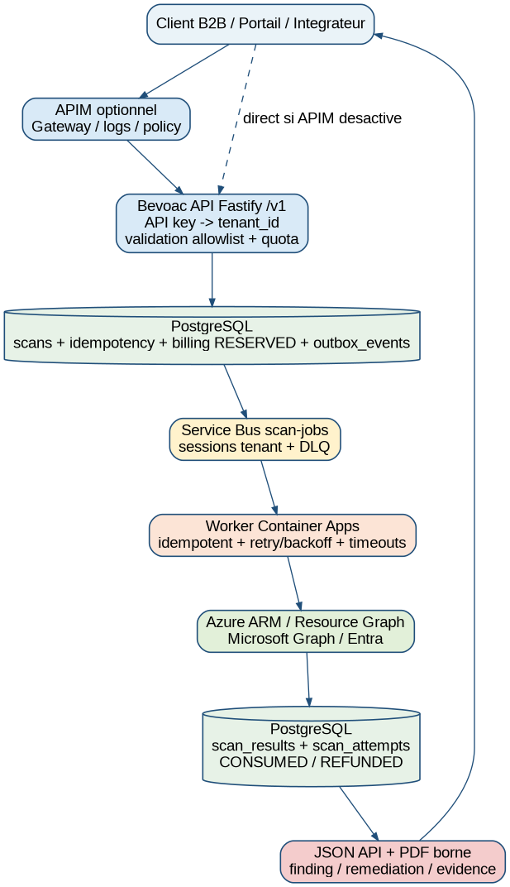
Schema 1 - Architecture Bevoac V5.2 B2B Azure-first

2.1 Flux d onboarding Azure securise
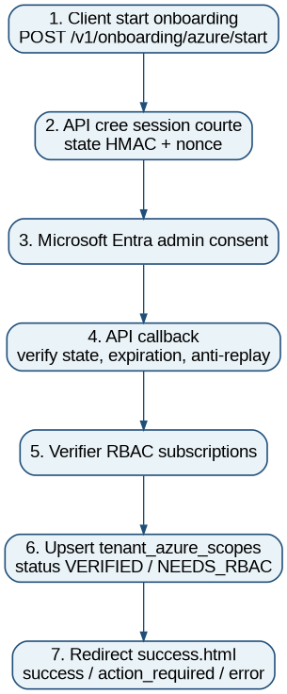
Schema 2 - Onboarding Azure: API start, admin consent, callback et scopes

2.2 Cycle de vie d un scan
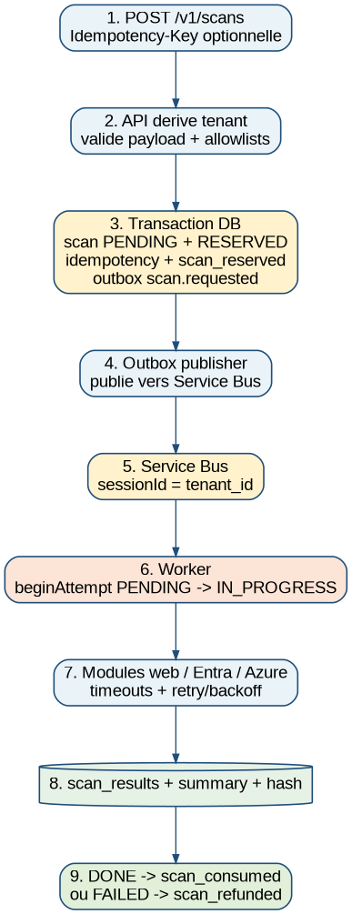
Schema 3 - Cycle de vie scan: idempotence, outbox, worker, billing

2.3 Isolation tenant
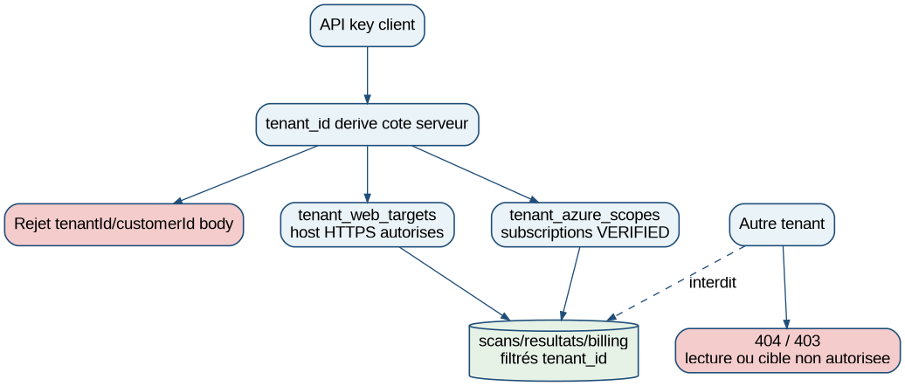
Schema 4 - Isolation logique tenant et anti cross-customer abuse

2.4 Outbox et billing
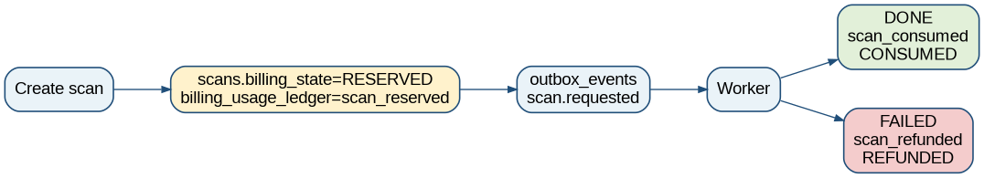
Schema 5 - Transactional outbox et transition billing

2.5 Worker, DLQ et replay
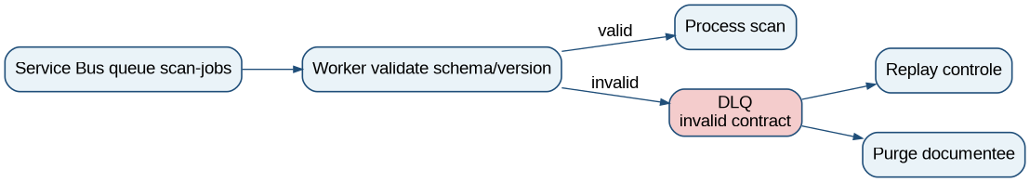
Schema 6 - Worker, DLQ, replay et purge controlee

2.6 APIM optionnel
Schema 7 - APIM en frontal de l API Bevoac

3. Prerequis poste admin et conventions
Outil | Usage | Validation
Azure CLI | Connexion, logs, outputs, Container Apps, Service Bus, APIM | az --version ; az account show
Terraform >= 1.6 | Provisioning IaC | terraform version ; terraform validate
Docker | Build/push images API/worker | docker version ; docker build --platform linux/amd64
Node.js 20 LTS | Scripts DB et checks | node -v ; npm -v
jq | Lecture JSON | jq --version
VPN/VM/runner prive | Acces Key Vault/PostgreSQL prives | nslookup + psql + az keyvault secret show depuis reseau autorise
Commandes de validation poste admin
az login --tenant <TENANT_BEVOAC_DEPLOIEMENT>
az account set --subscription <SUBSCRIPTION_BEVOAC_CONTROL_PLANE>
az account show -o table
terraform version
docker version
node -v
npm -v
jq --version

3.1 Variables shell communes
export RESOURCE_GROUP="rg-<prefix>"
export ACR_LOGIN_SERVER="<acr>.azurecr.io"
export ACR_NAME="$(echo "$ACR_LOGIN_SERVER" | cut -d. -f1)"
export API_BASE_URL="https://<api_fqdn>"
export APIM_URL="https://<apim>.azure-api.net"
export SB_NAMESPACE_SHORT="sb-<prefix>"
export SB_NAMESPACE_FQDN="$SB_NAMESPACE_SHORT.servicebus.windows.net"
export QUEUE_NAME="scan-jobs"
Rappel critique: Azure CLI Service Bus attend le nom court du namespace, par exemple sb-bevoac-poc, pas le FQDN sb-bevoac-poc.servicebus.windows.net.

4. Variables, nommage et configuration
Variable IaC | Valeur cible | Usage
tenant_id | <tenant de deploiement> | Tenant Azure du control plane
prefix | bevoac-poc / bevoac-prod | Prefixe ressources
environment | poc/staging/prod | Contexte runtime
deploy_container_apps | false puis true | Bootstrap sans images puis activation
api_image | <acr>/bevoac-api-enterprise:v5.2.0-pilot-hardening | Image API taguee
worker_image | <acr>/bevoac-worker-enterprise:v5.2.0-pilot-hardening | Image worker taguee
enable_service_bus_sessions | true | Fair scheduling tenant
enable_private_endpoints | true | Posture production
enable_postgres_public_access | false en prod | PostgreSQL ferme au public
monitor_action_group_id | <action group id> | Creation alertes Azure Monitor
enable_retention_scheduler | true | Container Apps Job retention
enable_apim_gateway | true/false | Gateway optionnelle

4.1 Variables runtime critiques
Variable runtime | Valeur cible | Commentaire
NODE_ENV | production | Exigences strictes
PG_SSL_MODE | verify-full | SSL PostgreSQL
SERVICEBUS_AUTH_MODE | managed_identity | Managed identity en Azure
SERVICEBUS_FQ_NAMESPACE | <sb>.servicebus.windows.net | Namespace Service Bus FQDN
SERVICEBUS_SESSIONS_ENABLED | true | Doit correspondre a la queue
ADMIN_AUTH_MODE | oidc | Admin enterprise
ONBOARDING_STATE_SECRET | 64+ chars | Distinct du secret admin
API_PUBLIC_BASE_URL | https://<api> | Base publique stable
PDF_GENERATION_TIMEOUT_MS | 20000+ | Timeout PDF
MAX_RESULT_JSON_BYTES | 8388608 | Borne resultats

5. Microsoft Entra App Registration et OIDC admin
Parametre | Valeur | Commentaire
Supported account types | Accounts in any organizational directory | Multi-tenant client
Redirect URI Web | https://<api>/v1/onboarding/azure/callback | Callback API, pas success.html
Client secret | Key Vault | Rotation controlee
Graph permissions | Moindre privilege selon modules | A calibrer par modules Entra
Azure RBAC | Reader/Security Reader ou roles cibles | Sur subscriptions/management groups audites
Verifier issuer/audience/roles du token admin
ADMIN_TOKEN=$(az account get-access-token --resource "api://<admin-app-client-id>" --query accessToken -o tsv)
export ADMIN_TOKEN
python3 - <<'PY'
import os, json, base64
payload=os.environ["ADMIN_TOKEN"].split(".")[1]
payload += "=" * (-len(payload) % 4)
data=json.loads(base64.urlsafe_b64decode(payload.encode()))
print(json.dumps({k:data.get(k) for k in ["aud","iss","roles","scp","tid","upn"]}, indent=2))
PY

6. Deploiement Terraform from scratch
cd bevoac-iac-enterprise
cp terraform.tfvars.example terraform.tfvars
# Renseigner tenant_id, prefix, environment, admin OIDC, Microsoft app, images, private endpoints.
terraform init
terraform fmt -recursive
terraform validate
terraform plan -out=tfplan.bootstrap
terraform apply tfplan.bootstrap
rm -f tfplan.bootstrap
Etape | Action | Preuve
1 | deploy_container_apps=false si ACR vide | Plan sans image inexistante
2 | terraform apply socle | ACR, PG, SB, KV, Log Analytics, frontend
3 | build/push images | Tags visibles ACR
4 | migrations DB | schema_migrations + tables critiques
5 | deploy_container_apps=true + images | Plan propre
6 | terraform apply final | API/worker/revisions deployes
7 | tests health/scans/PDF/DLQ | HTTP 200, scan DONE, DLQ 0

6.1 Key Vault prive et Terraform
En production, Terraform doit etre execute depuis un runner/VM/VPN ayant acces au VNet et aux Private Links. En POC uniquement, on peut ouvrir temporairement Key Vault a son IP, appliquer, puis refermer.
Ouverture temporaire POC uniquement
export MY_IP="$(curl -s ifconfig.me)"
az keyvault update --name <kv_name> --resource-group "$RESOURCE_GROUP" --public-network-access Enabled
az keyvault network-rule add --name <kv_name> --resource-group "$RESOURCE_GROUP" --ip-address "$MY_IP/32"
az keyvault secret show --vault-name <kv_name> --name pg-password --query id -o tsv
terraform plan -out=tfplan
terraform apply tfplan
az keyvault update --name <kv_name> --resource-group "$RESOURCE_GROUP" --public-network-access Disabled

7. Build, push et mise a jour des images
export VERSION="v5.2.0-pilot-hardening-$(date +%Y%m%d%H%M)-$(git rev-parse --short HEAD)"
cd bevoac-iac-enterprise
export ACR_LOGIN_SERVER="$(terraform output -raw acr_login_server)"
az acr login --name "$(echo "$ACR_LOGIN_SERVER" | cut -d. -f1)"
cd ..
docker buildx build --platform linux/amd64 -t "$ACR_LOGIN_SERVER/bevoac-api-enterprise:$VERSION" --push ./bevoac-api-enterprise
docker buildx build --platform linux/amd64 -t "$ACR_LOGIN_SERVER/bevoac-worker-enterprise:$VERSION" --push ./bevoac-worker-enterprise
Mettre a jour les images dans Terraform
# terraform.tfvars
api_image = "<acr>.azurecr.io/bevoac-api-enterprise:<VERSION>"
worker_image = "<acr>.azurecr.io/bevoac-worker-enterprise:<VERSION>"
terraform fmt -recursive
terraform validate
terraform plan -out=tfplan.apps
terraform apply tfplan.apps
Verifier images deployees
az containerapp show --resource-group "$RESOURCE_GROUP" --name ca-<prefix>-api --query "properties.template.containers[0].image" -o tsv
az containerapp show --resource-group "$RESOURCE_GROUP" --name ca-<prefix>-worker --query "properties.template.containers[0].image" -o tsv

8. PostgreSQL, migrations versionnees et controles schema
cd bevoac-api-enterprise
npm install
npm run check
npm test
npm run migrate-db
Controles SQL apres migrations
SELECT version, name, applied_at FROM schema_migrations ORDER BY version;
SELECT to_regclass('public.outbox_events');
SELECT column_name FROM information_schema.columns WHERE table_name='scans' AND column_name IN ('billing_state','billing_state_updated_at','billing_error');
SELECT conname FROM pg_constraint WHERE conname IN ('valid_scan_billing_state','valid_ledger_event_type');
V5.2 utilise les migrations versionnees. init-db.js reste utile pour bootstrap historique mais le runbook client doit privilegier npm run migrate-db et schema_migrations.

9. Gestion des tenants, plans et API keys
cd bevoac-api-enterprise

az keyvault update \
--name kvbevoac<ENV> \
--resource-group "$RESOURCE_GROUP" \
--public-network-access Enabled
node scripts/create-tenant.js "CLIENT_DEMO" standard primary
node scripts/register-web-target.js <BEVOAC_TENANT_ID> https://www.example.com
Plan | Quota mensuel | Scans actifs | Limite ressources | PAYG
free | 30 | 1 | 10 | Non
standard | 2500 | 3 | 500 | Non
business | 10000 | 10 | 2500 | Non
payg | variable | 10 | selon config | Oui
La cle brute est affichee une seule fois. Elle doit etre stockee dans un coffre de secrets. Toute cle vue en recette ou capture doit etre regeneree avant usage client.
Verification operateur
PGPASSWORD="$PG_PASSWORD" psql \
"host=$PG_HOST port=${PG_PORT:-5432} dbname=${PG_DATABASE:-postgres} user=$PG_USER sslmode=require"

SELECT id, company_name, plan_code, is_active, created_at FROM tenants ORDER BY created_at DESC;
SELECT tenant_id, label, is_active, expires_at, last_used_at, created_at FROM api_keys ORDER BY created_at DESC;

10. Onboarding Azure securise
Demarrer onboarding
export API_BASE_URL="https://<api_fqdn>"
export API_KEY="biv_live_xxx"
curl -s -X POST "$API_BASE_URL/v1/onboarding/azure/start" -H "Authorization: Bearer $API_KEY" -H "Content-Type: application/json" -d '{}' | jq .
Verifier statut et RBAC
curl -s "$API_BASE_URL/v1/onboarding/azure/status" -H "Authorization: Bearer $API_KEY" | jq .
curl -s -X POST "$API_BASE_URL/v1/onboarding/azure/verify" -H "Authorization: Bearer $API_KEY" | jq .
Etat | Signification | Action
COMPLETED/ACTIVE | Consentement et RBAC valides | Peut lancer scans infra
ACTION_REQUIRED/NEEDS_RBAC | Consentement OK mais RBAC insuffisant | Attribuer Reader/Security Reader
FAILED | Erreur state, consentement ou token | Relancer onboarding et verifier logs

11. Autorisation de cibles et anti cross-customer abuse
- Le client ne fournit jamais tenantId/customerId dans le body.
- Les hosts web doivent exister dans tenant_web_targets.
- Les subscriptions Azure doivent exister dans tenant_azure_scopes avec status VERIFIED et is_active true.
- Les lectures de scans doivent retourner 404 pour tout scan d un autre tenant.
# Test attendu: body tenantId interdit -> 400
curl -s -o /tmp/tenant-in-body.json -w "%{http_code}
" -X POST "$API_BASE_URL/v1/scans" -H "Authorization: Bearer $API_KEY" -H "Content-Type: application/json" -d '{"tenantId":"00000000-0000-4000-8000-000000000000","cloudProvider":"azure","scanProfile":"web","modules":["web"],"azure":{"targetUrl":"https://example.com"}}'
# Test attendu: lecture croisee -> 404
curl -s -o /tmp/cross.json -w "%{http_code}
" "$API_BASE_URL/v1/scans/$SCAN_ID_A" -H "Authorization: Bearer $API_KEY_TENANT_B"

12. Catalogue complet des URLs API
Methode | Endpoint | Auth | Role
GET | /v1/health | Publique ou gateway | Sante API
POST | /v1/scans | API key | Creer un scan
GET | /v1/scans | API key | Lister scans tenant
GET | /v1/scans/:scanId | API key | Lire statut/resultat
GET | /v1/scans/:scanId/pdf | API key | Rapport PDF
GET | /v1/billing/overview | API key | Billing tenant
GET | /v1/billing/current-month/scans | API key | Details scans du mois
POST | /v1/onboarding/azure/start | API key | Demarrer admin consent
GET | /v1/onboarding/azure/callback | State HMAC | Callback Microsoft
GET | /v1/onboarding/azure/status | API key | Statut onboarding
POST | /v1/onboarding/azure/verify | API key | Reverification RBAC
GET | /v1/admin/billing/overview | OIDC admin | Vue globale
GET | /v1/admin/billing/tenants/:tenantId/ledger | OIDC admin | Ledger tenant
POST | /v1/admin/billing/close-month | OIDC admin | Cloture mensuelle

12.1 Erreurs API principales
HTTP | Cause probable | Action
400 | Payload invalide, tenantId body, URL non HTTPS/private | Corriger payload
401 | API key absente/invalide/expiree ou APIM key manquante selon mode | Verifier Authorization et APIM
403 | Target non autorisee ou scope Azure non verified | Onboarding/register target
404 | Scan inexistant ou autre tenant | Verifier tenant/API key
409 | Idempotency key conflictuelle | Rejouer avec bonne cle
429 | Quota ou active scan limit | Attendre ou upgrader plan
500 | Erreur serveur | Logs API/worker

13. Commandes client / integrateur
Variables client
export API_BASE_URL="https://<api_fqdn>"
export API_KEY="biv_live_xxx"
export TARGET_URL="https://www.example.com"
Auth et health
curl -i "$API_BASE_URL/v1/health"
# Attendu: HTTP 200
curl -s -o /tmp/no-auth.json -w "%{http_code}
" "$API_BASE_URL/v1/scans"
# Attendu: 401
curl -s -o /tmp/list.json -w "%{http_code}
" "$API_BASE_URL/v1/scans" -H "Authorization: Bearer $API_KEY"
# Attendu: 200
Scan web sans Idempotency-Key client
RESP=$(curl -s -X POST "$API_BASE_URL/v1/scans" -H "Authorization: Bearer $API_KEY" -H "Content-Type: application/json" -d '{"cloudProvider":"azure","scanProfile":"web","modules":["web"],"azure":{"targetUrl":"https://www.example.com"}}')
echo "$RESP" | jq .
export SCAN_ID=$(echo "$RESP" | jq -r '.scanId')
export IDEM=$(echo "$RESP" | jq -r '.idempotencyKey')
# Attendu: idempotencyKeySource=server_generated, billing.billingState=RESERVED
Replay idempotent
curl -s -X POST "$API_BASE_URL/v1/scans" -H "Authorization: Bearer $API_KEY" -H "Content-Type: application/json" -H "Idempotency-Key: $IDEM" -d '{"cloudProvider":"azure","scanProfile":"web","modules":["web"],"azure":{"targetUrl":"https://www.example.com"}}' | jq .
# Attendu: meme scanId, idempotentReplay=true
Scan infra Azure reel
export MICROSOFT_TENANT_ID="<tenant_microsoft_verifie>"
export SUBSCRIPTION_ID="<subscription_verifiee>"
RESP=$(curl -s -X POST "$API_BASE_URL/v1/scans" -H "Authorization: Bearer $API_KEY" -H "Content-Type: application/json" -H "Idempotency-Key: infra-$(date +%s)" -d "{"cloudProvider":"azure","scanProfile":"infra","modules":["storage"],"azure":{"microsoftTenantId":"$MICROSOFT_TENANT_ID","subscriptionIds":["$SUBSCRIPTION_ID"]}}")
echo "$RESP" | jq .
Polling
for i in {1..60}; do
curl -s "$API_BASE_URL/v1/scans/$SCAN_ID?includeResult=false" -H "Authorization: Bearer $API_KEY" | jq '{scanId,status,billingState:.billing.billingState,errorMessage,resultSummary}'
sleep 5
done
Rapport PDF
curl -L "$API_BASE_URL/v1/scans/$SCAN_ID/pdf" -H "Authorization: Bearer $API_KEY" -o bevoac-report.pdf
file bevoac-report.pdf
ls -lh bevoac-report.pdf

14. Commandes administrateur Bevoac
Billing admin OIDC
curl -s "$API_BASE_URL/v1/admin/billing/overview" -H "Authorization: Bearer $ADMIN_TOKEN" | jq .
curl -s "$API_BASE_URL/v1/admin/billing/tenants/<TENANT_ID>/ledger" -H "Authorization: Bearer $ADMIN_TOKEN" | jq .
Diagnostics admin
az containerapp logs show --resource-group "$RESOURCE_GROUP" --name ca-<prefix>-api --tail 300
az containerapp logs show --resource-group "$RESOURCE_GROUP" --name ca-<prefix>-worker --tail 300
az servicebus queue show --resource-group "$RESOURCE_GROUP" --namespace-name "$SB_NAMESPACE_SHORT" --name "$QUEUE_NAME" --query countDetails -o json

15. Billing, quotas, backpressure et limites ressources
Validation ledger
SELECT scan_id, event_type, billing_units, amount_eur_ht, metadata, recorded_at
FROM billing_usage_ledger
WHERE scan_id = '<SCAN_ID>'
ORDER BY recorded_at ASC;
-- Attendu succes: scan_reserved puis scan_consumed
-- Attendu echec controle: scan_reserved puis scan_refunded
Validation scans.billing_state
SELECT id, status, billing_state, billing_state_updated_at, billing_error
FROM scans
WHERE id = '<SCAN_ID>';
-- Attendu: PENDING/RESERVED, IN_PROGRESS/RESERVED, DONE/CONSUMED, FAILED/REFUNDED
Contrat API recommande: exposer billingState au niveau racine et dans billing.billingState pour GET /v1/scans/:scanId. Cela evite la confusion observee pendant les tests.

16. Rapport PDF
- Le PDF est un livrable de synthese, pas la source exhaustive.
- La source exhaustive reste le JSON stocke dans scan_results.
- Le PDF doit afficher controls executes, findings, ressources, evidence utile et remediation.
- Generation autorisee seulement si scan DONE ou FAILED avec resultat.
curl -L "$API_BASE_URL/v1/scans/$SCAN_ID/pdf" -H "Authorization: Bearer $API_KEY" -o report.pdf
file report.pdf
# Attendu: PDF document, taille > 0

17. Catalogue modules et ressources scannees
Module | Controle |  | Prerequis
web | headers, TLS, DNS, nmap |  | targetUrl HTTPS allowliste
entra | conditional access, MFA, roles, guests, risky sign-ins |  | Graph permissions
storage | Storage accounts, TLS, public access, network ACLs |  | Azure Reader/RBAC
nsg | NSG rules exposition |  | Network Reader
vms | VM exposure, disks, OS basics |  | Compute Reader
keyvault | Soft delete, purge, RBAC, network |  | Key Vault Reader
logs | Log Analytics/retention |  | Operational Insights Reader
governance | Policy/tags/baseline |  | Policy Reader
finops | Unused/expensive resources |  | Reader
entra_b2b | B2B users and guests |  | Graph permissions
Statut finding |  | Signification
FAILED |  | Controle en ecart
WARNING |  | Risque ou hygiene a corriger
PASSED |  | Controle conforme
INFO |  | Information/exposition contextuelle

18. Worker, Service Bus sessions, DLQ et KEDA
Etat nominal queue
export SB_NAMESPACE_FQDN="$(terraform output -raw service_bus_namespace)"
export SB_NAMESPACE_SHORT="${SB_NAMESPACE_FQDN%%.servicebus.windows.net}"
export QUEUE_NAME="scan-jobs"
az servicebus queue show --resource-group "$RESOURCE_GROUP" --namespace-name "$SB_NAMESPACE_SHORT" --name "$QUEUE_NAME" --query "{requiresSession:requiresSession,active:countDetails.activeMessageCount,deadLetter:countDetails.deadLetterMessageCount,transferDeadLetter:countDetails.transferDeadLetterMessageCount}" -o json
# Attendu hors test volontaire: active=0, deadLetter=0, requiresSession=true
DLQ stats/replay
cd bevoac-worker-enterprise
node scripts/dlq-stats.js
DRY_RUN=true MAX_REPLAY=10 node scripts/dlq-replay.js
# Production: ne jamais purger sans date, operateur, cause, messageId/sequenceNumber, decision et resultat.
Si la queue utilise les sessions, certaines operations DLQ peuvent necessiter sessionId ou recours au portail Azure selon limitations SDK/outillage. Documenter tout replay/purge.

19. Securite code et ecosysteme Azure
Zone | Controle | Validation
API key | Hash en base, tenant derive | Rotation et last_used_at
Admin | OIDC en production | Verifier aud/iss/roles
SSRF | HTTPS, DNS public, IP pinning, redirections revalidees | Tests negatives localhost/private IP
Secrets | Key Vault, RBAC, purge protection | Pas de secrets Git/ticket/capture
PostgreSQL | SSL, private endpoint, backup | RLS a evaluer
Service Bus | RBAC sender/receiver, sessions, DLQ | Surveiller DLQ/backlog
APIM | Gateway optionnelle | Mode subscription key explicite
Logs | API/worker/diagnostics | Redaction PII/resource IDs sensibles
- Pentest API/SSRF/auth/PDF avant engagement contractuel.
- Test de charge multi-tenant avant production.
- Backup/restore documente et execute.
- Rotation secrets/key vault et API keys avant client si exposition en recette.
- RLS PostgreSQL ou decision documentee avec tests d isolation renforces.

20. Observabilite, alertes et supervision
Signal | Source | Seuil | Action
HTTP 5xx | Container Apps logs | >1% sur 5 min | Incident API
Queue active depth | Service Bus | croissance continue | Verifier worker/KEDA
DLQ count | Service Bus | >0 | Incident DLQ
Scans PENDING anciens | PostgreSQL | >15 min | Verifier outbox/SB/worker
Scans FAILED spike | PostgreSQL/logs | par tenant/module | Analyser credentials/module
PDF timeout | API logs | >0 recurrent | Optimiser ou reduire payload
PostgreSQL CPU/memory/storage | Azure Monitor | >70-85% | Sizing/rétention/index
Key Vault denied | Azure diagnostics | toute hausse | Verifier private endpoints/RBAC
az monitor metrics alert list --resource-group "$RESOURCE_GROUP" --query "[].{name:name,enabled:enabled,severity:severity}" -o table
az containerapp logs show --resource-group "$RESOURCE_GROUP" --name ca-<prefix>-api --tail 300
az containerapp logs show --resource-group "$RESOURCE_GROUP" --name ca-<prefix>-worker --tail 300

21. Troubleshooting structure
Symptome | Cause probable | Correction
curl HTTP 000 | API_BASE_URL vide ou DNS/TLS | echo $API_BASE_URL ; curl -v $API_BASE_URL/v1/health
401 APIM Ocp-Apim-Subscription-Key | APIM subscription key requise | Ajouter header Ocp-Apim-Subscription-Key ou subscription_required=false
404 APIM Resource not found | Aucune operation APIM proxy | Ajouter azurerm_api_management_api_operation /*
403 No verified Azure subscription | tenant_azure_scopes absent/non VERIFIED | Onboarding/verify ou utiliser tenant existant verifie
billingState null en jq | Champ imbrique sous billing.billingState | Utiliser .billing.billingState et harmoniser DTO racine
Terraform KV ForbiddenByConnection | Key Vault prive depuis poste public | Runner VNet/VPN ou ouverture temporaire POC
Terraform would destroy private endpoints | enable_private_endpoints=false | Ne pas appliquer; remettre true
Service Bus namespace not found | FQDN utilise au lieu nom court | Utiliser ${SB_NAMESPACE_FQDN%%.servicebus.windows.net}
Alert DLQ aggregation BadRequest | aggregation Total non supportee | Utiliser Maximum
Retention job HCL trigger_type | Argument provider non supporte | Utiliser schedule_trigger_config uniquement
Node module pg missing | node_modules incomplet / Node non LTS | Node 20 LTS + rm -rf node_modules + npm install + runtime checks
# Diagnostic scan bloque PENDING
curl -i "$API_BASE_URL/v1/health"
curl -s "$API_BASE_URL/v1/scans/<SCAN_ID>" -H "Authorization: Bearer $API_KEY" | jq .
az servicebus queue show --resource-group "$RESOURCE_GROUP" --namespace-name "$SB_NAMESPACE_SHORT" --name "$QUEUE_NAME" --query countDetails -o json
az containerapp logs show --resource-group "$RESOURCE_GROUP" --name ca-<prefix>-worker --tail 300
# Outbox bloquee
SELECT id, aggregate_id, status, attempts, last_error, created_at, updated_at
FROM outbox_events
WHERE status IN ('PENDING','FAILED','PROCESSING') AND created_at < NOW() - INTERVAL '10 minutes'
ORDER BY created_at ASC;

22. Maintenance Azure, ACR et Docker
az containerapp revision list --name ca-<prefix>-api --resource-group "$RESOURCE_GROUP" -o table
az containerapp revision list --name ca-<prefix>-worker --resource-group "$RESOURCE_GROUP" -o table
az acr repository list --name "$ACR_NAME" -o table
az acr repository show-tags --name "$ACR_NAME" --repository bevoac-api-enterprise --orderby time_desc --top 10 -o table
az acr repository show-tags --name "$ACR_NAME" --repository bevoac-worker-enterprise --orderby time_desc --top 10 -o table
Secret | Rotation | Validation
MICROSOFT_CLIENT_SECRET | Creer nouveau secret App Registration, mettre Key Vault, redeployer | Onboarding/verify OK
ONBOARDING_STATE_SECRET | Rotation planifiee, invalider anciennes sessions | Nouvel onboarding OK
PG_PASSWORD | Rotation PG + Key Vault + redeploiement | API health OK
API keys client | Creer nouvelle cle, basculer client, desactiver ancienne | 401 ancienne, 200 nouvelle
ADMIN OIDC roles | Gerer par groupe Entra | Token contient roles/scp

23. Scenario de validation from scratch
Phase | Action | Preuve a montrer
1 | Deployer infra et images | Terraform outputs + images ACR
2 | Executer migrations DB | schema_migrations + tables critiques
3 | Creer tenant standard ou utiliser tenant existant | API key affichée une fois / stockage secret
4 | Onboarding Microsoft | status ACTIVE ou NEEDS_RBAC explicable
5 | Enregistrer web target | tenant_web_targets
6 | Lancer scan web | PENDING -> DONE, billing CONSUMED
7 | Lancer scan infra réel | resourcePreflight + DONE/CONSUMED
8 | Lire JSON includeResult=false | résumé léger
9 | Télécharger PDF | PDF document >0
10 | Verifier billing | scan_reserved -> scan_consumed
11 | Verifier DLQ | active=0 deadLetter=0
12 | Verifier isolation tenant | 404 lectures croisées
13 | Verifier APIM | /v1/health 200 via gateway selon mode
14 | Verifier retention job | execution Container Apps Job + logs
15 | Verifier alerting | alertes Azure Monitor enabled
16 | Backup/restore staging | preuve de restauration
17 | Charge/pentest | rapports signes ou tickets de correction

24. Annexes staging-only et elements obsoletes
Element | Usage acceptable | Interdit/attention
PostgreSQL public admin IP | Diagnostic/POC uniquement | Ne pas conserver en prod
Key Vault public access Enabled | POC temporaire pour Terraform local | Refermer apres apply
Service Bus RootManageSharedAccessKey | KEDA legacy/diagnostic | Preferer RBAC/managed identity
register-tenant-scope break-glass | Staging si onboarding indisponible | Ne pas simuler un client en prod
docker system prune -a | Poste local uniquement | Risque suppression images utiles
terraform.tfstate local | POC seulement | Backend distant chiffre/verrouille en prod

25. Fonctionnalites non incluses et roadmap
Sujet | Statut | Decision
AWS/GCP runtime | Non livre | Roadmap
Production enterprise sans reserve | Non declaree | Apres charge, pentest, restore, DR
RLS PostgreSQL | Non confirme | Sprint securite tenant
Sandbox dedie par scan | Non livre | Roadmap isolation forte
Zero-secret cross-tenant Azure | Non livre | Connector/managed identity client a etudier
SIEM/SOC integration | Partiel | Roadmap ops
Compliance garantie | Non promise | Necessite cadre juridique/securite

26. Checklist readiness production B2B
Element | Statut attendu | Preuve
API/worker V5.2 images taguees | A valider | az containerapp show image
npm run check API/worker | Obligatoire | OK CI
Contrats synchronises | Obligatoire | sync-contracts + grep version
Migrations DB | Obligatoire | schema_migrations
Auth/multi-tenant | Obligatoire | 401/403/404 tests
Scans web/infra réels | Obligatoire | DONE/CONSUMED
PDF | Obligatoire | fichier lisible
DLQ | Obligatoire | active=0 deadLetter=0
APIM | Optionnel/recommande | health/scans via gateway
Alerting | Obligatoire pilote | alerts enabled
Retention job | Obligatoire pilote | execution logs
Backup/restore | Obligatoire avant prod | restore drill
Pentest | Obligatoire avant prod | rapport
Load test multi-tenant | Obligatoire avant prod | rapport k6
Documentation client | Obligatoire | runbook V5.2 final

27. Tests de charge, pentest et Go/No-Go
Test charge minimal
API_BASE_URL="$API_BASE_URL" BEVOAC_API_KEY="$API_KEY" BEVOAC_TARGET_URL="https://www.example.com" k6 run tests/load/k6-bevoac-api.js
Critere | Attendu
http_req_failed | <1% hors 429 attendus
http_req_duration p95 | <800 ms pour API create/list hors worker
DLQ | 0 hors test volontaire
PENDING ancien | 0 scan >10-15 min
PostgreSQL CPU/memory | Sous seuil alertes
Worker replicas | Scale up/down attendu
- Pentest minimum: auth API key, cross-tenant, SSRF, PDF generation, onboarding state, admin OIDC, APIM policies, rate limits, secrets in logs.
- Aucun engagement production sans rapport de pentest ou analyse de risques acceptee par le client.

28. Retention, RGPD et backup/restore
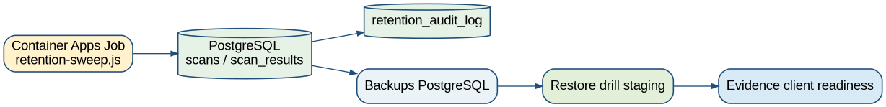
Schema 8 - Retention, audit log et backup/restore
Retention job Azure
export RETENTION_JOB_NAME="$(terraform output -raw retention_job_name)"
az containerapp job show --resource-group "$RESOURCE_GROUP" --name "$RETENTION_JOB_NAME" -o table
az containerapp job start --resource-group "$RESOURCE_GROUP" --name "$RETENTION_JOB_NAME"
az containerapp job execution list --resource-group "$RESOURCE_GROUP" --name "$RETENTION_JOB_NAME" -o table
Audit retention
SELECT action, affected_rows, metadata, created_at
FROM retention_audit_log
ORDER BY created_at DESC
LIMIT 10;
- Tester restore PostgreSQL sur environnement isole.
- Verifier tenants, scans, scan_results, billing ledger et idempotency apres restore.
- Documenter RPO/RTO, date, operateur, ressource source, ressource restauree, resultat.

29. Annexe SQL operateur utile
-- Derniers scans
SELECT id, tenant_id, status, billing_state, created_at, completed_at
FROM scans ORDER BY created_at DESC LIMIT 20;
-- Isolation tenant d un scan
SELECT id, tenant_id, status, billing_state FROM scans WHERE id='<SCAN_ID>';
-- Resultat stocke
SELECT scan_id, tenant_id, compression, result_size_bytes, result_sha256, result_summary
FROM scan_results WHERE scan_id='<SCAN_ID>';
-- Attempts worker
SELECT attempt_id, scan_id, tenant_id, status, error_message, started_at, completed_at
FROM scan_attempts WHERE scan_id='<SCAN_ID>' ORDER BY started_at DESC;
-- Outbox
SELECT id, aggregate_id, tenant_id, event_type, status, attempts, published_at, last_error, created_at, updated_at
FROM outbox_events WHERE aggregate_id='<SCAN_ID>' ORDER BY created_at DESC;
-- Ledger billing
SELECT scan_id, event_type, billing_units, amount_eur_ht, metadata, recorded_at
FROM billing_usage_ledger WHERE scan_id='<SCAN_ID>' ORDER BY recorded_at ASC;
-- Scans bloques
SELECT id, tenant_id, status, billing_state, created_at, updated_at
FROM scans WHERE status IN ('PENDING','IN_PROGRESS') AND created_at < NOW() - INTERVAL '15 minutes';

30. Matrice alignement code / documentation
Capacite V5.2 | Source de verite | Preuve
Idempotence serveur | Code + docs + tests | POST sans header -> server_generated
Outbox | Code + docs + SQL | outbox_events PUBLISHED
Contrats | API/worker schema + version | sync-contracts
Migrations | schema_migrations | npm run migrate-db
Billing | ledger + scans.billing_state | reserved/consumed/refunded
Worker | scan_attempts + scan_results | DONE/FAILED
Retry/backoff | withRetry + logs | 429/503 si observes
Retention | Container Apps Job | execution + retention_audit_log
Alerting | Azure Monitor | alertes enabled
APIM | Gateway + operations proxy | health/scans via APIM
CI | GitHub Actions | jobs verts
Controle zero divergence avant publication
grep -R "2026-04-28" -n docs contracts bevoac-api-enterprise bevoac-worker-enterprise || true
grep -R "2026-05-06-production-hardening-v5" -n contracts bevoac-api-enterprise/contracts bevoac-worker-enterprise/contracts
npm --prefix bevoac-api-enterprise run check
npm --prefix bevoac-api-enterprise test
npm --prefix bevoac-worker-enterprise run check
terraform -chdir=bevoac-iac-enterprise fmt -recursive
terraform -chdir=bevoac-iac-enterprise validate

31. Annexes Mermaid et sources
Les fichiers .mmd suivants sont fournis dans le package sous docs/mermaid. Ils doivent etre versionnes dans le depot et rester alignes avec le runbook.
Fichier | Role
architecture_v5_2.mmd | Source Mermaid du schema V5.2
onboarding_v5_2.mmd | Source Mermaid du schema V5.2
scan_lifecycle_v5_2.mmd | Source Mermaid du schema V5.2
tenant_isolation_v5_2.mmd | Source Mermaid du schema V5.2
outbox_billing_v5_2.mmd | Source Mermaid du schema V5.2
dlq_operations_v5_2.mmd | Source Mermaid du schema V5.2
apim_v5_2.mmd | Source Mermaid du schema V5.2
retention_backup_v5_2.mmd | Source Mermaid du schema V5.2

31.x architecture_v5_2.mmd
flowchart LR
Client[Client B2B / Portail / Integrateur] -->|Bearer Bevoac API key| APIM[APIM optionnel]
APIM --> API[Bevoac API Fastify /v1]
Client -->|direct si APIM desactive| API
API --> Auth[API key hash -> tenant_id]
API --> Allow[Allowlist web/Azure + validation payload]
API --> Idem[Idempotency key client ou server-generated]
API --> Billing[Billing RESERVED + quota/backpressure]
API --> Outbox[(PostgreSQL outbox_events)]
Outbox --> SB[Azure Service Bus scan-jobs sessions tenant]
SB --> Worker[Worker Container Apps idempotent]
Worker --> Web[Scanners web SSRF/DNS guard]
Worker --> Graph[Microsoft Graph / Entra]
Worker --> ARM[Azure ARM / Resource Graph]
Worker --> Results[(scan_results + scan_attempts)]
Results --> API
API --> PDF[PDF bounded finding/remediation/evidence]
Admin[Admin Bevoac OIDC] --> API

31.x onboarding_v5_2.mmd
sequenceDiagram
participant Client as Admin client
participant API as Bevoac API
participant MS as Microsoft Entra
participant ARM as Azure Management
participant DB as PostgreSQL
Client->>API: POST /v1/onboarding/azure/start
API->>DB: create session + state_hash + nonce_hash
API-->>Client: authorizationUrl
Client->>MS: admin consent
MS->>API: GET /v1/onboarding/azure/callback?tenant&state
API->>API: verify HMAC, expiry, anti-replay, api_key_id
API->>ARM: discover subscriptions / verify RBAC
API->>DB: upsert tenant_azure_integrations + tenant_azure_scopes
API-->>Client: redirect success/action_required/error

31.x scan_lifecycle_v5_2.mmd
sequenceDiagram
participant Client
participant API
participant DB as PostgreSQL
participant OB as Outbox publisher
participant SB as Service Bus
participant Worker
Client->>API: POST /v1/scans Idempotency-Key optional
API->>DB: derive tenant, authorize target, lock quota month
API->>DB: insert scans PENDING, billing_state RESERVED
API->>DB: insert scan_reserved + idempotency + outbox event
OB->>SB: publish scan.requested version 2026-05-06-production-hardening-v5
Worker->>SB: accept tenant session
Worker->>DB: beginAttempt PENDING -> IN_PROGRESS
Worker->>Worker: run modules + retry/backoff + timeouts
Worker->>DB: scan_results + scan_attempts + DONE/FAILED
Worker->>DB: scan_consumed or scan_refunded
Client->>API: GET /v1/scans/{scanId} and PDF

31.x tenant_isolation_v5_2.mmd
flowchart TD
Key[Bearer API key] --> Hash[hash lookup api_keys]
Hash --> Tenant[tenant_id derived server-side]
Tenant --> Reject[Reject tenantId/customerId in client body]
Tenant --> Web[tenant_web_targets allowlist]
Tenant --> Azure[tenant_azure_scopes VERIFIED]
Web --> Scans[(scans filtered by tenant_id)]
Azure --> Scans
Scans --> Results[(scan_results filtered by tenant_id)]
Other[Other tenant API key] --> OtherTenant[other tenant_id]
OtherTenant -. 404 .-> Scans

31.x outbox_billing_v5_2.mmd
flowchart LR
POST[POST /v1/scans] --> Tx[DB transaction]
Tx --> Scan[scans: PENDING + billing_state RESERVED]
Tx --> Idem[scan_request_idempotency]
Tx --> Ledger1[billing_usage_ledger: scan_reserved]
Tx --> Outbox[outbox_events: scan.requested]
Outbox --> Publisher[Outbox publisher retry/backoff]
Publisher --> SB[Service Bus]
SB --> Worker[Worker]
Worker --> Success[DONE]
Worker --> Failure[FAILED]
Success --> Ledger2[scan_consumed + billing_state CONSUMED]
Failure --> Ledger3[scan_refunded + billing_state REFUNDED]

31.x dlq_operations_v5_2.mmd
flowchart TD
SB[Service Bus scan-jobs] --> Worker[Worker validates schema]
Worker -->|valid| Process[Process scan]
Worker -->|invalid schema/version| DLQ[Dead-letter]
Process -->|success| Done[DONE + completeMessage]
Process -->|handled failure| Failed[FAILED + scan_refunded + completeMessage]
Process -->|transient infra error| Retry[abandon / retry by delivery count]
Retry --> SB
DLQ --> Stats[dlq-stats]
DLQ --> Replay[controlled replay]
DLQ --> Purge[documented purge only]

31.x apim_v5_2.mmd
flowchart LR
Client[Client / Integrateur] --> APIM[Azure API Management]
APIM -->|subscription key optional by policy| API[Bevoac API]
APIM --> Logs[Gateway logs]
API --> Auth[Bevoac Bearer API key]
Auth --> Tenant[tenant_id]
API --> Rate[Backend rate limit]
API --> Service[Scans / Billing / Onboarding]
note1[Decision: documenter clairement APIM key obligatoire ou subscription_required=false]

31.x retention_backup_v5_2.mmd
flowchart TD
Cron[Container Apps Job retention] --> Sweep[retention-sweep.js]
Sweep --> DB[(PostgreSQL)]
Sweep --> Audit[retention_audit_log]
Backup[PostgreSQL automated backups] --> Restore[Restore drill staging]
Restore --> Verify[Verify tenants/scans/results]
Verify --> Evidence[Backup/restore evidence for client readiness]

32. Conclusion
Cette edition complete transforme le runbook V5.2 en document de demonstration, d exploitation et de validation client/admin. Elle reintegre la granularite V4.2, les annexes Mermaid V5.1, les corrections post-tests et les points d exploitation qui avaient provoque des erreurs pendant la recette.
Decision finale: Bevoac V5.2 peut etre presente comme socle B2B Azure-first production-oriented pour pilote cadre. Pour parler de production enterprise sans reserve, il faut fournir les preuves formelles de charge, pentest, backup/restore, DR, RLS ou equivalent, supervision et runbook incident.

