Welcome to Mighty Oak Acorn Workbook

Overview
As part of CSE 170 Technical Teamwork, you will work in teams of 3-4 on four different Acorn projects. This workbook is to assist you in forming those projects.

Purpose
The purpose of working on projects is to help you better understand the complexity and practicality of the elements you learned in class. You and your team create the projects through careful preparation, guidance by the Spirit, and teamwork using inspiration, collaboration, and innovation.

Background
Please read and watch the following information
- https://www.byui.edu/president/past-presidents/jacob-spori
- https://www.byui.edu/devotionals/justin-hodges

Requirements
Each project will focus on the Influence model and the Institutional Learning Outcomes.
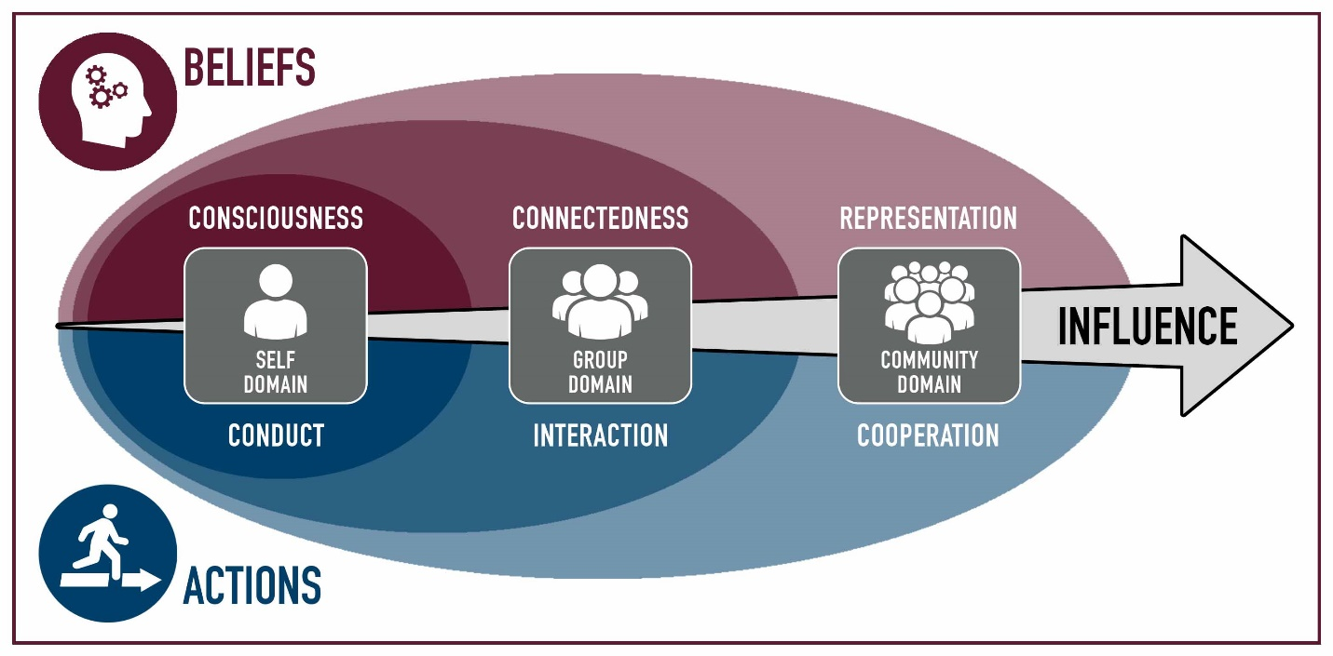
Each project will focus on the Self, the Group, or the Community. Tying in the Belief or Action attributes associated in the Model of Consciousness: Conduct, Connectedness, Interaction, Representation, and Cooperation.

The university has four Institutional Learning Outcomes.
Each of your Acorn Projects will be assigned one of these learning outcomes.


- A Disciple of Jesus Christ
  - We believe in Jesus Christ as the Son of God and strive to follow Him.
- Sound Thinkers
  - We frame and solve problems using creative and critical thinking.
- Effective Communicators
  - We develop and express ideas that are purposeful, organized, and clear

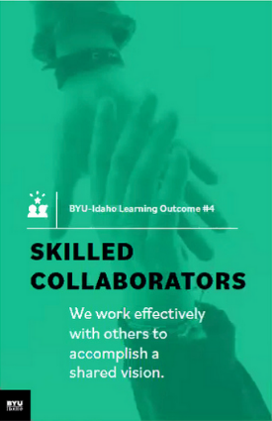
- Skilled Collaborators
  - We work effectively with others to accomplish a shared vision.
NOTE: All I.L.O.s need a project.

Four Project Breakdown:
A project will consist of the following parts
- List the values associated with the project & a statement of the project vision
- Describe each of your roles
- A statement of your vision of success
- Each project must be a minimum of 10-20 hours.
- The project will have a Specific, Measurable, Achievable, Realistic, Timely Goal.
- Definition of the Goal: Who, What, Where, When, How & Why
- List of Milestone, Achievements, Checkpoints, and Deliverables.
What should you do for your project? That is up to you and your team. You and your team will have to have some brainstorming ideas. Research some ideas, have backup ideas, and work together to synergize to come up with an innovative project.

Types of Projects
Acorn projects are small; they are smaller than class projects and bigger than individual and team assignments. You work on the Acorn Projects as a team.
Examples of Acorn project:
Rules: You may use one of these examples as is. You may modify another. The other two you must come up with as a team.
- Attend a Career Services event as a team and work on a deliverable
- Participate in “Get Involved”: Recreation, Ushering, Get Connected, I-Serve, Peer Mentoring, Rep Council, Tutoring
- Participate in a service project, service information, training that will help other students at BYU-Idaho.
- Create a program together, use a collaborative tool and resource repository.
- Join a Department Society and work together to contribute to a project
- Attend a Society Event such as a Hack-A-Thon, participate as a team
- Participate in a Sport, Sporting Event, or Team activity
- Attend a Leadership conference/activity produced by Student Services
- Participate in an Escape Room, Rope Course, or similar activity
- Discover 4+ campus building activities: for example Geology, Animal, Garden tour, Planetarium
- Plan three group date, with at least 3 activities
- Play 5 different players vs the board, 2-3 times, or an RPG game

Participation
Each project should be a significant effort. It will require some brainstorming, planning, execution, and reflections.
Each project should for the team be about 10-20 hours cumulative, with multiple sessions. If there are four in a group, this breaks down to 2-4 hours each. I suspect that you will be around 3-5 hours each.
You work together as a team and do not split up the projects individually among yourselves.

Brainstorming
The following are tools and concepts you should know about brainstorming and managing your team’s project and members. We will be covering each of these throughout the semester in detail and are here for reference and reminders.
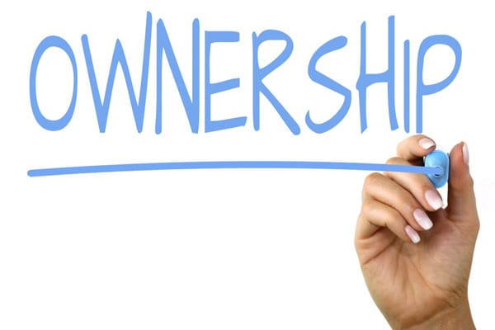
- Ownership
  - Ownership is one of the hardest things to learn. Ownership is taking the goal of the team and making it yours. It goes along with the scripture, “Be One.” You put your whole might, mind, heart, and soul into it.
- Listening

  - Listening is a key element in brainstorming. We have two ears and one mouth. For some reason, our ear does not hear when our mouth is moving and making sounds. Lord intended us to listen twice as much as we talk. If it became a problem, use the tool “the Talking stick,” which the person holding the stick gets to talk about, then pass it along.
  - “Seek first to understand, then to be understood” – Steven R. Covey

- Brainstorming
  - This process is where you through ideas on the wall and vote on them. It is best to come prepared with 4-5 ideas, accept other ideas, and be prepared to have your ideas merge with others to be better ideas.
  - A couple of questions to ask to help with the process
    - If you had unlimited finances, what would you do?
    - If you had magic, what would you do?
    - If you had unlimited time, what would you do?

- Problem Solving
  - We are problem solvers. For thousands of years, your ancestors solved problems. You can solve problems. The problem sometimes is making a choice and committing to it.
  - Steps: Describe the problem, gather information, determine important factors, visualize the solution, create action steps.
- Decision making

  - Do not get stuck in the analysis paralysis loop, which is thinking about a solution and not taking any action. Pick a solution nd go with it. A boat never sails if it does not get in the water.
  - Sort, Rank, and Vote on the solution. And then do it. The change will happen along the way that will make it better.

- Conflict Management
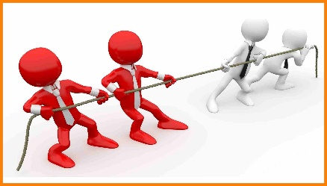
  - Everyone has different experiences and opinions based on those experiences. Everyone has different backgrounds and values-based on those backgrounds. That is ok and is necessary. Without conflict, a boat does not sail, and planes don’t fly. We do not strengthen our muscles, bones, and tendons. Good Conflict Management creates a space where ideas can share, discuss, analyze, poked at, torn apart, and put back together better, without insults, put-downs, or negative feels.
  - “You can empower yourself, but can only encourage others.”
  - Tools: Negotiate with rules and limits, be cooperative, be direct, be aware of yourself and others, establish trust, be open.

- Communication
Oh, communication. Say what you mean. Say what you are going to say, say it, and say what you said. Keeping your thoughts back does not work with brainstorming. Letting everyone participate is also just as important. Being present is also needful.
    - Form of Communication: Nonverbal, Oral, and Written
    - Blueprint of Communication: Message, Sender, and Receiver
    - Assure good communication: Common ground, Sincerity, Authority (to act, not be acted upon), and clarity.
    - Barriers of Communication: lack of receptiveness and a good environment.
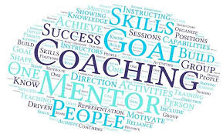
- Coaching and Mentoring
  - Ask for help is necessary. Ask to have some to report to also necessary. You don’t think you need a coach; you can do it on your own. Think again. Every professional has a coach; that is how they got to be a professional—sports, Business, C.E.O., etc.

- Change

  - Things are going to change; plan on it. The first plan never works out. The original idea will not be the final product. Being adaptable is necessary. Ask a carpenter if every cut is exact or is just close enough. Ask an artist if all lines are straight. An Engineer is there no tolerances. Build in the wiggle room.
    - When change is needed, leading change can make it happen
    - How to lead change: recognize the change, empower others to make the change, base change on value, mission, and vision, establish urgency, move ahead with the unknowns (manage and mitigate the risks, don’t get stuck in analysis paralysis),

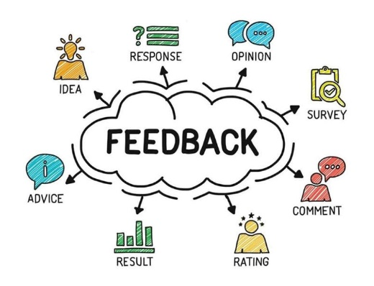
- Feedback
  - You are going to receive feedback. Prepare for it. That is how you learn. Make sure you go in without your eye wide shut, seeing but not seeing. Other perspectives allow you to see what you forgot you saw. Remember, the feedback is not you. It is reality. It is you being looked at through someone else’s eyes and mind, repeated back to you through your eyes and mind. It is like taking a photograph, making a drawing of it, and then you are describing what you saw from the drawing. Receiving feedback is like receiving the word at the end of the play, the game Telestrations.
  - “Consider feedback to be a gift. It truly is.”

Acorn Project Worksheet Explanation
Record the summary of your brainstorming activities.

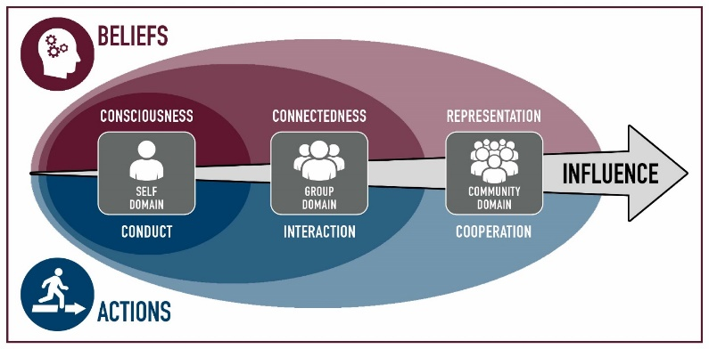
Project Influence
Pick one of the following:
- Self
  - oBelief: Consciousness
  - oActions: Conduct
- Group
  - oBelief: Connectedness
  - oAction: Interaction
- Community
  - oBelief: Representation

  - oAction: Cooperation
Explain how this project will Influence you, your team/group, or the community.

Project Mission Focus:
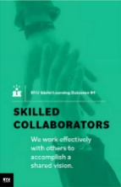
Identify 1 of the following for this Project Goal. Must have one project goal for each I.L.O.

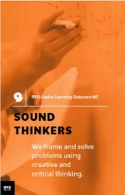

- oDisciple of Jesus Christ
- oSound Thinkers
- oEffective Communicators
- oSkilled Collaborators

Personal Values
Values are our core beliefs or desires that guide or motivate our attitudes and actions. List your values and the forms that they take; principles, standards, personal qualities, character traits, or ethics codes.

Vision Statement
A vision is a picture of future success. Our vision is when we think far enough to realize that there will be challenges for which we can prepare.

S.M.A.R.T. Goals
“A Goal Without a Deadline is Only a Dream!”
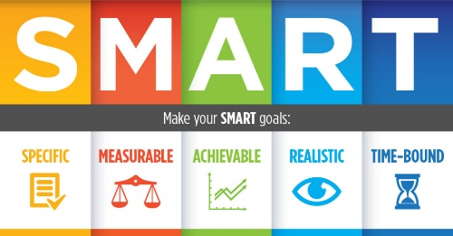
Define your Acorn project as a “SMART” (Specific, Measurable, Attainable, Relevant, and Timely) goal.
- Specific - Describe this Acorn Project Goal in enough detail so that you, your teammates, and the instructor know specifically what you are going to do, how it is important, or how it will impact you. Is it challenging?
- Measurable - Describe how this Acorn Project Goal is Measurable. How will you know when the goal is completed? What is your exit strategy? What are the milestones?
- Attainable - Describe how this Acorn Project Goal is Attainable. Can it be accomplished? You have 10-12 weeks to complete the project with four people.
- Relevant – Describe how this Acorn Project Goal is Relevant. How does it relate to BYU-Idaho I.L.O.s? How will it help grow your Acorn into a might oak?
- Timely - Describe how this Acorn Project Goal is Timely. Can it be accomplished in a reasonable amount of time? Ten cumulative hrs. minimum per project
Re-write the SMART goal as a single sentence.

Milestones 
It takes more than one step to complete goals. List up to 10-12 milestones, achievements, checkpoints, or deliverables for your goal. Following the network of high-level objectives, break down each objective into separate activities necessary to accomplish it. Order and prioritize the activities by the longest and plan.

Approval of Project

You will submit your projects for review & approval to your instructor. Expect a week for feedback. You can continue as if it was approved; meanwhile, your instructor will give you additional tasks and ideas to improve the projects. Submit a final revision with changes for approval.


Bi-Weekly Status of Project
As mentioned in the brainstorming, you will have changes, conflicts, decision making. Change is normal. Each week you need to meet with your team to discuss the progress of your Acorn Projects. You can complete them in sequence or parallel.
You will be required to provide the status of your Acorn projects every other week. You will need to indicate the percentage done.

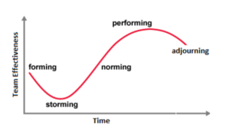
Stages of Team Development
As you move with your Acorn project, you and your team will hit some challenges and accomplish some breakthroughs. Here is a guide to let you know what you will face as your team pulls together. It is expected that each goal has multiple sessions/milestones, to show these phases.
The first stage in a team’s development is Forming (“Pickup Sticks,” “Polite”).
Most team members are eager to be on the team. However, they often come with high, unrealistic expectations. These expectations come with some anxiety about how they will fit in, how much they can trust others, and how much time to set aside. Team members are also unclear about norms, roles, goals, and timelines. In this stage, there is a high dependence on the leading figure for purpose and direction. Behavior is usually tentative and polite. The major issues are personal well-being, acceptance, and trust.

The second stage in a team’s development is Storming (“At Odds,” “Testing”).
As the team gets some experience working together under their belt, there is a dip in morale as team members experience discrepancies between their initial expectations and reality. The difficulties in accomplishing the task and working together lead to confusion and frustration, and growing dissatisfaction. Negative reactions to each other develop, and subgroups form, which polarize the team. The breakdown of communication and the inability to problem-solve result in lowered trust. The primary issues in this stage cocern power. Control and conflict.

The third stage in a team’s development is Norming (“Coming Around,” “Valuing”).
As the issues encountered in the second stage are addressed and resolved, morale begins to rise. Task accomplishment and technical skills increase, contributing to a positive, even euphoric feeling—clarity and commitment increase on purpose, values, norms, roles, and goals. Trust and cohesion grow as communication becomes more open and task-oriented. There is a willingness to share responsibility and control. Team members value the differences among themselves. The team starts thinking in terms of “we” rather than “1.1! Because the newly developed feelings of trust and cohesion are fragile, team members avoid conflict for fear of losing the positive climate. This reluctance to deal with conflict can slow progress and lead to less effective decisions. Issues at this stage concern the sharing of control and avoidance of conflict.

The fourth stage in a team’s development is Performing (“As One,” “Trusting”).
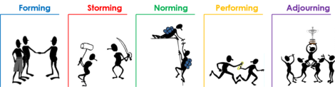
At this stage, both productivity and morale are high, and they reinforce one another. There is a sense of pride and excitement in being part of a high-performing team. The primary focus is on performance. The purpose of roles and goals are clear. Standards are high, and there is a commitment to meeting standards and continuous improvement. Team members are confident in their ability to perform and overcome obstacles. They are proud of their work and enjoy working together. Communication is open, and leadership is shared. Mutual respect and trust are the norms. Issues include continued refinements and growth.

Pushing Through

As mentioned in the brainstorming, you will have changes, conflicts, decision-making. Each week you need to meet with your team to discuss the progress of your Acorn Projects. You can complete them in sequence or parallel.
You will be required to provide the status of your Acorn projects every other week. You will need to indicate the percentage done.

The finish line

No runner stops exactly at the finish line; No athlete walks straight to the car and goes home; No engineer throws away all the equipment after an experiment. After camping, what do you keep and what do you throw away. There is clean up, reflection, lessons learned, and preparing to do it again.
You will need to complete the following for each Acorn:
- Presentation
  - Your team will be required to present a 3-5 minute briefing of your Acorn Project to the class.
- Lessons Learned
  - You need to reflect on the vision and goal of the project. Think if you were to do each of the projects again, how would you do better. What advice would you give someone?
  - You need to ve at least two lessons learned for each of the 4 Acorn Projects.
  - Also, additional lesson learned on your team dynamics.
- S.T.A.R
  - Write up a summary of your experience in the following format
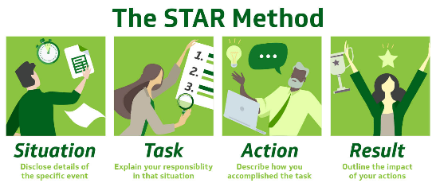
    - S. Situation
    - T. Task
    - A. Achievement
    - R. Results
- Participation
  - Each of you will provide a report on how you participate and
  - Each of you will report on how each member of the team participated.
  - As a team, you will determine how many hours you spend on each project.
- Stop, Start, and Continue
  - As a team and as an individual, you need to reflect on three things:
    - Stop: List an item that your team and yourself that you need to stop doing that hindered the team and project.
    - Start: List an item that would improve and innovate the project.
    - Continue: List items that went well and is necessary for the success of the project
  - Complete Stop, Start, and Continue for each of your projects.

Presentation of Acorns Ceremony
On the Last of Class, we will have a ceremony where I will present you with four Acorns, one for each project that you completed.



Other Resources
- https://www.byui.edu/mighty-oaks

Acorn Project Worksheet
Project Mission Focus: Disciple of Jesus Christ
- Team Name: What up cuz!?
- Team member’s Names: Ammon, Mo
- Project Title: Devotional Reflection/Study
- Project Influences: We both attend devotional every week and wanted to ponder what was learned from each devotional.
 | Belief | Actions
Self | ü Consciousness | oConduct
Group | ü Connectedness | ü Interaction
Community | oRepresentation | ü Cooperation
Explain: This project will bring consciousness and connectedness to our group because we will be going to a church devotional to where we our personal beliefs can be grown. By attending in a group and discussing of it afterwards we allow the opportunity to connect to each other and understand their beliefs and even their consciousness of the subject at hand. We will be interacting with each other when we discuss what the topic at hand was, and cooperation will be present when scheduling times to discuss, or if one can’t make it, having the other commit so that he may share their findings. If both can’t make it, we will have to cooperate and find a time to read or view the recording of the Devotional.

- Project Values: Spiritual Wellbeing, Communication, Evoking thoughts and emotions.
- Description:
  - Attend Devotional every week mentally prepared to hear what will be said. Take notes or allow ourselves to be open to the spirit and its teachings. Take what we learn from devotional and share in a brief paragraph our insights from the speakers. We do not want to just share our thoughts between the two of us, so we will also be extending an invitation to those around us to come, listen and share their thoughts as well.

- Vision Statement:
  - Come closer to God and to those around us as we allow ourselves to be spiritually uplifted.

- SMART Goal:
  - Specific: Come closer to God by listening to keynote speakers the University has chosen
  - Measurable: Write up a brief summary of our insights
  - Attainable: Attend Devotional
  - Relevant: Invite others to join us.
  - Timely: Attend at least 4 devotionals between now and the end of the semester. This should fulfill the time requirements between attending, inviting other and the discussions afterwards.
Summary:
We want to become closer to God and invite others to do so as well. To attend a minimum of 4 devotionals should allow us to find patterns of God in our lives as we make additional time outside of church for our spiritual wellbeing. This project would not only allow for ourselves to be spiritually edified, but as we invite others to attend devotional they will hopefully gain the same benefit

- Audience (Who, What, Where, When, Why, How):
- Who:
  - Ammon and I. We will ponder about who else might need the invite and ask them to join us.
- What:
  - Devotional and the group discussions we’ll have afterwards.
- Where:
  - The I-Center
- When:
  - Every Tuesday at 11:30
- Why:
  - To listen to speakers, gain spiritual knowledge, and find others who might need a group to go with.

- Roles and Responsibilities:
Role Responsibilities
  - 1: Mo/Ammon - Invites - Inviting others to come to devotional
  - 2: Mo/Ammon - Discussions - Sharing our thoughts and findings, hopefully allowing others to do the same.
  - 3:
  - N:
- Milestones
  - 1. 11/1 Devotional #1
  - 2. 11/8 Devotional #2
  - 3. 11/15 Devotional #3
  - 4. 11/29 Devotional #4
  - 5. First week of Dec. Final get together before ensuing finals and discuss favorite talks/topics from Devotionals that we have attended.
- Instructor Improvements Suggestions:
  - _________________________________________________________
  - __________________________________________________________
[ ] Approved Date: __________________
Acorn Project Worksheet
Project Mission Focus: Sound Thinkers
- Team Name: What up cuz!?
- Team member’s Names: Ammon, Mo
- Project Title: Web Design & Development Society
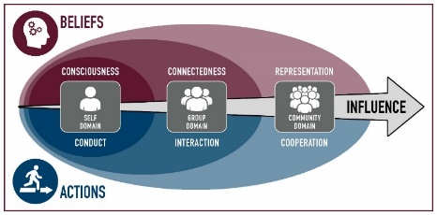
- Project Influences: Both take a web development class and thought it would be an interesting society to join.
 | Belief | Actions
Self | oConsciousness | oConduct
Group | Connectedness | ü Interaction
Community | ü Representation | ü Cooperation
Explain:

- Project Values:
  - Teamwork, constructive criticism, positive feedback and gaining knowledge.
- Description:
  - We would attend the bi-monthly web development and design society to gain more skills concerning web design. This would help us in our efforts to complete our classwork for WDD-130. If possible, we would both attend the society meetings and take what we have learned there and apply it to our work. As we draw closer to the end of the semester, we would also peer review each other’s final project and provide insight on how it might be made better.

- Vision Statement:
  - To learn more about Web Design, increase our skills in the matter and to then turn in the best possible project we can for our WDD-130 class.

- SMART Goal:
  - Specific: Complete Personal Website
  - Measurable: Attend society meetings and show progress to each other.
  - Attainable: Turn in final Web Design Project that has been edited by each other.
  - Relevant: Stay on top of due dates, possibly by a day so that we may give feedback with enough time to implement changes.
  - Timely: Work with each other’s schedules so that if one cannot make it to a society meeting, the other can and let the other know what was missed and if anything taught might be beneficial for our endeavors.
Summary:
We want to learn more about Web Design and Development and how we can gain more skills in the subject. We have a goal in mind and that is to turn in the best possible version of our website that we will be designing for class. This project would allow us to not only become better web developers but also work on a project that is due for another class.

- Audience (Who, What, Where, When, Why, How):
- Who:
  - Ammon and I. We have extended an invitation to other classmates so there may be a group who end up going.
- What:
  - WDD Society and WDD-130 Final Project
- Where:
  - STC 231 and Study rooms
- When:
  - Every 2nd and 4th Wednesday of the month. Also whenever else we need to meet to discuss more about our websites.
- Why:
  - It will allow us to work on a project we have for another class while obtaining more skills outside said class.
- How:
  - By attending the WDD society and meeting outside of class the likelihood of understanding what we are being taught will increase exponentially

- Roles and Responsibilities:
Role Responsibilities
  - 1: Mo - Information Gathering -Take notes from both society meetings and class and share.
  - 2: Mo - Scheduling -Figure out when society meetings are being held and reserving study rooms if necessary.
  - 3: Ammon – Due Dates -Stay on top of due dates and remind when upcoming milestones are approaching.
  - N:
- Milestones
  - 1. 10/27 Society Meeting
  - 2. 11/01 Personal Siteplan
  - 3. 11/09 Society Meeting
  - 4. 11/23 Society Meeting
  - 5. 12/13 Final Project Due
- Instructor Improvements Suggestions:
  - _________________________________________________________
  - __________________________________________________________
[ ] Approved Date: __________________
Acorn Project Worksheet
Project Mission Focus: Effective Communicator
- Team Name: What up cuz!?
- Team member’s Names: Ammon, Mo
- Project Title: Escape Room
- Project Influences: We both love escape rooms and like solving puzzles.
 | Belief | Actions
Self | ü Consciousness | oConduct
Group | ü Connectedness | ü Interaction
Community | oRepresentation | ü Cooperation
Explain: I think that it hits these categories because we must cooperate not only with each other in the escape room but also to get there and plan it. Also, we must interact heavily with each other because we must work as a team to get out

- Project Values: Teamwork, communication, problem solving
- Description: We will be planning on going to an escape room in the next few weeks. To solve the escape room, we must constantly collaborate in a timely manner to escape the room. I will be responsible for planning and setting up the time we are going to do it. Mo is going to get us there and we will have to figure each other’s roles when we get into the room because they’re all different.

- Vision Statement: This will be a success because we have a passion for escape rooms and have a goal in mind and an estimated date, so it will come through.

- SMART Goal:
  - Specific: Finish and escape the escape room.
  - Measurable: Escape the room in under 55 minutes.
  - Attainable: Complete at least 5 clues, finishing it is also very attainable.
  - Relevant: Don’t get stressed in the escape room and keep calm.
  - Timely: Do the escape room on the date we planned and spend at least 10 hours driving, completing it, and planning the activity. Also evaluating how we did at the end.
Summary: In summary we have a goal and it’s a simple one. To finish the room but also build our communication and teamwork skills. If we work together this is very attainable and its also just a fun way to interact and practice these skills.

- Audience (Who, What, Where, When, Why, How):
- Who: Mo and I are going along with a date. So, there will be 4 of us.
- What: We will be going to an escape room and completing an online escape room for practice.
- When: Sometimes in the next two weeks.
- Why: Because it will demonstrate being an effective communicator.
- How: By taking the necessary steps to get to the room and complete it using communication between one another.

- Roles and Responsibilities:
Role Responsibilities
  - 1: Ammon Planning the date and the time
  - 2: Mo Driving to the escape room
  - 3: Ammon Choosing which theme to play
  - N: Mo Driving home/evaluating escape room and our
performance
- Milestones
  - 1. Brainstorm activity for effective communicator
  - 2. Complete a practice escape or clue game online
  - 3. Plan date and time for escape room. Get dates.
  - 4. Choose theme that would require most teamwork
  - 5. Complete escape room
  - 6. Talk about what went well, what went wrong and just overall quality of the room
- Instructor Improvements Suggestions:
  - _________________________________________________________
  - __________________________________________________________
[ ] Approved Date: __________________
Acorn Project Worksheet
Project Mission Focus: Skill Collaborators
- Team Name: What up cuz!?
- Team member’s Names: Ammon, Mo
- Project Title: Ropes Course
- Project Influences: I have been wanting to do the ropes course for a while now and when I suggested it to Mo he agreed
 | Belief | Actions
Self | ü Consciousness | oConduct
Group | oConnectedness | ü Interaction
Community | oRepresentation | ü Cooperation
Explain: It takes a lot of mental and physical strength do a ropes course because your so high and completing physically challenging obstacles. You also get to interact with one another and cooperate to maneuver around the obstacles.

- Project Values: Communication, skill, collaboration, interaction
- Description: We will be going through the gravity course together, helping and assisting one another when needed.

- Vision Statement: This will be successful because we both want to try the ropes course and experience the different obstacles, but also because we are both skilled and have experienced and done ropes course.

- SMART Goal:
  - Specific: Get through the ropes course in one piece
  - Measurable: Be able to do the obstacles without slipping or falling
  - Attainable: Communicate and be helpful towards one another
  - Relevant: Show skills on the ropes course. Collaborate with one another
  - Timely: Finish the ropes course in under an hour
Summary: We will be guided through the ropes course on ropes and obstacles. There will be ziplines also which will be fun.

- Audience (Who, What, Where, When, Why, How):
Who: Mo and I
What: Going through a ropes course and completing training for course
Where: The ropes course on BYUI campus
When: Next week. Tuesday or Thursday
Why: because it will show that we can complete skills while also collaborating to get through obstacles
How: By staying near one another just in case the other needs help.

- Roles and Responsibilities:
Role Responsibilities
  - 1: Ammon Buy ticket for ropes course
  - 2: Mo Buy ticket for ropes course
  - 3: Ammon Do training and ropes course obstacles
  - N: Mo Do training and ropes course obstacles
- Milestones
  - 1. Brainstorm activity for skill collaboration
  - 2. Set date and time for ropes course
  - 3. Buy tickets
  - 4. Go through training for ropes course
  - 5. Complete ropes course
  - 6. Communicate what we did well and what skills we used
- Instructor Improvements Suggestions:
  - _________________________________________________________
  - __________________________________________________________
[ ] Approved Date: __________________

