Ammon Fleming

A Personal User Manual

My Style:

* Lead others by example
* Be someone others look up to for direction and guidance
* Do things how I think is best
* Quickest way to get something done is the best way

What I value:

* I value a good work ethic. My own work, others works, group work
* I value dedication to something or someone
* Teamwork. I love when teams can work together because with my personality I like to be with others and see others' inputs.

What I don’t have patience for:

* People slacking off
* Not contributing to a team, function or event
* Those who think they’re better than others (We’re all just learning)
* Those who aren't optimistic

How best to communicate with me:

* Communicate through examples
* Helping or assisting me
* By matching my energy/just being fun
* Sound intellectual, like use words that are meaningful and substantial

How to help me:

* Be by my side along the way if I need help
* I am a Y type of management in the sense where I need direction but not strict rules or instructions. I like to figure things out on my own.
* Show me and then let me do right after
* Don’t give long lectures. Give me time to act and show my skills

What people misunderstand about me:

* I am outgoing. I am an orange personality. I like other companies and their energy
* I think highly of myself and what I can accomplish on my own
* I am one of the hardest workers you will meet.
* I do love my alone time but only when I am trying to focus on a task or homework
* I am a leader if I am given the chance and by my own examples is when I lead best.

Health, Work, Play and Love Dashboard

**Health:** I’m doing good. I exercise frequently, I don't eat too badly and I walk around a lot. I would say I am pretty healthy. ¾.

**Work:** I work really well and get all of my tasks done. I am a water instructor, a programmer, and a web developer. I am an uncle and a brother and I feel as though I balance all of those well within my life. ¾ .

**Play:** I am always active on the weekends and constantly am out socializing with friends and just having fun. I look for ways to be with others. I need to be better at meeting new people because I tend to only talk to those I know and normally communicate with. 4.

**Love:** I try to have respect and love for myself and then it goes to my mom and dad and then siblings and just trying to show them that I love them even though I am so far away. I definitely need to be better at calling them and telling them how my day was. 2/4.

Workview and Lifeview Compass

**Workview:** I work because I want to improve or learn a new skill. I believe that procrastinating and holding something back is just holding you back. Learn all that you can if you have time so that you can relax later. Work shows how much you care about something. If you're always late turning in things then how does that reflect on you. It reflects badly. I feel fulfilled when I finish a long day of work because I kept myself busy and knew that I was doing the right thing.

**Lifeview:** I am here because I am supposed to gain knowledge and learn everything I can about this life and the gospel and to have a family of my own. The purpose of life for me is to live it right and to leave this earth saying “Congrats you lived a good life.” I want a family and a loving wife and money and wealth and a strong testimony and I need to take the steps to get there. I know there is a God up there and he is watching over me and protecting me every step of the way. Good and evil are now complete opposites in the sense that good is evil and evil is good.

**Comparison:** My view on how work and life compliment each other is that we need to work to have a good life. If we are constantly stressed about homework or a project or getting into work on time we are constantly going to be stressed and uptight. If we just do things when they need to get done or earlier we can have a more relaxing life. They clash when you put work over your personal life. There needs to be a boundary saying hey I need to get this done but not to the point where I am obsessing over it.

Good Time Journal Entries

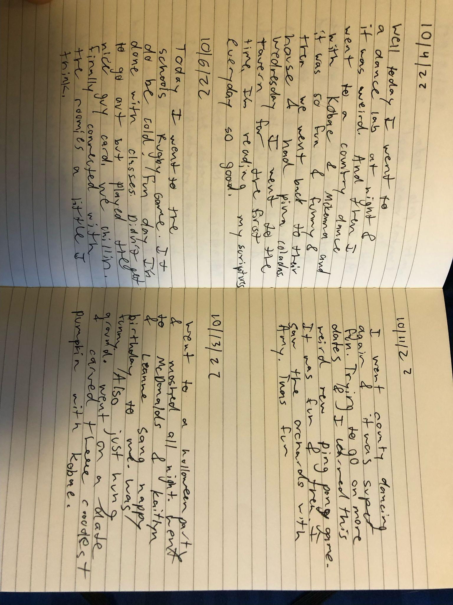

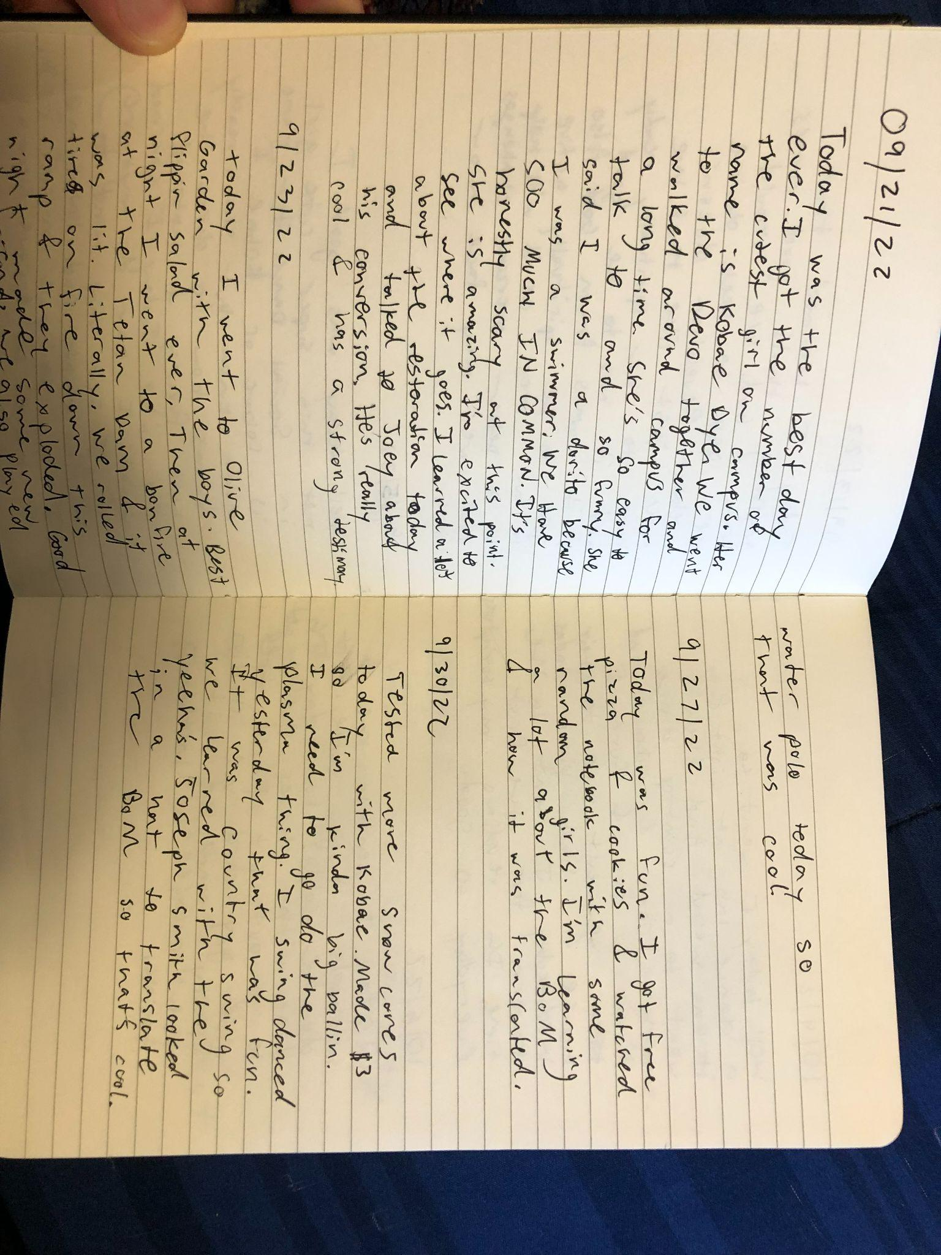

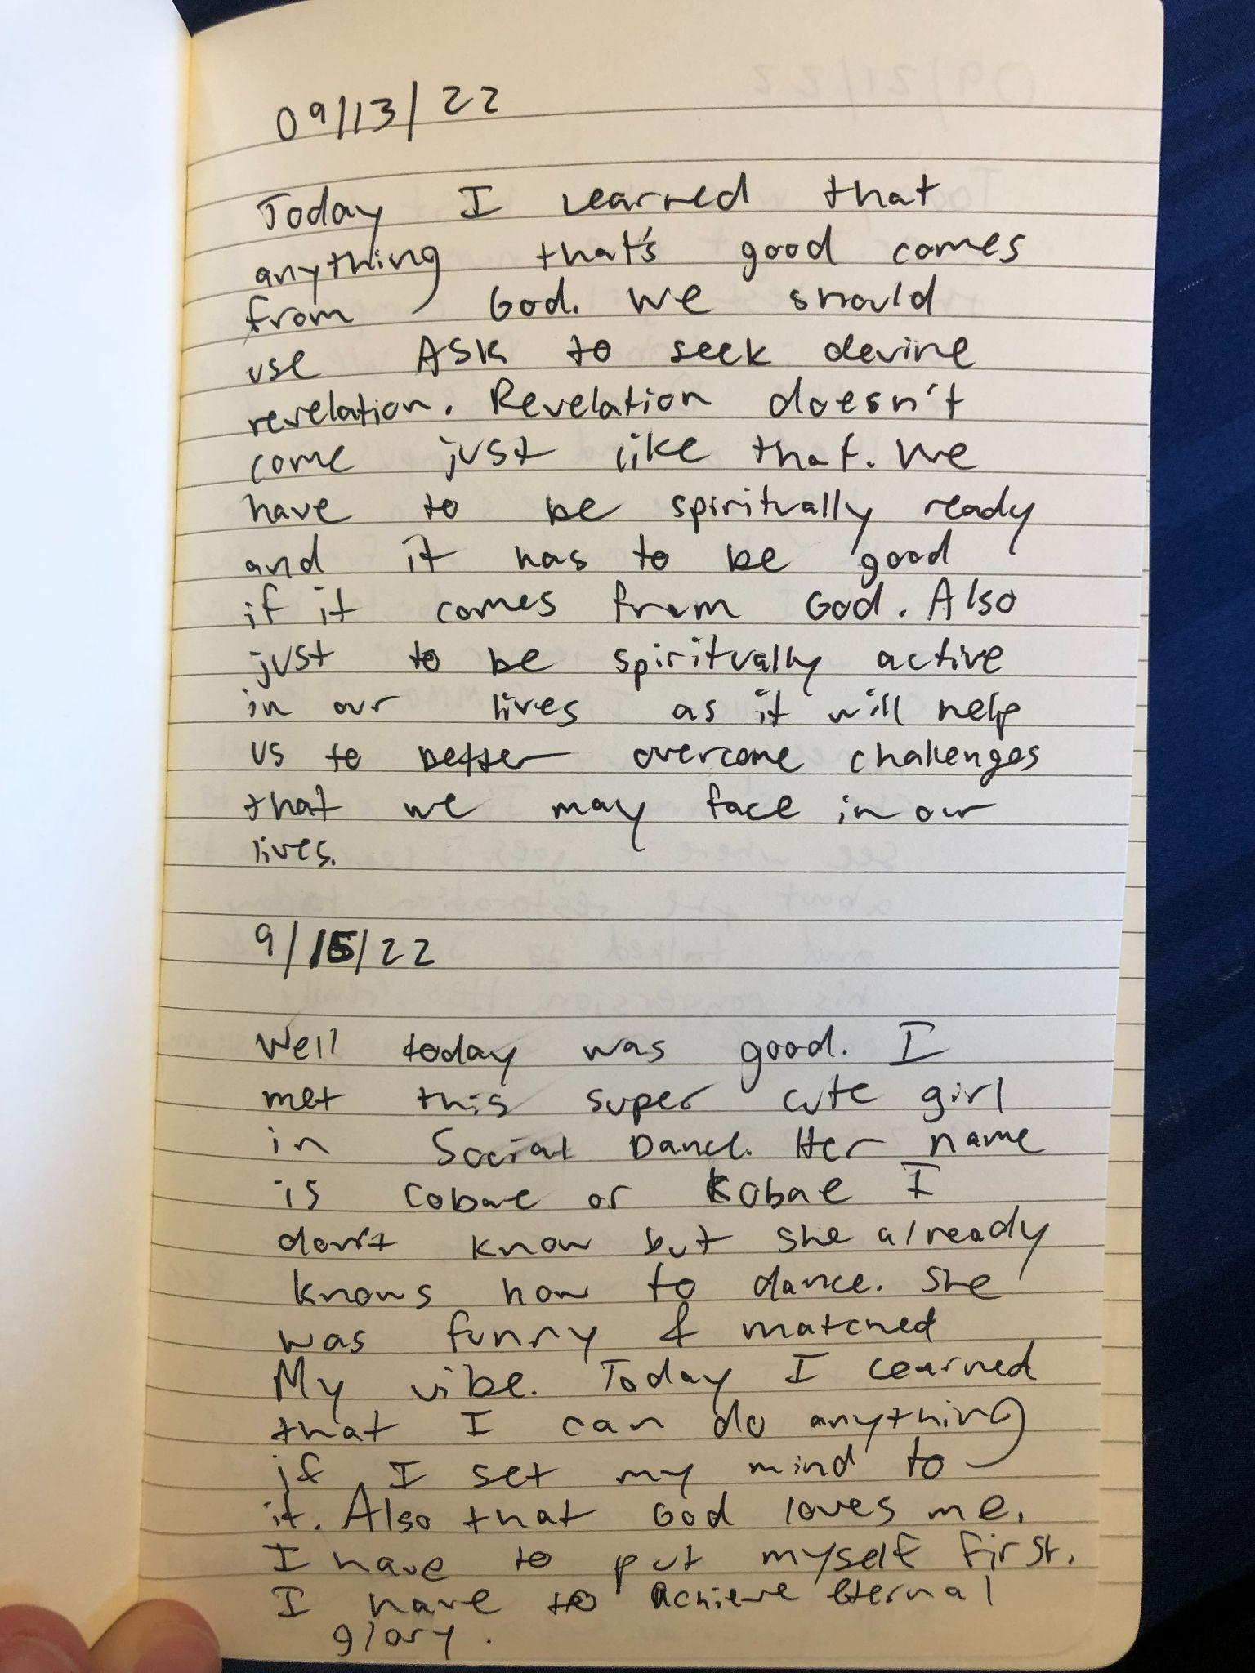

1. Engagement:High, Flow, Energy:Low
2. Engagement:High, Energy:Low
3. Engagement:High, Energy:High
4. Engagement:Low, Flow, Energy:Low
5. Engagement:High, Flow, Energy:High
6. Engagement:Low, Energy:Low
7. Engagement:Low, Flow, Energy:Low
8. Engagement:High, Flow, Energy:High
9. Engagement: Low, Energy:Low
10. Engagement:High, Energy:High

Mind Map



Job For:

Engagement:

* Teach others how to dance for a job
* Work with others like you work with a partner when you dance
* Build software through various steps

Flow:

* Have a job like a lifeguard that is easy going
* Job where I didn’t have to work as much and make my own work
* Good job with good management

Energy:

* Fun job with high energy
* Lots of people around me so I can build off their ideas
* Fun vacations and time off. Maybe a job with lots of interaction and parties.

Odyssey Plans





