|  |  |  |  |  |  |
| --- | --- | --- | --- | --- | --- |
| **PM592: Regression Analysis for Data Science** | | | Name: Flemming Wu |  |  |
| **HW3** |  |  |  |  |  |
| *LINE assumptions, categorical predictors* | | | | |  |

**Instructions**

* Answer questions directly within this document.
* Upload to Blackboard by the due date & time.
* Clearly indicate your answers to all questions.
* If a question requires analysis, attach all relevant output to this document in the appropriate area. Do not attach superfluous output.
* There are 3 questions and 30 points possible.

|  |  |  |  |  |  |  |
| --- | --- | --- | --- | --- | --- | --- |
| **Question 1** |  |  |  |  | [11 points] |  |

Revisit your model from Homework 2, Question 1. Recall this was a regression between SBP (Y) and BMI (X).

|  |  |
| --- | --- |
|  | 1a. [3 points]. Assess each of the assumptions of linear regression, providing relevant plots and statistics to support your conclusions. |

> wcgs <- readRDS("../HW01/wcgs.rds")

> mod1a<- lm(sbp ~ bmi, data = wcgs)

> plot(mod1a)

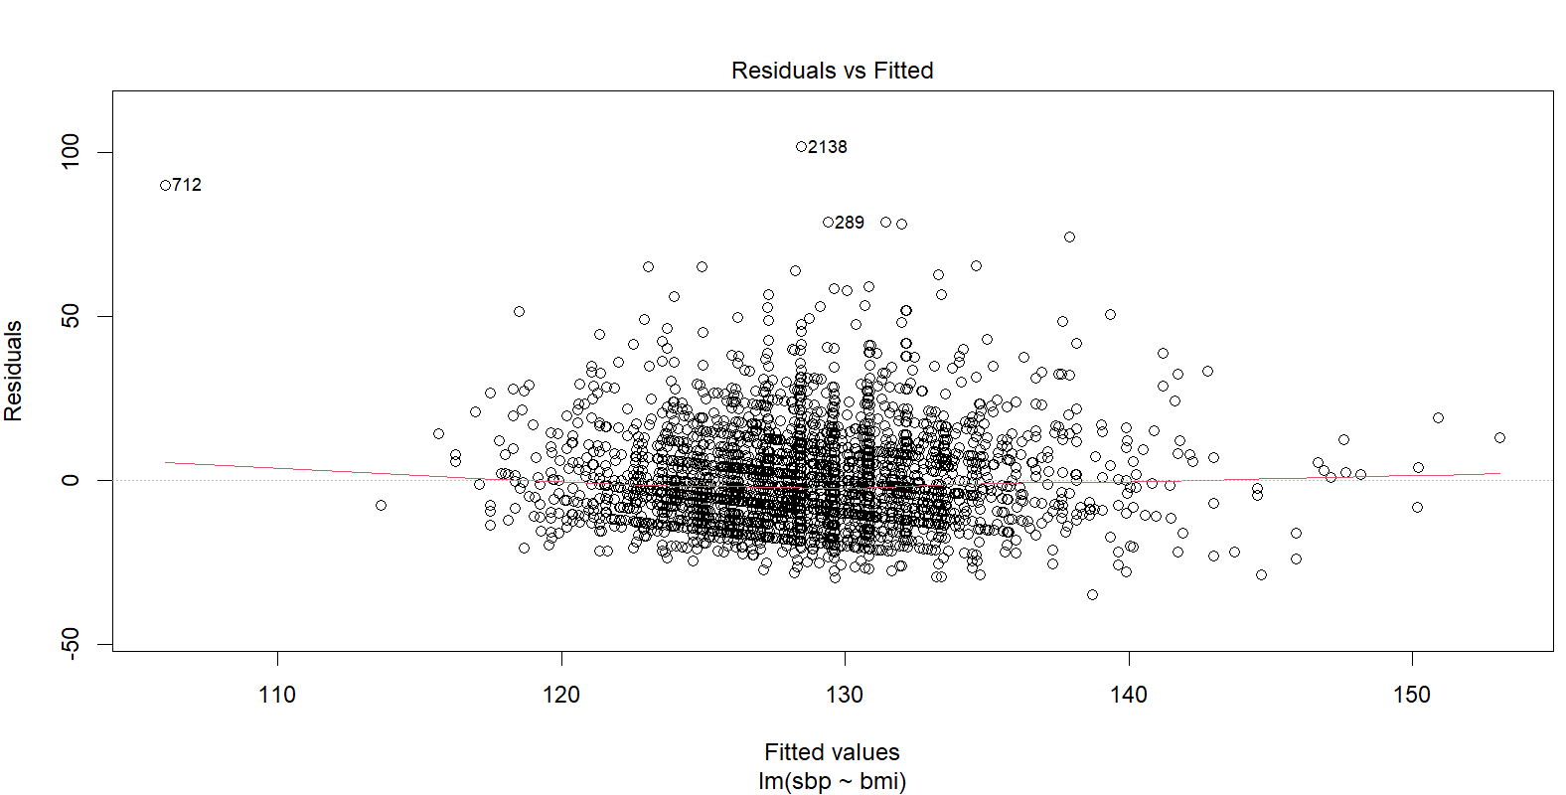

From the residuals vs fitted values plot, there doesn’t seem to be a significant pattern, so the assumption of linearity is met. However, there is an outlier on the left side of the plot that drives up the variance on the left.

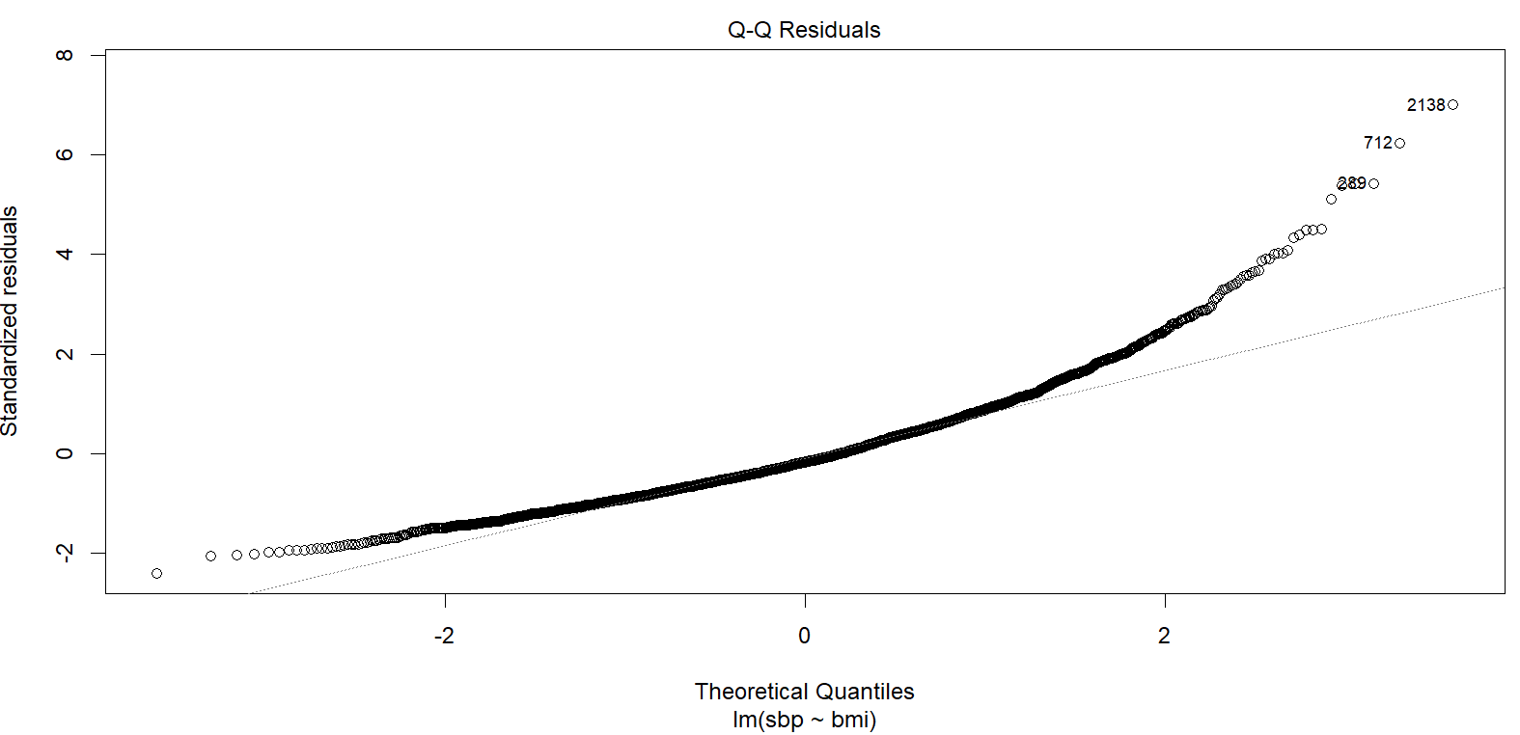

From the QQ plot of the residuals, it seems that the assumption of normality is violated, as there is a lot of deviation from the straight line.

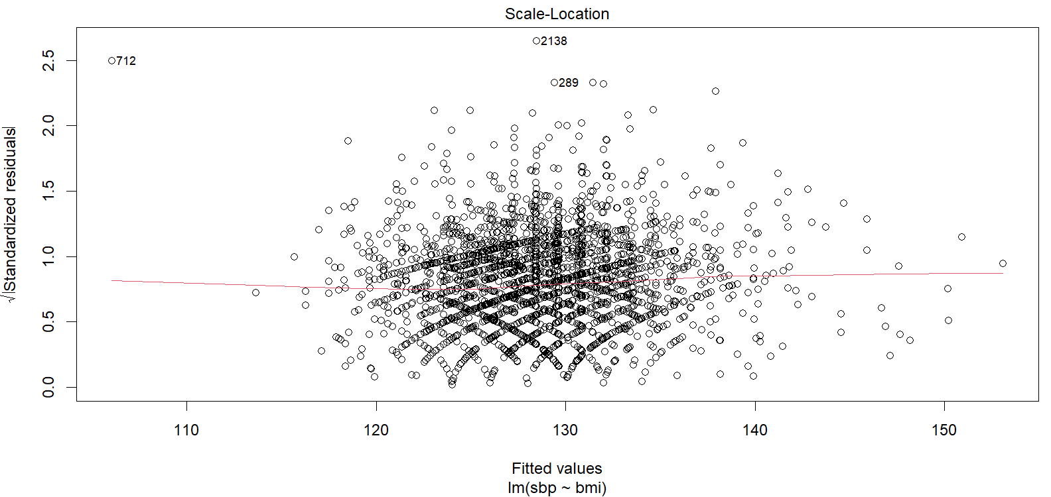

Based on the standardized residuals vs predicted value plot, it appears that the assumption of homoscedasticity is met.

The assumption of independence is met, as individuals in the study are independent of each other.

|  |  |
| --- | --- |
|  | 1b. [1 point] Provide a scatter plot of the relationship between ln(SBP) and BMI. What are your impressions? |

> ggplot(wcgs, aes(y=sbp_log, x=bmi)) +

+ geom_point()

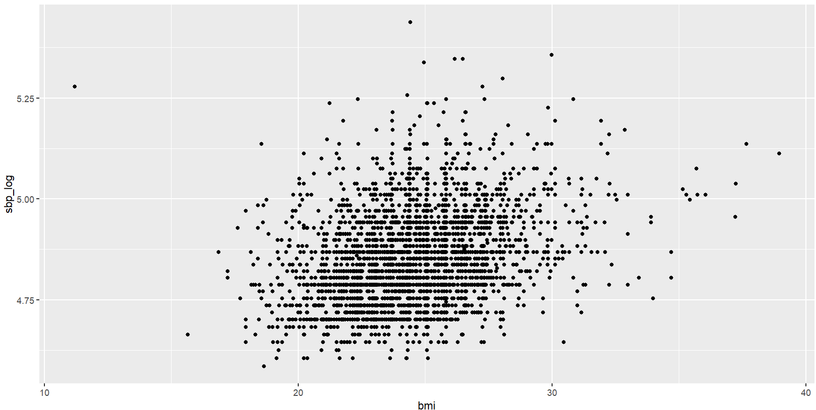

From the scatterplot there does seem to be a very slight relationship between BMI and the natural log of SBP. There is an outlier on the left with a very low BMI of about 11.

|  |  |
| --- | --- |
|  | 1c. [1 point] Provide the theoretical regression equation for the relationship of ln(SBP) regressed on mean-centered BMI. What is the null and alternative hypothesis that would test whether ln(SBP) is associated with BMI? |

The theoretical regression equation for the relationship of ln(SBP) regressed on mean-centered BMI is:

, where X is the mean-centered BMI and Y hat is the predicted ln(SBP)

Null hypothesis: The natural log of SBP is not associated with BMI

Alternative hypothesis: The natural log of SBP is associated with BMI

|  |  |
| --- | --- |
|  | 1d. [1 point] Provide the best-fit linear regression equation for the relationship of ln(SBP) regressed on mean-centered BMI. |

> wcgs <-

+ wcgs %>%

+ mutate(bmi_c = bmi - mean(bmi))

> mod1d <- lm(sbp_log ~ bmi_c, data = wcgs)

> summary(mod1d)

Call:

lm(formula = sbp_log ~ bmi_c, data = wcgs)

Residuals:

Min 1Q Median 3Q Max

-0.28274 -0.07345 -0.01275 0.06153 0.59943

Coefficients:

Estimate Std. Error t value Pr(>|t|)

(Intercept) 4.8504967 0.0019080 2542.24 <2e-16 ***

bmi_c 0.0128913 0.0007432 17.34 <2e-16 ***

---

Signif. codes: 0 ‘***’ 0.001 ‘**’ 0.01 ‘*’ 0.05 ‘.’ 0.1 ‘ ’ 1

Residual standard error: 0.1072 on 3152 degrees of freedom

Multiple R-squared: 0.08713, Adjusted R-squared: 0.08684

F-statistic: 300.8 on 1 and 3152 DF, p-value: < 2.2e-16

The best-fit linear regression equation for the relationship of ln(SBP) regressed on mean-centered BMI is:

|  |  |
| --- | --- |
|  | 1e. [1 point] Provide the test statistic and p-value that test your hypotheses in (1c). |

The test statistic and p-value for testing my hypothesis are 17.34 and p < 2e-16, respectively. These statistics indicate that there is a relationship between BMI and the natural log of SBP.

|  |  |
| --- | --- |
|  | 1f. [1 point] What is the interpretation of in your equation? |

A of 0.0129 in the above equation says that a 1-unit increase in BMI is associated with a 1.29% increase in SBP.

|  |  |
| --- | --- |
|  | 1g. [3 points] Assess each of the assumptions of this linear regression, providing relevant plots and statistics to support your conclusions. |

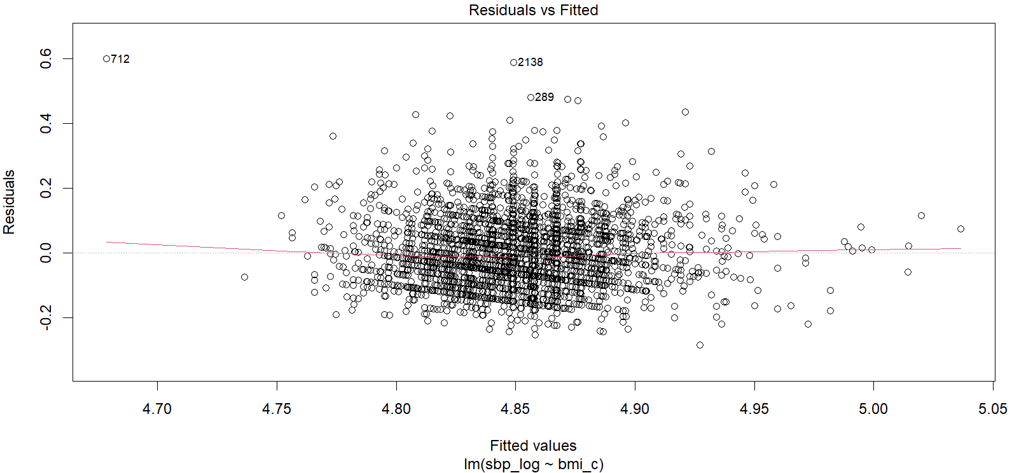

The residual plot shows a relatively flat scatter with a mean of 0, and there doesn’t appear to be a pattern, so the assumption of linearity is met.

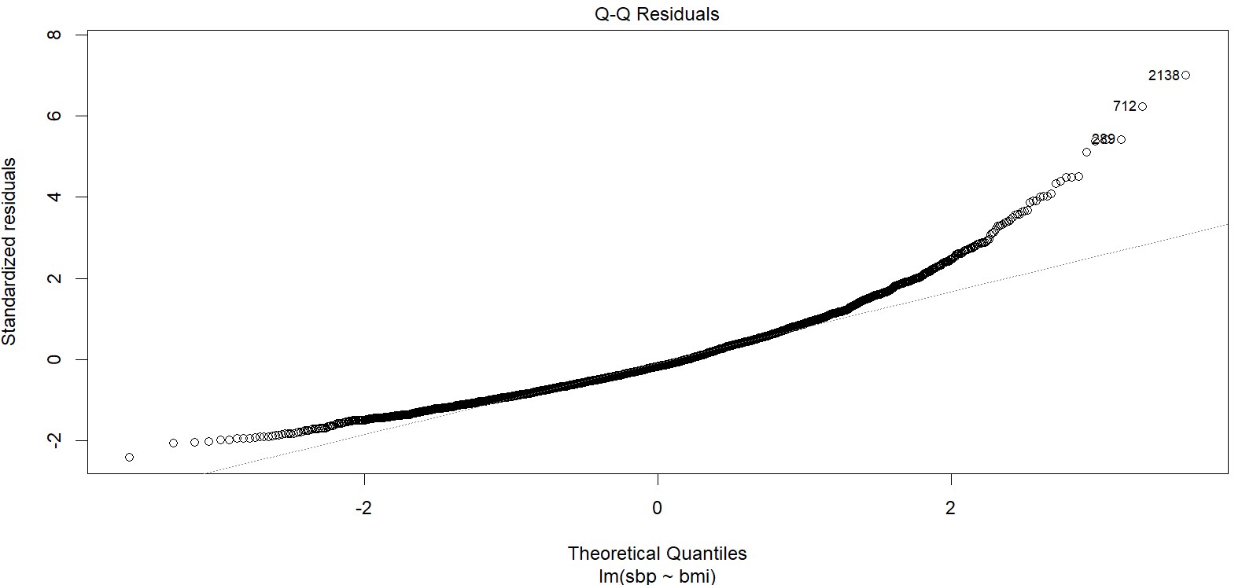

The QQ plot of the residuals shows deviations from the line at the ends, indicating some deviation from normality.

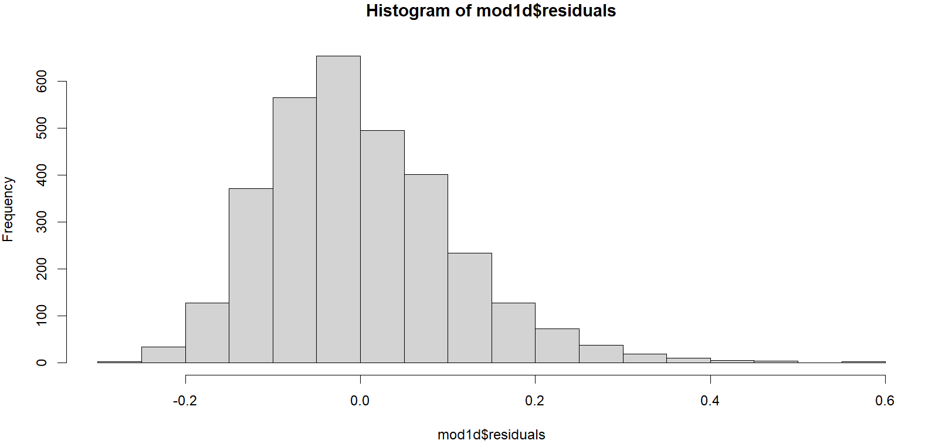

Judging from the histogram of the residuals of the regression model, it appears that the distribution is slightly skewed left. However, since the number of observations is in the thousands, the Central Limit Theorem will make the regression robust to non-normality of the residuals. Therefore, the assumption of normality can be assumed to be met.

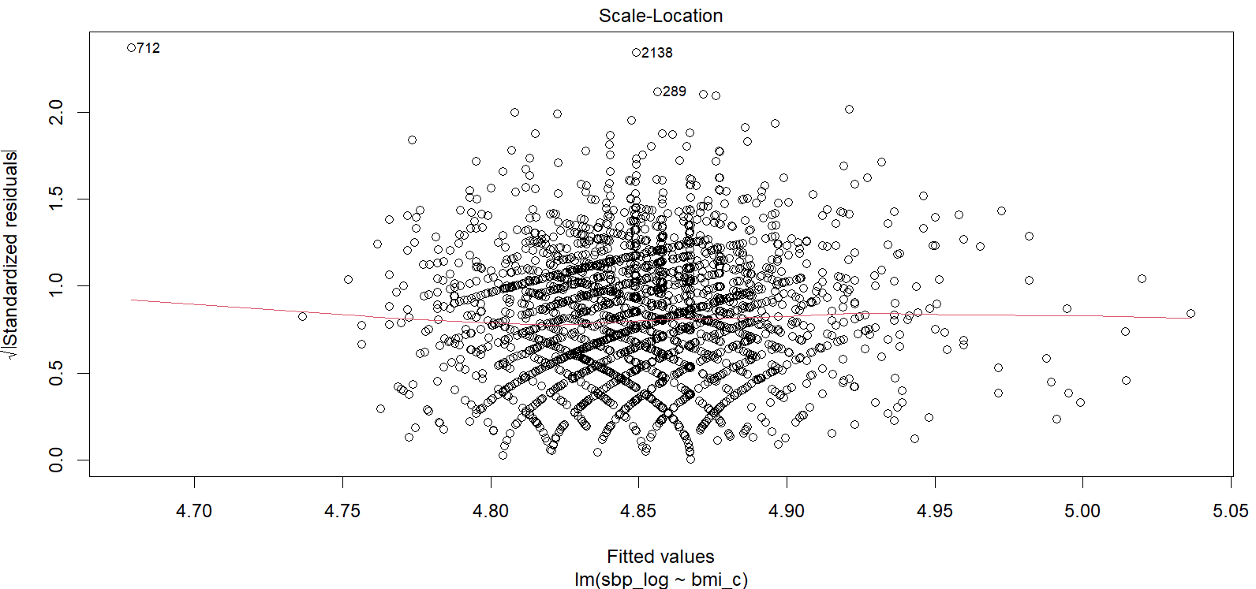

Lastly, the variance of residuals across all values of X look more or less consistent, meeting the assumption of homoscedasticity.

|  |  |  |  |  |  |  |
| --- | --- | --- | --- | --- | --- | --- |
| **Question 2** |  |  |  |  | [9 points] |  |

Continue to use your WCGS file.

|  |  |
| --- | --- |
|  | 2a. [1 point] Create a boxplot of SBP vs. personality type (dibpat). |

> ggplot(wcgs, aes(x=dibpat, y=sbp)) +

+ geom_boxplot() +

+ theme_bw()

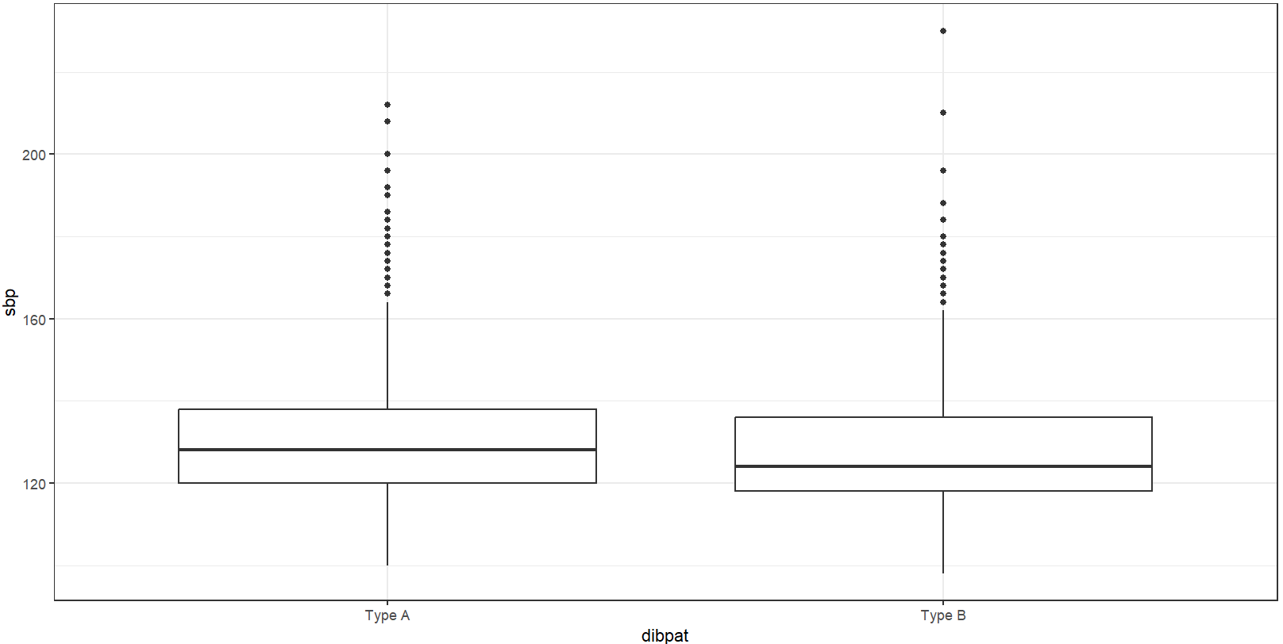

|  |  |
| --- | --- |
|  | 2b. [1 point] Create a scatterplot of SBP vs. personality type, with a linear regression line. |

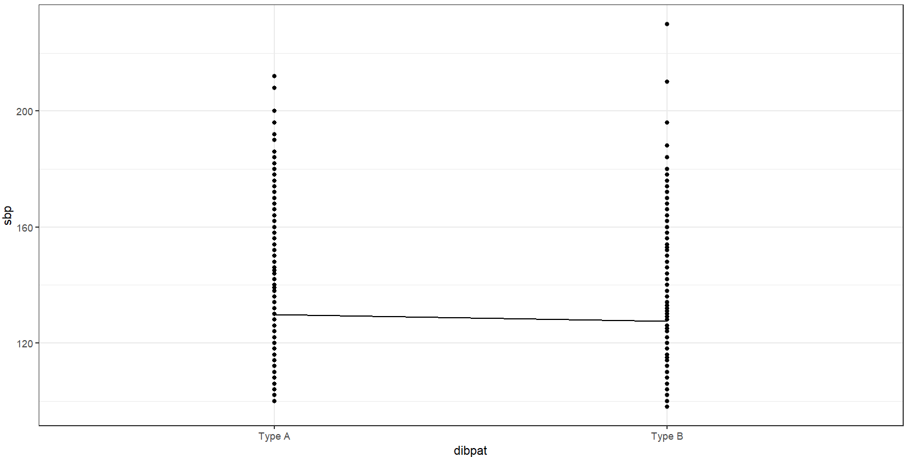

|  |  |
| --- | --- |
|  | 2c. [1 point] Do you prefer using the boxplot or scatterplot to display this relationship? List at least one pro and con of each. |

I personally prefer the boxplots to display the relationship. The boxplots give a better idea of where most points in each dibpat category actually lie, since points are plotted on top of each other in the scatterplot. However, in the scatterplot it is easier to tell the difference in means between the two groups.

|  |  |
| --- | --- |
|  | 2d. [2 points] Regress SBP on personality type. Provide the best-fit regression equation and interpret the values of the intercept and slope in this equation. |

> wcgs$dibpat.f <- as.factor(wcgs$dibpat)

> mod2c <- lm(sbp ~ dibpat.f, data = wcgs)

> summary(mod2c)

Call:

lm(formula = sbp ~ dibpat.f, data = wcgs)

Residuals:

Min 1Q Median 3Q Max

-29.782 -9.782 -1.782 8.455 102.534

Coefficients:

Estimate Std. Error t value Pr(>|t|)

(Intercept) 129.7823 0.3782 343.163 < 2e-16 ***

dibpat.fType B -2.3164 0.5369 -4.315 1.65e-05 ***

---

Signif. codes: 0 ‘***’ 0.001 ‘**’ 0.01 ‘*’ 0.05 ‘.’ 0.1 ‘ ’ 1

Residual standard error: 15.08 on 3152 degrees of freedom

Multiple R-squared: 0.005871, Adjusted R-squared: 0.005556

F-statistic: 18.62 on 1 and 3152 DF, p-value: 1.649e-05

The best-fit linear regression equation for the relationship of SBP regressed on personality type is:

The intercept is the mean SBP value for those of Type A personality. The slope indicates that people with Type B personality have a mean SBP that is -2.32 units lower than the mean of those with Type A personality.

|  |  |
| --- | --- |
|  | 2e. [2 points] Assess each of the assumptions of this linear regression, providing relevant plots and statistics to support your conclusions. |

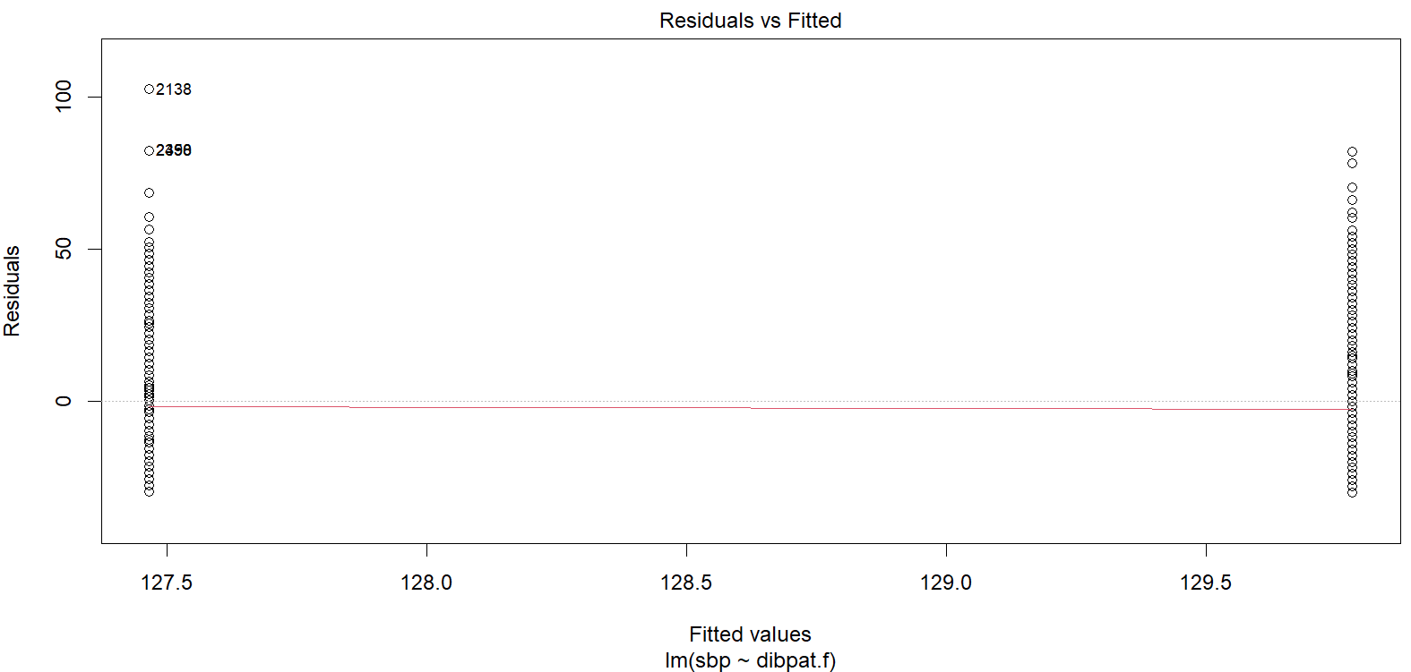

The residual plot has a midline that goes through the mean SBP of both personality types, and they appear to be distributed around the midline the same in both groups. The linearity assumption is met.

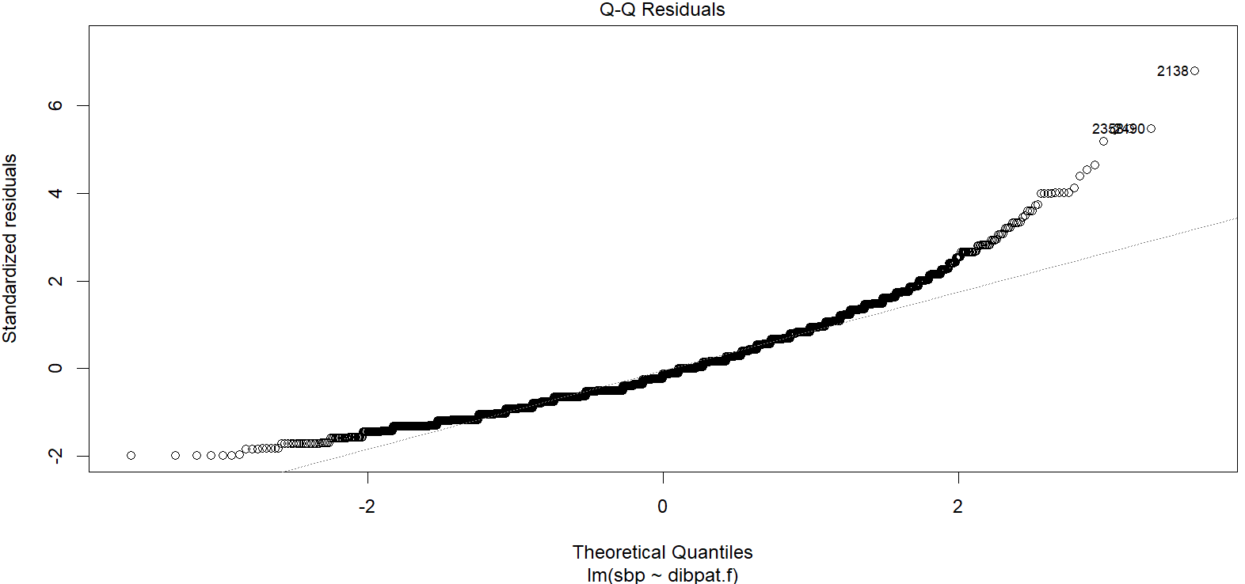

In the QQ plot of the residuals, there seems to be a deviation from the straight line, especially at the higher edge

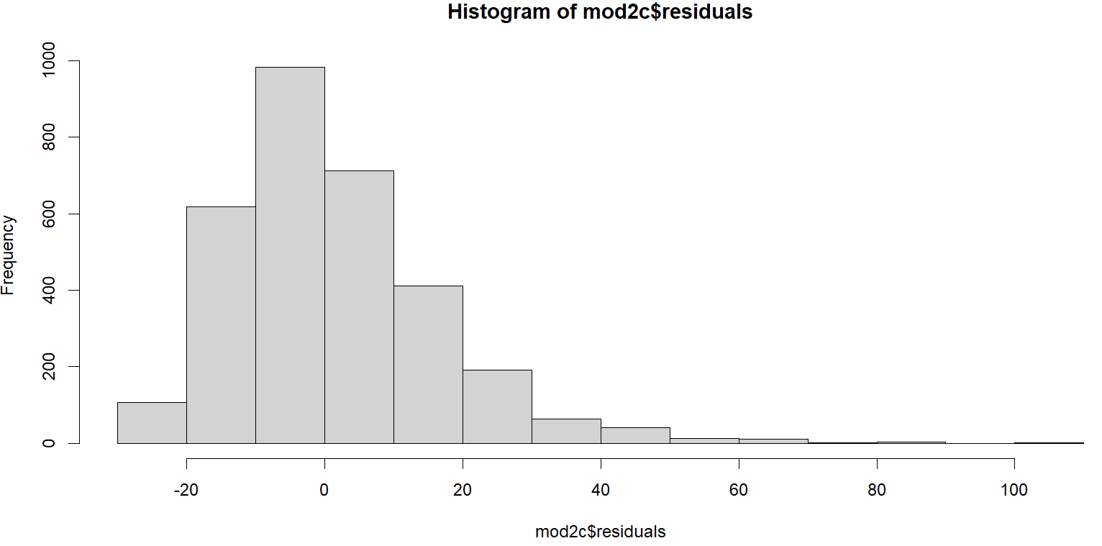

The histogram of the residuals shows a left skew. However, since the number of observations is in the thousands, the Central Limit Theorem will make the regression robust to non-normality of the residuals. Therefore, the assumption of normality can be assumed to be met.

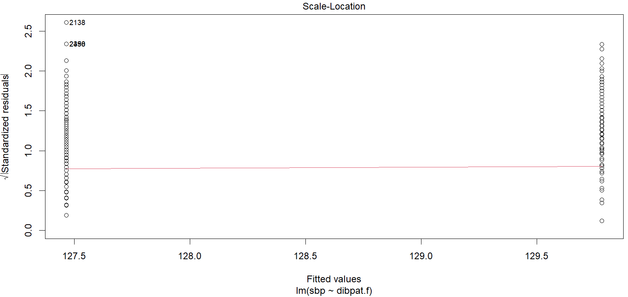

Lastly, the variance of residuals appears to be the same for both personality types, the assumption of homoscedasticity is met.

|  |  |
| --- | --- |
|  | 2f. [2 points] Is this regression method equivalent to 1) a two-sample t-test assuming equal but unknown variance or 2) a two-sample t-test assuming unequal but unknown variance? Explain why, and provide your output comparing the regression results to the appropriate t-test. |

This regression method is equivalent to a two-sample t-test assuming equal but unknown variance because in order for the regression to be valid, it has to meet the assumption of homoscedasticity, which means that the variance of Y should be consistent for all (or in this case both) values of X.

Two-sample t-test assuming equal but unknown variance:

> t.test(sbp ~ dibpat.f, data = wcgs)

Welch Two Sample t-test

data: sbp by dibpat.f

t = 4.3173, df = 3137.2, p-value = 1.629e-05

alternative hypothesis: true difference in means between group Type A and group Type B is not equal to 0

95 percent confidence interval:

1.264410 3.368466

sample estimates:

mean in group Type A mean in group Type B

129.7823 127.4658

Linear regression

> mod2c <- lm(sbp ~ dibpat.f, data = wcgs)

> summary(mod2c)

Call:

lm(formula = sbp ~ dibpat.f, data = wcgs)

Residuals:

Min 1Q Median 3Q Max

-29.782 -9.782 -1.782 8.455 102.534

Coefficients:

Estimate Std. Error t value Pr(>|t|)

(Intercept) 129.7823 0.3782 343.163 < 2e-16 ***

dibpat.fType B -2.3164 0.5369 -4.315 1.65e-05 ***

---

Signif. codes: 0 ‘***’ 0.001 ‘**’ 0.01 ‘*’ 0.05 ‘.’ 0.1 ‘ ’ 1

Residual standard error: 15.08 on 3152 degrees of freedom

Multiple R-squared: 0.005871, Adjusted R-squared: 0.005556

F-statistic: 18.62 on 1 and 3152 DF, p-value: 1.649e-05

The p-values are the same in both tests: 1.65e-05

The mean for Type A is the same as the regression intercept: 129.78

The absolute values of the test statistic are the same in both tests: 4.315

|  |  |  |  |  |  |  |
| --- | --- | --- | --- | --- | --- | --- |
| **Question 3** |  |  |  |  | [10 points] |  |

Continue to use your WCGS file. In this question we will look at a different way that we can examine the relationship between BMI and SBP.

Whenever we categorize a continuous variable, some information always gets lost. However, in some cases categorizing a continuous variable can help satisfy some regression assumptions. In other cases, a variable’s categorical value may be the only information recorded in the data set.

In this question we will gain practice examining a categorical predictor.

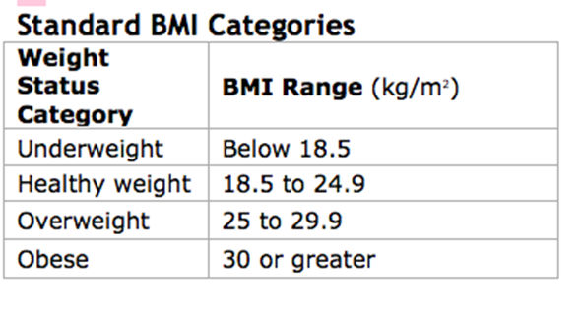

|  |  |
| --- | --- |
|  | 3a. [1 point] Categorize BMI using the cut point criteria defined above, and provide the number of individuals that fall into each category. |

> wcgs <-

+ wcgs %>%

+ mutate(bmi_cat = cut(bmi,

+ breaks = c(-Inf, 18.5, 25, 30, Inf),

+ labels = c("Underweight", "Healthy weight", "Overweight", "Obsese"),

+ right = F, include.lowest = F))

> table(wcgs$bmi_cat)

Underweight Healthy weight Overweight Obsese

23 1833 1217 81

|  |  |
| --- | --- |
|  | 3b. [2 points] Define a set of dummy variables that are sufficient to describe these four categories. Make healthy weight the reference group. |

> wcgs$bmi_cat <- relevel(wcgs$bmi_cat, ref = "Healthy weight")

|  |  |
| --- | --- |
|  | 3c. [2 points] Using notation and the variables you defined in 3b, write the theoretical regression equation for the regression of SBP on BMI. State the null and alternative hypotheses that would test if BMI category is related to SBP. |

: BMI category is not related to SBP

: BMI category is related to SBP

|  |  |
| --- | --- |
|  | 3d. [2 points] Write your best-fit regression equation and interpret the intercept and slope values. |

The intercept of 125.98 is the mean SBP for individuals that are of healthy weight.

The slope for the underweight category (-0.77) can be interpreted to say that the mean SBP for underweight individuals is -0.77 units lower than the mean SBP for healthy weight individuals.

The slope for the overweight category (5.85) can be interpreted to say that the mean SBP for overweight individuals is 5.85 units higher than the mean SBP for healthy weight individuals.

The slope for the obese category (15.55) can be interpreted to say that the mean SBP for obese individuals is 15.55 units higher than the mean SBP for healthy weight individuals.

|  |  |
| --- | --- |
|  | 3e. [2 points] What are your decisions for the hypotheses in 3c? Provide the test statistic and p-value. |

> summary(mod3d)

Call:

lm(formula = sbp ~ bmi_cat, data = wcgs)

Residuals:

Min 1Q Median 3Q Max

-37.531 -9.983 -1.983 8.017 104.017

Coefficients:

Estimate Std. Error t value Pr(>|t|)

(Intercept) 125.9825 0.3436 366.692 <2e-16 ***

bmi_catUnderweight -0.7652 3.0863 -0.248 0.804

bmi_catOverweight 5.8482 0.5439 10.752 <2e-16 ***

bmi_catObsese 15.5483 1.6701 9.310 <2e-16 ***

---

Signif. codes: 0 ‘***’ 0.001 ‘**’ 0.01 ‘*’ 0.05 ‘.’ 0.1 ‘ ’ 1

Residual standard error: 14.71 on 3150 degrees of freedom

Multiple R-squared: 0.05421, Adjusted R-squared: 0.05331

F-statistic: 60.18 on 3 and 3150 DF, p-value: < 2.2e-16

The F-test tests whether BMI overall is associated with SBP. The test-statistic and p-value are 60.18 (on 3 and 3150 degrees of freedom) and 2.2e-16, respectively. The low p-value (<< 0.01) suggests there is enough evidence to reject the null hypothesis and accept the alternative hypothesis that BMI is associated with SBP.

|  |  |
| --- | --- |
|  | 3f. [1 point] Which BMI categories have mean SBP values that are significantly different from the “healthy weight” mean SBP value? |

It appears that the BMI categories “Overweight” and “Obese” have mean SBP values that are significantly different from the “healthy weight” mean SBP value, both with p-values < 2e-16. On the other hand, the “underweight” category has a mean SBP value that is not significantly different from the “healthy weight” mean SBP value.