User Guide
Consentio PM
Version 1.0 — June 2026
Internal use only

1. Introduction
Consentio PM is Consentio’s internal project management tool. It is organized into two distinct spaces, accessible from the left sidebar:
- Consentio Implementation: tracking client implementation projects (onboarding, deployment, etc.)
- Consentio Flywheel: tracking supplier activation waves

User roles
Role | Permissions
Administrator | Full access to all features, user and tag management, project/wave deletion
Manager | Create and edit projects/waves, manage templates, access all data
Member | View all projects, edit assigned tasks, manage suppliers in Flywheel

2. General Navigation

Switching spaces
A selector in the top-left of the sidebar allows switching between the Implementation and Flywheel spaces.

The sidebar
- Dashboard: overview of current activity
- My Tasks: all tasks assigned to you
- All Projects: full list of projects or waves
- Templates: reusable template library
- Active projects or waves appear directly in the sidebar for quick access
At the bottom of the sidebar, a Global section (visible to Admins only) gives access to Administration.

3. Implementation Space

3.1 Dashboard
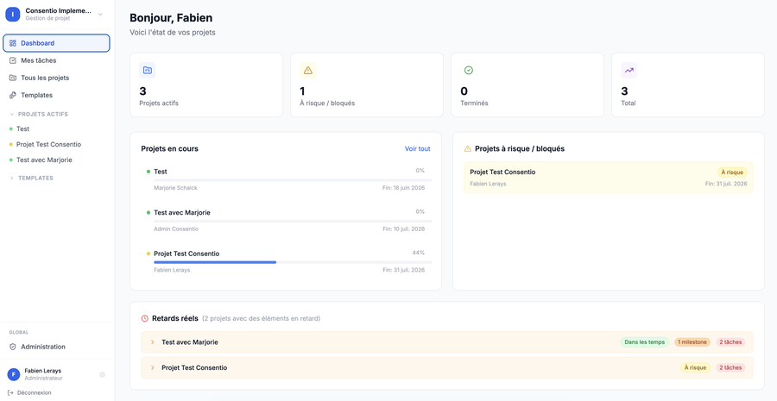
The Implementation space Dashboard
The dashboard provides an overview of current activity:
- Key indicators: number of active projects, overdue tasks, tasks due today
- Quick preview of projects and their progress
- "Projects at risk / blocked" panel on the right

3.2 My Tasks
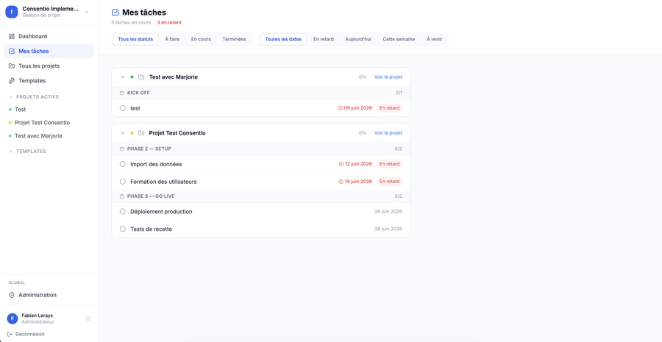
"My Tasks" page with status filters and overdue badges
This page lists all tasks personally assigned to you, grouped by project and milestone.
Available features:
- Status filters: To Do / In Progress / Done
- Date filters: Overdue / Today / This Week / Upcoming
- Visual badges: overdue tasks appear in red, tasks due today in orange
- Quick status change: click the circle icon to the left of the task name (To Do → In Progress → Done)
- Open task detail: click the task name to open the full panel

3.3 Project List
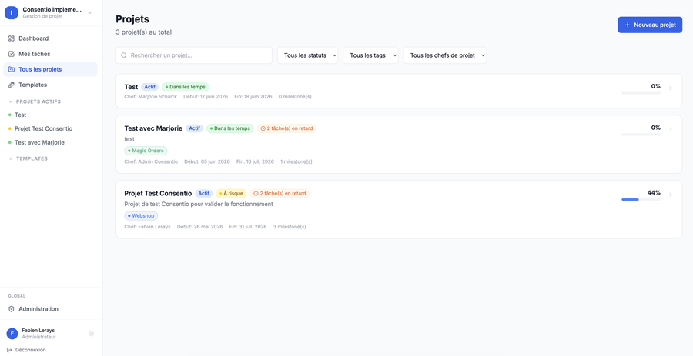
Project list with status, tag, and project manager filters
Accessible via “All Projects” in the sidebar.
Available filters:
- Search by name
- Filter by status (Active, Completed, On Hold, Cancelled)
- Filter by tag
- Filter by project manager
Each project card shows: name, status, health status (on track / at risk / overdue / blocked), associated tags, project manager, dates, and overall progress.
💡 Tip Click “New Project” (blue button, top right) to create a project from a template or from scratch.

3.4 Project Detail
When you click on a project, you access its detail page with four tabs:

Summary tab
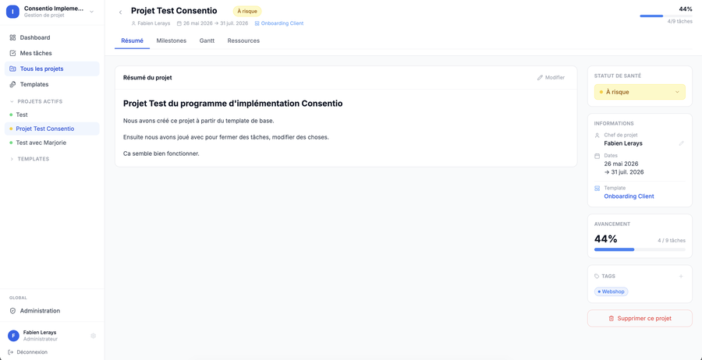
Project Summary tab with the right-hand sidebar
- Editable title: click directly on the project name in the header to edit it
- Rich summary: rich text area (headings, lists, bold, italic…) to describe project status
- Right sidebar:
  - Health status: editable via a dropdown (On Track / At Risk / Overdue / Blocked / Cancelled / Completed)
  - Project manager: editable via the pencil icon
  - Project dates
  - Template used
  - Overall progress (% of tasks completed)
  - Tags: add and remove tags via a picker
  - "Delete this project" button: at the bottom, with mandatory confirmation before permanent deletion

Milestones tab
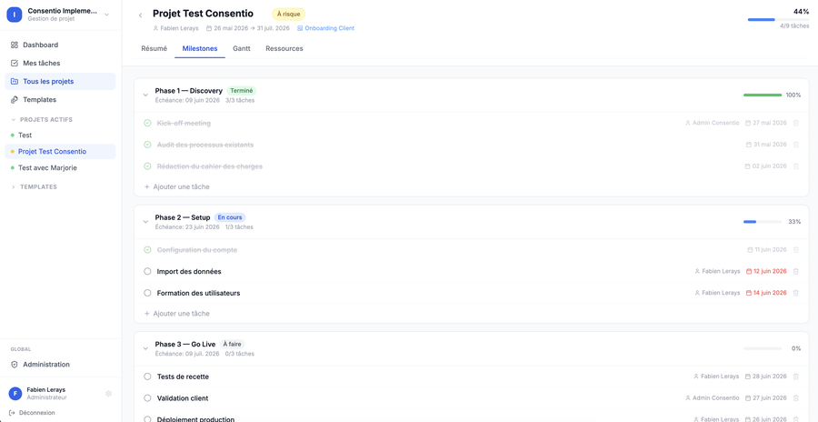
Milestones tab showing phase progress
View of all milestones and their associated tasks.
- Add a milestone: “+” button at the bottom of the list
- Add a task to an existing milestone: “+” button on the milestone row
- Change task status: click the circle icon to the left of the name (To Do → In Progress → Done)
- Open task detail: click the name to open the side panel
- Delete a task: trash icon visible on hover
⚠️ Note When all tasks in a milestone are completed, the milestone automatically switches to “Done”.

Gantt tab
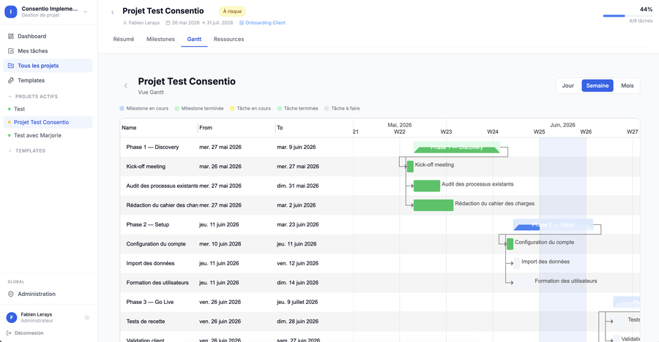
Gantt chart with Day/Week/Month selector
Planning visualization as a Gantt chart.
- View selector: Day / Week / Month (buttons, top right)
- Milestones appear in blue, tasks in grey/yellow/green depending on status
- The red vertical line indicates today’s date

Resources tab
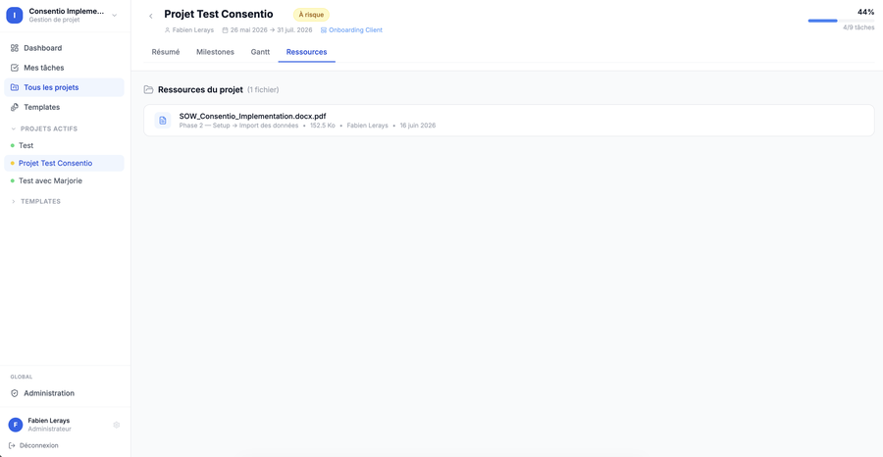
Project Resources tab
View of human resources associated with the project.

3.5 Task Detail Panel
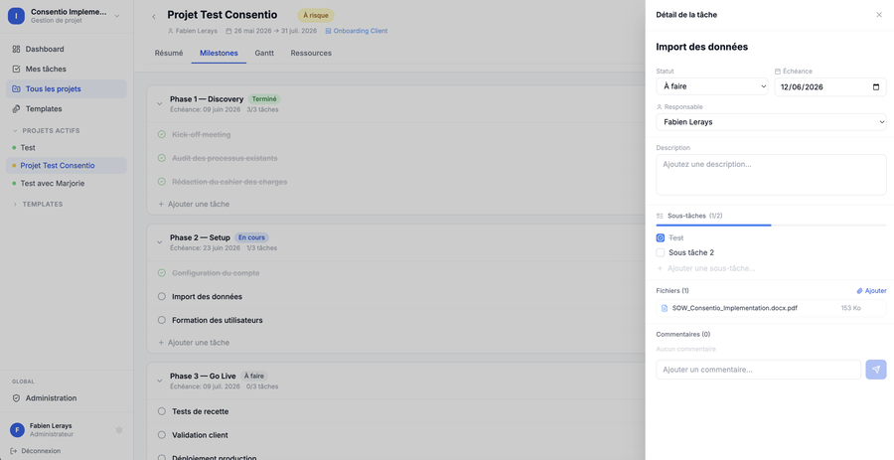
Side panel with sub-tasks, files, and comments
Clicking a task name opens a panel on the right side of the screen.
Available fields:
- Name: editable directly, auto-saved when you click away
- Status: dropdown (To Do / In Progress / Done)
- Due date: date picker
- Assignee: dropdown with all team members
- Description: free text area
- Sub-tasks: see dedicated section below
- Files: downloadable attachments
- Comments: discussion thread

Sub-tasks
The Sub-tasks section lets you break a task into smaller steps.
- Add a sub-task: type in the “Add a sub-task…” field and press Enter (or click “Add”)
- Check a sub-task: click the checkbox — the text is struck through and progress updates
- Delete a sub-task: hover the row to reveal the trash icon
- The progress bar at the top of the section shows the ratio of checked / total sub-tasks

File attachments
- Add a file: click “Add” next to “Files”
- Download: download icon visible on hover for each file
- Delete: trash icon visible on hover

Comments
- Type your message in the field at the bottom and press Send
- Each comment shows the author and date
- Admins can delete any comment; other members can only delete their own

3.6 Templates (Implementation)
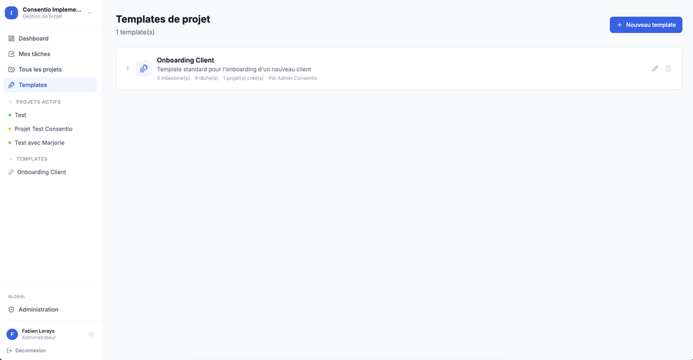
Project template library
Templates allow creating reusable project structures (predefined milestones and tasks).
- Create a template: “New Template” button
- Edit a template: pencil icon on the template card
- Delete: trash icon (not available for the default template)
- A template can be set as default (star ⭐) — it is pre-selected when creating a project

4. Flywheel Space
The Flywheel space is dedicated to tracking supplier activation waves. It works very similarly to the Implementation space, with a few specific features.

4.1 Flywheel Dashboard
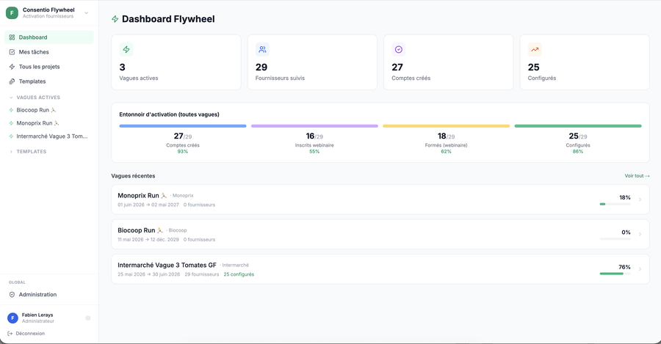
Flywheel Dashboard with activation funnel
Overview of current Flywheel activity: active waves count, suppliers tracked, accounts created, configured suppliers. Includes an activation funnel showing progress across all waves.

4.2 My Tasks (Flywheel)
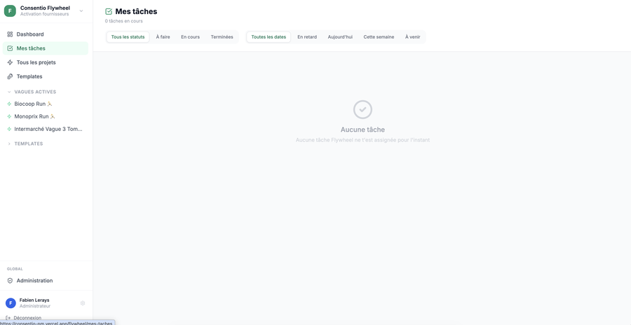
"My Tasks" page in the Flywheel space
Same as the Implementation space: all your assigned tasks, grouped by wave then by milestone, with the same filters and visual badges.

4.3 Wave List ("All Projects")
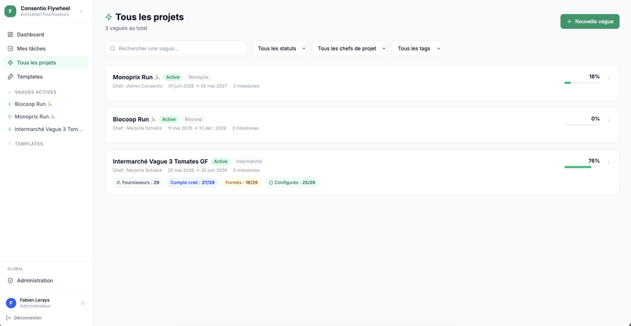
Wave list with supplier KPIs
Available filters:
- Search bar (wave name or client name)
- Filter by status (Active, Completed, On Hold, Cancelled)
- Filter by project manager
- Filter by tag
Each wave card shows: name, client, status, tags, project manager, dates, supplier KPIs (accounts created, trained, configured) and overall progress.

4.4 Wave Detail

Summary tab
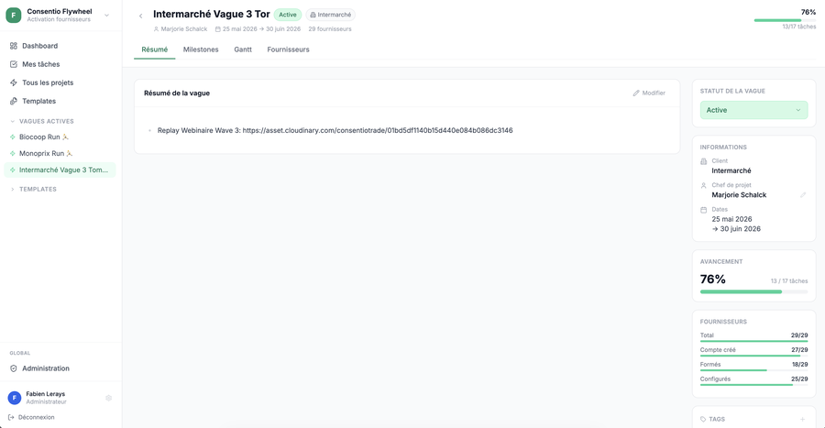
Wave summary with supplier KPIs sidebar
- Editable title: click the name in the header
- Rich summary of the wave
- Right sidebar:
  - Wave status (Active / Completed / On Hold / Cancelled)
  - Project manager: editable via the pencil icon
  - Client and dates
  - Overall progress
  - Supplier KPIs (accounts created, trained, configured) with progress bars
  - Tags: add and remove
  - "Delete this wave" button with confirmation

Milestones tab
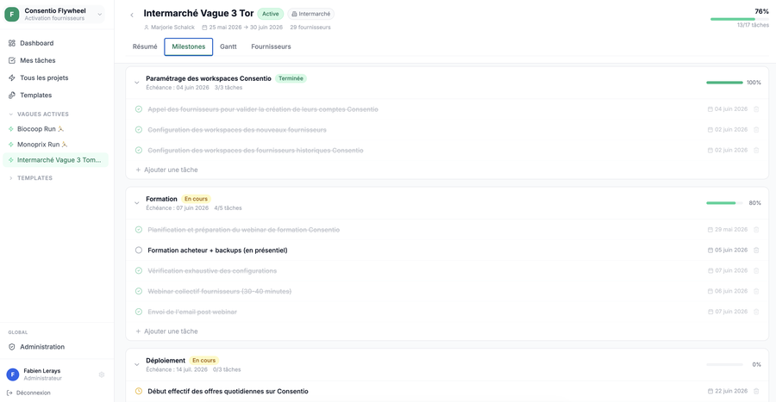
Flywheel wave milestones
Same as the Implementation Milestones tab. The task panel opens by clicking on a task name.

Gantt tab
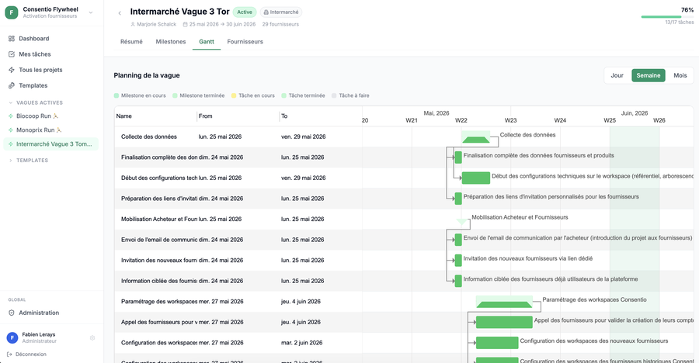
Wave Gantt chart in green theme
Same as the Implementation Gantt, with an emerald green theme.

Suppliers tab
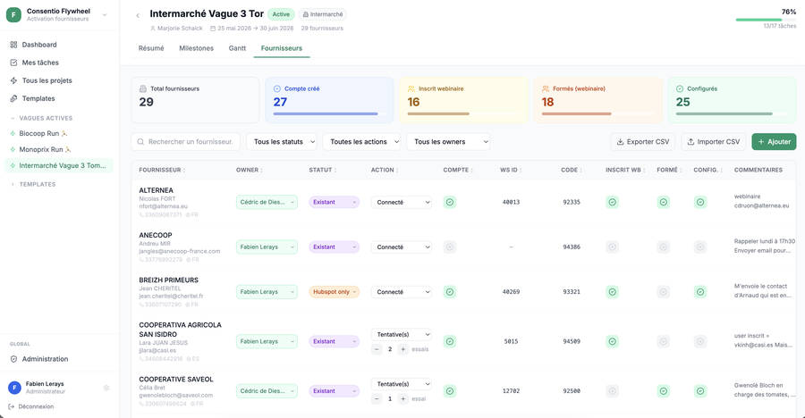
Supplier tracking table
Full supplier tracking table for the wave.
Table columns:
Column | Description
Supplier | Name, contact (first/last name), email, phone, language
Owner | Team member responsible for this supplier
Status | New / Already has WS / Existing / Hubspot only
Action | To Contact / OK-No Need / Connected / Attempt(s)
Account | Consentio account created? (checkbox)
WS ID | Workspace identifier (editable)
Code | Supplier code (editable)
Reg. WB | Registered for webinar? (checkbox)
Trained | Attended webinar? (checkbox)
Config. | Configured? (checkbox)
Comments | Free notes (click to edit)

Attempt counter: when the “Attempt(s)” action is selected, − and + buttons appear to record the number of call attempts.
Table features:
- Sort: click any column header to sort ascending or descending (↑/↓)
- Filters: status, action, owner (in addition to the main search)
- WS ID and Code editable: click the field in the cell to edit, auto-saved
- Edit a supplier: pencil icon → opens a modal with all fields
- Delete a supplier: trash icon (Manager/Admin only)
- Add a supplier: “Add” button (Manager/Admin)
- Import from CSV: “Import CSV” button — supported columns: SUPPLIER_NAME, SUPPLIER_CODE, USER_EMAIL, USER_FIRST_NAME, USER_LAST_NAME, SUPPLIER_PHONE_NB, LANGUAGE (Manager/Admin)
- Export to CSV: “Export CSV” button — exports the current filtered view with all columns
⚠️ Note Members can edit supplier information (status, action, owner, comments…) but cannot add, import, or delete suppliers.

4.5 Templates (Flywheel)
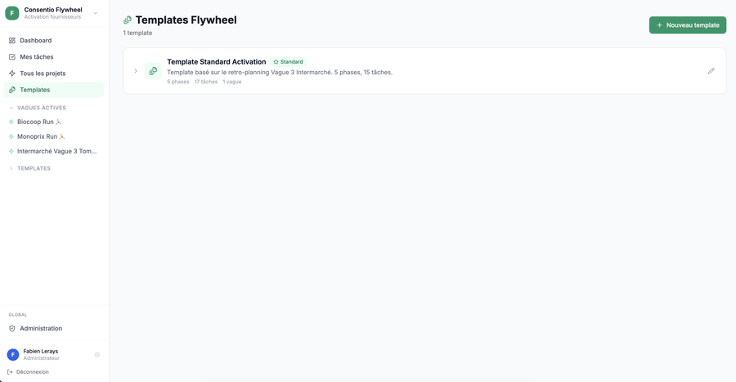
Flywheel template library
Same as the Implementation templates.

5. Administration (Admins only)
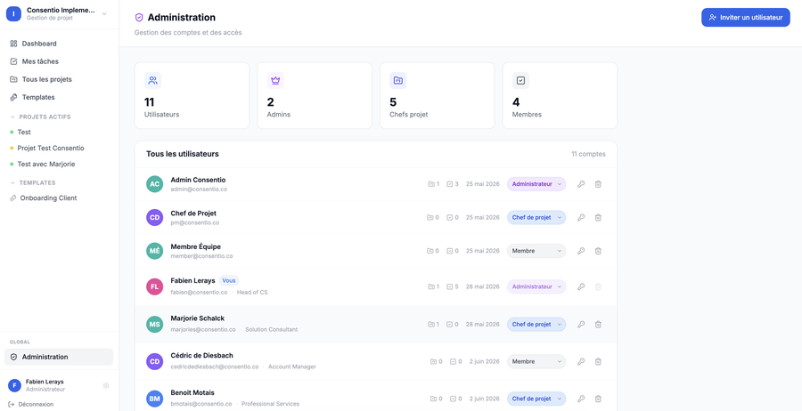
Administration page — user list
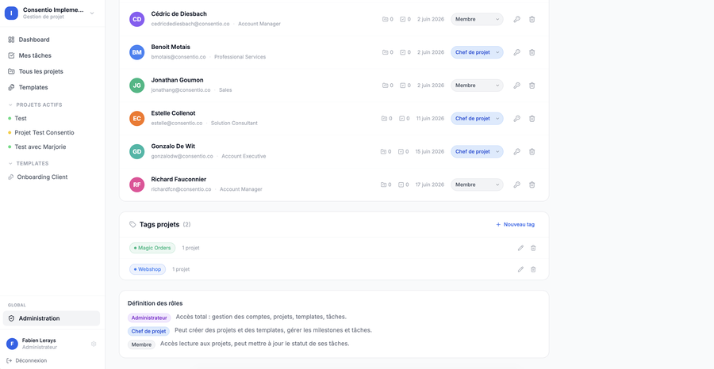
Tags and role definitions
Accessible from the “Global” section at the bottom of the sidebar.

User management
- View all members: list with name, email, role, and creation date
- Add a user: “Invite User” button — fill in name, email, temporary password, and role
- Change role: selector on each row
- Reset password: dedicated button to generate a new temporary password
- Delete a user: trash icon

Tag management
Tags are shared between both spaces (Implementation and Flywheel).
- Create a tag: name + custom color
- Edit / Delete an existing tag

6. Common Features
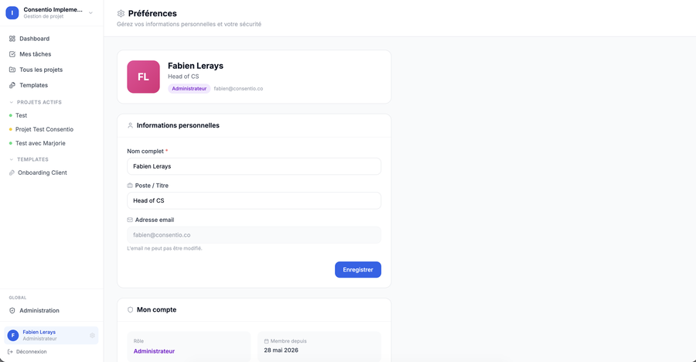
User profile / Preferences page

Profile / Preferences
Click your name at the bottom of the sidebar to access your profile and update your name or password.

Sign out
“Sign out” button at the bottom of the sidebar.

General permission rules
- Admins: can do everything
- Managers: can create, edit, and delete projects/waves and manage templates — cannot manage users
- Members: can view everything, edit assigned tasks, and manage Flywheel suppliers (except adding/deleting)

Guide generated June 2026
Consentio PM — Internal use

