ИУ7-63Б, Авдейкина Валерия
Лаб. работа /proc (версия булочной с однопоточным сервером)
Время обслуживания клиента сервером в случае однопоточной версии программы измеряется на стороне клиента. Пример работы программы представлен на рисунке 1 (клиент 3 обслужился раньше, чем 1 и 2, так как они опоздали; аналогично с клиентом 7 – клиент 6 опоздал).
Листинг 1: Содержимое файла bakery.x
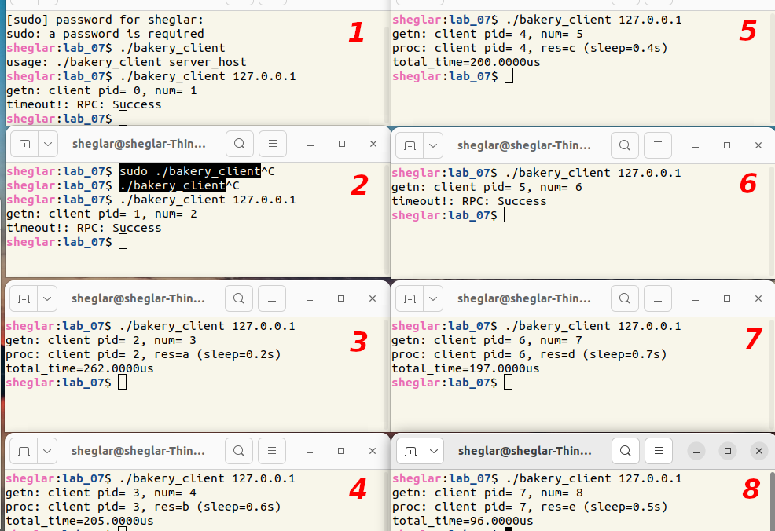Рисунок 1: Пример работы программы
1  2  3  4  5  6  7  8  9  10  11  12  13  14  15  16  17  18  19  20 | /*  * filename: bakery.x  * function: Define constants, non-standard data types and the calling  * process in remote calls  */  struct BAKERY  {  int num;  int pid;  int res;  };  program BAKERY_PROG  {  version BAKERY_VER  {  struct BAKERY GETN(struct BAKERY) = 1;  struct BAKERY WAIT(struct BAKERY) = 2;  struct BAKERY PROC(struct BAKERY) = 3;  } = 1; /* Version number = 1 */  } = 0x20000001; /* RPC program number */

Листинг 2: Исходный код сервера (файл bakery_server.c)
1  2  3  4  5  6  7  8  9  10  11  12  13  14  15  16  17  18  19  20  21  22  23  24  25  26  27  28  29  30  31  32  33  34  35  36  37  38  39  40  41  42  43  44  45  46  47  48  49  50  51  52  53  54  55  56  57  58  59  60  61  62  63  64  65  66  67  68  69  70  71  72  73  74  75  76  77  78  79  80  81  82  83  84  85  86  87  88  89  90  91  92  93  94  95  96  97  98  99 | /*  * This is sample code generated by rpcgen.  * These are only templates and you can use them  * as a guideline for developing your own functions.  */  #define _GNU_SOURCE  #define MAX_CLIENT 40  #include <stdio.h>  #include <pthread.h>  #include <stdlib.h>  #include <time.h>  #include <unistd.h>  #include <stdbool.h>  #include "bakery.h"  #define MY_TIMEOUT_SEC 1  struct thread_arg  {  int pid;  int num;  int res;  };  bool choosing[MAX_CLIENT] = { 0 };  int number[MAX_CLIENT] = { 0 };  int curr_res = 'a';  int local_pid = 0;  int last_num = 0;  // получение номера  struct BAKERY *  getn_1_svc(struct BAKERY *argp, struct svc_req *rqstp)  {  static struct BAKERY result;  int i = local_pid;  local_pid++;  choosing[i] = true;  int max_n = 0;  for (int j = 0; j < MAX_CLIENT; j++)  if (number[j] > max_n)  max_n = number[j];  number[i] = max_n + 1;  result.pid = i;  result.num = number[i];  choosing[i] = false;  return &result;  }  // обслуживание (булочная)  struct BAKERY *  wait_1_svc(struct BAKERY *argp, struct svc_req *rqstp)  {  static struct BAKERY result;  int i = argp->pid;  result.pid = i;  result.num = argp->num;  time_t start, end;  for (int j = 0; j < MAX_CLIENT; j++)  {  while (choosing[j]);  /* Если клиент опоздал, то есть его номер меньше,  чем номер последнего обслуженного, выполняется  отказ в обслуживании */  if (last_num > number[i]) {  number[i] = 0;  result.res = '0';  return &result;  }  /* Если время ожидания превысило MY_TIMEOUT_SEC,  значит, клиенты с меньшим номером опоздали */  start = clock();  while ((number[j] > 0) && (number[j] < number[i] ||  (number[j] == number[i] && j < i)))  {  end = clock();  if ((end - start) / CLOCKS_PER_SEC > MY_TIMEOUT_SEC)  break;  }  }  result.res = curr_res;  curr_res++;  last_num = number[i];  number[i] = 0;  /* Если нет клиентов, ожидающих обслуживания,  сбрасывается номер последнего обслуженного  клиента */  for (int j = 0; j < MAX_CLIENT; j++)  if (number[j] > 0)  return &result;  last_num = 0;  return &result;  }  // не используется в однопоточной версии  struct BAKERY *  proc_1_svc(struct BAKERY *argp, struct svc_req *rqstp)  {  return NULL;  }

Листинг 3: Исходный код клиента (файл bakery_client.c)
1  2  3  4  5  6  7  8  9  10  11  12  13  14  15  16  17  18  19  20  21  22  23  24  25  26  27  28  29  30  31  32  33  34  35  36  37  38  39  40  41  42  43  44  45  46  47  48  49  50  51  52  53  54  55  56  57  58  59  60  61  62  63  64  65  66  67  68  69  70  71  72  73  74  75 | /*  * This is sample code generated by rpcgen.  * These are only templates and you can use them  * as a guideline for developing your own functions.  */  #include <stdio.h>  #include <stdlib.h>  #include <unistd.h>  #include <time.h>  #include "bakery.h"  void  bakery_prog_1(char *host)  {  CLIENT *clnt;  struct BAKERY *result_1;  struct BAKERY getn_1_arg;  struct BAKERY *result_2;  struct BAKERY proc_1_arg;  struct BAKERY *result_3;  struct BAKERY wait_1_arg;  time_t time_numb, time_wait, time_serv;  clnt = clnt_create (host, BAKERY_PROG, BAKERY_VER, "udp");  if (clnt == NULL) {  clnt_pcreateerror (host);  exit (1);  }  srand(time(NULL));  double sleep_time = (double)rand() / RAND_MAX * 1000000 * 1.5;  usleep(sleep_time);  time_numb = clock();  result_1 = getn_1(&getn_1_arg, clnt);  if (result_1 == (struct BAKERY *) NULL) {  clnt_perror (clnt, "call failed");  }  time_numb = clock() - time_numb;  printf("getn: client pid=%2d, num=%2d\n", result_1->pid, result_1→num);  wait_1_arg.num = result_1->num;  wait_1_arg.pid = result_1->pid;  sleep(rand() % 7 + 5);  time_wait = clock();  result_2 = wait_1(&wait_1_arg, clnt);  if (result_2->res == '0') {  clnt_perror (clnt, "timeout!");  clnt_destroy (clnt);  exit (1);  }  time_wait = clock() - time_wait;  time_serv = 0;  double t = (double) (time_numb + time_wait + time_serv) * 1000000 / CLOCKS_PER_SEC;  printf("proc: client pid=%2d, res=%c (sleep=%.1fs)\ntotal_time=%.4fus\n", result_2->pid, result_2->res, sleep_time / 1000000, t);  clnt_destroy (clnt);  }  int  main (int argc, char *argv[])  {  char *host;  if (argc < 2) {  printf ("usage: %s server_host\n", argv[0]);  exit (1);  }  host = argv[1];  bakery_prog_1 (host);  exit (0);  }

Листинг 4: bakery_clnt.c
/*
* Please do not edit this file.
* It was generated using rpcgen.
*/

#include <memory.h> /* for memset */
#include "bakery.h"

/* Default timeout can be changed using clnt_control() */
static struct timeval TIMEOUT = { 25, 0 };

struct BAKERY *
getn_1(struct BAKERY *argp, CLIENT *clnt)
{
static struct BAKERY clnt_res;

memset((char *)&clnt_res, 0, sizeof(clnt_res));
if (clnt_call (clnt, GETN,
(xdrproc_t) xdr_BAKERY, (caddr_t) argp,
(xdrproc_t) xdr_BAKERY, (caddr_t) &clnt_res,
TIMEOUT) != RPC_SUCCESS) {
return (NULL);
}
return (&clnt_res);
}

struct BAKERY *
wait_1(struct BAKERY *argp, CLIENT *clnt)
{
static struct BAKERY clnt_res;

memset((char *)&clnt_res, 0, sizeof(clnt_res));
if (clnt_call (clnt, WAIT,
(xdrproc_t) xdr_BAKERY, (caddr_t) argp,
(xdrproc_t) xdr_BAKERY, (caddr_t) &clnt_res,
TIMEOUT) != RPC_SUCCESS) {
return (NULL);
}
return (&clnt_res);
}

struct BAKERY *
proc_1(struct BAKERY *argp, CLIENT *clnt)
{
static struct BAKERY clnt_res;

memset((char *)&clnt_res, 0, sizeof(clnt_res));
if (clnt_call (clnt, PROC,
(xdrproc_t) xdr_BAKERY, (caddr_t) argp,
(xdrproc_t) xdr_BAKERY, (caddr_t) &clnt_res,
TIMEOUT) != RPC_SUCCESS) {
return (NULL);
}
return (&clnt_res);
}

Листинг 5: bakery_svc.c
/*
* Please do not edit this file.
* It was generated using rpcgen.
*/

#include "bakery.h"
#include <stdio.h>
#include <stdlib.h>
#include <rpc/pmap_clnt.h>
#include <string.h>
#include <memory.h>
#include <sys/socket.h>
#include <netinet/in.h>

#ifndef SIG_PF
#define SIG_PF void(*)(int)
#endif

static void
bakery_prog_1(struct svc_req *rqstp, register SVCXPRT *transp)
{
union {
struct BAKERY getn_1_arg;
struct BAKERY wait_1_arg;
struct BAKERY proc_1_arg;
} argument;
char *result;
xdrproc_t _xdr_argument, _xdr_result;
char *(*local)(char *, struct svc_req *);

switch (rqstp->rq_proc) {
case NULLPROC:
(void) svc_sendreply (transp, (xdrproc_t) xdr_void, (char *)NULL);
return;

case GETN:
_xdr_argument = (xdrproc_t) xdr_BAKERY;
_xdr_result = (xdrproc_t) xdr_BAKERY;
local = (char *(*)(char *, struct svc_req *)) getn_1_svc;
break;

case WAIT:
_xdr_argument = (xdrproc_t) xdr_BAKERY;
_xdr_result = (xdrproc_t) xdr_BAKERY;
local = (char *(*)(char *, struct svc_req *)) wait_1_svc;
break;

case PROC:
_xdr_argument = (xdrproc_t) xdr_BAKERY;
_xdr_result = (xdrproc_t) xdr_BAKERY;
local = (char *(*)(char *, struct svc_req *)) proc_1_svc;
break;

default:
svcerr_noproc (transp);
return;
}
memset ((char *)&argument, 0, sizeof (argument));
if (!svc_getargs (transp, (xdrproc_t) _xdr_argument, (caddr_t) &argument)) {
svcerr_decode (transp);
return;
}
result = (*local)((char *)&argument, rqstp);
if (result != NULL && !svc_sendreply(transp, (xdrproc_t) _xdr_result, result)) {
svcerr_systemerr (transp);
}
if (!svc_freeargs (transp, (xdrproc_t) _xdr_argument, (caddr_t) &argument)) {
fprintf (stderr, "%s", "unable to free arguments");
exit (1);
}
return;
}

int
main (int argc, char **argv)
{
register SVCXPRT *transp;

pmap_unset (BAKERY_PROG, BAKERY_VER);

transp = svcudp_create(RPC_ANYSOCK);
if (transp == NULL) {
fprintf (stderr, "%s", "cannot create udp service.");
exit(1);
}
if (!svc_register(transp, BAKERY_PROG, BAKERY_VER, bakery_prog_1, IPPROTO_UDP)) {
fprintf (stderr, "%s", "unable to register (BAKERY_PROG, BAKERY_VER, udp).");
exit(1);
}

transp = svctcp_create(RPC_ANYSOCK, 0, 0);
if (transp == NULL) {
fprintf (stderr, "%s", "cannot create tcp service.");
exit(1);
}
if (!svc_register(transp, BAKERY_PROG, BAKERY_VER, bakery_prog_1, IPPROTO_TCP)) {
fprintf (stderr, "%s", "unable to register (BAKERY_PROG, BAKERY_VER, tcp).");
exit(1);
}

svc_run ();
fprintf (stderr, "%s", "svc_run returned");
exit (1);
/* NOTREACHED */
}

Листинг 6: bakery_xdr
/*
* Please do not edit this file.
* It was generated using rpcgen.
*/

#include "bakery.h"

bool_t
xdr_BAKERY (XDR *xdrs, BAKERY *objp)
{
register int32_t *buf;

if (!xdr_int (xdrs, &objp->num))
return FALSE;
if (!xdr_int (xdrs, &objp->pid))
return FALSE;
if (!xdr_int (xdrs, &objp->res))
return FALSE;
return TRUE;
}

