Group 6- Machine Learning
By
Omar J. Nasir

“Machine Learning is a field of study that gives computers ability to learn without being explicitly programmed.”

Arthur Samuel, 1959

For our project, we will define machine learning through the regression algorithm. It will be supervised learning as covered in the class. Basically, we will take the dataset and split it into two modes: training and test. 80% of the data set will be in training and 20% will be used to test. The predictive effectiveness of the learning model will be compared with actual data and the model will be deemed to, say 80% or 90% accurate.

Artificial Intelligence and Machine Learning are disciplines of Applied Mathematics and Statistics, so some mathematics and statistics would be necessary.

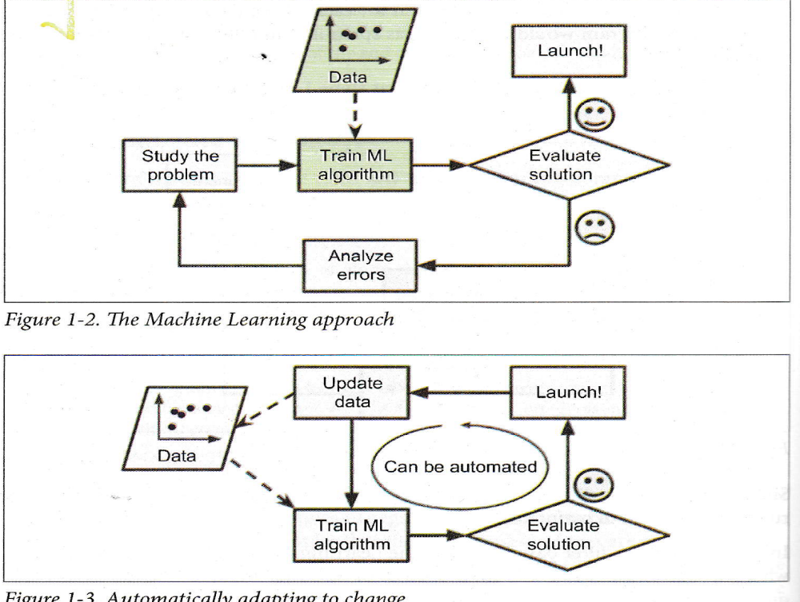
Aurelien Geron: Hands on Machine Learning with Scikit-Learn, Keras and Tensor Flow
The Machine Learning Approach which we would use would be similar and predictive analysis performed. The machine will learn to use past data to predict future values.

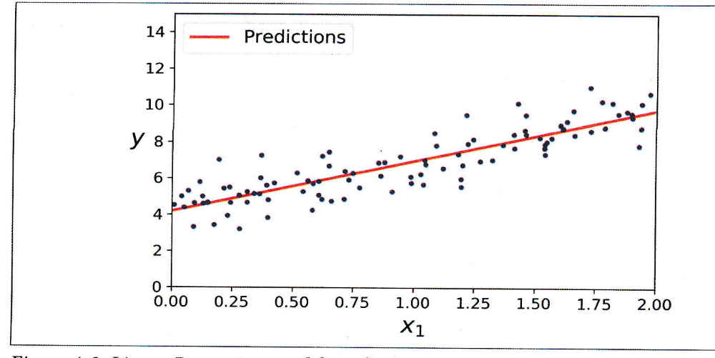
Linear Regression Model Predictions.

If you noticed in this model, the red line passes through some points, and other points are off the line. The simple equation of this line would be:

Y= mx + c (where c is the intercept at the y axis). However this equation is not completely true. We need to add another term.

Y=mx +c +e ( e is the error term).

The first order probabilistic model is y=bo + b1x + e where bo is the intercept on the y axis and b1 the slope of the line. The slope of the line m-tan x= ht/base and tan 45 degrees =1.

We will calculate or obtain the MSE (Mean Square Error) and would try to minimize in our subsequent discussion. The correlation coefficients r and r² would also be calculated.

With that we are to a good start !

