

Game Manual

## Story Development

*Jack’d is a western take on the classic fairy tale of Jack & The Bean Stalk.*

*The focus of this project was to develop the introduction scene / first level of the game – where the user learns the controls, and conquers the objectives leading to the next level. The first level ends when Jack reaches the clouds by climbing the beanstalk. Future development includes creating additional levels, thus expanding Jack’s horizons…*

## Character

*The player plays as Jack (3rd person view), a young lad who traded the family cow for some magic beans. Rumor has it, that these beans grow into a colossal bean stalk that reaches through the clouds! In the clouds rests a castle, and in that castle, alas… The Giant, but behold… The Golden Goose of Legend!*

*However, trading the family cow has consequences – as dear Jack is about to find out… The family cow’s friends miss their compadre and are seeking justice! To have any chance of climbing the beanstalk and finding the Golden Goose, Jack must first fend off and conquer all the family cow’s friends.*

*Once the waves have been decimated, and the bean stalk has finished growing, Jack can climb the beanstalk and complete the level.*

## Enemies

The family cow’s friends are armed and dangerous! With sharp horns, and a deadly kick, these four-legged foes want nothing more than justice for their friend. There are 2 types of friends Jack must overcome:

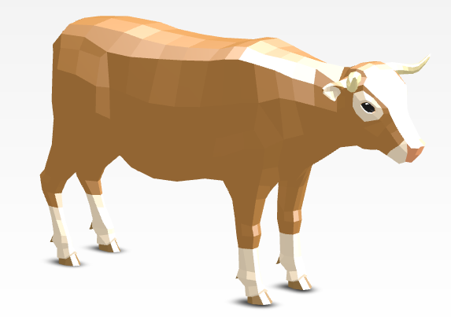Cow

*“A basic enemy with slow pace, and moderate damage infliction”*

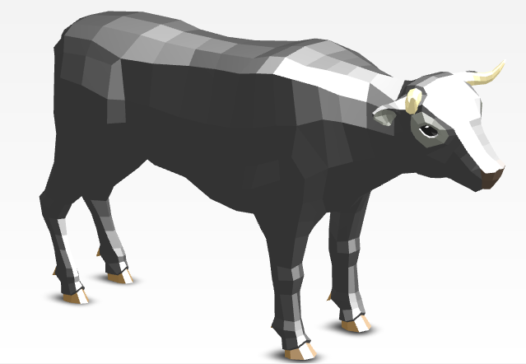Bull

*“A leaner, meaner, and more worthy opponent – beware the horns!”*

## Objectives

This game focuses on 3 primary objectives of varying difficulty:

1. *Plant the magic beans*

As this is the player’s first interaction with the game aside from movement, this is an easy objective, where the user simply plants the magic beans in the dirt patch shown (Pressing the ‘F’ key when standing over the dirt patch).

This triggers the growth of the bean stalk and invokes the enemies to attack!

1. *Fight the enemy waves*

Once the beans have been planted, the wave counter begins promptly. This game currently features 5 enemy waves, with successive difficulty.

1. *Climb the bean stalk*

Having defeated the enemy waves and having waited until the bean stalk is full grown, the player can then climb the beanstalk - completing the level.

## Game Features

* Day / night cycle (animation curve)
  + *A goal of this project since conception to add realism*
* Beanstalk growth management (animation curve)
  + *The designer felt instant growth of the bean stalk would reduce the user experience, so a growth plan was formulated*
* Asynchronous loading scene
* Roulette Playlist
* Immersive audio experience, with a complete array of player sounds
  + *This includes a heartbeat that can be heard louder when the player’s health is low. Wear headphones to better experience this effect!*
* Customize volume of audio
* Clean, modern in-game pause menu
* Mini Map
  + Shows the locations and rotation of Jack (white arrow), enemies (red triangles), the beanstalk (green dot), and the map boundaries (gray halo). The color of the enemies’ icon also indicates the enemies’ health:
    - red = healthy
    - orange = okay health
    - yellow = dying
* Money

The player’s money doubles as their score (don’t worry though, spending money will not reduce your score!). Money would be more useful in future implementations, as further development would include the addition of a shop – where weapons, health, and abilities could be purchased.

## Scenes

* Main Menu
  + Main Pane
  + Instructions Pane
  + Credit Pane – which includes references and credits asset sources
* Loading
* Main Game

## Design Decisions

* Choosing approximated colliders for the beanstalk, instead of spending a considerable amount of time fine-tuning the collision. This allowed more time to develop the other game features.
* Spending time selecting an appropriate theme, assets, and soundtrack
  + A goal of this game was to create an immersive experience for the player that was in keeping with the ‘western’ theme
  + The desert biome was also selected to add to this effect
* Providing variety in the waves (both with the number of enemies, and with the difficulty of said enemies) was implemented to give the user a sense of progression and achievement.
* The ‘pause menu’ was implemented for convenience and audio adjustments, to fine tune the player’s game style.
* Although realism was not a significant focus of this game, pseudo-realistic player and enemy movement and day / night cycles were added to improve user experience.

