The LeBlanc Problem in FLEXI

This summary describes the result of running the LeBlanc problem in Flexi. The LeBlanc problem [1] is an extreme case of one dimensional Riemann shock-tube problem, having strong shock and rarefaction waves. The shock tube is initialized with an ideal gas having gamma = 5/3 filling a one dimensional space spanning [0, 9]. An interface is established at x = 3 such that initially the gas has density, velocity and pressures defined as
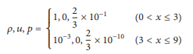

At t = 0, the gas is released so that a shock propagates to the right while a rarefaction wave propagates to the left. If the calculation is performed using a nonrobust scheme, it will fail. The simulation was done using the Flexi code. A The computational mesh was a three dimensional box with side lengths (Lx, Ly, Lz) = (9, 1,1) discretized into 900 elements in the x-direction and 1 element each in the y- and z-directions. Zero-gradient boundary conditions were imposed on the sides with weak Dirichlet conditions at the left and right boundaries.
Flexi supports fully unstructured curved hexahedral meshes with non-conforming element interfaces, allowing for complex geometries and meshing flexibility. Its mesh generator can generate curved meshes from a variety of linear meshes from open-source or commercial grid generators. Flexi is based on the highly efficient Discontinuous Galerkin Spectral Element Method, allowing one to exploit spectral convergence with very high orders of accuracy. Simulations utilizing O(20) and more are possible. The Flexi framework is designed to fully exploit modern parallel architectures up to maximum scale, with actual production runs over 100,000 cores. The solver itself and its I/O scale efficiently to multiple hundred thousand cores, the tool chain allows for parallel post-processing and visualization of huge amounts of data.
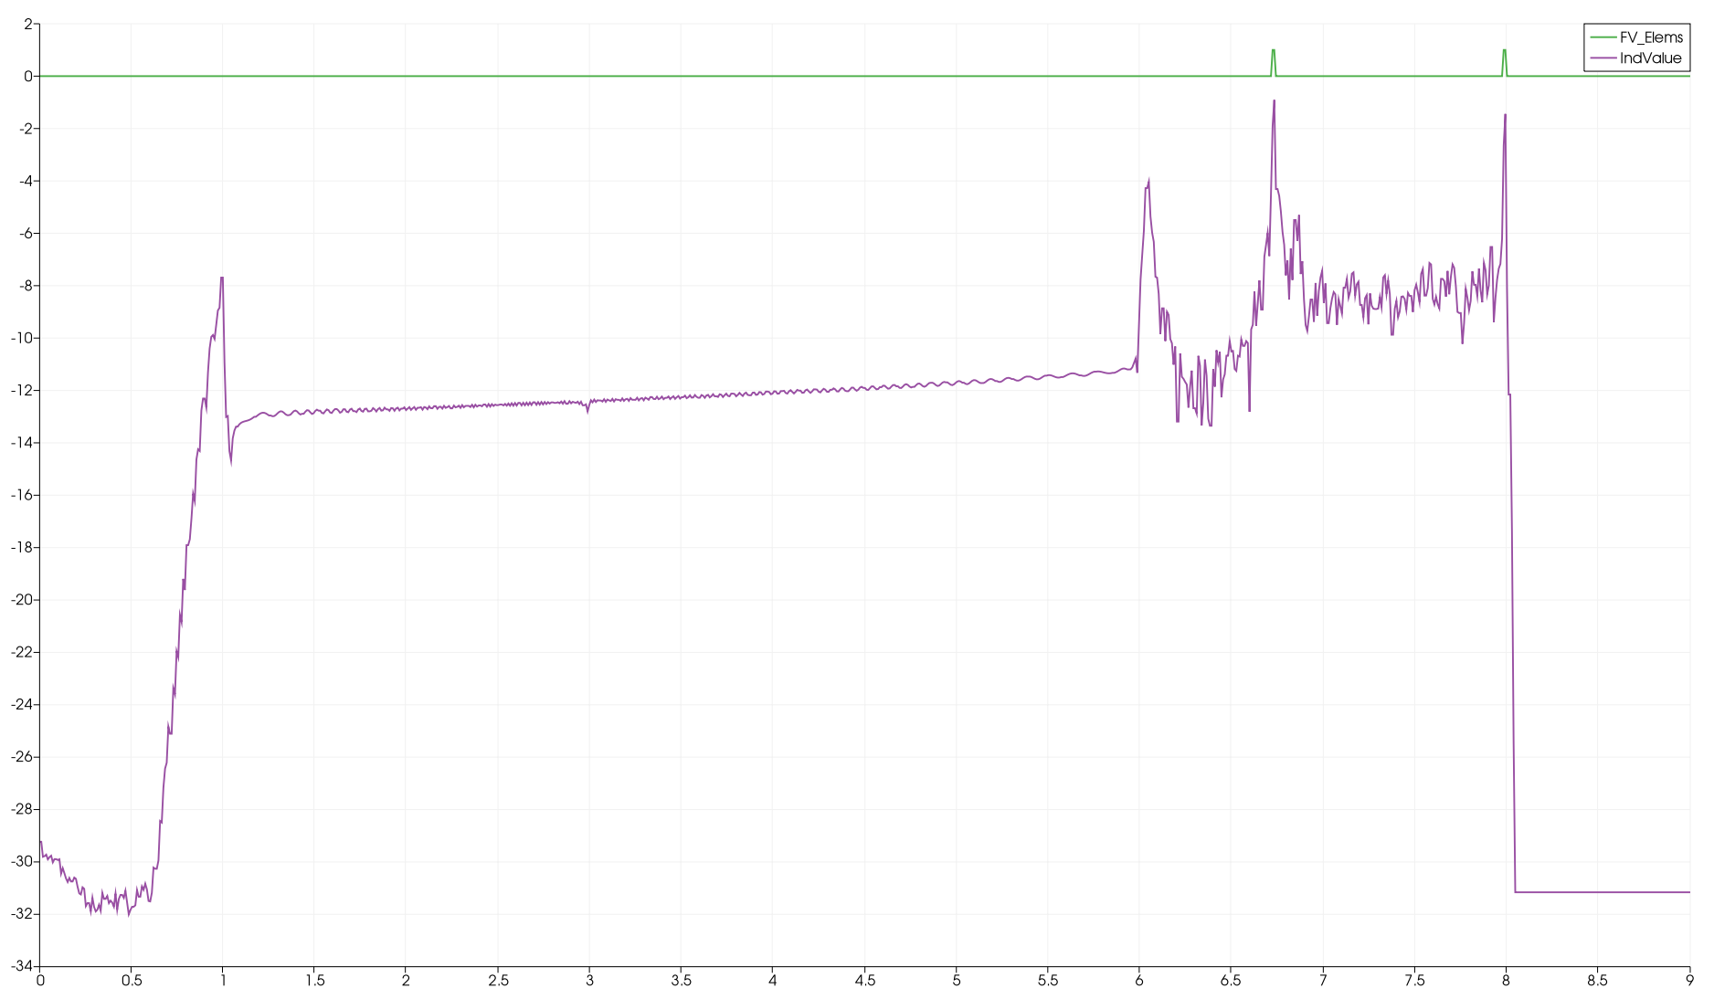Figure 2: Area of Finite Volume Solution and Persson Indicator Values
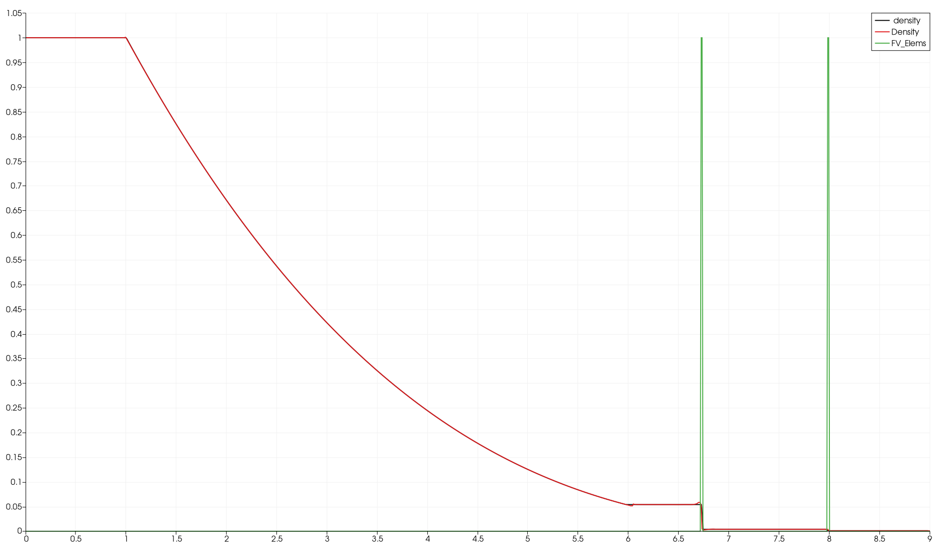Figure 1: Density (Flexo) vs. Exact

Figures 1 and 2 show selected results of Flexi on the LeBlanc problem at time t = 6. Note the excellent agreement between the calculated density and the exact solution in Figure 1. Discrepancy is seen only at the shock locations (green vertical lines) and then with only a slight difference. In this figure, the green rectangular areas show the location, spatially, where the finite volume method was employed around the two shock waves. The discontinuous Galerkin finite element method is used over the remainder of the domain – these selections are performed automatically in Flexi as the solution time moves forward. Here, the Persson indicator is used to determine where in the solution domain the finite volume method should be used. The indicator results at t = 6 are shown in Figure 2. Only when the indicator falls within a large enough set of values (input data) does the code switch from the DSG method to the finite volume method. This Persson indicator was very effective on this problem and placed the finite volume sections of the problem very near the shocked areas but not elsewhere over the domain.
1. X. Zhang and C.-W. Shu, “On positivity preserving high order Discontinuous Galerkin schemes for compressible Euler equations on rectangular meshes,” Journal of Computational Physics, vol. 229, pp. 8918–8934, 2010.

