1. The topmost grid has a pager. The sub-grids have buttons on the toolbar but no pager.

2. We want it to be obvious which sublevel items belong to a particular parent. Our POC model makes the background color the same for a parent and its children.

The following example indents the columns and data and the indentation area in front of the child items has a grey background. ***I believe this would be our preferred look.***

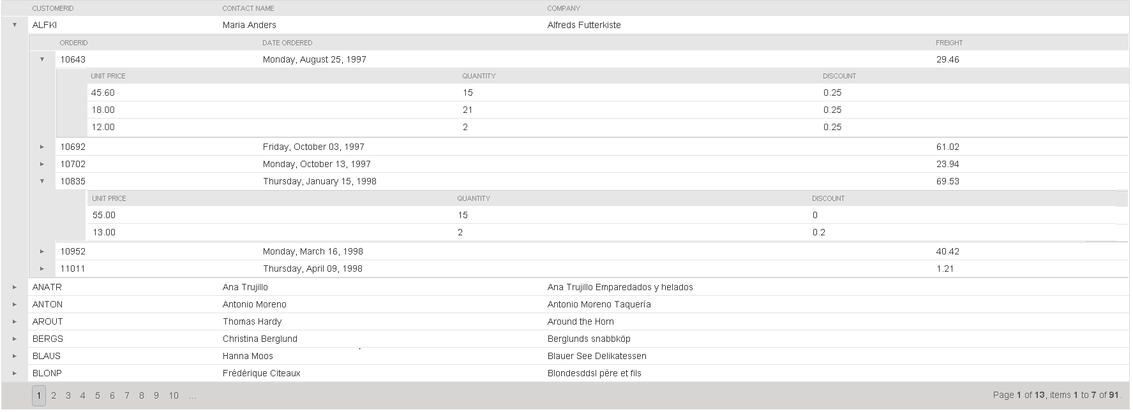

The following shows all of the children surrounded by a red bounding box. If you have suggestions let us know.

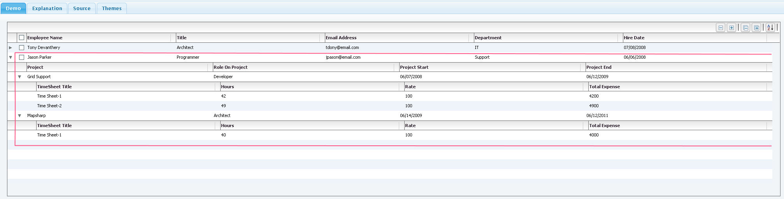

3. Some of the columns may contain buttons, links Icons etc. I assume this is possible using itemrenderers.

4. The data (topmost) will be loaded from a database using lazyloading via a rest service call. Inside the callback (that your control calls) we will likely us angular to make the rest call and get back json.

5. Hovering over icons will show a tooltip.

6. Use angular to write as much of this code as possible.