|  |
| --- |
| EXTRACTION OF CAFFEINE FROM TEA |
| REPORT WRITING |
|  |

KARNATAKA LAW SOCIETY’S

GOGTE INSTITUTE OF TECHNOLOGY



|  |  |  |
| --- | --- | --- |
| **NAME** | **ROLL NO** | **SIGNATURE** |
| RAHUL.K | 1311 |  |
| RASHMI.K | 1323 |  |
| SHRIGOURI.A | 1330 |  |
| SUMEDHA.K | 1334 |  |
| VAISHNAVI.H | 1338 |  |
| VENKATESH.D | 1339 |  |
| PRIYANKA. | 1342 |  |
| VAISHNAVI.R | 1346 |  |
| DHANASHRI.D | 1349 |  |
| ATREAY.K | 1354 |  |

**INTRODUCTION:**

Caffeine, 1,3,7 – trimethylxanthine, is an alkaloid stimulant commonly found in tea, coffee and cola beverages. It usually tastes bitter and has a stimulating effect to the brain and central nervous system, helping humans to be physiologically active. Several factors such as variety of coffee bean or tealeaf, location of the plant’s growth and method of brewing may affect the amount of caffeine in coffee or tea. Belonging to the alkaloid class of compounds, caffeine are nitrogenous basic compounds and can be considered to be constructed from the purine ring system.

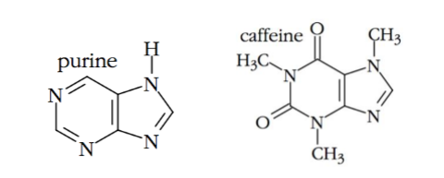

Figure 1. Lewis Structures of purine and caffeine.

Isolation of caffeine may be done through extraction wherein the sample is distributed between two or more phases. [3] Extraction is a method used for separating an organic compound from a mixture. In this technique, one or more compounds would be dissolved selectively into a particular solvent. The extract would be the solution of the dissolved compounds. [4] Although, tea leaves contain another component that may be co-extracted such as tannins, the differential solubility of caffeine and tannins in dichloromethane (CH2Cl2) allows the separation of the two during extraction.

To further purify a natural product and isolate it from undesired compounds, the sublimation method may be used. In this process, the product will undergo a direct phase change from solid to vapor without passing the liquid state.

.

**RESULTS AND DISCUSSION**

Table 1. Tabulation of experimental results

|  |  |
| --- | --- |
| **Brand of Tea** | Red Label |
| **Weight of Tea Leaves** | 40 g |
| **Volume of H­2 O used** | 300 ml |
| **Color of aqueous tea extracted** | Dark brown |
| **Volume of chloroform** | 10 ml |
| **Weight of NaOH pallets used** | 6 gm |

|  |  |
| --- | --- |
| **Color of chloroform** | Colorless |
| **Weight of empty evaporating dish** | 50.925 |
| **Weight of evaporating dish & extracted caffeine** | 52.6875 |
| **Weight of extracted caffeine** | 1.7625 |
| **Yield of extracted caffeine** | 1.08 |
| **Color & appearance of extracted caffeine** | White solid |

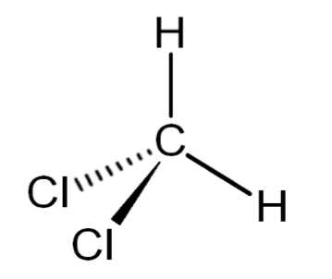 In the experiment, caffeine is extracted from Lipton Yellow Label tea leaves after subjecting it to boiling, extraction, and sublimation. The compound, an alkaloid, is polar and is soluble in boiling water at 666 mg/ml [6]. After cooling the tea extract, it was transferred to a separatory funnel for extraction. In this, dichloromethane or methylene chloride (CH2Cl2) was added. CH2Cl2 is a volatile liquid, with a density of 1.33 g/cm3. This liquid is also polar with the presence of two more electronegative chlorines against two hydrogens, creating a dipole moment (Figure 2). Caffeine, although highly soluble in water at high temperatures, is more soluble in CH2Cl2 at room temperature. The cooling of the tea extract before the extraction was done due to this. Densities of liquids are at work in the extraction setup, with CH2Cl2’s 1.33g/cm3 higher than water’s density of 1.00g/cm3. Thus, caffeine will be dissolved in the lower CH2Cl2 layer (Figure 4), leaving the upper water layer with less and less caffeine as the three 20 mL extractions are finished.

Although caffeine is the substance of interest in this experiment, tea leaves also contain a compound called gallic acid, a phenolic acid. This compound is better known for its antioxidant properties, with the potential to initiate apoptosis in cells [7] and promote cancer cell death [8]. In the extraction setup, both caffeine and gallic acid are present in the lower layer to be extracted. Due to this, a washing step involving the addition of 6M NaOH solution is done. The alkaline solution, when added to the CH2Cl2 layer, will react with the gallic acid to form water, carbon dioxide, and a gallic acid salt (Figure 3).

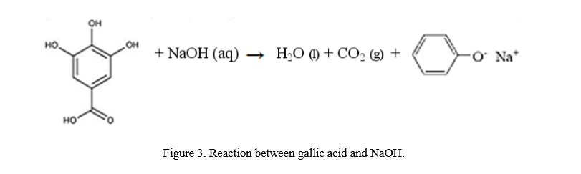

Figure 3. Reaction between gallic acid and NaOH.

When the washing was conducted in the separatory funnel, bubbles readily evolved (Figure 4), hinting the presence of carbon dioxide gas. The addition of the sodium ion increases the polarity of gallic acid, increasing its solubility in water. In theory, the gallic acid in the form of its salt must now be in the upper water layer, and the lower CH2Cl2 layer must contain the caffeine to be extracted.

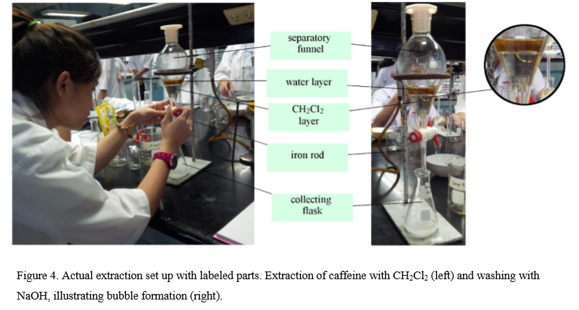

After drying the substance through adding anhydrous Na2SO4, the product was sublimed and weighed. The weight of the crude caffeine obtained from the experiment was 0.1171 grams, leading to a percent yield of 1.08% (Table 1). This was computed by dividing the experimental yield of crude caffeine by the total grams of tea leaves used, which is 10.8469 grams. Thus, the experimental results show that a tea bag of Lipton Yellow Label black tea has approximately

23.42 milligrams of crude caffeine. Ideally, 8 fluid ounces of Lipton Yellow Label black tea (approximately one tea bag) has 55 milligrams of caffeine.

**SAMPLE COMPUTATIONS**

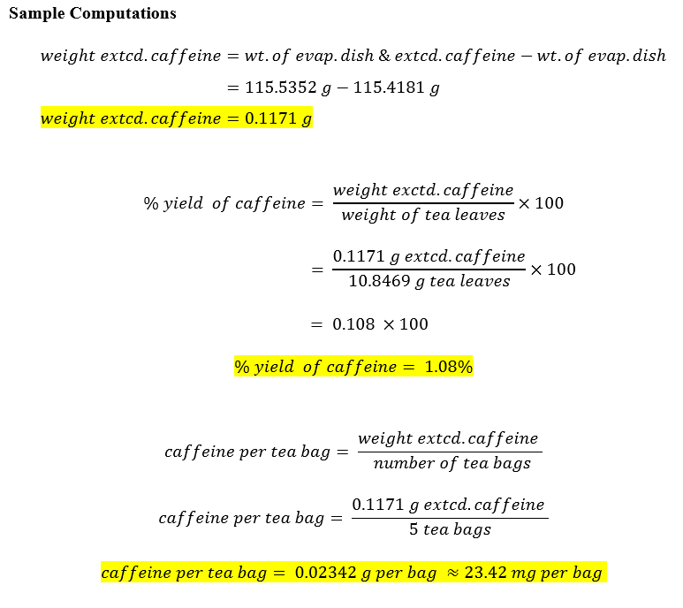

The lower yield of 23.42 milligrams compared to the ideal 55 milligrams can be attributed to some errors in the duration of the experiment. In the infusion setup, the tea leaves were brewed for five minutes until the extract was dark brown. A darker color could have been achieved if the teas were infused for a longer period of time. A darker color signifies a stronger caffeine extract, thus, a larger yield. An increase in the temperature controlled by the Bunsen flame could also potentially increase caffeine yield, since the latter’s solubility in boiling water is significantly high. Due to the experiment’s restrictions, the purity of the obtained crude caffeine was not tested.

**EXPERIMENTAL**

Five Lipton tea bags were used in this experiment. The combined weights of the tea leaves were recorded and returned in the bags and were secured with a staple wire. The teabags were boiled in 100 mL water for 5 minutes. The side of the flask was cooled in running water for 2 minutes and an ice cube was mixed with the tea extract to cool it to room temperature. The tea extract was transferred in a separatory funnel containing 20 mL of CH2Cl2 (Dicholoromethane). The stopcock of the separatory funnel was opened to release the pressure constantly. The lower layer was drained into a clean flask and the extraction was repeated twice. The remained brown layer was discarded and the separatory funnel was cleaned. The CH2Cl2 layer was then returned to the separatory funnel and 20 mL of 6M NaOH was added. The NaOH layer then was discarded. The CH2Cl2 layer was drained into a clean, dry 125 mL Erlenmeyer flask containing half spatula of anhydrous Na2SO4 and was swirled until the Na2SO4 settled. The mixture was decanted in a preweighed evaporating dish. The evaporating dish was placed on top of a 250 mL beaker to allow it to evaporate until the white residue was obtained. The white residue weighed and the percent yield was calculated. The extracted caffeine was then transferred into an empty preweighed vial.

**REFERENCES**

[1] Snelling. (2003). Extraction of Caffeine from Tea Leaves. Retrieved September 18, 2016

from http://www2.volstate.edu/CHEM/2010/Labs/Caffeine_Extraction.htm

[2] Isolation of Caffeine from Tea Leaves. Retrieved September 19.

**CONCLUSION**

In this experiment, the caffeine was extracted from the tea bag. The caffeine was evaporated. The amount of caffeine in 40 g of tea is 1.9g.