Karnataka Law Society’s

Gogte Institute of Technology, Belgaum.



*Report on,*

***Cosmic Physics***

*By,*

|  |  |  |  |
| --- | --- | --- | --- |
| **Name** | **Roll No.** | **USN** | **Signature** |
| K Rahul | 1311 | *2GI19CS175* |  |
| Venkatesh Dhongadi | 1339 | *2GI19EC055* |  |
| Aakriti Jha | 1345 | *2GI19IS001* |  |
| Vaishnavi Rajoli | 1346 | *2GI19IS058* |  |

Black holes

A black hole is a region of [spacetime](https://en.wikipedia.org/wiki/Spacetime) where [gravity](https://en.wikipedia.org/wiki/Gravitation) is so strong that nothing—no [particles](https://en.wikipedia.org/wiki/Particle) or even [electromagnetic radiation](https://en.wikipedia.org/wiki/Electromagnetic_radiation) such as [light](https://en.wikipedia.org/wiki/Light)—can escape from it. The theory of [general relativity](https://en.wikipedia.org/wiki/General_relativity) predicts that a sufficiently compact [mass](https://en.wikipedia.org/wiki/Mass) can deform spacetime to form a black hole. The boundary of the region from which no escape is possible is called the [event horizon](https://en.wikipedia.org/wiki/Event_horizon). Although the event horizon has an enormous effect on the fate and circumstances of an object crossing it, it has no locally detectable features. In many ways, a black hole acts like an ideal [black body](https://en.wikipedia.org/wiki/Black_body), as it reflects no light. Moreover, [quantum field theory in curved spacetime](https://en.wikipedia.org/wiki/Quantum_field_theory_in_curved_spacetime) predicts that event horizons emit [Hawking radiation](https://en.wikipedia.org/wiki/Hawking_radiation), with [the same spectrum](https://en.wikipedia.org/wiki/Thermal_radiation) as a black body of a temperature inversely proportional to its mass. This temperature is on the order of billionths of a [kelvin](https://en.wikipedia.org/wiki/Kelvin) for [black holes of stellar mass](https://en.wikipedia.org/wiki/Stellar_black_hole), making it essentially impossible to observe.

Black holes of stellar mass are expected to form when very massive stars collapse at the end of their life cycle. After a black hole has formed, it can continue to grow by absorbing mass from its surroundings. By absorbing other stars and merging with other black holes, [supermassive black holes](https://en.wikipedia.org/wiki/Supermassive_black_hole) of millions of [solar masses](https://en.wikipedia.org/wiki/Solar_mass) (M☉) may form. There is consensus that supermassive black holes exist in the centres of most [galaxies](https://en.wikipedia.org/wiki/Galaxy).

Properties and structure

The [no-hair conjecture](https://en.wikipedia.org/wiki/No-hair_theorem) postulates that, once it achieves a stable condition after formation, a black hole has only three independent physical properties: [mass](https://en.wikipedia.org/wiki/Mass), [charge](https://en.wikipedia.org/wiki/Electric_charge), and [angular momentum](https://en.wikipedia.org/wiki/Angular_momentum); the black hole is otherwise featureless. If the conjecture is true, any two black holes that share the same values for these properties, or parameters, are indistinguishable from one another. The degree to which the conjecture is true for real black holes under the laws of modern physics, is currently an unsolved problem.

These properties are special because they are visible from outside a black hole. For example, a charged black hole repels other like charges just like any other charged object. Similarly, the total mass inside a sphere containing a black hole can be found by using the gravitational analog of [Gauss's law](https://en.wikipedia.org/wiki/Gauss%27s_law), the [ADM mass](https://en.wikipedia.org/wiki/ADM_mass), far away from the black hole. Likewise, the angular momentum can be measured from far away using [frame dragging](https://en.wikipedia.org/wiki/Frame_dragging) by the [gravitomagnetic field](https://en.wikipedia.org/wiki/Gravitomagnetism).

## Formation and evolution

Given the bizarre character of black holes, it was long questioned whether such objects could actually exist in nature or whether they were merely pathological solutions to Einstein's equations. Einstein himself wrongly thought black holes would not form, because he held that the angular momentum of collapsing particles would stabilize their motion at some radius. This led the general relativity community to dismiss all results to the contrary for many years. However, a minority of relativists continued to contend that black holes were physical objects, and by the end of the 1960s, they had persuaded the majority of researchers in the field that there is no obstacle to the formation of an event horizon.

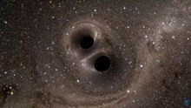

Simulation of two black holes colliding

## Observational evidence

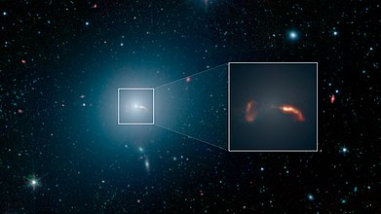

By nature, black holes do not themselves emit any electromagnetic radiation other than the hypothetical [Hawking radiation](https://en.wikipedia.org/wiki/Hawking_radiation), so astrophysicists searching for black holes must generally rely on indirect observations. For example, a black hole's existence can sometimes be inferred by observing its gravitational influence upon its surroundings.

On 10 April 2019 an image was released of a black hole, which is seen in magnified fashion because the light paths near the event horizon are highly bent. The dark shadow in the middle results from light paths absorbed by the black hole. The image is in [false color](https://en.wikipedia.org/wiki/False_color), as the detected light halo in this image is not in the visible spectrum, but radio waves.

The brightening of this material in the 'bottom' half of the processed EHT image is thought to be caused by [Doppler beaming](https://en.wikipedia.org/wiki/Relativistic_beaming), whereby material approaching the viewer at relativistic speeds is perceived as brighter than material moving away. In the case of a black hole this phenomenon implies that the visible material is rotating at relativistic speeds (>1,000 km/s), the only speeds at which it is possible to centrifugally balance the immense gravitational attraction of the singularity, and thereby remain in orbit above the event horizon. This configuration of bright material implies that the EHT observed [M87*](https://en.wikipedia.org/wiki/M87*) from a perspective catching the black hole's accretion disc nearly edge-on, as the whole system rotated clockwise. However, the extreme [gravitational lensing](https://en.wikipedia.org/wiki/Gravitational_lens) associated with black holes produces the illusion of a perspective that sees the accretion disc from above. In reality, most of the ring in the EHT image was created when the light emitted by the far side of the accretion disc bent around the black hole's gravity well and escaped such that most of the possible perspectives on M87* can see the entire disc, even that directly behind the "shadow".

Worm Holes

A wormhole is a hypothetical shortcut between two distant regions of space-time. Although a three dimensional wormhole is impossible to fully visualize, a two dimensional analogue can be constructed to aid visualization. Imagine an intrinsically flat, two dimensional, space as a folded piece of paper embedded in a higher three dimensional space, where a tube connects two distant points, A and B, on the paper. The length through the tube (the wormhole) can be much less than the distance from A to B along the paper, creating a shortcut.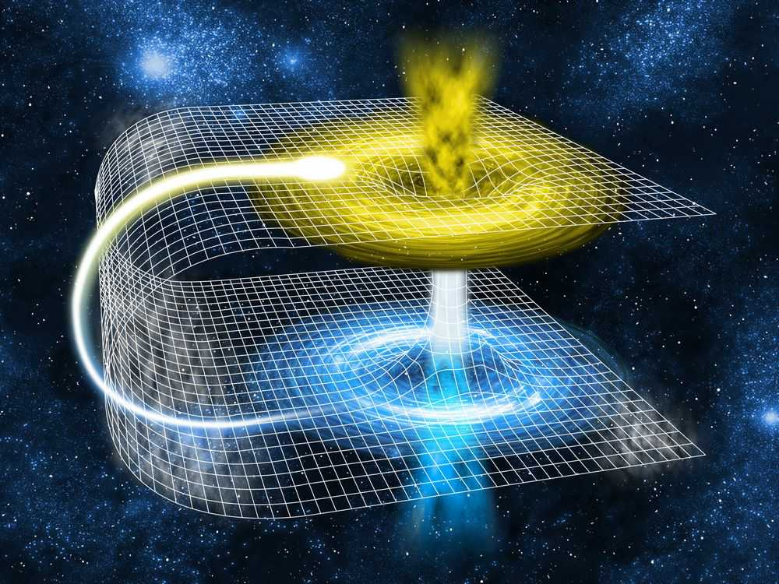 A full three dimensional wormhole would have entrances and exits that are three dimensional spheres rather than two dimensional rings like the mouths of the paper tube. Such lower dimensional, human-friendly, visualizations are termed embedding diagrams, and the iconic wormhole image is usually shown as the well known

Schwarzchild embedding diagram, which is the wormhole analogue for a static, non-rotating, Schwarzchild black hole.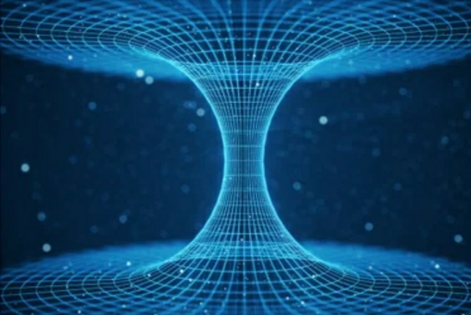 An observer passing through such a wormhole could, in principle, traverse the wormhole in less time than it would take to travel from point A to point B through normal space-time outside the wormhole. Moreover, if A and B are sufficiently distant in space and the wormhole length is sufficiently short, an observer could potentially traverse the wormhole in a time less than it would take to send a light signal from A to B through normal space. Wormholes could thus be used as a cosmic ``cheat" to effectively bypass the limitation that no object can travel faster than the speed of light in special and general relativity. Faster than light travel itself presents many paradoxes, since it could be used to send messages and information back in time.

Do Worm holes exist ?

No observational evidence for wormholes currently exists, but mathematical solutions describing wormholes have long been known to be valid theoretical solutions to Einstein's field equations of General Relativity. However, wormholes made completely of normal matter with positive energy density would be inherently unstable, and would be likely to collapse in the presence of nearby matter or matter that tried to traverse the wormhole. However, stable, traversible wormholes could exist if their entrances and exits were held open by exotic matter with a negative energy density.

Examples of such exotic matter include the quantum field configuration responsible for the Casimir Effect in quantum field theory. Whether such exotic matter could occur naturally in high enough densities to permit a stable wormhole to form via ordinary physical processes or whether it could be created artificially with sufficiently advanced technology remain open theoretical questions.

Time Travel

In addition to facilitating effectively faster than light travel, wormholes could potentially be used as time machines, in the following sense first developed by Caltech theoretical physicist Kip Thorne. Imagine an advanced technology capable of creating, manipulating, and containing both ends of a stable, traversible, wormhole.

Place one end in a laboratory on Earth and the other on a spacecraft capable of traveling through space at some reasonable fraction of the speed of light.

Imagine the wormhole connecting the lab and spaceship is created in some future year, say 2500.

Now keep one end on Earth and send the spaceship off in any direction at some appreciable fraction of the speed of light for a finite duration after which it will decelerate, turn around, come back to Earth, and stop, so the wormholes ends are brought back together.

Relativity tells us that the clocks of observers left on Earth andthose in a relativistically moving spacecraft will begin to differ by an amount that depends on the speed of the craft.

Since moving clocks run slow in relativity, a spaceship observer might experience a short subjective duration of say, a few weeks, but thousands or millions of years could pass in the external universe depending on how fast they were traveling. In this sense, time travel to the future is easy, and does not require wormholes, just a ship capable of moving at relativistic speeds.

A spaceship executing the above maneuver might find itself thousands or millions of years in the future after stopping. Yet an observer at the wormhole mouth in the laboratory on Earth would still have its clock synchronized with the shipboard wormhole.

If the ship finds itself, say in year 3500, after returning to Earth, any observers on the ship could return to the year 2500, traveling 1000 years into the past, simply by stepping through their shipboard wormhole back into the laboratory on Earth.

In this way, wormholes could theoretically be used to travel into the past. However, in this case, the shipboard time travelers could never travel to before the year 2500. This poses a striking answer to the question, ``If time travel to the past is possible, how come we aren't being constantly visited by time travelers from the future?"

For these types of wormhole time machines, the answer is simply, because they haven't been invented yet! Time travel of this sort can never take an observer back to before the original date when the wormhole connection was set up.

This is a particularly clever resolution to an interesting time travel paradox.

The Multiverse

If we define "universe" as "all there is" or "all that exists," then obviously, by definition, there can be only one universe.

But if we define "universe" as "all we can ever see" (no matter how large our telescopes) or "space-time regions that expand together," then many universes may indeed exist. There is nothing in science more awesome, more majestic. To discern the nature of ultimate reality, one must begin with the challenge of multiple universes.

So what is a "multiverse"?

As physicist and Nobel laureate Steven Weinberg told me on "Closer to Truth" (the source of all following interviews), "The word 'universe,' I suppose, should properly mean the whole thing — everything. But when we think of 'universe,' we sometimes use the word to mean just our Big Bang, the things we can see out to almost 14 billion light-years in all directions. And in this manner, it's reasonable to question: Is our universe unique? Are there multiple Big Bangs? Could there be multiple Big Bangs in different senses?"

Eternal chaotic inflation, which generates multiple universes, builds from the theory of cosmic inflation, originated by physicist Alan Guth at the Massachusetts Institute of Technology. He formulated cosmic inflation to solve several deep problems in the cosmology of our universe — for example, why was the early universe extremely (and strangely) homogeneous, even though separated regions were causally disconnected? (Regions could not cause effects with others because the distances were too great and the elapsed time was too short, even though information was being exchanged at the speed of light, what theorists call the "horizon problem".)

According to quantum field theory, the word "vacuum" indicates a sector of space that has local-minimum energy, but not the lowest possible energy, and the word "false" is used to mean ultimately unstable, though the vacuum can remain stable for a very long time. The significance is that a "false vacuum" can "tunnel" into a lower energy state, releasing or "creating" enormous energy.

How big is the Universe ?

One great question of existence is simply, how big is it? By "it" I mean everything that exists. All there is. What are the physical dimensions of all-there-is?

A place to start is the size of the universe in which we find ourselves. According to one of Guth's models, our pocket universe may be at least 10^23 times larger than our observable universe (because, in order to work, inflation requires at least 100 doublings of the size of the universe, 2^100 = roughly 10^30). This means that the pocket universe we call home would be 100 billion trillion times larger than everything we can see with our largest telescopes. (Models, no surprise, do jump around.)

Multiple Types of Multiverses

Most scientists support cosmic inflation because it can account for the origin and structure of our cosmos and explain several profound problems. Sir Martin Rees, the U.K.'s Astronomer Royal, calls the multiverse "speculative science, not just metaphysics." He said he's confident there is far more to physical reality than the vast domain that we see through our telescopes, and he would be amazed, he said, "if the universe didn't extend thousands of times beyond what we can see."

But there are unanswered questions, two critical ones: "First, is our Big Bang the only one? And, second, if there are many Big Bangs, are they all governed by the same laws of physics?"

Do all things exist

In a multiverse, one cannot avoid infinity, and infinity does strange things. There are two types of possible infinities in a multiverse: Type I: A single universe may be infinite in size (e.g., in our universe, if space and galaxies would continue forever without end or closure), or Type II: All the separate universes in a multiverse can be infinite in number (irrespective of whether any or all of the universes are infinite in size themselves).

The consequences of either infinity become bizarre. First of all, even Tegmark's Level I multiverse, assuming it's infinite, must contain everything that's physically possible. This means, for example, that every "Star Wars" scenario really exists out there, including those that didn't make it into the films and even all those the writers didn't think of!

Similarly, as long as there is sufficient space for unending random shufflings of particles (and a universe of infinite size certainly has sufficient space), there would have to be a sector of space out there identical to our sector of space, with persons identical to you and to me. Tegmark estimates that our closest identical copy is 10^10^28 m away.