**COMSATS UNIVERSITY ISLAMABAD**

**ATTOCK CAMPUS**



**NAME:** ABBAS KHAN & VAREESHA SHUAIB

**REG. NO.:** SP22-BSE-020 & SP22-BSE-018

**SUBJECT:** DEVOPS FOR CLOUD COMPUTING

**__________________________________________**

**DATED: 1ST JUNE 2025**

# Created GitHub repository:

We created a GitHub repository with the name DevOps-Project.

Link: [DevOps/DevOps-Project at main · flickShot555/DevOps](https://github.com/flickShot555/DevOps/tree/main/DevOps-Project)

The GitHub repository that is linked with the pipeline is at

Link: [flickShot555/tic-tac-toe](https://github.com/flickShot555/tic-tac-toe)

# Created an EC2 instance and installed Jenkins:

We created an EC2 instance on AWS server, the same We are using for our DevOps Project. We named the project ‘DevOps-Project’ and is live at

URL: <http://16.170.248.68>

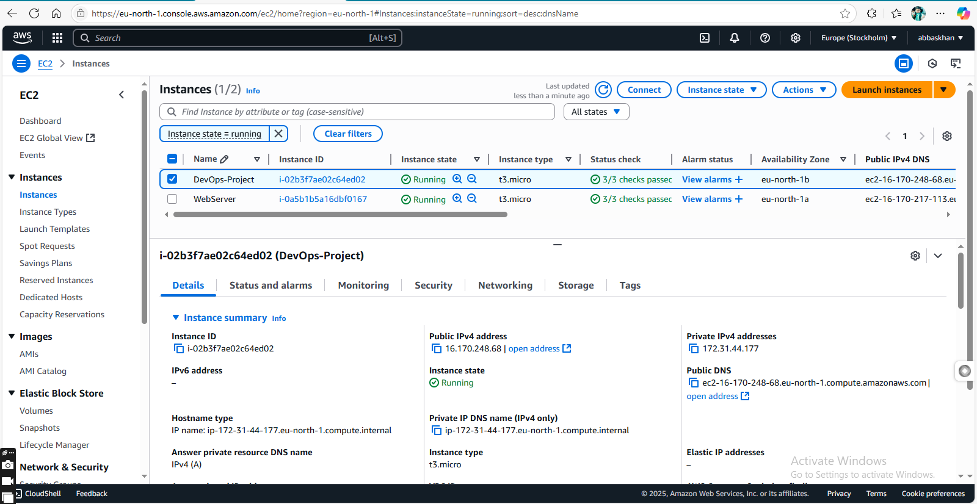

We installed, configured, and ran Jenkins on the instance

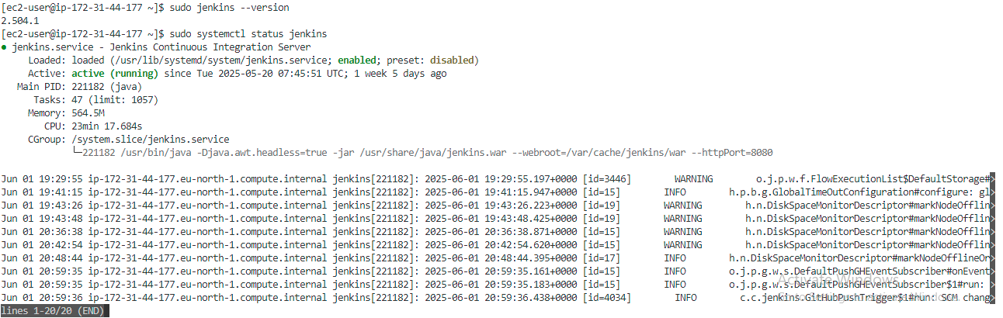

# Configuring the Jenkins Pipeline:

Security Groups:

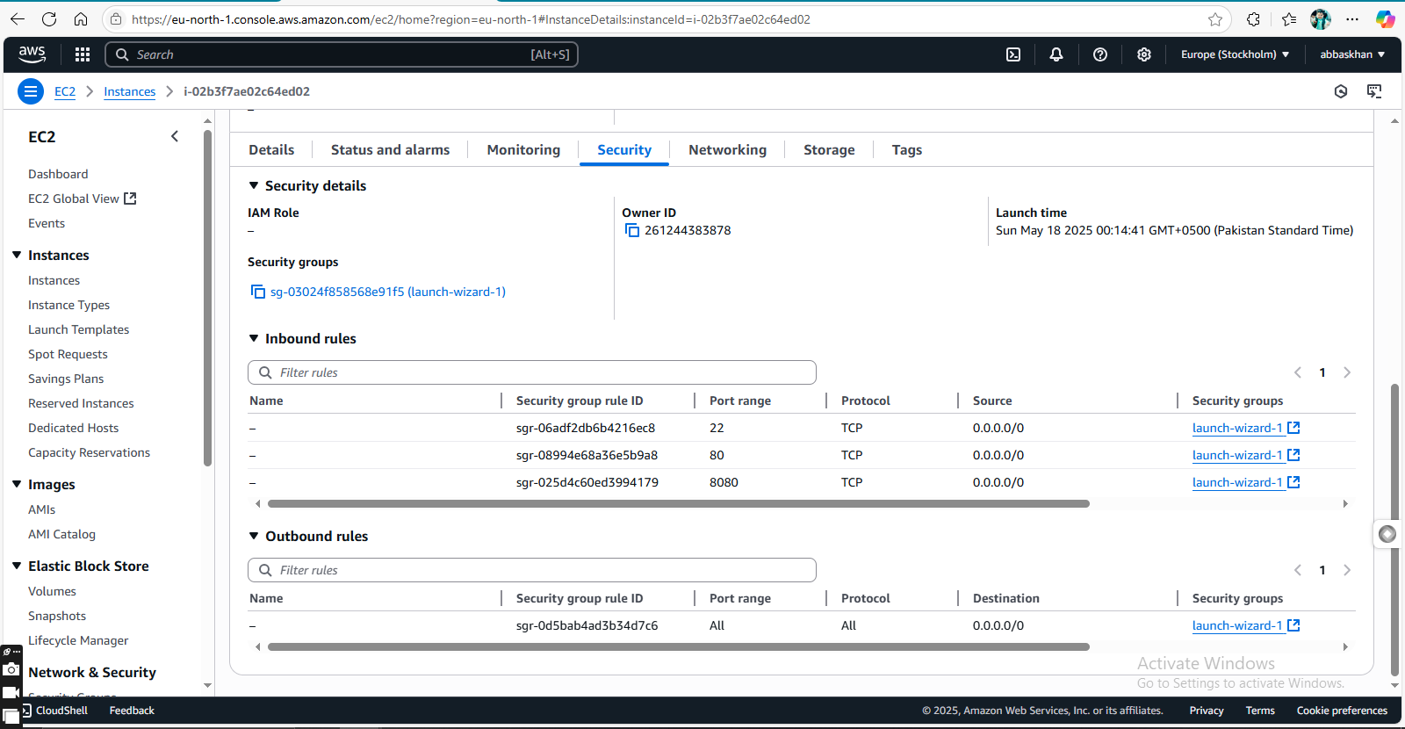

Key Pairs:

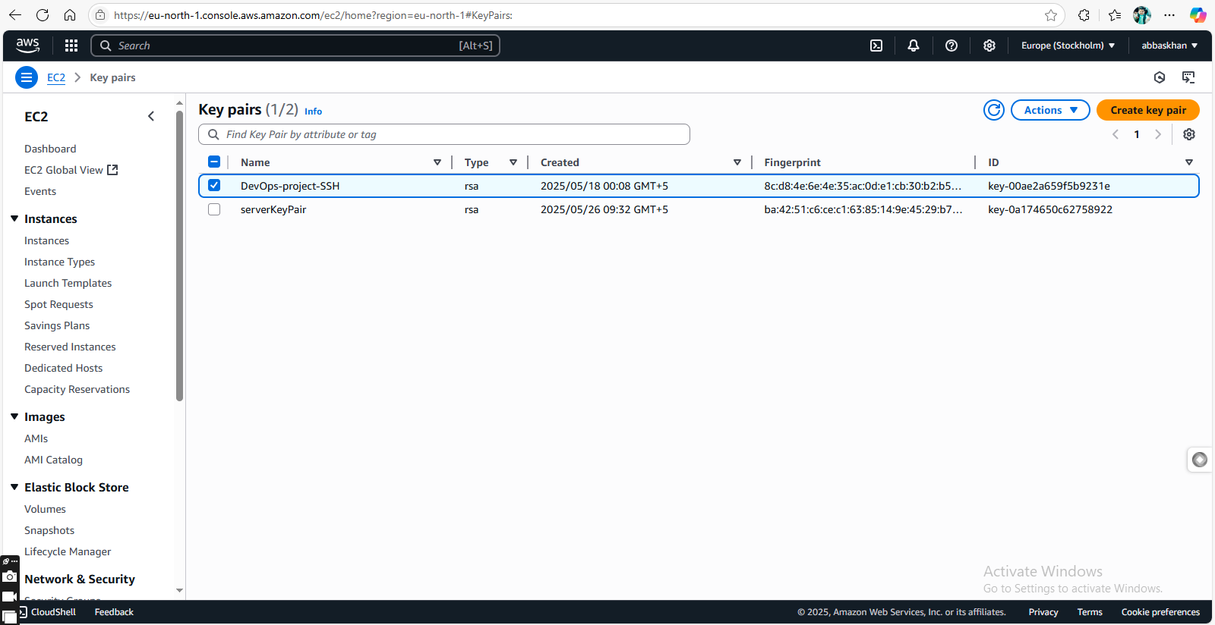

Networking Settings:

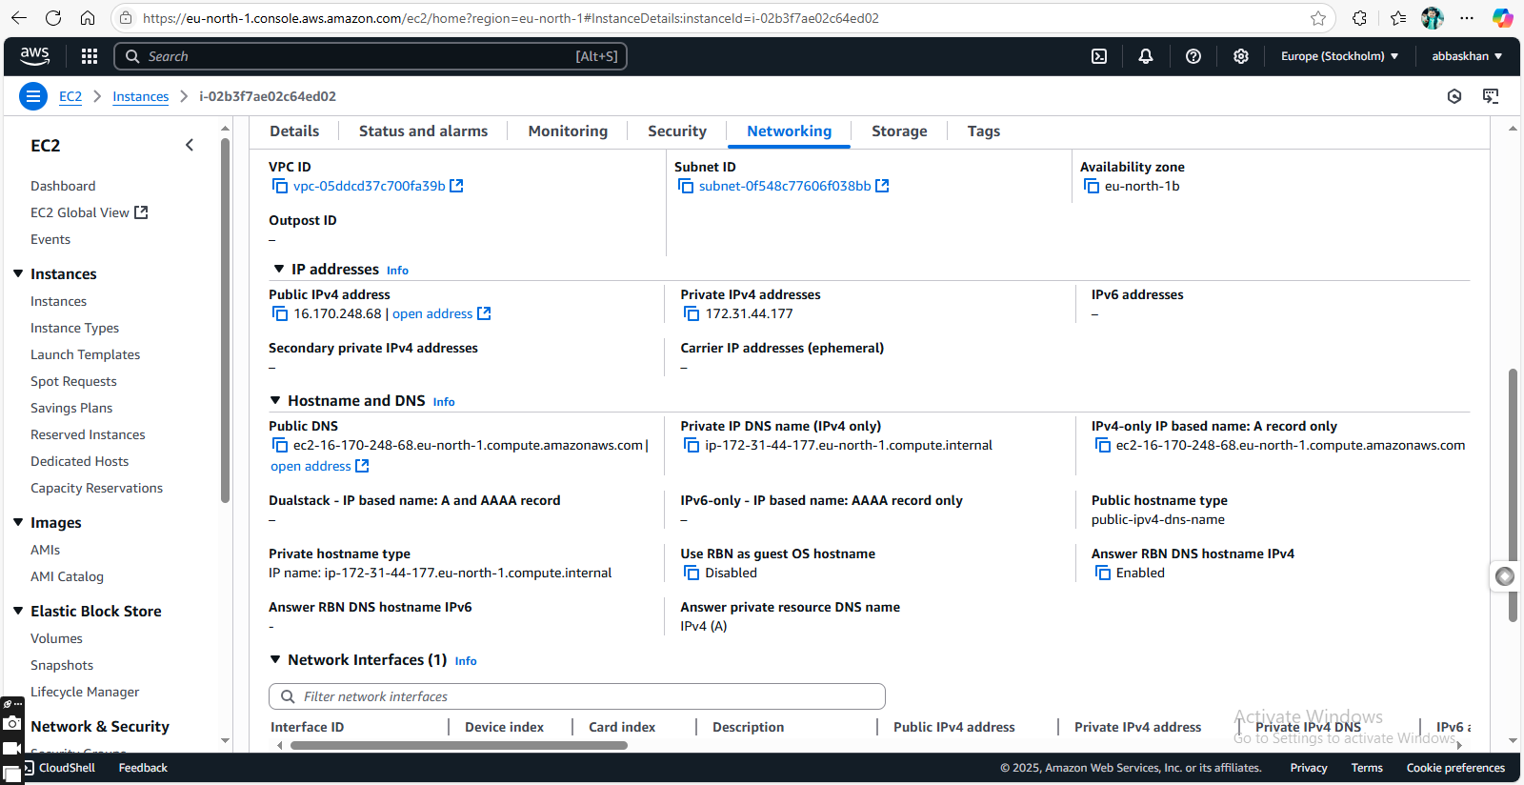

# Jenkins Dashboard:

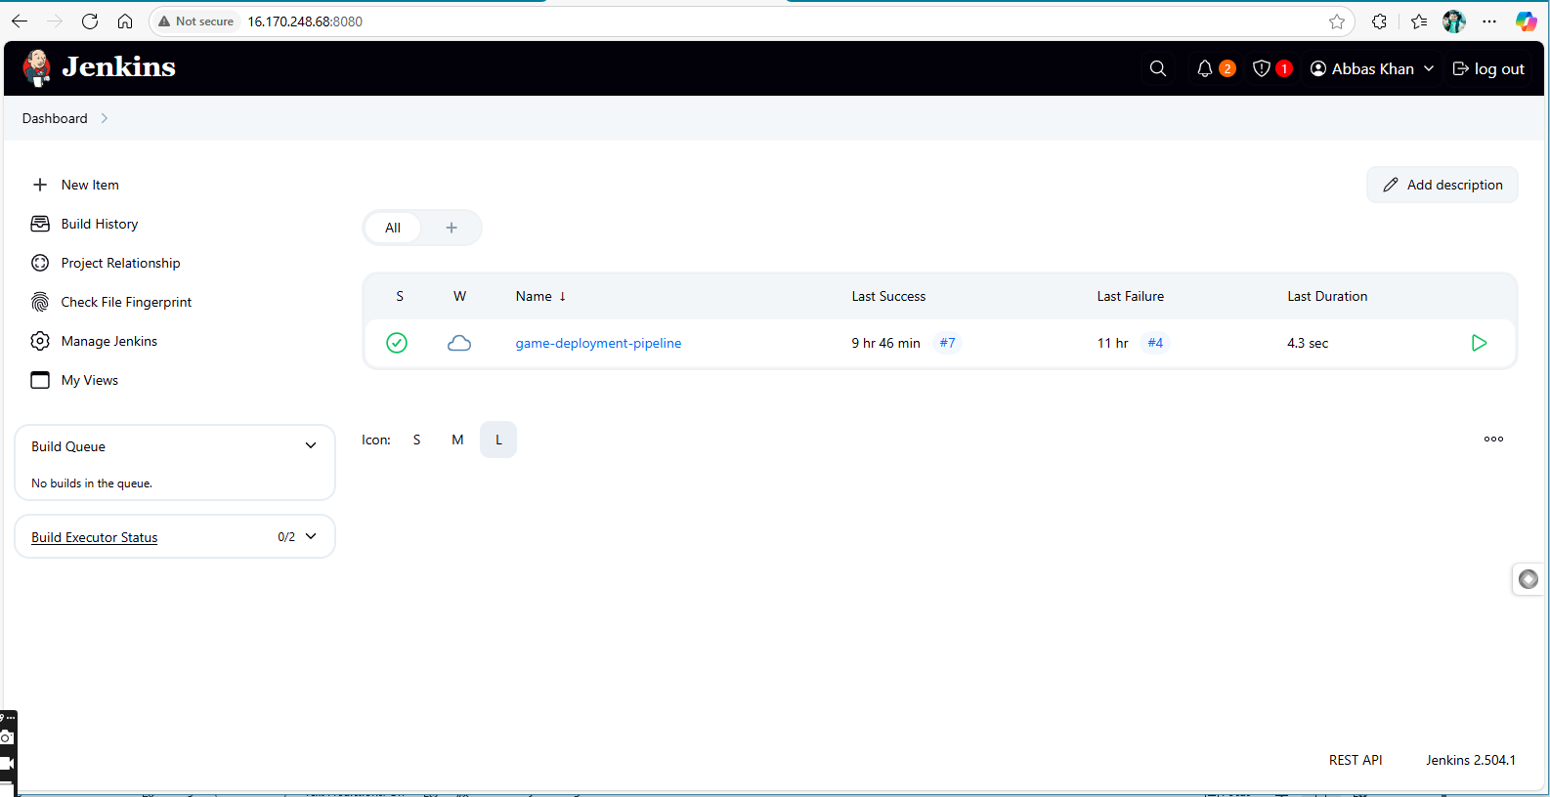

WE configured the instance:

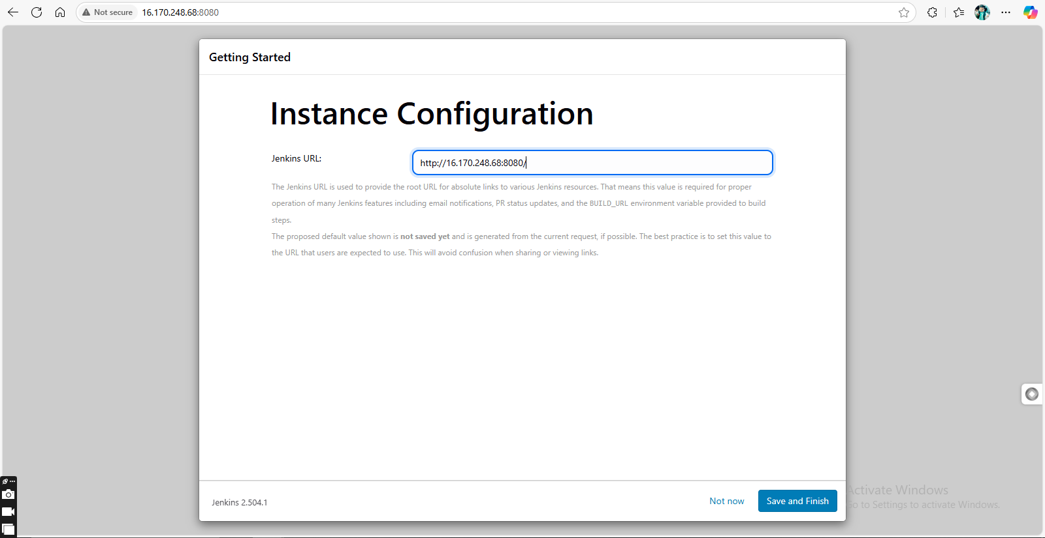

# Jenkins Job Configuration:

# Jenkinsfile in GitHub:

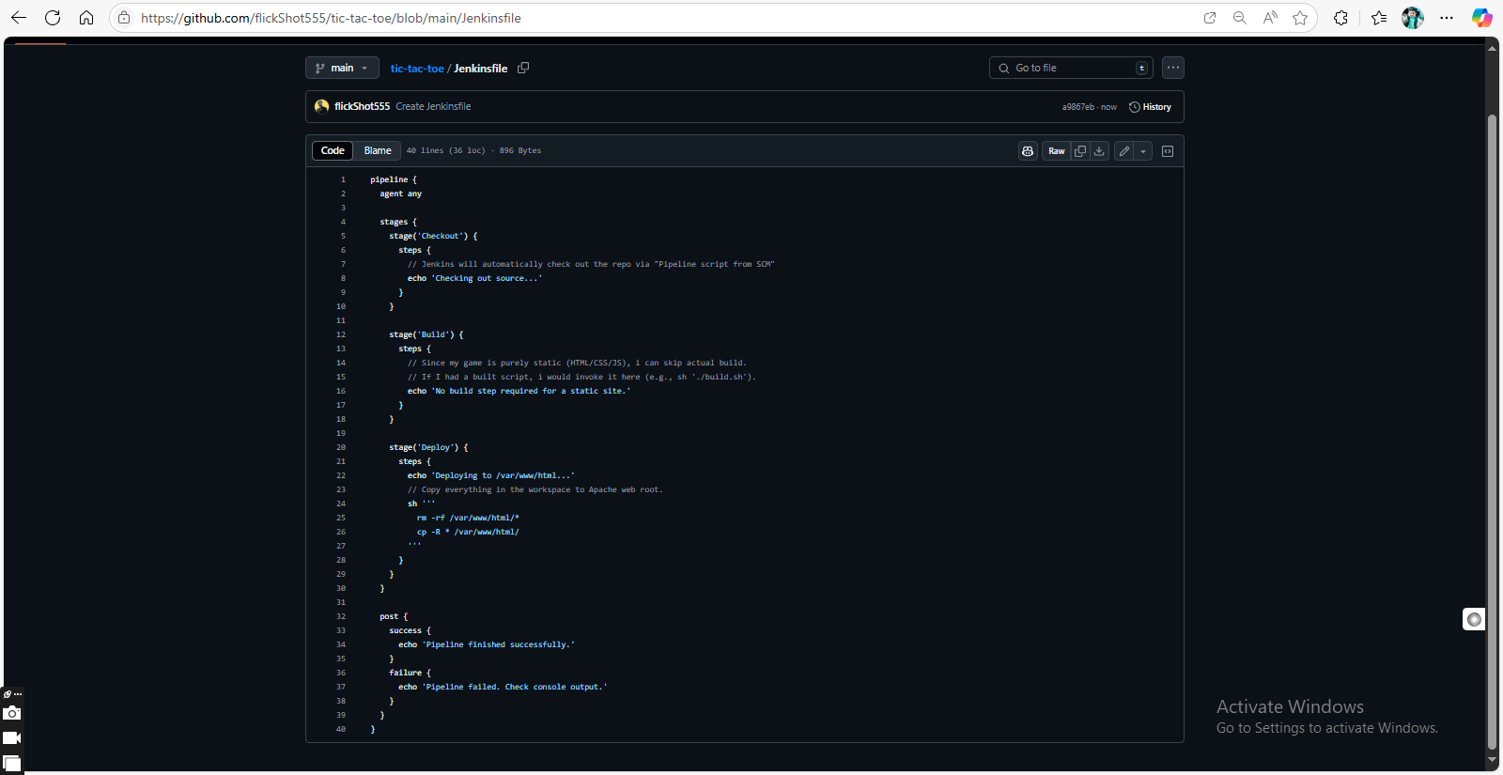

# Build console output:

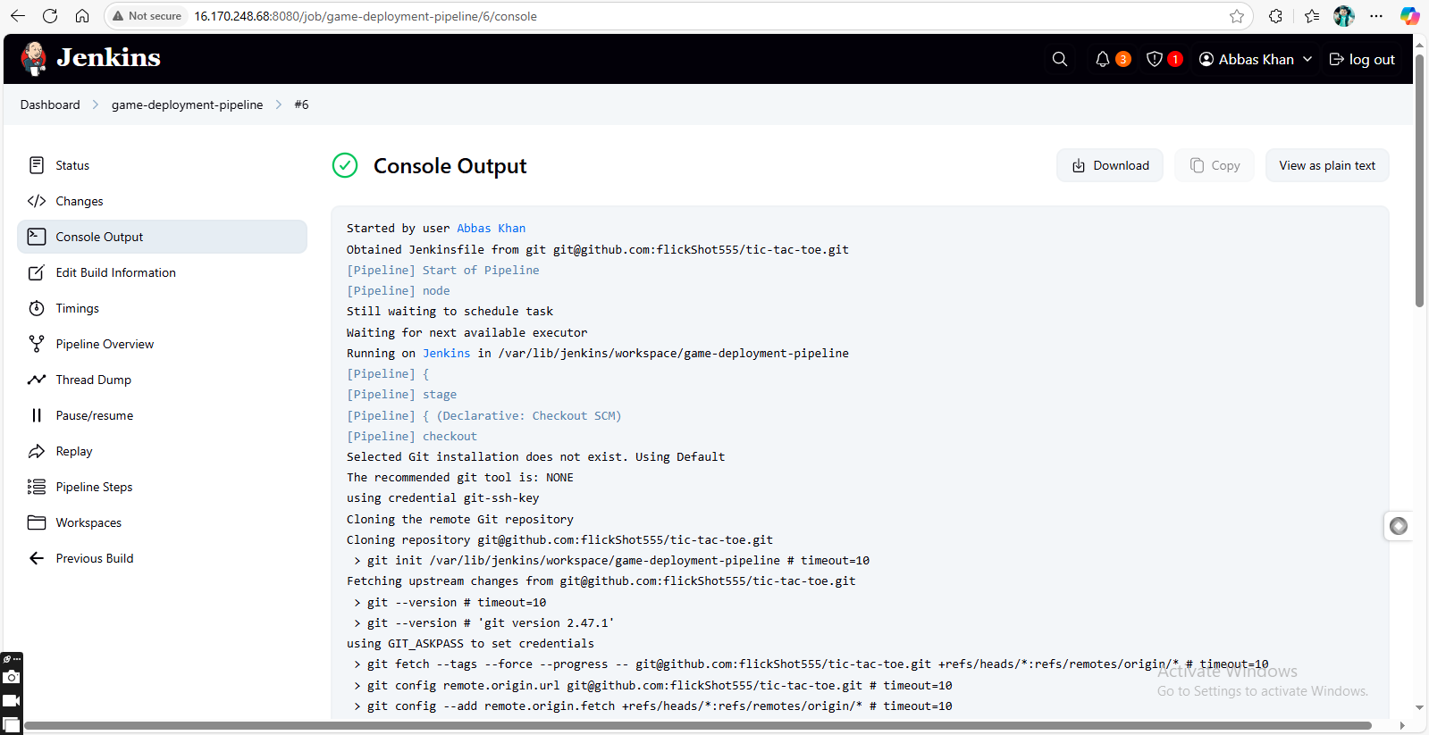

Complete text:

Started by GitHub push by flickShot555

Obtained Jenkinsfile from git git@github.com:flickShot555/tic-tac-toe.git

[Pipeline] Start of Pipeline

[Pipeline] node

Running on [Jenkins](http://16.170.248.68:8080/computer/(built-in)/) in /var/lib/jenkins/workspace/game-deployment-pipeline

[Pipeline] {

[Pipeline] stage

[Pipeline] { (Declarative: Checkout SCM)

[Pipeline] checkout

Selected Git installation does not exist. Using Default

The recommended git tool is: NONE

using credential git-ssh-key

> git rev-parse --resolve-git-dir /var/lib/jenkins/workspace/game-deployment-pipeline/.git # timeout=10

Fetching changes from the remote Git repository

> git config remote.origin.url git@github.com:flickShot555/tic-tac-toe.git # timeout=10

Fetching upstream changes from git@github.com:flickShot555/tic-tac-toe.git

> git --version # timeout=10

> git --version # 'git version 2.47.1'

using GIT_ASKPASS to set credentials

> git fetch --tags --force --progress -- git@github.com:flickShot555/tic-tac-toe.git +refs/heads/*:refs/remotes/origin/* # timeout=10

> git rev-parse refs/remotes/origin/main^{commit} # timeout=10

Checking out Revision 94cf155f9f02ccaec4e79690af28e87144c0ad74 (refs/remotes/origin/main)

> git config core.sparsecheckout # timeout=10

> git checkout -f 94cf155f9f02ccaec4e79690af28e87144c0ad74 # timeout=10

Commit message: "Update README.md"

> git rev-list --no-walk a9867ebd46d9ab1a1af54f468aee1e2f6c493652 # timeout=10

[Pipeline] }

[Pipeline] // stage

[Pipeline] withEnv

[Pipeline] {

[Pipeline] stage

[Pipeline] { (Checkout)

[Pipeline] echo

Checking out source...

[Pipeline] }

[Pipeline] // stage

[Pipeline] stage

[Pipeline] { (Build)

[Pipeline] echo

No build step required for a static site.

[Pipeline] }

[Pipeline] // stage

[Pipeline] stage

[Pipeline] { (Deploy)

[Pipeline] echo

Deploying to /var/www/html...

[Pipeline] sh

+ rm -rf /var/www/html/Jenkinsfile /var/www/html/README.md /var/www/html/index.html /var/www/html/script.js /var/www/html/style.css

+ cp -R Jenkinsfile README.md index.html script.js style.css /var/www/html/

[Pipeline] }

[Pipeline] // stage

[Pipeline] stage

[Pipeline] { (Declarative: Post Actions)

[Pipeline] echo

Pipeline finished successfully.

[Pipeline] }

[Pipeline] // stage

[Pipeline] }

[Pipeline] // withEnv

[Pipeline] }

[Pipeline] // node

[Pipeline] End of Pipeline

Finished: SUCCESS

# Apache hosted Game in browser:

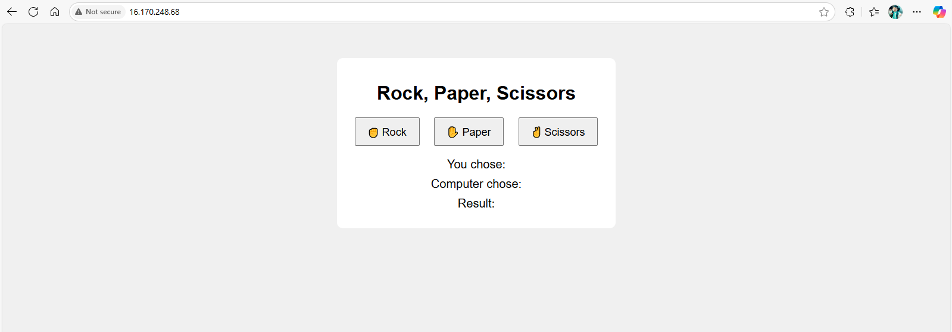

# GitHub Webhook:

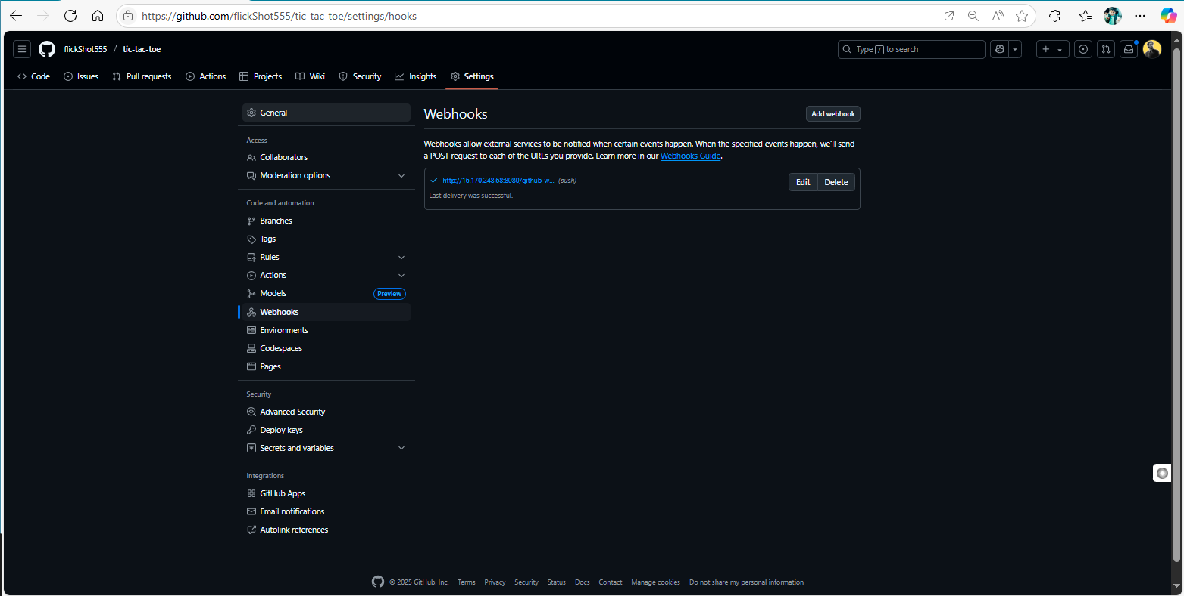

# Node status:

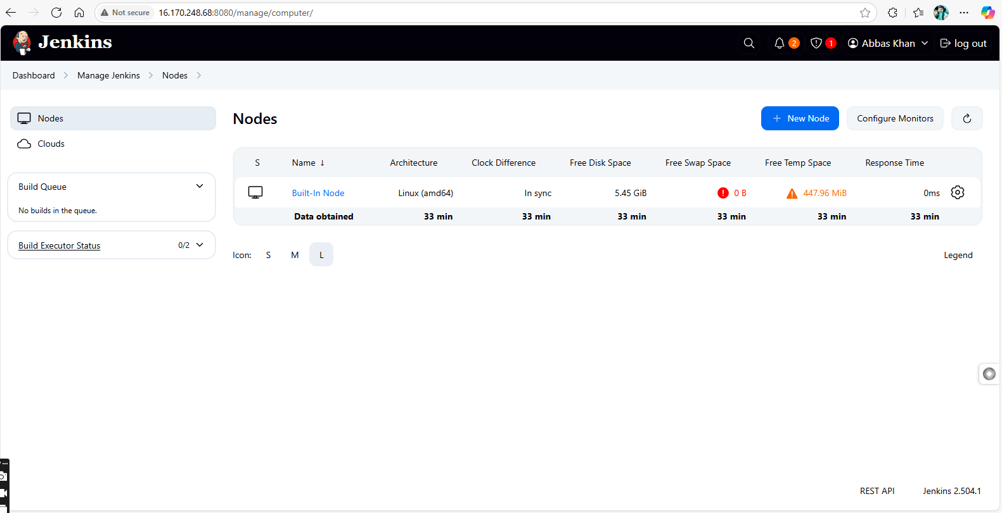

# Finally Configured pipeline:

Links:

1. Game: [Rock Paper Scissors Game](http://16.170.248.68/)

2. Jenkins dashboard: [Dashboard - Jenkins](http://16.170.248.68:8080/)

3. GitHub repo: [flickShot555/tic-tac-toe](https://github.com/flickShot555/tic-tac-toe)

Problems faced:

We faced a lot of problems while setting the node ‘online’ for running the Jenkins job. As the threshold amount of vacant memory was more than the actual amount of free memory.

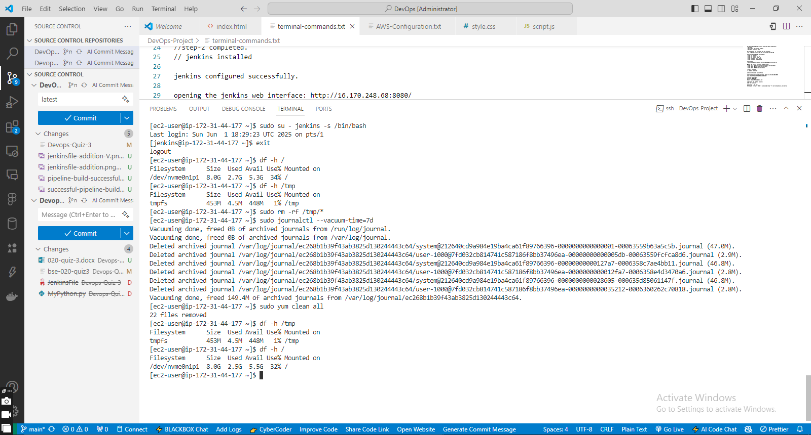

DEVOPS FOR CLOUD COMPUTING