**COMSATS UNIVERSITY ISLAMABAD ATTOCK CAMPUS**



**ABBAS KHAN**

**SP22-BSE-020**

**DEVOPS FOR CLOUD COMPUTING**

**User Creation**

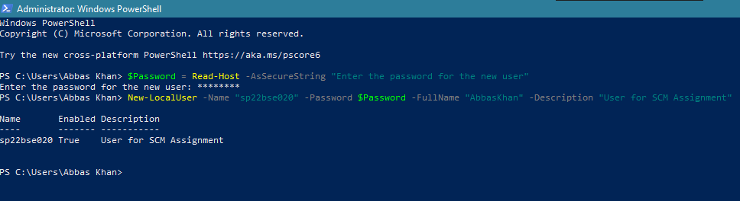

**Commands for basic Setup:**

1. **git config --global user.name "Your Name"**

**Purpose:**

Sets the global Git username that will be associated with my commits.

**Screenshot:**



1. **git config --global user.email "youremail@example.com"**

**Purpose:**

Sets the global email address to be associated with m commits.

**Screenshot:**



1. **git –version**

**Purpose:**

Used to check the currently installed version of Git on the system. Also helps to verify Git is installed correctly and shows the exact version number.

**Screenshot:**



1. **Cd ~, mkdir, cd filename**

**Purpose:**

Used to create the folder in the user named Muhammad Uzair.

**Screenshot:**

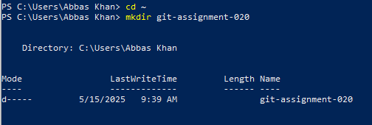

**Commands for Initialization:**

1. **git init**

**Purpose:**

This Command is used to Initializes a new Git repository in the current directory.

**Screenshot:**

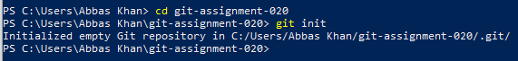

1. **git init -M main**

**Purpose:**

This command renames the current Git branch to main, even if a branch with that name already exists.

**Screenshot:**



**Commands for Staging and Committing**

1. **git add filename.txt**

**Purpose:**

This command is used to stage a specific file (filename.txt) so that it will be included in the next commit.

**Screenshot:**



1. **git commit -m "your message"**

**Purpose:**

Command used to Commits staged changes with a descriptive message.

**Screenshot:**



1. **git commit -a -m "your message"**

**Purpose:**

It is used to automatically stage and commit all modified files in one step with a commit message.

**Screenshot:**



**Commands for Status and Logs**

1. **git status**

**Purpose:**

This Command is used to show the current state of the working directory and staging area.

**Screenshot:**



1. **git log**

**Purpose:**

This command is used to display the commit history of the repository.

**Screenshot:**

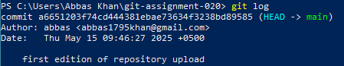

1. **git diff**

**Purpose:**

This command is used to show that which lines have been added or removed.

**Screenshot:**



1. **git diff –staged**

**Purpose:**

This command is used to show the changes between the staging area and the last commit.

**Screenshot:**



**Commands on Branching**

1. **Git branch**

**Purpose:**

This command is used to list, create, or delete branches in a Git repository.

**Screenshot:**



1. **Git branch -a**

**Purpose:**

This command is used to list all branches, including:

* + Local branches (on computer)
  + Remote branches (on GitHub)

**Screenshot:**



1. **Git switch -c branch_name**

**Purpose:**

This command is used to create a new branch and switch to it immediately.

**Screenshot:**



1. **Git switch branch_name**

**Purpose:**

It is used to switch from your current branch to another existing branch in the Git repository.

**Screenshot:**

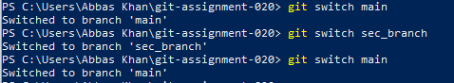

1. **Git branch -d branch_name**

**Purpose:**

This command is used to delete the branch using the name of the branch.

**Screenshot:**



**Command for Merging**

1. **Git merge branch_name Purpose:**

It is used to combine the changes from the specified branch into the current branch you’re on.

**Screenshot:**

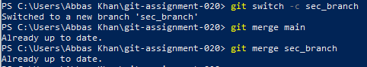

**Commands for Remote Repository**

1. **git remote add origin** <https://github.com/flickShot555/Planning-App.git>

**Purpose:**

This command adds a remote repository (on GitHub) and names it origin.

**Screenshot:**



**Commands for SSH setup**

1. **Ssh-keygen -o**

**Purpose:**

This command is used to is used to generate a new SSH key pair (public and private keys) for secure authentication with GitHub or other services.

**Screenshot:**

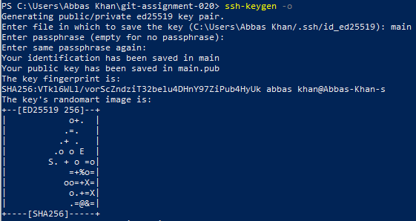

**Commands for tags**

1. **Git tag -a v1.0 -m “version 1.0”**

**Purpose:**

This command creates an annotated tag in Git with the name v1.0 and the message "version 1.0".

**Screenshot:**



1. **Git show v1.0**

**Purpose:**

This command is used to display detailed information about the tag v1.0 — including the commit it points to. **Screenshot:**

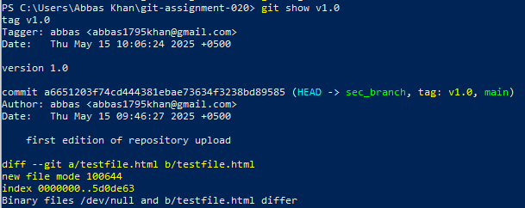

1. **Git push origin v1.0**

**Purpose:**

This command is used to push the tag v1.0 from your local repository to the remote repository.

**Screenshot:**

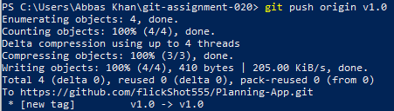

1. **Git clone repository_link**

**Purpose:**

This command is used to create a full copy of a remote Git repository on your local machine.

**Screenshot:**

