**COMSATS UNIVERSITY ISLAMABAD**

**ATTOCK CAMPUS**



**Name:** Abbas Khan

**Reg. No:** SP22-BSE-020

**Subject:** DevOps for Cloud Computing

**Assignment:** 2

**Date:** 5th April 2025

Solution:

* **Image pulling:**

“docker pull nginx:latest”

I ran the first command to pull the official nginx image from the Docker hub.

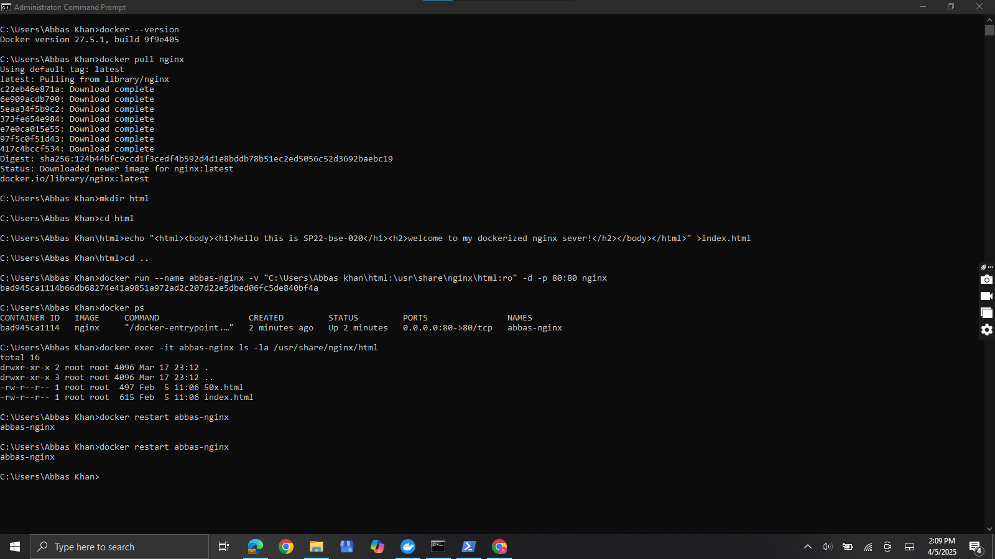

* **Directory and file creation:**

1. “mkdir html”
2. “>echo "<html><body><h1>hello this is SP22-bse-020</h1><h2>welcome to my dockerized nginx sever!</h2></body></html>" >index.html”

I ran these two commands for creating the html directory and creating an html file with the written content in it respectively.

* **Mapping & Running NGINX**

“docker run --name abbas-nginx -v "C:\Users\Abbas khan\html:\usr\share\nginx\html:ro" -d -p 80:80 nginx”

I ran this command to first map my own html volume to the html volume of the nginx server and then run the container.

I named my container as abbas-nginx, as it is easier for me to remember.



* **Verification**

“http:localhost:80”

I ran the above command in the URL bar of my browser to ensure my webpage is running fine on the server.

At first it was not running as my port 80 was listening to Apache(XAMPP), but then I turned it off and I restarted my container and it went well.



Other Screenshots:

