COMSATS UNIVERSITY ISLAMABAD

ATTOCK CAMPUS

ABBAS KHAN

SP22-BSE-020

DEVOPS FOR CLOUD COMPUTING

QUIZ #3

26/5/2025

1. Creating a multibranch github repository:

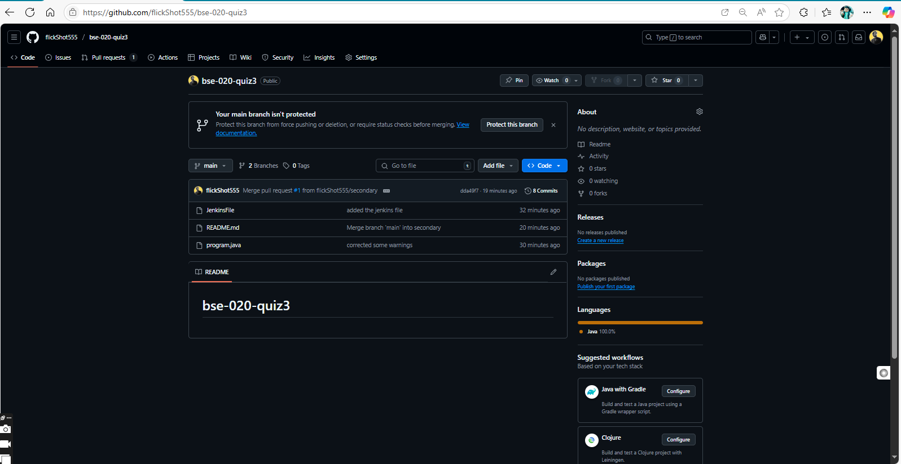

2. repository name: shown in the above figure.

3. main branch: shown in the above figure.

4. secondary branch: shown below.

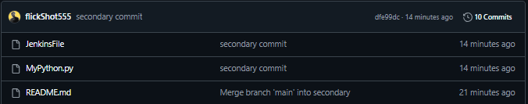

5. creating the multibranch pipeline in Jenkins:

My pipeline failed.

