

ASSIGNMENT 4

Mad


DECEMBER 25, 2024
SARDAR MUHAMMAD AHSAN KHAN
Sp22-bse-016

- Part 1 and 3:
Code:
import React, { useState, useEffect } from 'react';
import { View, Text, TextInput, TouchableOpacity, Alert, StyleSheet, Image, FlatList } from 'react-native';
import { NavigationContainer } from '@react-navigation/native';
import { createNativeStackNavigator } from '@react-navigation/native-stack';
import { Provider, useDispatch, useSelector } from 'react-redux';
import { configureStore } from '@reduxjs/toolkit';
import { setUser, setLocation } from './reducers/userReducer'; // Redux actions
import * as Location from 'expo-location';
import AsyncStorage from '@react-native-async-storage/async-storage';

// Redux Store Setup
const store = configureStore({
reducer: {
user: userReducer,
},
});

// Reducer for managing user state
const initialState = {
username: '',
email: '',
phone: '',
password: '',
location: null,
};

const userSlice = createSlice({
name: 'user',
initialState,
reducers: {
setUser: (state, action) => {
state.username = action.payload.username;
state.email = action.payload.email;
state.phone = action.payload.phone;
state.password = action.payload.password;
},
setLocation: (state, action) => {
state.location = action.payload;
},
},
});

export const { setUser, setLocation } = userSlice.actions;
const userReducer = userSlice.reducer;

// Sample order data
const data = [
{
id: '1',
order: 'Beef Burger, Ice Cream, Berries',
date: '21,Thu 10:00',
price: '$38.15',
image: 'https://simplehomeedit.com/wp-content/uploads/2024/03/HomemadeBeefBurgers-4.webp',
},
{
id: '2',
order: 'Beef Burger, Peparini Moo, Cheese Dust',
date: '15,Fri 18:00',
price: '$38.15',
image: 'https://encryptedtbn0.gstatic.com/images?q=tbn:ANd9GcSuMQPEM152oLXMsDadiGcp7jK2ug92FXng2g&s',
},
{
id: '3',
order: 'Beef Burger, Ketchup, French Fries',
date: '11,Mon 09:00',
price: '$30.50',
image: 'https://www.recipetineats.com/tachyon/2022/09/CrispyFries_8.jpg?resize=500%2C375',
},
];

// Screens
const SignupScreen = ({ navigation }) => {
const dispatch = useDispatch();
const [username, setUsername] = useState('');
const [email, setEmail] = useState('');
const [phone, setPhone] = useState('');
const [password, setPassword] = useState('');

// Renamed setUser to handleUserSignup to avoid conflict
const handleUserSignup = () => {
const usernameRegex = /^[A-Za-z]+$/;
const emailRegex = /^[^\s@]+@[^\s@]+\.[^\s@]+$/;
const phoneRegex = /^\+92-3\d{2}-\d{7}$/;
if (!usernameRegex.test(username)) {
Alert.alert('Error', 'Username must contain alphabets only.');
return;
}
if (!emailRegex.test(email)) {
Alert.alert('Error', 'Invalid email format.');
return;
}
if (!phoneRegex.test(phone)) {
Alert.alert('Error', 'Phone number must match +92-3xx-xxxxxxx format.');
return;
}
if (password.length < 6) {
Alert.alert('Error', 'Password must be at least 6 characters long.');
return;
}

dispatch(setUser({ username, email, phone, password }));
navigation.navigate('Login');
};

return (
<View style={styles.container}>
<Text style={styles.title}>Sign Up</Text>
<TextInput style={styles.input} placeholder="Username" value={username} onChangeText={setUsername} />
<TextInput style={styles.input} placeholder="Email" value={email} onChangeText={setEmail} keyboardType="email-address" />
<TextInput style={styles.input} placeholder="Phone (+92-3xx-xxxxxxx)" value={phone} onChangeText={setPhone} keyboardType="phone-pad" />
<TextInput style={styles.input} placeholder="Password" value={password} onChangeText={setPassword} secureTextEntry />
<TouchableOpacity style={styles.button} onPress={handleUserSignup}>
<Text style={styles.buttonText}>Sign Up</Text>
</TouchableOpacity>
</View>
);
};

const LoginScreen = ({ navigation }) => {
const dispatch = useDispatch();
const [email, setEmail] = useState('');
const [password, setPassword] = useState('');

useEffect(() => {
(async () => {
let { status } = await Location.requestForegroundPermissionsAsync();
if (status === 'granted') {
let location = await Location.getCurrentPositionAsync({});
await AsyncStorage.setItem('userLocation', JSON.stringify(location));
dispatch(setLocation(location));
} else {
Alert.alert('Error', 'Location permission not granted');
}
})();
}, []);

const validateAndLogin = () => {
const emailRegex = /^[^\s@]+@[^\s@]+\.[^\s@]+$/;
if (!emailRegex.test(email)) {
Alert.alert('Error', 'Invalid email format.');
return;
}
if (password.length < 6) {
Alert.alert('Error', 'Password must be at least 6 characters long.');
return;
}
navigation.navigate('Profile');
};

return (

<View style={styles.container}>
<Text style={styles.title}>Login</Text>
<TextInput style={styles.input} placeholder="Email" value={email} onChangeText={setEmail} keyboardType="email-address" />
<TextInput style={styles.input} placeholder="Password" value={password} onChangeText={setPassword} secureTextEntry />
<TouchableOpacity style={styles.button} onPress={validateAndLogin}>
<Text style={styles.buttonText}>Login</Text>
</TouchableOpacity>
</View>
);
};

const ProfileScreen = () => {
const { location } = useSelector((state) => state.user);

return (
<View style={styles.container}>
<Text style={styles.title}>My Profile</Text>
{location ? (
<Text style={styles.location}>
Latitude: {location.coords.latitude}, Longitude: {location.coords.longitude}
</Text>
) : (
<Text style={styles.location}>Location not available</Text>
)}

<FlatList
data={data}
keyExtractor={(item) => item.id}
renderItem={({ item }) => (
<View style={styles.orderItem}>
<Image source={{ uri: item.image }} style={styles.orderImage} />
<View style={styles.orderDetails}>
<Text style={styles.orderText}>{item.order}</Text>
<Text style={styles.orderDate}>{item.date}</Text>
</View>
<Text style={styles.orderPrice}>{item.price}</Text>
</View>
)}
/>
</View>
);
};

// App Component
export default function App() {
return (
<Provider store={store}>
<NavigationContainer>
<Stack.Navigator initialRouteName="Signup">
<Stack.Screen name="Signup" component={SignupScreen} />
<Stack.Screen name="Login" component={LoginScreen} />
<Stack.Screen name="Profile" component={ProfileScreen} />
</Stack.Navigator>
</NavigationContainer>
</Provider>
);
}

// Styles
const styles = StyleSheet.create({
container: {
flex: 1,
backgroundColor: '#E8F0FE',
padding: 20,
},
title: {
fontSize: 24,
fontWeight: 'bold',
marginBottom: 20,
textAlign: 'center',
},
input: {
borderWidth: 1,
borderColor: '#ccc',
borderRadius: 8,
padding: 10,
marginBottom: 15,
},
button: {
backgroundColor: '#007BFF',
padding: 15,
borderRadius: 8,
alignItems: 'center',
},
buttonText: {
color: '#fff',
fontSize: 16,
},
orderItem: {
flexDirection: 'row',
backgroundColor: '#444',
padding: 15,
borderRadius: 10,
marginBottom: 15,
},
orderImage: {
width: 50,
height: 50,
borderRadius: 25,
marginRight: 15,
},
orderDetails: {
flex: 1,
},
orderText: {
color: '#FFF',
fontSize: 16,
marginBottom: 5,
},
orderDate: {
color: '#AAA',
fontSize: 12,
},
orderPrice: {
color: '#FFF',
fontSize: 16,
},
location: {
fontSize: 16,
marginTop: 10,
color: '#333',
},
});
Output:

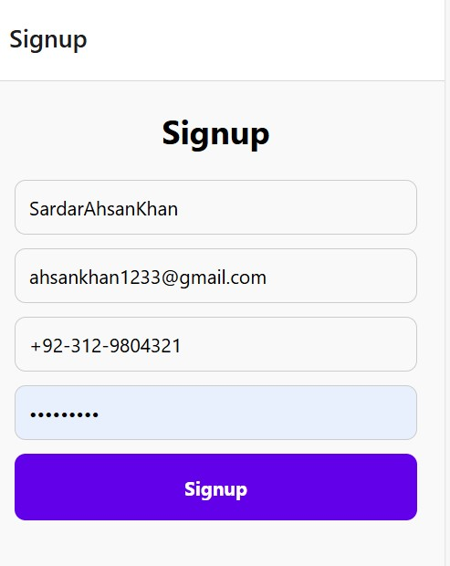
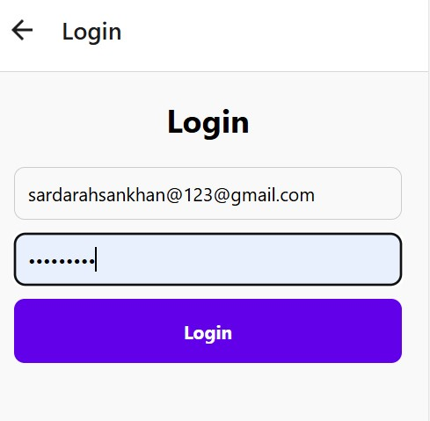
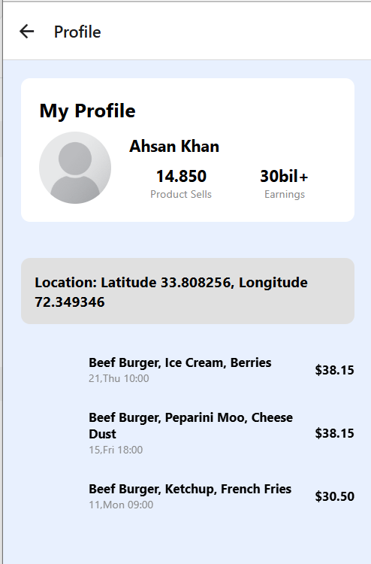

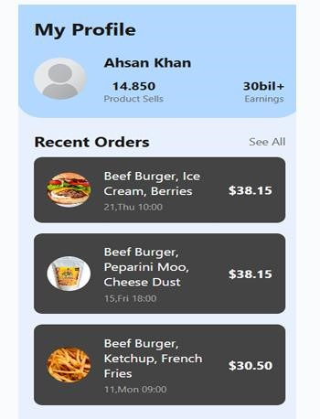
- Part # 2:
import React, { useState } from 'react';
import { View, TextInput, Alert, StyleSheet, TouchableOpacity, Text, ScrollView, Image } from 'react-native';
import AsyncStorage from '@react-native-async-storage/async-storage';

const FIREBASE_API_ENDPOINT = 'https://ahsan-8f472-default-rtdb.firebaseio.com';

export default function App() {
const [email, setEmail] = useState('');
const [password, setPassword] = useState('');
const [confirmPassword, setConfirmPassword] = useState('');
const [isLogin, setIsLogin] = useState(false);
const [userData, setUserData] = useState(null); // For displaying user data from Firebase

const register = async () => {
if (!email || !password || !confirmPassword) {
Alert.alert('Error', 'All fields are required.');
return;
}

if (password !== confirmPassword) {
Alert.alert('Error', 'Passwords do not match.');
return;
}

try {
await AsyncStorage.setItem('user', JSON.stringify({ email, password }));
Alert.alert('Success', 'User registered successfully!');
} catch (error) {
Alert.alert('Error', 'An error occurred during registration.');
}
};

const login = async () => {
if (!email || !password) {
Alert.alert('Error', 'Both fields are required.');
return;
}

try {
const storedUser = await AsyncStorage.getItem('user');
const user = storedUser ? JSON.parse(storedUser) : null;

if (user && user.email === email && user.password === password) {
Alert.alert('Success', 'Login successful!');

// Firebase Insert Example
await fetch(`${FIREBASE_API_ENDPOINT}/users.json`, {
method: 'POST',
body: JSON.stringify({ email }),
headers: {
'Content-Type': 'application/json',
},
});
} else {
Alert.alert('Error', 'Incorrect email or password.');
}
} catch (error) {
Alert.alert('Error', 'An error occurred during login.');
}
};

const retrieveData = async () => {
try {
const response = await fetch(`${FIREBASE_API_ENDPOINT}/users.json`);
const data = await response.json();
const userArray = Object.values(data); // Convert object to array
setUserData(userArray); // Set the retrieved data to the state
} catch (error) {
Alert.alert('Error', 'Failed to retrieve data.');
}
};

return (
<ScrollView contentContainerStyle={styles.container}>
{/* Header with Icon */}
<View style={styles.header}>
<Image
source={{
uri: 'https://www.bing.com/images/search?view=detailV2&ccid=HV0w4p9U&id=033B8983ABEBA64C1BA26A9CE0EE48FF4321D2C7&thid=OIP.HV0w4p9UfSW0iI36Xs41ggHaD7&mediaurl=https%3a%2f%2fstatic.vecteezy.com%2fsystem%2fresources%2fpreviews%2f025%2f337%2f736%2foriginal%2fpeople-avatar-smiling-human-circle-portrait-female-and-male-person-round-avatars-flat-icon-illustration-collection-vector.jpg&cdnurl=https%3a%2f%2fth.bing.com%2fth%2fid%2fR.1d5d30e29f547d25b4888dfa5ece3582%3frik%3dx9IhQ%252f9I7uCcag%26pid%3dImgRaw%26r%3d0&exph=1017&expw=1920&q=Human+Avatar&simid=607996456152694274&FORM=IRPRST&ck=EE9818E2145D2B61445BC28F406E4BA8&selectedIndex=8&itb=0',
}}
style={styles.headerIcon}
/>
<Text style={styles.headerText}>
{isLogin ? 'Welcome Back!' : 'Create Your Account'}
</Text>
</View>

<View style={styles.formContainer}>
<TextInput
style={styles.input}
placeholder="Email"
value={email}
onChangeText={setEmail}
keyboardType="email-address"
/>
<TextInput
style={styles.input}
placeholder="Password"
value={password}
secureTextEntry
onChangeText={setPassword}
/>
{!isLogin && (
<TextInput
style={styles.input}
placeholder="Confirm Password"
value={confirmPassword}
secureTextEntry
onChangeText={setConfirmPassword}
/>
)}
<TouchableOpacity
style={[styles.button, styles.primaryButton]}
onPress={isLogin ? login : register}
>
<Text style={styles.buttonText}>{isLogin ? 'Login' : 'Register'}</Text>
</TouchableOpacity>

<TouchableOpacity onPress={() => setIsLogin(!isLogin)} style={styles.switchButton}>
<Text style={styles.switchText}>
{isLogin ? "Don't have an account? Register" : 'Already have an account? Login'}
</Text>
</TouchableOpacity>

{/* Button to fetch user data from Firebase */}
<TouchableOpacity onPress={retrieveData} style={[styles.button, styles.secondaryButton]}>
<Text style={styles.buttonText}>Retrieve Data</Text>
</TouchableOpacity>

{/* Display fetched data */}
{userData && (
<View style={styles.dataContainer}>
<Text style={styles.dataText}>Fetched Users:</Text>
{userData.map((user, index) => (
<Text key={index} style={styles.userText}>
{user.email}
</Text>
))}
</View>
)}
</View>
</ScrollView>
);
}

const styles = StyleSheet.create({
container: {
flexGrow: 1,
justifyContent: 'center',
alignItems: 'center',
backgroundColor: '#f9f9f9',
paddingVertical: 20,
},
header: {
width: '100%',
padding: 20,
flexDirection: 'row',
alignItems: 'center',
justifyContent: 'center',
backgroundColor: '#4CAF50',
borderBottomLeftRadius: 50,
borderBottomRightRadius: 50,
elevation: 5,
},
headerIcon: {
width: 40,
height: 40,
marginRight: 10,
borderRadius: 20,
},
headerText: {
fontSize: 24,
color: '#fff',
fontWeight: 'bold',
},
formContainer: {
backgroundColor: '#ffffff',
borderRadius: 20,
width: '90%',
padding: 25,
marginVertical: 20,
shadowColor: '#000',
shadowOffset: { width: 0, height: 5 },
shadowOpacity: 0.1,
shadowRadius: 10,
elevation: 5,
},
input: {
borderWidth: 1,
borderColor: '#ddd',
borderRadius: 12,
padding: 14,
marginBottom: 15,
fontSize: 16,
backgroundColor: '#f9f9f9',
},
button: {
paddingVertical: 15,
borderRadius: 50,
alignItems: 'center',
justifyContent: 'center',
marginBottom: 15,
elevation: 3,
},
primaryButton: {
backgroundColor: '#4CAF50',
},
secondaryButton: {
backgroundColor: '#007BFF',
},
buttonText: {
color: '#fff',
fontSize: 16,
fontWeight: 'bold',
},
switchButton: {
alignItems: 'center',
marginTop: 15,
},
switchText: {
color: '#4CAF50',
fontSize: 14,
fontWeight: '500',
},
dataContainer: {
marginTop: 20,
padding: 15,
backgroundColor: '#f2f2f2',
borderRadius: 12,
borderWidth: 1,
borderColor: '#ddd',
},
dataText: {
fontSize: 18,
fontWeight: 'bold',
color: '#333',
},
userText: {
fontSize: 16,
marginVertical: 5,
color: '#555',
},
});
Sign up:
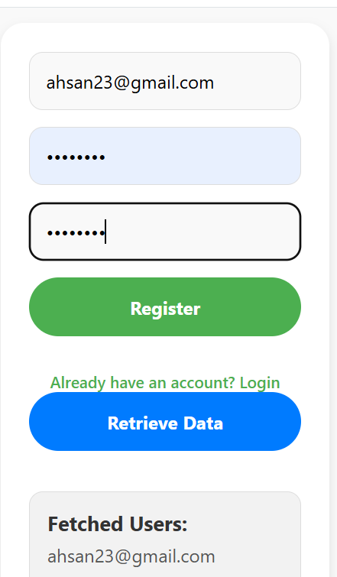
Login :

