**TME 196 – Impact Biomechanics**

**Assignment 3 Report**

**Group A2 – Target age 30 years old**

|  |  |
| --- | --- |
| Fikri Farhan Witjakson | fikrif@student.chalmers.se |
| Vignesh Krishnan | vigkri@student.chalmers.se |
| Vincent Jip | jipv@student.chalmers.se |

During impact, the seat belt protects the occupant and the airbag prevents the head from hitting the steering column. The target age group of the occupant is 30 years. Compared to older age groups, the bone density and structure of a 30 years old is significantly stronger than 60 years old and could be a good reason as to why the occupant has lesser risk of injury.

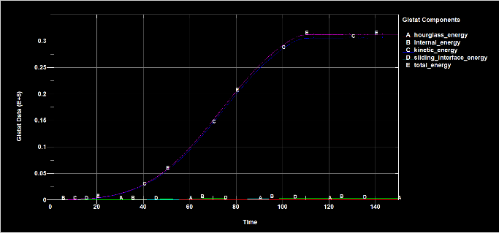 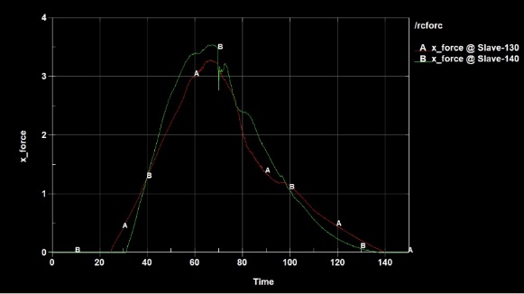

A 1 Energy Balance A 2 Knee force

The total energy (ref figure A 1) is dominated by the kinetic energy which increases during the crash. There is a small component of internal energy and sliding energy which could be due to the stiffness and resistance from the parts while the sliding energy could be due to pre-tensioner or may be due to belt sliding during crash.

Looking at the force plot (ref figure A 2) for the right and left knee during crash, it can be understood that the knees come in contact with the dash board during crash and there are possibilities of injury.

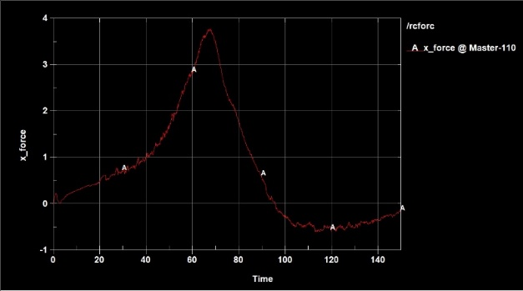

A 3 Pelvis seat force

Seat to pelvis force curve (ref figure A 3) also suggests that the negative force could be that the human body model rises from the seat at the time of crash.

1. **Head Injury**

|  |  |  |  |
| --- | --- | --- | --- |
|  | **2.5kN** | **4.0kN** | **5.5kN** |
| Local | 0.0804 | 0.078 | 0.076 |
| Global HIC value | 162.4 | 163.6 | 161.1 |
| Global AIS 2+ risk approximation | 0.05-0.10 | 0.05-0.10 | 0.05-0.10 |

* 1. **Local tissue criteria**

It was observed that during crash, the head hits the airbag and the 1st principal St Venant strain was maximum, suggesting that the airbag was successful in mitigating the impact on the head, which otherwise would have hit the steering wheel.



* 1. **Global criteria**

The AIS2+ Head Injury Criteria – 15 (HIC) value was used for the global criteria. The values suggests that the chances of the occupant suffering a serious head injury is very low. As can be seen from the AIS2+ curve, the risk for severe head injury is approximately 5-10%.



1. **Chest Injury**

|  |  |  |  |  |  |
| --- | --- | --- | --- | --- | --- |
|  | **Global Criteria** | | **Local Criteria** | | |
| **Chest Deflection**  **(mm)** | **Fracture**  **Risk**  **(%)** | **Number of broken ribs** | **Ribs that have high risk of fracture** | |
| 2.5 kN | 44.5 | 2.42 | 0 | - | |
| 4.0 kN | 50.7 | 8.02 | 3 | Right: | 8,9 |
| Left: | 4 |
| 5.5 kN | 55 | 14.75 | 6 | Right: | 7,8,9,10 |
| Left: | 3,4 |

* 1. **Local tissue criteria**

The rib failure risk assessed as percentage for each rib. The ribs with high risk of fracture (i.e. risk > 0.90), were identified for each load case and averaged. This led to the conclusion that the risk of rib fracture is high (6ribs) for the 5.5kN load case. In the 4kN load case, high risk for 3 ribs is seen, while for the 2.5kN load case, there is no high risk of fracture for any ribs. For AIS2+, i.e, two or more ribs fractured, the 2.5kN load case has the least risk and the 5.5kN load case has the highest risk.

* 1. **Global criteria**

The peak chest compression was recorded for all the load cases and was found to be maximum in the 5.5kN load case and least in 2.5kN load case, as expected. This suggests that the effect of high load limiter increases the risk and number of rib fractures.