Name________________________ Mark _____________________/50

[**Instructions**: Remove everything that is not a heading below and fill in with your own diagrams, etc.]

## Brief introduction __/3

## Use case diagram with scenario __14

[Use the lecture notes in class.

Ensure you have at least one exception case, and that the <<extend>> matches up with the Exceptions in your scenario, and the Exception step matches your Basic Sequence step.

Also include an <<include>> that is a suitable candidate for dynamic binding]

Example:

### Use Case Diagrams

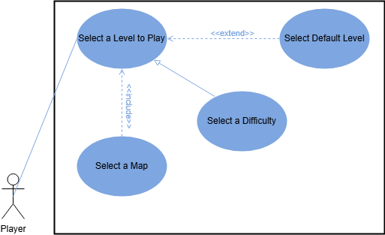

### Scenarios

**Name:** Select a Level to Play

**Summary:** The player chooses a level to play.

**Actors:** Player.

**Preconditions:** Data about different level options is loaded. The player clicked the player button in the main menu. There is no round currently running.

**Basic sequence:**

**Step 1:** Accept map selection.

**Step 2:** Accept difficulty selection.

**Step 3:** Load a level based on player’s map choice

**Step 4:** Start the first round

**Exceptions:**

**Step 1:** Player doesn’t make a choice for the map: default map is selected

**Step 2:** Player doesn’t make a choice about the difficulty: default difficulty is selected

**Post conditions:** A level will be loaded.

**Priority:** 1*

**ID:** SL1

*The priorities are 1 = must have, 2 = essential, 3 = nice to have.

## Data Flow diagram(s) from Level 0 to process description for your feature _______14

[Get the Level 0 from your team. Highlight the path to your feature]

Example:

### Data Flow Diagrams

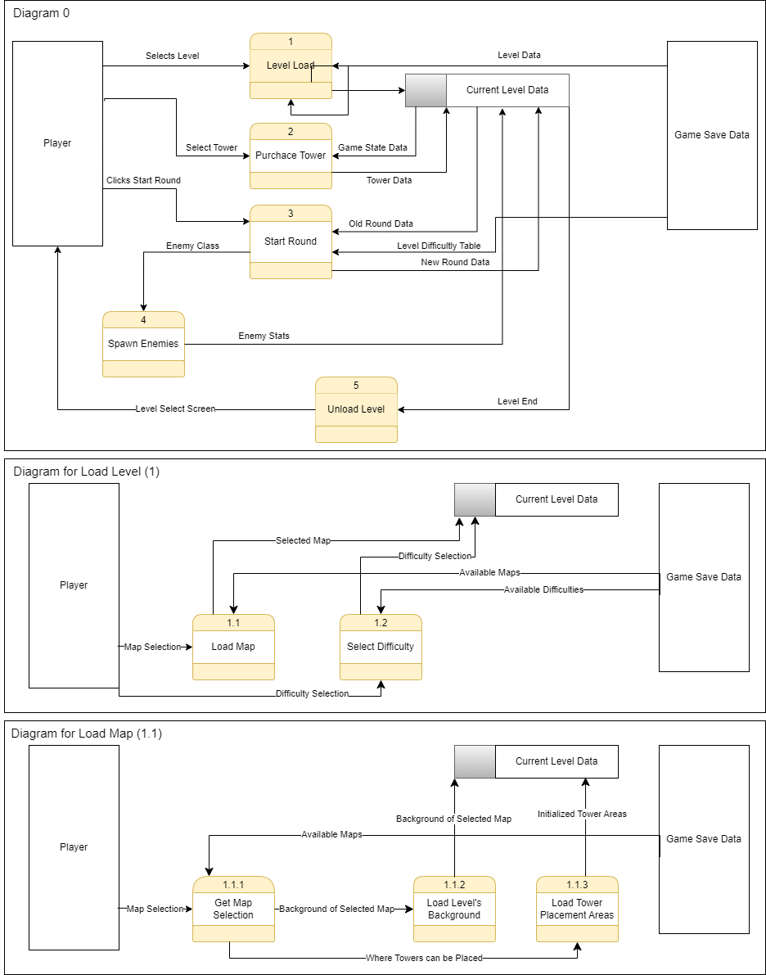

### Process Descriptions

Level Load*:

IF player clicks play THEN

Show level selection screen

IF player chooses map THEN

Set level map to player’s choice

ELSE

Set level map to default map

END_ELSE

IF player chooses difficulty THEN

Set level difficulty to player’s choice

ELSE

Set level difficulty to default difficulty

END_ELSE

Load level map’s background

Initialize level map’s tower areas

Unload Level*:

IF game over THEN

Unload towers

Unload background

Show main menu

## Acceptance Tests ________9

Run feature (number of maps) * (number of different difficulties) times, each time selecting selecting a new combination of map and difficulty until all combinations of map and difficulties have been selected.

The expected output should have the following characteristics:

* Map ID of the map that was selected
* Difficulty level of the difficulty selected

## Timeline _________/10

### Work items

|  |  |  |
| --- | --- | --- |
| Task | Duration (PWks) | Predecessor Task(s) |
| 1. Requirements Collection | 5 | - |
| 2. Plan Dynamic Binding | 2 | 1 |
| 3. Plan Pattern | 2 | 1 |
| 4. Tower Zone Design | 6 | 1 |
| 5. Level Management Design | 10 | 1 |
| 6. Find/Create backgrounds | 8 | - |
| 7. Design Maps | 5 | 6, 4 |
| 8. Level Management Programming | 10 | 2, 3, 5 |
| 9. Tower Zone Programming | 4 | 2, 3, 4 |
| 10. Testing | 2 | 7, 8, 9 |
| 11. User Documentation | 2 | 7, 8, 9 |

### Pert diagram

### Gantt timeline

|  |  |  |  |  |  |  |  |  |  |  |  |  |  |  |  |  |  |  |  |  |  |  |  |  |  |  |  |  |  |  |  |  |
| --- | --- | --- | --- | --- | --- | --- | --- | --- | --- | --- | --- | --- | --- | --- | --- | --- | --- | --- | --- | --- | --- | --- | --- | --- | --- | --- | --- | --- | --- | --- | --- | --- |
| 1 |  |  |  |  |  |  |  |  |  |  |  |  |  |  |  |  |  |  |  |  |  |  |  |  |  |  |  |  |  |  |  |  |
| 2 |  |  |  |  |  | 1 |  |  |  |  |  |  |  |  |  |  |  |  |  |  |  |  |  |  |  |  |  |  |  |  |  |  |
| 3 |  |  |  |  |  | 1 |  |  |  |  |  |  |  |  |  |  |  |  |  |  |  |  |  |  |  |  |  |  |  |  |  |  |
| 4 |  |  |  |  |  | 1 |  |  |  |  |  |  |  |  |  |  |  |  |  |  |  |  |  |  |  |  |  |  |  |  |  |  |
| 5 |  |  |  |  |  | 1 |  |  |  |  |  |  |  |  |  |  |  |  |  |  |  |  |  |  |  |  |  |  |  |  |  |  |
| 6 |  |  |  |  |  |  |  |  |  |  |  |  |  |  |  |  |  |  |  |  |  |  |  |  |  |  |  |  |  |  |  |  |
| 7 |  |  |  |  |  |  |  |  |  |  |  | 4, 6 | |  |  |  |  |  |  |  |  |  |  |  |  |  |  |  |  |  |  |  |
| 8 |  |  |  |  |  |  |  |  |  |  |  |  |  |  |  | 2, 3, 5 | |  |  |  |  |  |  |  |  |  |  |  |  |  |  |  |
| 9 |  |  |  |  |  |  |  |  |  |  |  | 2, 3, 4 | |  |  |  |  |  |  |  |  |  |  |  |  |  |  |  |  |  |  |  |
| 10 |  |  |  |  |  |  |  |  |  |  |  |  |  |  |  |  |  |  |  |  |  |  |  |  |  | 7, 8, 9 | |  |  |  |  |  |
| 11 |  |  |  |  |  |  |  |  |  |  |  |  |  |  |  |  |  |  |  |  |  |  |  |  |  | 7, 8, 9 | |  |  |  |  |  |
|  | 1 | 2 | 3 | 4 | 5 | 6 | 7 | 8 | 9 | 10 | 11 | 12 | 13 | 14 | 15 | 16 | 17 | 18 | 19 | 20 | 21 | 22 | 23 | 24 | 25 | 26 | 27 | 28 | 29 | 30 | 31 | 32 |