Developer Manual

Team 5 Guys

Contents

Environment Setup 2

High Level Overview 2

Context Diagram 2

Class Diagrams 2

Enemies 2

Towers 3

Level Manager 4

Round Manager 5

User Interface 6

Creating a Scene (Prefab Equivalent) 6

Documentation 6

Test Plan 6

Static and Dynamic Binding 6

Patterns 7

Code Reuse 7

# Environment Setup

# High Level Overview

## Context Diagram

## Class Diagrams

### Enemies

### Towers

### Level Manager

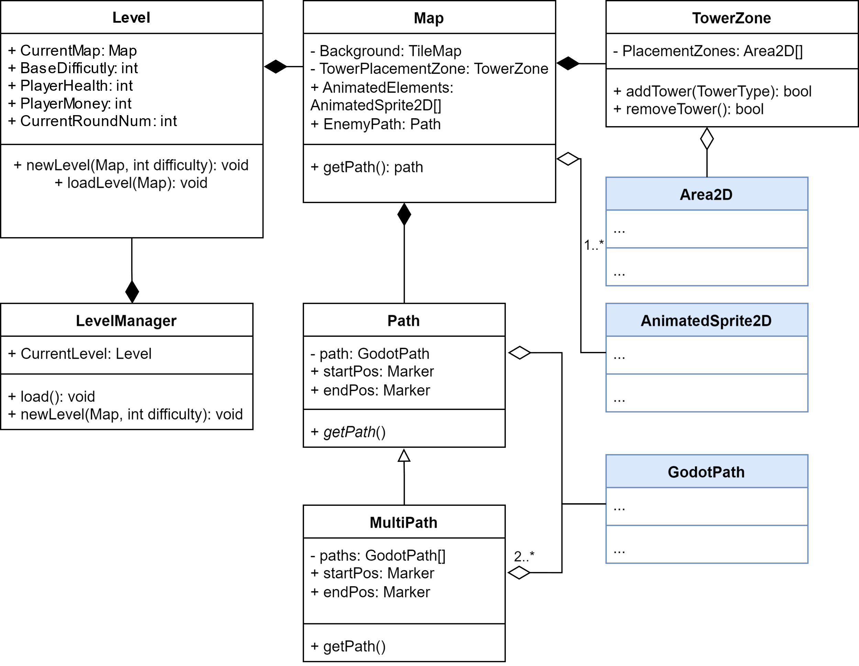

### Round Manager

### User Interface

# Scenes (Prefab Equivalent)

## Introduction to Scenes

There is no concept of a prefab, there are however scenes. Scenes allow us to get the general structure and functionality of an object figured out using Godot’s node system. Once the scene is created you can, use the scene to define other scenes, or use it in your game.

The general structure for Kill Mo’ Chickens will be:

Each feature will have some collection of scenes associated with it. Each feature’s scenes will be connected to a main scene that will mediate a connection for the scenes where needed.

## Creating a Scene

tkEndedHere

# Documentation

# Test Plan

# Static and Dynamic Binding

# Patterns

# Code Reuse