Name________________________ Mark _____________________/50
[Instructions: Remove everything that is not a heading below and fill in with your own diagrams, etc.]

Brief introduction __/3

Use case diagram with scenario __14
[Use the lecture notes in class.
Ensure you have at least one exception case, and that the <<extend>> matches up with the Exceptions in your scenario, and the Exception step matches your Basic Sequence step.
Also include an <<include>> that is a suitable candidate for dynamic binding]
Example:

Use Case Diagrams
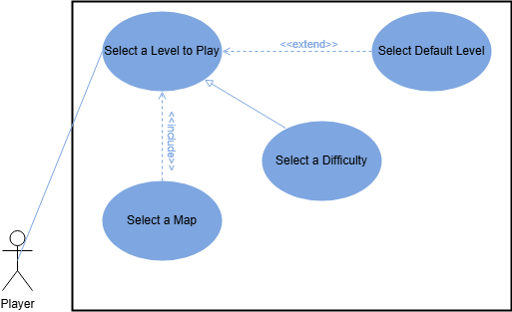

Scenarios
Name: Select a Level to Play
Summary: The player chooses a level to play.
Actors: Player.
Preconditions: Data about different level options is loaded. The player clicked the player button in the main menu. There is no round currently running.
Basic sequence:
Step 1: Accept map selection.
Step 2: Accept difficulty selection.
Step 3: Load a level based on player’s map choice
Step 4: Start the first round
Exceptions:
Step 1: Player doesn’t make a choice for the map: default map is selected
Step 2: Player doesn’t make a choice about the difficulty: default difficulty is selected
Post conditions: A level will be loaded.
Priority: 1*
ID: SL1
*The priorities are 1 = must have, 2 = essential, 3 = nice to have.

Data Flow diagram(s) from Level 0 to process description for your feature _______14
[Get the Level 0 from your team. Highlight the path to your feature]
Example:

Data Flow Diagrams
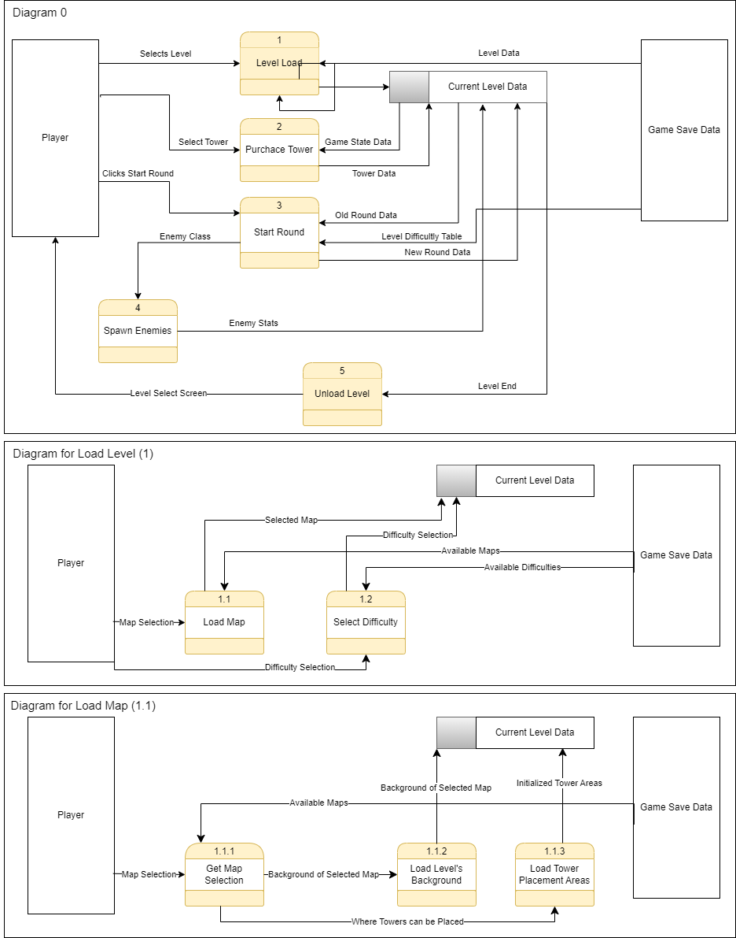

Process Descriptions
Level Load*:
IF player clicks play THEN
Show level selection screen
IF player chooses map THEN
Set level map to player’s choice
ELSE
Set level map to default map
END_ELSE
IF player chooses difficulty THEN
Set level difficulty to player’s choice
ELSE
Set level difficulty to default difficulty
END_ELSE
Load level map’s background
Initialize level map’s tower areas
Unload Level*:
IF game over THEN
Unload towers
Unload background
Show main menu

Acceptance Tests ________9
Run feature (number of maps) * (number of different difficulties) times, each time selecting selecting a new combination of map and difficulty until all combinations of map and difficulties have been selected.
The expected output should have the following characteristics:
- Map ID of the map that was selected
- Difficulty level of the difficulty selected

Timeline _________/10

Work items
Task | Duration (PWks) | Predecessor Task(s)
1. Requirements Collection | 5 | -
2. Plan Dynamic Binding | 2 | 1
3. Plan Pattern | 2 | 1
4. Tower Zone Design | 6 | 1
5. Level Management Design | 10 | 1
6. Find/Create backgrounds | 8 | -
7. Design Maps | 5 | 6, 4
8. Level Management Programming | 10 | 2, 3, 5
9. Tower Zone Programming | 4 | 2, 3, 4
10. Testing | 2 | 7, 8, 9
11. User Documentation | 2 | 7, 8, 9

Pert diagram
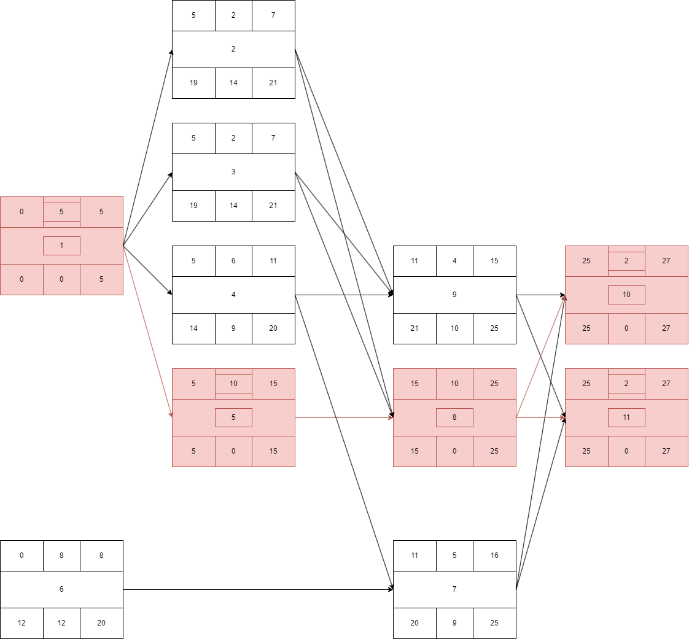

Gantt timeline
1
2 |  |  |  |  |  | 1
3 |  |  |  |  |  | 1
4 |  |  |  |  |  | 1
5 |  |  |  |  |  | 1
6
7 |  |  |  |  |  |  |  |  |  |  |  | 4, 6
8 |  |  |  |  |  |  |  |  |  |  |  |  |  |  |  | 2, 3, 5
9 |  |  |  |  |  |  |  |  |  |  |  | 2, 3, 4
10 |  |  |  |  |  |  |  |  |  |  |  |  |  |  |  |  |  |  |  |  |  |  |  |  |  | 7, 8, 9
11 |  |  |  |  |  |  |  |  |  |  |  |  |  |  |  |  |  |  |  |  |  |  |  |  |  | 7, 8, 9
 | 1 | 2 | 3 | 4 | 5 | 6 | 7 | 8 | 9 | 10 | 11 | 12 | 13 | 14 | 15 | 16 | 17 | 18 | 19 | 20 | 21 | 22 | 23 | 24 | 25 | 26 | 27 | 28 | 29 | 30 | 31 | 32

