Bug/Feature | Status (Pending/Coded/Complete)
Make it so that you can still press random after entering a grammar. | Coded
Put some constraints on the e and ::= symbols?  They cannot be $  They cannot be the same as a non-terminal.  They can’t both be the same symbol (Yes, one of your classmates made ::= the epsilon symbol!) | Coded
Remove e from rules that are not otherwise empty when you translate from the original grammar to the working grammar  A ::= e B B  B ::= e C C  C ::= e A A  C ::= e | Coded
Duplicate e in the same rule gets you stuck in a loop.  A ::= e | Q | B | e  A ::= Q B  B ::= e  B ::= Q A | Coded
From JS: The system does not detect loops in the first table and soft locks:  A ::= B i  B ::= C j  C ::= A k | e | Coded
A cycle with no terminals soft-locks the system:  A::=B  B::=C  C::= A  I think a grammar with no terminals should be rejected immediately. | Coded
From CC: You should produce an error message if a rule is not reachable:  If one of your non-terminal production rules is epsilon, and you don't use that non-terminal in any other production rules (it is a useless non-terminal and so are all of it's production rules), the simulator will freeze right after you finish the follow table. It will not allow you to continue with any more steps or select anything, and only shows the message: "  Now we can build the Final Production Table. We will use the first table as our final production table. To create the Final Production Table, we need to fill the First table with the Follow Table Values. Select a Follow Table Value to begin."  If my useless non-terminal contains additional production rules than just epsilon, (even if it includes other non-terminals that are useful), I get the same error. The simulator will not allow the Final Production Table to be built.  A ::= a  C ::= e | Coded
We need to handle nulls in the follow table like we do in the first:  D ::= R  R ::= B C - Since C is nullable, the follow of B should also include the follow of R, but it does not.  B ::= + | e  C ::= Y | z  Y ::= x | e | Not a bug/Already happens?  This is already handled, While follow(B) is not directly set in step 5, during step 6 (filling in the First() values in the follow table) Follow(R) is added to Follow(B).
From BR:  When back filling First() values in the First Table, if you have a non LL1 parsable grammar (I'm not sure this is a required prerequisite, but it's how I got the error to appear) it is possible to enter a loop trying to fill in the cells where it won't stop and tell you that the grammar is not parsable. I found a few different ways of causing this loop, but one was, starting from the bottom non-terminal row, D, clicking the First(B) which allows you to fill in the First(A) and First(D) columns, then selecting First(C) and then First(D) will get you into a cycle. I have also been able to select First(A) which then results in a cycle of selecting First(A) then the + terminal column back and forth in another cycle that the simulator does not stop.  This behavior may also be from the productions after 'A' being unreachable.  A ::= +  B ::= A C D  B ::= D A C  C ::= e  C ::= D B A  D ::= e  D ::= C B | Coded
With grammar  W ::= X  X ::= e  Fill in the es and then click on the 1 at the intersection of W and First(X). It tells you “Place a 1 in all the columns in the W where there is a value in the X row.”  There are none and the system freezes  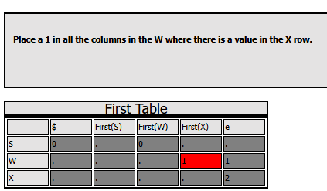  ------------  From LM This grammar produces a similar soft lock:  V ::= G K O  V ::= + O ) ( - ) - ( +  G ::= O K V  G ::= V O K  G ::= ) ( + + ( +  O ::= e  O ::= ) +  K ::= e  K ::= G V O  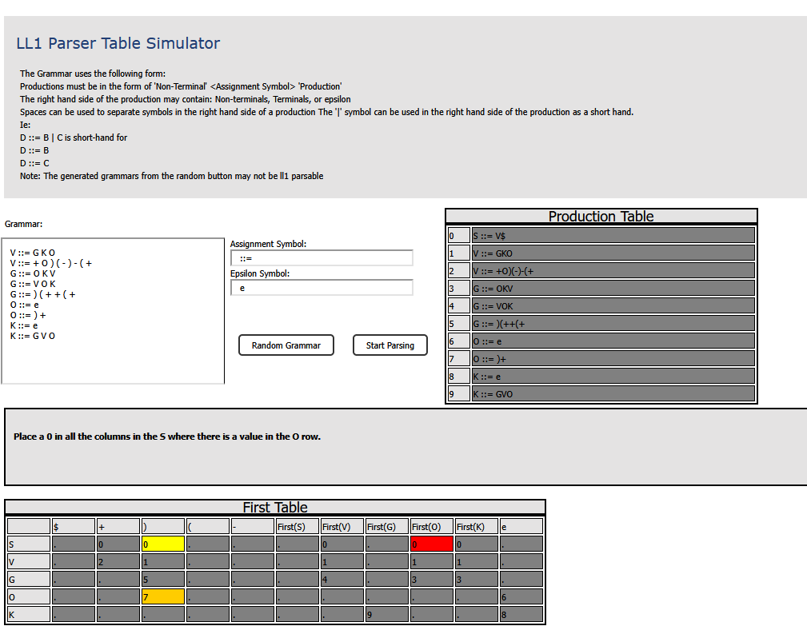 | Coded
From ZX:  Your Answer:  D ::= A + D  D ::= game  A ::= [ M + A m ]  A ::= # M + N #  A ::= M N  A ::= e  M ::= over  M ::= e  N ::= not  Your Answer:  D ::= A E  E ::= + A E  E ::= e  A ::= Q + T W  Q ::= # M + N #  T ::= M N  W ::= e  M ::= F  F ::= over  N ::= not  I came up with two grammar.( the second one is improved based on the first grammar ) Both could generate Transition Table succsessfully in UI emulater. But the first one will lead to "Conflict detected. Grammar is not LL(1)!" problem in the other emulator. Given the first grammar as example. I found a legitimate error in the UIdaho simulator. I noticed that the UIdaho simulator mishandles epsilon (e) productions and does not properly compute the follow sets or transitions that depend on nullable non-terminals. This leads to incorrect or incomplete parsing tables.Take the production A ::= M N and the fact that both M and N can derive epsilon (M ::= e, N ::= not, and not is a terminal). When M ::= e is used, the parser must look ahead to N and apply the follow set of A to guide parsing. Similarly, the production A ::= e gives additional follow set propagation requirements. Also, the rule A ::= e, A can be empty.If A can be empty, then the symbol after it (+) should appear in First(+ D), but more importantly, the Follow(D) should propagate to A when A is at the end of a production or followed by something nullable.  In the correct implementation (as seen in the other simulator), the follow set of A is accurately propagated to account for all derivations in D ::= A + D. But in the UIdaho simulator, the follow set of A does not include the terminal $, even though D ::= A + D and A ::= e clearly require that $ be in Follow(A) (since A can vanish, and the next symbol in D is + or end of input). This results in:  1.Missing or incorrect entries in the parsing table, especially for nullable cases.  2.Incomplete derivation paths due to missing follow set items.  In an LL(1) parser, correct handling of First and Follow sets is essential for deciding which production to apply based on the current input symbol. If the follow sets are computed incorrectly, the parser’s prediction becomes flawed, causing rejection of valid input strings or incorrect parse trees. | Not a bug?  Looking at the description:  Take the production A ::= M N and the fact that both M and N can derive epsilon (M ::= e, N ::= not, and not is a terminal). When M ::= e is used, the parser must look ahead to N and apply the follow set of A to guide parsing.  I have no idea what is meant by “the parser must look ahead to N and apply the follow set of A to guide parsing.” No it should not, if M is e then First(A) ::= First(N), and in the follow table if Follow(M) ::= First(N), and Follow(N) ::= Follow(A).  In addition both simulators give the same result and nether one gives an error
From ES: Example of one that got me stuck ( I eventually got the left recursive error after refreshing and retrying to add values in a different order.)  A ::= E + | e  B ::= C * | e  C ::= ( S ) | i  D ::= A | D G  E ::= G | e  G ::= ( S ) | g  From JP: Another one that gets you stuck  Your Answer:  X ::= C R M P  X ::= C P M R  P ::= X C M R  M ::= R X C P  M ::= - ( - ( ) ) ) - -  M ::= + + - ( -  R ::= e  R ::= ( - ) + - - - ) -  C ::= e  C ::= - ( + X (  From LM: This one also gets you stuck:  L ::= A B E  L ::= E A B  E ::= A L B  A ::= e  A ::= L E B  B ::= e  B ::= A E L  From CG: This one also gets stuck in the first table  A ::= a B  A ::= e  B ::= b B  B ::= C  C ::= c A  C ::= e | Coded
From OK: I got into a situation in the UIdaho simulator where I got trapped in an infinite loop for the grammar I suggested to the parser. The simulator alternates between asking me to do these two tasks in the first table:  1. Place a 0 in all the columns in the S where there is a value in the L row.  2. Place a 0 in all the columns in the S where there is a value in the W row.  Zeros have already been placed in these columns yet the simulator continues to infinitely alternate between the two. According to the other simulator, the grammar I constructed is determined to not be LL1 parsable yet I'm not given this at all in the UIdaho simulator and am stuck in a infinite loop when it should give me a message saying it isn't LL1 parsable.  H ::= A W L | +  A ::= W L + H - -  L ::= e  L ::= W A  W ::= e  W ::= L H A | Coded

Grammars with Cycles:

X ::= A
A ::= a B
B ::= b C
C ::= c A | e

String: abcab

R ::= x Y
Y ::= z A
A ::= N
N ::= C
C ::= y R | e

String: x z y x z y

D ::= A m n
A ::= B x C
B ::= y C A
B ::= e
C ::= z B
C ::= e

String: y z x x m n

A ::= B
B ::= F
F ::= C
C ::= a A| e

String: a a a

E = B A
A = + B
B = - C
C = M A | D F
D = / F D | e
M = * F M | e
F = ( E ) | id

String: + *

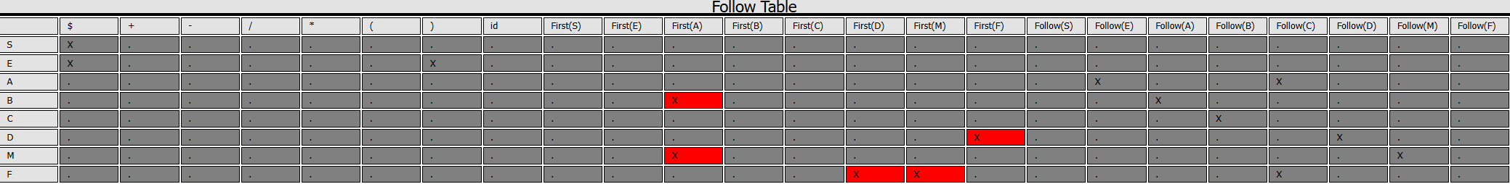

T ::= (╯° A
T ::= (╯- A
T ::= e
A ::= □ B
A ::= o B
A ::= 3 B
B ::= °)╯ C
B ::= -)╯ C
C ::= ︵┻━┻
C ::= T

String: (╯° 3 °)╯(╯- □ -)╯︵┻━┻

