**OCT-Embedding and Flash-Freezing Protocol**

**Solutions needed**

*Dry ice 2-3 lbs*

*Optimal Cutting Temperature (OCT) compound as needed*

**Materials needed**

Falcon tube

Silicon ice cube tray/mold

Metal forceps (sharp or blunt)

Red plastic tub & lid

Large polystyrene cooler

Paper towel

**Protocol**

1. Bring the red plastic tub and lid to chem stores to pick up dry ice.
   1. Chem stores is open from 9-11:30am and 12:30-4pm Monday through Friday.
2. Empty dry ice from red tub into large polystyrene cooler then shake the cooler to generate a flat surface for the silicone ice cube tray/mold to sit atop and remain level and undistorted.
3. Pour a small amount of OCT to one silicone ice cube mold, only use enough to fully coat the bottom of the mold.
4. Transfer the silicone tray/mold into the polystyrene cooler.
   1. Make sure the tray and the liquid within it are sitting level atop the dry ice.
   2. Replace the lid and wait ~5-10 minutes for OCT to freeze (OCT will turn white once it is frozen).
5. Weigh the brain just prior to starting step 6.

** The remaining steps must be performed quickly to prevent the OCT from thawing. **

1. Remove the silicone tray/mold from the polystyrene cooler.
   1. Add OCT to mold containing frozen base layer, fill to approximately 2/3 full and avoid producing air bubbles.
   2. Use a metal forceps to remove and/or move any bubbles away to the side.
2. Place the brain into the OCT.
   1. Use metal forceps to move the brain to the center of the mold (diagonal with the caudal side up) See photo 1 for how to orient the brain. Remove and/or move any bubbles away to the side.
   2. Pour OCT on top of brain, ensuring that it is fully submerged and covered in OCT.
   3. Take note of the orientation of the brain and which corner the dorsal side is on.
3. Put the ice cube tray back into the polystyrene cooler for ~5-10 minutes, until block is completely frozen.
4. Remove the tray. Using a sharpie, mark the corner where the dorsal side of the brain is facing.
5. Remove the OCT-embedded brain from the silicone ice cube tray/mold by everting the mold into an empty falcon tube.
6. Place the falcon tube containing the OCT-embedded brain into the -80°C freezer.

**Photo 1.**

Dorsal

Top view – caudal side shown

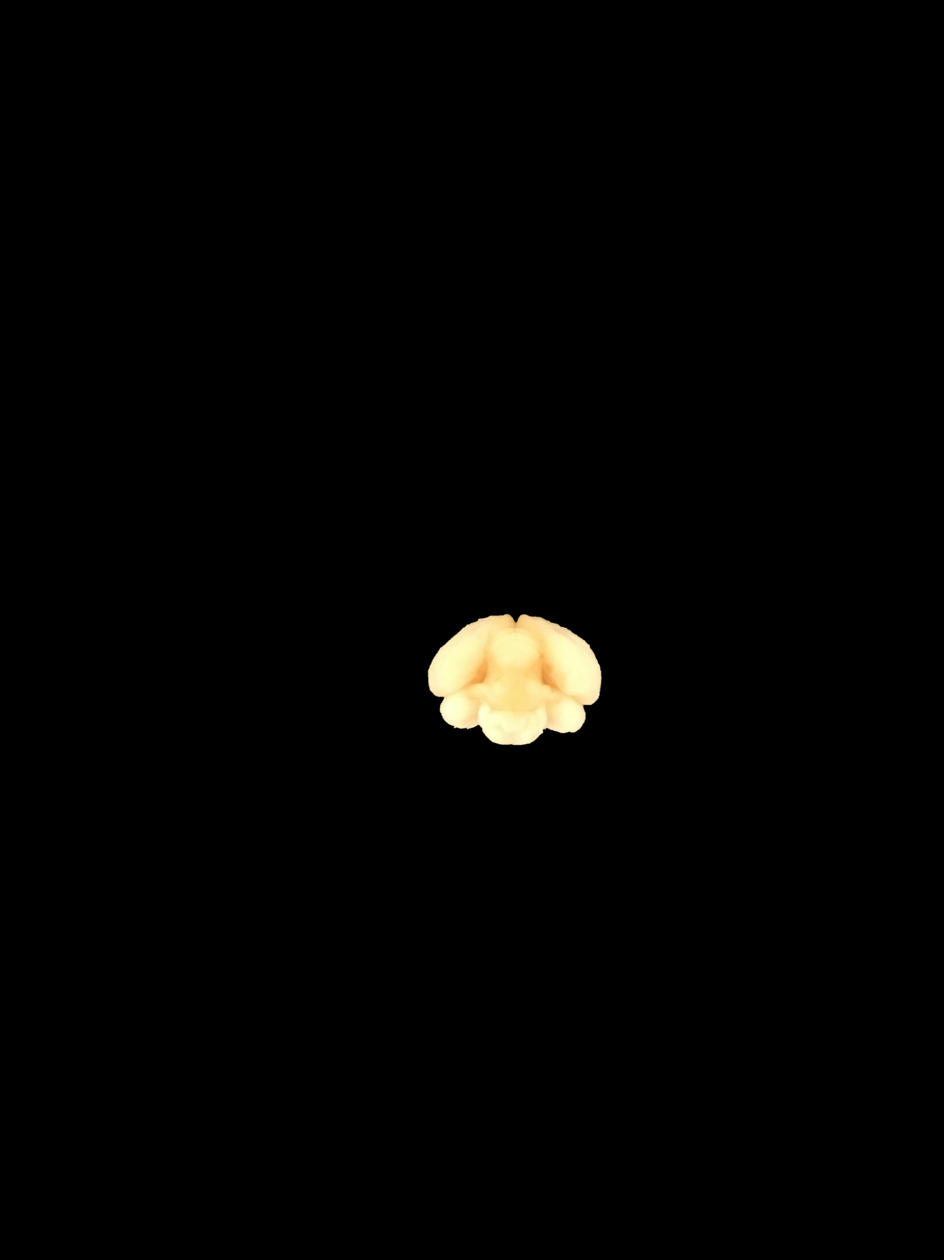

Right hemisphere

Left hemisphere

Ventral