# Network Topology and Water Balances

By Samuel Hutchinson, December 2019

**Introduction:** The Hydrology group wishes to analyse the network topology more specifically. This report summarises the processes of how the hydrology group have developed tools to generate relationships of branch topology and calculate water balances of a pool[1] in the water delivery network. This ground up approach has enabled the ability to audit the branch efficiency report that RUBICON can supply.

## Generating topological awareness of pools

To the extent that the hydrology team have investigated, no accurate and concise linkage between assets is available in a format easy to work with. If one wanted to understand the relationship between a meter on a property e.g. M1893/1 and its nearest regulator (in this case Andreattas Reg.), one would have to look up that meter on network visualiser or MI maps and manually explore the relationship through laterals to the nearest upstream regulator. One would then find the object numbers[2] of each asset to get the required data from a production database, e.g. SC_EVENT_LOG. To find all the meters in an entire pool it can easily be seen that this method does not scale.

A branch summary can be exported as a comma separated file (csv). This file contains information about a branch and the objects in that branch. Unfortunately, it lacks a lot of features. It does not link laterals to a pool, nor provide object numbers, and contains many inconsistencies. By manually working through the csv and comparing with network visualiser, the laterals are defined and inconsistencies removed. This csv is still not in a format to perform routine large searches on a branch to get data.

The next step is to parse through the csv and generate a more hierarchical link of all the topology in a branch. A program was written to do just this. It moves though the csv and builds up a structure of the network that makes links between any point in a branch and its upstream and downstream neighbours. It finds the object numbers of that asset and makes links in a table so that any relationship required for analysis can be easily extracted later. See example output in Table 1 below. Additional tools have been developed include methods for getting a list of object numbers between any two points, see RHS of Table 1.

|  |  |  |
| --- | --- | --- |
| Upstream objects…  └─── OVERS REGULATOR - Regulator (30840)  ├─── M2615A/1 - D/S Meter (67510)  ├─── M2038/2 - D/S Meter (64930)  ├─── N665/P - D/S Meter (70693)  ├─── M2615/D - D/S Meter (70048)  ├─── M2038C/1 - D/S Meter (64933)  ├─── M1631H/1 - D/S Meter (67513)  ├─── OT L185 - D/S Offtake (30862)  │ ├─── M2038B/1 - D/S Meter (64936)  │ ├─── M1997/2 - D/S Meter (64939)  │ ├─── M1997/3 - D/S Meter (64942)  │ ├─── M1985/1 - D/S Meter (64954)  │ └─── SV 185-1 - D/S Scour Valve (57141)  ├─── M1631D/1 - D/S Meter (68062)  ├─── MC10 TEMPORALIS ESCAPE - D/S Escape (55372)  └─── QUARY RD REGULATOR - Regulator (30868)  └─── Downstream objects… | | **OBJECT LINK LINK TYPE**  30822 30840 Regulator  30840 67510 D/S Meter  30840 64930 D/S Meter  30840 70693 D/S Meter  30840 70048 D/S Meter  30840 64933 D/S Meter  30840 67513 D/S Meter  30862 64936 D/S Meter  30862 64939 D/S Meter  30862 64942 D/S Meter  30862 64954 D/S Meter  30862 57141 D/S Scour Valve  30840 30862 D/S Offtake  30840 68062 D/S Meter  30840 55372 D/S Escape  30840 30868 Regulator |
|  |  | |

Table : This is an example output of the parsing program. The output has been truncated to only visualise the relationships between Overs and Quarry Rd in LVBC. **NB**: Object numbers in the topology are in brackets and D/S means downstream.

## Working with metering data

To generate the efficiency report for a pool, the water balance is calculated. The inputs of the calculation are the flows in, delivered to, and out of the pool. It calculates the difference between the input and the output minus deliveries. In this study the water balance includes anything that can be measured, and excludes: evaporation, seepage, unmetered flows[3].

VOLUME IN

VOLUME OUT

unmetered flows,  
evaporation  
seepage

metered deliveries

This study explored two sources for water volumes in the balance calculation. The first source described is calculating the numerical integral of the flow of water through a certain meter over time. The second uses the total volume accumulated as calculated by the RTU[4] at the gate and periodically sent to the production database.

### Volume from numerical integration of flows

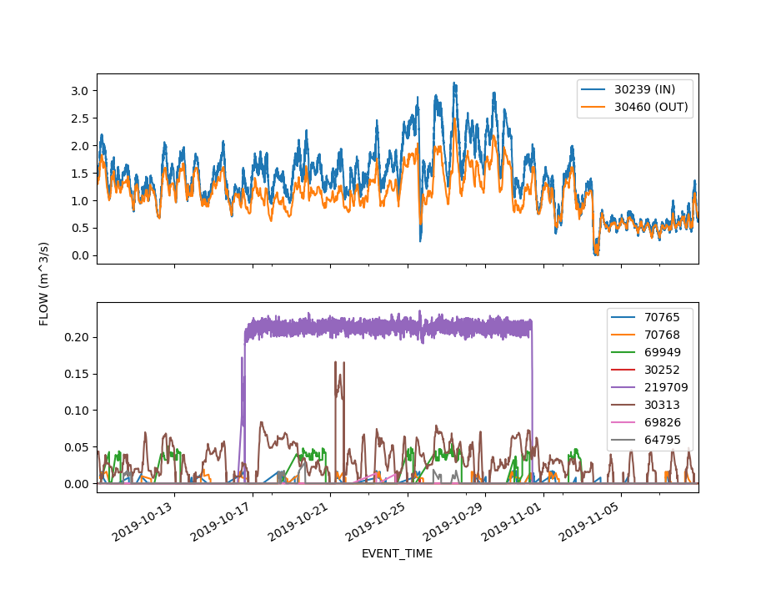To calculate the total volume through a meter between a given time, all the flows of that meter are integrated numerically against time using the trapezoidal integration rule. Since datapoints of the flow rates are relatively close for active sites (see Figure 1) using this rule is fairly acceptable.

Figure : Flow data for all meters within the Andreattas pool over a period of a month. Object numbers are cited. The upper sub-plot is of branch regulators IN and OUT of the pool (Andreattas and Jones respectively). The lower sub-plot is the flow rates of the meters with the pool.

### Volume from RTU totaliser

The RTU keeps track of the volume of water that has passed through the meter over time. It does this by doing its own integration of flow in real time. This occurs every few seconds in the RTU and then around twice a day (depending on the polling configuration of the gate) this totaliser value is sent over SCADA to MI. Calculating the volume of water between two time periods should be as trivial as taking the totaliser value at those two time periods and subtracting the earlier one from the later. However, this is not the case.

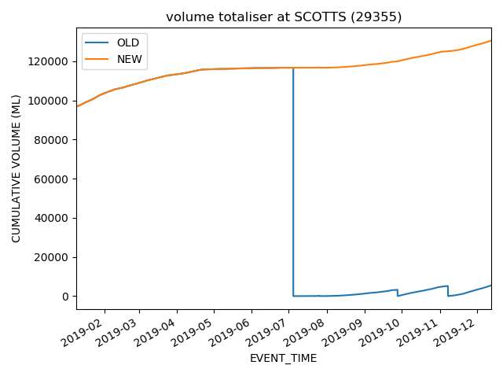There are a few situations that can occur to make this data messy (no longer monotonically increasing) and require some data processing to address. The first and most obvious artefact of the totaliser is that the value must periodically reset back to zero. Generally, this is done at the beginning of the season, but after some investigation it seems it can happen whenever the RTU resets. This situation is easily addressed by just checking when the series goes from a non-zero value to zero and adding the last non-zero value to the later points in the series. See Figure 2.

Figure : Totaliser volume through Scott’s Rd Regulator. The “Old” data series is as taken from the SCADA database, the “NEW” values are a new data series that has had the resets to zero cleaned up.

If the RTU has reset (totaliser has gone to zero) and has been offline, it will continue to calculate the totaliser and transmit the most up to date value when it comes online again. This can cause there to never be a “0.0” value in the database when it has reset, making it difficult to track the reset and handle the data. Sometimes the value drops to zero in the database and does not coincide with a reset to zero (as the posterior values match the previous totaliser value). This effect can be so drastic that the totaliser value ramps down and back up again over several tens of database entries. These artefacts are illustrated in Figure 3 and Figure 4. The causes for this remain a curiosity. To handle all these artefacts the following logic test is performed:

For all the values in the period we are interested in:  
 if the (value – sensitivity) < all of the next 100 values,  
 then consider this a reset and handle accordingly  
 otherwise,  
 treat as other artefact and do not reset

The sensitivity value (1.0 used) is to prevent an artefact caused by float rounding of the decimal places in the totaliser occasionally causing the totaliser to break the monotonic increasing rule.   
E.g. 14.84500, 14.87500, 14.87000, 14.89000.

|  |  |
| --- | --- |
| Figure : An example of a brief drop to zero in the totaliser. Datapoints are marked with “X”s. | Figure : An example of a drop to zero for a period of time and a return. Datapoints are marked with "X"s. |

One can note that in dealing with the artefacts illustrated in Figure 3 and Figure 4, there is a possibility that the data might drop to zero at the end of a period we are interested in, giving an incorrect calculation of volume. This situation is handled by taking the maximum value of the cumulative volume for that period. In other words:

Volume = Max(Cumulative flow for period) – cumulative flow at beginning

This cannot handle the case where the flow is zero at the beginning of a period as it is very difficult to tell whether a jump upwards is due to a zero error or a huge flow demand at the meter. If this situation occurs, the volume may be hugely overestimated. By combining the two methods (manual integration and RTU totaliser) this situation can be flagged and dealt with.

## Summary of results

Water balances were calculated for every pool in the lake view branch for the period between 09/10 to 09/11 of 2019. Both meter volume methods were used (INTEGRATED and RTU) and were compared against the output of a RUBICON efficiency report (REPORTED) of the same time interval. To audit the accuracy of volume calculation through a single gate the following comparison in Figure 5 was made.

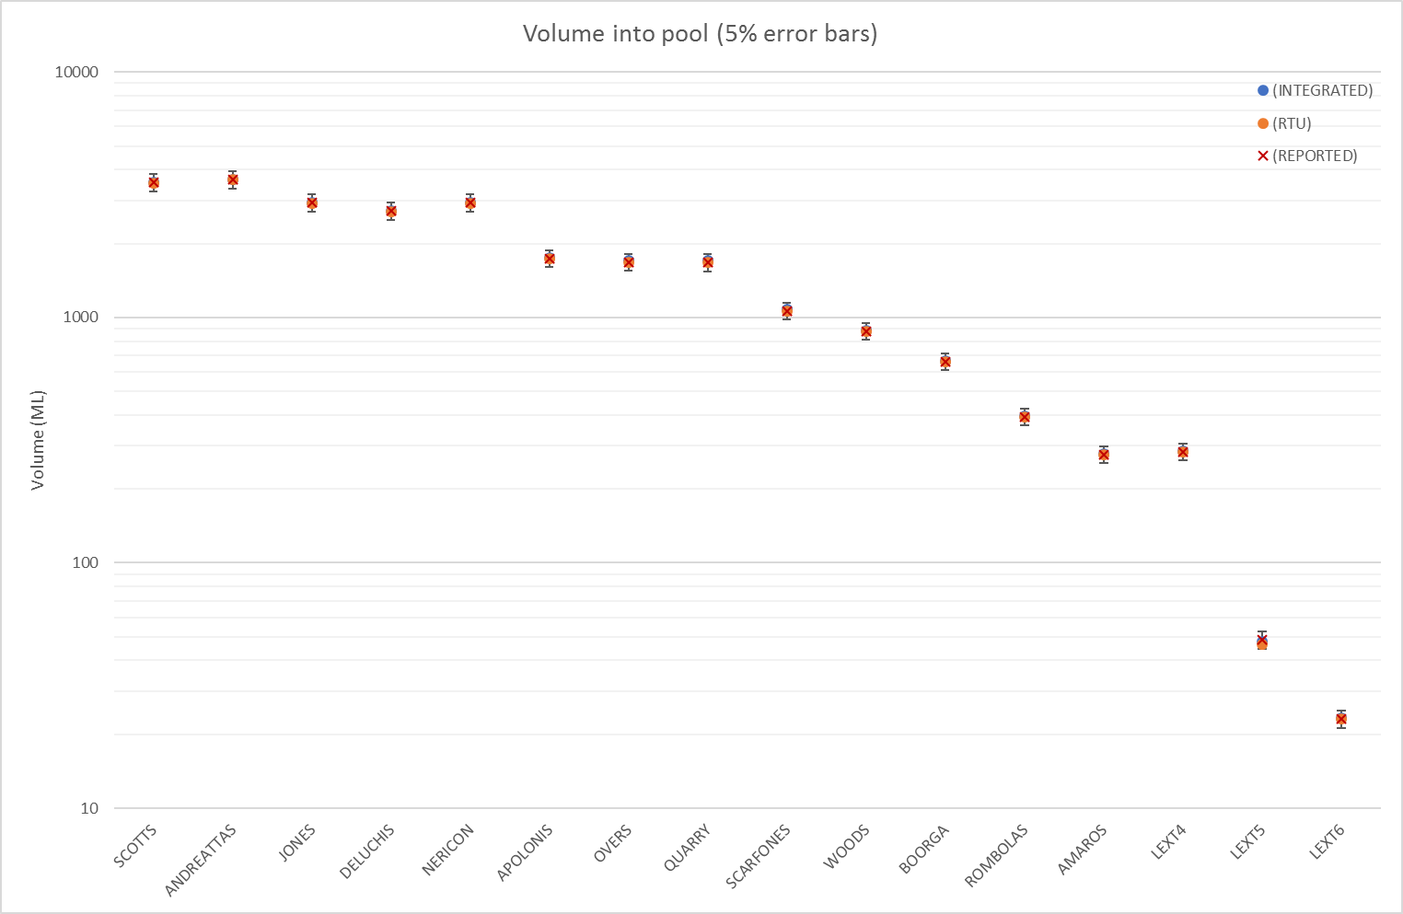

Figure : Flows of water through each regulator over a period of a month. Logarithmic scale is used to visualise error bars for very small values as well as very large. Most values overlap exactly and are hidden by REPORTED.

Figure 5 shows that our methods are within 5% (and in most cases with higher volumes, within 2%) of the RUBICON report. This builds a lot of confidence in our methods for a single gate.

To measure the accuracy of our methods against reported deliveries for each pool, the flows through each meter[5] in that pool were summed together. Flows at lateral offtakes were not considered, only their downstream meters. Figure 6 below illustrates the findings of these calculations. In seven cases both our methods are within 5% (including when the calculated deliveries sums to zero). In six cases, our calculations fall more than 5% under the REPORTED values, significantly in the case of the Nericon pool – see later.

In three cases our estimates exceeded the RUBICON report. Our methods do not consider manually read meters (without telemetry), and it is reasonable to assume RUBICON **does** include these meter readings in their report. This is a surprising output as we expected our methods to underestimate in all situations.

|  |
| --- |
|  |
| |  |  |  |  |  |  |  |  |  |  |  |  |  |  |  |  |  |  | | --- | --- | --- | --- | --- | --- | --- | --- | --- | --- | --- | --- | --- | --- | --- | --- | --- | --- | | **Volume in ML** | **SCOTTS** | **ANDREATTAS** | **JONES** | **DELUCHIS** | **NERICON** | **APOLONIS** | **OVERS** | **QUARRY** | **SCARFONES** | **WOODS** | **BOORGA** | **ROMBOLAS** | **AMAROS** | **LEXT4** | **LEXT5** | **LEXT6** | **TOTAL** | | **INTEGRATED** | 200.0 | 381.5 | 55.9 | 0 | 681.9 | 26.5 | 42.7 | 536.1 | 111.4 | 288.9 | 172.3 | 111 | 0 | 203.4 | 27.2 | 19.8 | 2858.6 | | **RTU** | 164.8 | 365.5 | 54.9 | 0 | 686.7 | 23.8 | 42.8 | 526.2 | 114.3 | 289.7 | 176.3 | 112.5 | 0 | 203.3 | 26.1 | 19.3 | 2806.2 | | **REPORTED** | 170.9 | 367.3 | 56.1 | 0 | **974.4** | 50.6 | 43.0 | 544.8 | 105.3 | 307.5 | 195.0 | **147.9** | 0 | 201.3 | 18.6 | 14.1 | 3196.8 | |

Figure : Comparison between our methods and the RUBICON report for deliveries within each pool. **Note:** the Volume axis in the graph is scaled logarithmically so that errors are visible. Differences can appear smaller than they are (see Nericon).

The REPORT values for Nericon did not at all match our calculations. Some of these deviations can be down to values from the RUBICON that had to be inferred. Rubicon splits Lateral 175 from the Nericon pool and does its own pool calculations, introducing errors in their report. OT L175 (the slipmeter at the offtake) has been in position mode and held open for the last several months and so its flow calculation is wrong as the offtake hasn’t been regulating. It reports ~ 50ML of flow going into LAT175 whilst the meters within LAT175 have consumed 898.5 ML (according to RUBICON), this drastically affected their balance calculations (as IN was << OUT). We added the values of Nericon and LAT175 together to make a concise representation of the Nericon Pool. As mentioned earlier, the RUBICON estimates LAT 175 deliveries at 898.5 ML. We made our own calculations of LAT 175 and our models calculate 595.4 ML and 616.0 ML for INTEGRATED and RTU respectively. This is the source for the difference in Nericon in Figure 6. The reason for this difference is still under speculation. We know that 9 out of 30 of the meters in LAT 175 have no telemetry, and LAT175 contains facilities for Lake Wyangan, we conclude that further inspection is required.

The balances were calculated for each method for comparison with RUBICON’s Gap columns and have been summarised in Figure 7. In general we expected the balances to be positive as no system is 100% efficient.

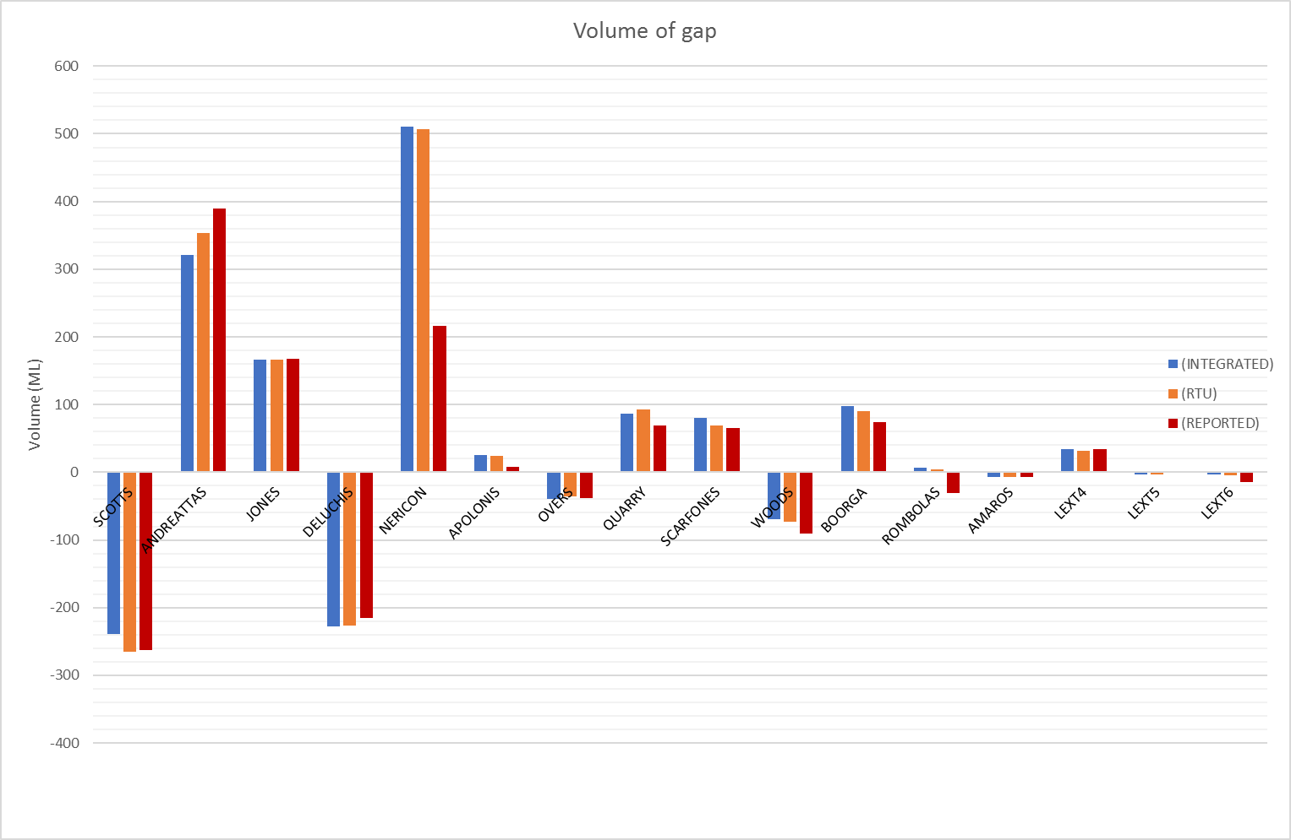

Figure : The water balances of the pools in Lake View for the Oct-Nov period. Negative values indicate that more water left the system than has entered. Positive values indicate that more water was sent into the pool than was consumed and/or exited the pool.

When examining Figure 7 one may note that both Scotts and Deluchis have significantly negative balances. Is it possible their pools contain unknown aquifers or springs? Unfortunately, this isn’t the case. It seems the difference in meter values between the flow in and flow out are negative. This indicates that either the regulators are underestimating their flow, or their downstream regulator are significantly overestimating. The negative values at Overs and Woods cannot be so simply explained and requires further investigation.

In general, there is reasonable agreement in balance between our methods and RUBICON. Our methods usually calculate a higher balance, indicating that the pools in our calculations are consuming water that we haven’t factored – it is reasonable to consider the meters without telemetry are reason for this. The large disagreement at Nericon is as discussed previously in the deliveries.

## Conclusion and further work

* Using the confidence gained in the development and explorations of these tools it is possible to generate an entire branch efficiency.
* Some assumptions we have made about RUBICON’s water balance are correct (data sources, branch topology, object numbers).
* Need to incorporate unmetered data such as sites without telemetry
* Need to estimate/calculate seepage and evaporation which requires the need to include channels in the topology and their dimensions.
* These tools are very pertinent to honours project (leak detection) and will continue to be developed and maintained for future use.

1. For the purpose of this study a pool is anything between two main branch regulators.
2. The unique identifier for each object in the MI databases. The object number ties all the information about that asset; e.g. flow, gate position, battery voltage, etc.
3. Unmetered flows are any flow that is not described in the events database; meters without telemetry, unauthorised access, leaks.
4. Remote Terminal Unit – the controller that manages control signals at a gate or meter. It reports back to MI over the SCADA network.
5. In this case a “Meter” is any property meter or escape