Project GR001 IP AXI_SRAMC
Hardware Design Document

Provided by Provided Date

Approved by Approved Date

Revision History
Version | Release Date | Owner | Description
V0.1 | 2023/8/7 | Neo Wang | Initial Version

Attention: The blue italics are template comments, please remove all of them before releasing the document！

注意： 蓝色斜体字部分是模版注释内容，请在正式发布的版本中将他们全部移除！

Contents
Revision History 2
Contents 3
Table List 5
Figure List 6
1 Introduction 7
2 Feature List 8
3 Functional Description 9
3.1 Architecture 9
3.2 Design Description 9
3.3 High Level Timing Diagram 10
3.4 Clock and Reset 10
3.4.1 Clock 10
3.4.2 Reset 10
3.5 I/O Interfaces 10
3.6 Address Mapping 13
4 Block Description 14
4.1 Read Handler and Write Handler 14
4.2 Arbiter and Decoder 15
4.3 ECC Encoder/Decoder 16
5 Use cases 17
5.1 Scenario 1 17
5.2 Scenario 2 18
6 Configuration 19
6.1 Parameter 19
6.2 Macro 19
6.3 Memory 19
7 PPA Information 20
7.1 Power 20
7.2 Performance 20
7.3 Area 20
8 Implementation Constraints 22
9 P & R Guidelines 23
10 Verification 24
11 Appendix 25

Table List

Table 3-1 Clock Requirements 10
Table 3-2 Reset Requirements 10
Table 3-3 I/O Interfaces (see 6 Configuration for configurable width) 12
Table 3-5 Address Mapping 13
Table 4-1 Request/Response Format of Arbiter/Decoder 15
Table 6-1 Parameter List 19
Table 6-2 Macro List 19
Table 6-3 Memory Requirements Table 19
Table 7-1 Power State Table 20
Table 7-2 Power Consumption Table 20
Table 7-3 Area Information 20
Table 7-4 VT Cell Number 21

Figure List

Figure 3-1 AXI_SRAMC architecture Diagram 9
Figure 3-2 High Level Timing Diagram 10
Figure 4-1 Read Handler Diagram 14
Figure 4-2 Write Handler Diagram 15
Figure 4-3 ECC Module Diagram 16
Figure 5-1 Data Path of Normal Write 17
Figure 5-2 Data Path of Partial Write 18

Introduction
Please provide brief and high-level description here for the IP or SYS. For example, design background and basic IP functions.
AXI_SRAMC is a SRAM memory controller based on the standard AXI bus. It provides an AXI4 slave interface that can be connected to AXI4 master or interconnect devices in the AXI4 systems and a user-defined master interface of memory wrapper which based on valid/ready handshake signal.

Feature List
Please list all main features of IP or Sub System here.

FL-001: the AXI4 slave interface supports 32-bit address bus and 64/128/256-bit data bus (the data width corresponds to the SRAM data width)
FL-002: burst transfer supports up to 16 beats for INCR or WRAP burst type
FL-003: supports narrow transfers
FL-004: supports 8 write/read outstanding
FL-005: configurable Regs Slice
FL-006: only support single-port SRAM
FL-007: supports SRAM capacity: 1KB~8MB
FL-008: supports single-bit error correcting code (ECC)

Functional Description
Please provide detailed function description and architecture diagram in this chapter.

Architecture
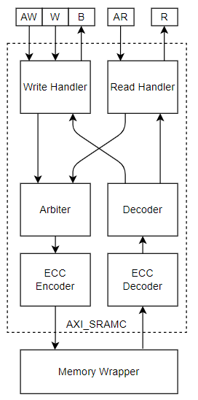
Figure 3-1 AXI_SRAMC architecture Diagram

Design Description
AXI_SRAMC is responsible for converting AXI access transactions into SRAM access transactions. The upstream AXI master initiates a read or write request to SRAM. AXI transaction is split and converted into a mem request through read/write handler module. And then, it is sent to the downstream memory wrapper. In order to complete data error correction and improve robustness, an ECC module is used to encode written data and decode read data. Because data granularity of the ECC module encoding and decoding is the bus bit width, for AXI write transaction of partial write, Module Write Handler needs to initiate a read operation to obtain complete write data before continuing the write operation.

High Level Timing Diagram
Please provide the high level I/O timing diagram for the whole IP or SYS.
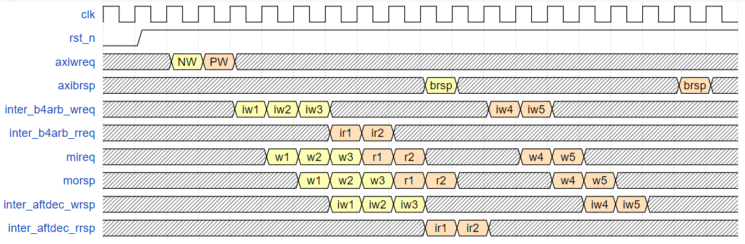
Figure 3-2 High Level Timing Diagram
As shown in Figure 3-2, there are two AXI write operation, the first is a normal write transaction (NW) with “wstrb==`1” and “burst length==3”, and the second is a partial write transaction (PW) with “wstrb!=`1” and “burst length==2”.

Clock and Reset
Please provide required clock and reset information in this chapter.

Clock
Clock Group | Clock Name | Frequency | Duty Cycle | Accuracy
group 1 | clk | 500MHz (TBD) | 45%~55% |  | ±100 ppm
Table 3-1 Clock Requirements

Reset
Reset Name | Related Clock | Comments
rst_n | clk
Table 3-2 Reset Requirements

I/O Interfaces
Please give the fully I/O interfaces in the interface table, the interfaces can be divided into different groups such as:
- Clock
- Reset
- Bus interfaces
- Interrupts
- DFT
- Etcs.

Category | Interface Name |  | Width | I/O | Description
clock | clk |  | 1 | I | AXI_SRAMC main clock
reset | rst_n |  | 1 | I | Reset signal, active low
AXI interfaces | awvaild |  | 1 | I | Write address valid
 | awready |  | 1 | O | Write address ready
 | awid |  | configurable | I | Write address ID
 | awaddr |  | configurable | I | Write address
 | awlen |  | 8 | I | AXI burst length
 | awsize |  | 3 | I | AXI burst size
 | awburst |  | 2 | I | AXI burst type
 | awcache |  | 4 | I | Memory type
 | awprot |  | 3 | I | Protection type
 | awqos |  | 4 | I | Quality of Service
 | awuser |  | configurable | I | User signal
 | wvalid |  | 1 | I | Write valid
 | wready |  | 1 | O | Write ready
 | wdata |  | configurable | I | Write data
 | wstrb |  | configurable | I | Write strobes
 | wlast |  | 1 | I | Write last
 | bvaild |  | 1 | O | Write response valid
 | bready |  | 1 | I | Response ready
 | bid |  | configurable | O | Response ID tag
 | bresp |  | 2 | O | Write response
 | arvaild |  | 1 | I | Read address valid
 | arready |  | 1 | O | Read address ready
 | arid |  | configurable | I | Read address ID
 | araddr |  | configurable | I | Read address
 | arlen |  | 8 | I | AXI burst length
 | arsize |  | 3 | I | AXI burst size
 | arburst |  | 2 | I | AXI burst type
 | arcache |  | 4 | I | Memory type
 | arprot |  | 3 | I | Protection type
 | arqos |  | 4 | I | Quality of Service
 | aruser |  | configurable | I | User signal.
 | rvaild |  | 1 | O | Read valid
 | rready |  | 1 | I | Read ready
 | rid |  | configurable | O | Read ID tag
 | rdata |  | configurable | O | Read data
 | rresp |  | 2 | O | Read response
 | rlast |  | 1 | O | Read last
Memory control interfaces | mivaild |  | 1 | O | Memory access valid
 | miready |  | 1 | I | Memory access ready
 | mipayload | RW | 1 | O | 0: read; 1: write
 |  | rmw | 1 |  | Read request of Write Handler. Reserved for AXI read transaction
 |  | axid | configurable |  | Upstream AXI ID
 |  | addr | configurable |  | Upstream AXI address
 |  | last | 1 |  | Last burst transfer flag
 |  | user | configurable |  | Upstream AXI user bit
 |  | data | Variable |  | Upstream AXI data and ECC bits
 | movaild |  | 1 | I | Memory response valid
 | moready |  | 1 | O | Memory response ready
 | mopayload | RW | 1 | I | 0: read; 1: write
 |  | rmw | 1 |  | Read request of Write Handler. Reserved for AXI read transaction
 |  | axid | configurable |  | Original AXI ID
 |  | addr | configurable |  | Address of this rdata
 |  | last | 1 |  | Last burst transfer flag
 |  | data | configurable |  | AXI rdata
Register | axi_sramc_idle |  | 1 | O | AXI_SRAMC module is idle
 | ecc_err |  | 1 |  | Rdata ECC error and uncorrectable
 | ecc_err_addr |  | configurable |  | Memory address corresponding to the ECC error
Table 3-3 I/O Interfaces (see 6 Configuration for configurable width)

Address Mapping
Field Name | Address Range
SRAM | 0x0~0x80_0000
Table 3-4 Address Mapping

Block Description
The IP or SYS could be divided into several sub modules, please provide detailed design information for each sub block in this chapter.

Read Handler and Write Handler
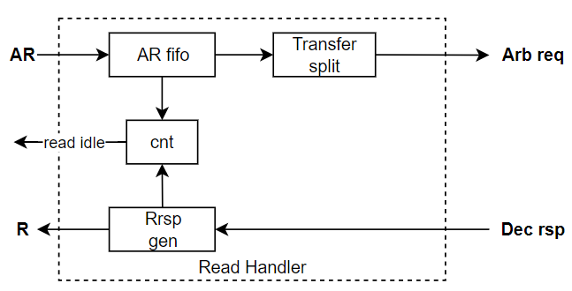
Figure 4-1 Read Handler Diagram
As shown in Figure 4-1, AXI read address channel transaction is buffered in a FIFO and the depth of the FIFO is 8. Transfer split is responsible for disassembling the burst transaction and converting it into the request format of the downstream arbiter (see in Table 4-1).
Name |  |  | Width | Description
Arbiter req | Vld |  | 1 | Valid signal
 | Rdy |  | 1 | Ready signal
 | payload | Axid | Configurable | AXI id
 |  | Addr | 32 | AXI address
 |  | Last | 1 | Last burst transfer flag
 |  | User | TBD | AXI user bit
 |  | RW | 1 | 0: read; 1: write
 |  | Rmw | 1 | Read request of Write Handler. Reserved for AXI read transaction
 |  | Data | Consistent with bus width | Write data. Reserved for AXI read transaction
Decoder rsp | Vld |  | 1 | Valid signal
 | Rdy |  | 1 | Ready signal
 | payload | Axid | Configurable | AXI id
 |  | Last | 1 | Last burst transfer response flag
 |  | RW | 1 | 0: read; 1: write
 |  | Rmw | 1 | Read request of Write Handler. Reserved for AXI read transaction
 |  | Data | Consistent with bus width | Read data. Reserved for AXI write transaction
Table 4-1 Request/Response Format of Arbiter/Decoder
Transfer split supports the burst type split specified in the AXI4 protocol, and the burst length supports a maximum of 16. To simplify the design, it does not support out-of-order reading, that is to say, the Rrsp gen will reply the read data in order, and use the field ‘Last’ in decoder response as the flag bit of the last data. A counter is used to record the read transaction. The counter plus one for the AR FiFO receiving a transaction, and counter minus one for the Rrsp gen completing an AR request.
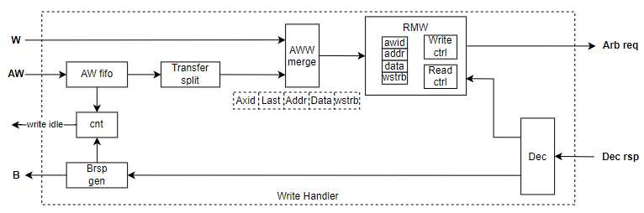
Figure 4-2 Write Handler Diagram
As shown in Figure 4-2, AXI write address channel transaction is also buffered in a FIFO and the depth of the FIFO is 8. Write transaction will also be disassembled and converted in the Transfer split. Module AWW merge is responsible for merging AW & W channel and generating the request packet. Considering the partial write, the write request with ‘wstrb != `1’ will be specially handled in module RMW (Read Modify Write). RMW will first initiate a read operation to read back the data of the complete bus bit width corresponding to the write address, then merge it with the actual data to be written, and finally write the combined data into memory. For the response returned by memory wrapper, whether it is routed to the RMW or the Brsp gen is determined by field ‘rmw’ in decoder rsp. When ‘rmw’ signal is set, it indicates that the response is a reply to a read request sent by RMW and this response will be routed to RMW. Since out-of-order writing is not supported, the Brsp gen will directly generate write response through field ‘Last’ and ‘Axid’. Similarly, a counter is used to record write transaction and generate a block Write Handler idle signal.

Arbiter and Decoder
As shown in Figure 3-1, a round robin arbiter is employed to arbitrate memory access requests from Write Handler and Read Handler. For the returned response, a decoder is used to complete the shunt. When field ‘RW’==1, this response will be routed to Write Handler, otherwise routed to Read Handler.

ECC Encoder/Decoder
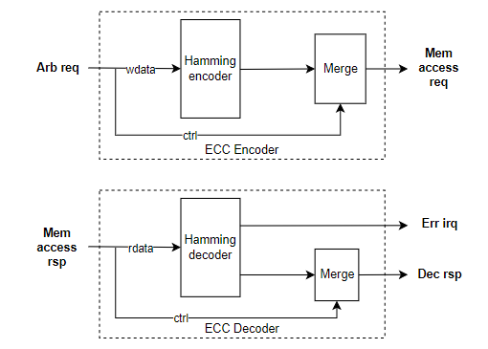
Figure 4-3 ECC Module Diagram
ECC module is employed to check and correct the memory data, which is shown in Figure 4-3. The AXI wdata written into mem will be encoded by a Hamming encoder, and then the written data and Hamming code related coding bits will be stored in memory together. The data read by memory will first be decoded by a Hamming decoder to obtain AXI rdata. The ECC module can detect and correct 1-bit errors and detect 2-bit errors. If there is a 2-bit error in the data, an ECC error interrupt register “ECC_ERR” will be set and the address corresponding to the error data will be written into register “ECC_ERR_ADDR”.

Use cases
Please draw all necessary data path flow for typical scenarios, and the necessary description was required.

Scenario 1
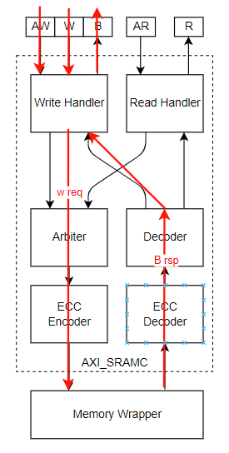
Figure 5-1 Data Path of Normal Write
The upstream AXI master initiates a normal write request to SRAM. AXI transaction is split and converted into a memory request in Write Handler. And then, it is sent to ECC Encoder to perform wdata Hamming encoding. Finally, it is sent to the downstream memory wrapper. When mem completes the write operation, it will return the relevant information of the write operation such as id, last flag to Write Handler to generate B channel response.

Scenario 2
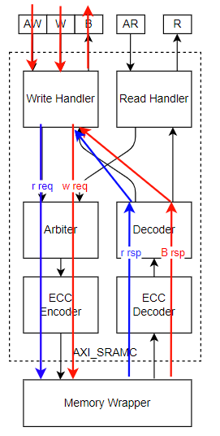
Figure 5-2 Data Path of Partial Write
The upstream AXI master initiates a partial write request to SRAM. First, Write Handler splits and converts the transaction, and then Write Handler will first initiate a read request of the corresponding address to memory, and after reading back the data, it will splice the read data with the original AXI partial write data. And finally write the spliced data into memory. For example, AXI original write data is 64’h1111_2222_3333_4444, address is ‘h1234 and wstrb is ‘hfe; Assume that the data stored at address ‘h1234 in memory is 64’h5555_6666_7777_8888 at this time. Then the data finally written to this address ‘h1234 is 1111_2222_3333_4488.

Configuration

Parameter
Parameter | Default Value | Description
AXI_ID_WIDTH | 6 | AXI ID width
AXI_ADDR_WIDTH | 32 | AXI address width
AXI_DATA_WIDTH | 64 | Bus data width, support 64/128/256
AXI_USER_WIDTH | 8(TBD) | TBD
Table 6-1 Parameter List

Macro
Macro | Default Value | Description
Table 6-2 Macro List

Memory
Mem Name | Depth | Width | Frequency | Type | Comments
ram_a | 16 | 32 | 500MHz | Single Port
ram_b | 32 | 64 | 1GHz | Dual Port
Table 6-3 Memory Requirements Table

PPA Information

Power
Please give the description regarding the whole low power design methodology in this chapter, and list all of power domain related information in below sheets.

Power State | Power Domain 1 | Power Domain 2 | Power Domain 3
Table 7-1 Power State Table

IP Name | Leakage Power | Internal Power | Switching Power | Total Power
Table 7-2 Power Consumption Table

Performance
Please give the peak performance information in this section.
For example:
- Max Frequency
- Max Bandwidth
- Max Outstanding Number

Please list the performance requirement to achieve the basic function.
- Latency
- Bandwidth

Area
Logic和mem区分开，加个表，包括各个VT cell比例
Please list the area and vt cell information in below tables, the synthesis configurations should be announced.
Logic Area | Memory Area | Total Area
Table 7-3 Area Information

SVT Cell Num | LVT Cell Num | ULVT Cell Num | Total Cell Num
Table 7-4 VT Cell Number

Implementation Constraints
Please list all design constraints if have:
For example:
- Multicycle
- False path
- Logical exclusive
- Etcs.

P & R Guidelines
Please provide guidelines for P & R stage.

Verification
Please list special requirements for verification.

Appendix

