我第一次分析西门子CT11协议，火警协议

W D A1 A2 Q 05 00 Alarm Local alarm -

W D A1 A2 Q 06 00 Alarm General alarm Reset

W D A1 A2 Q 01 00 Alarm Alarm -

W D A1 A2 N 01 85 Normal alarm Reset

W D A1 A2 U/Q 01 01 Alarm Alarm -

W D A1 A2 N 01 85 Alarm Alarm Reset

W D A1 A2 U/Q 01 01 Alarm Alarm Autom detector

W D A1 A2 N 01 85 Normal Alarm Reset

W D A1 A2 U/Q 01 02 Alarm Alarm Man detector

W D A1 A2 N 01 85 Normal Alarm Reset

W D A1 A2 U/Q 01 02 Alarm Alarm Autom detector

W D A1 A2 N 01 85 Normal Alarm Reset

W D A1 A2 U/Q 0E 02 Alarm Isolated Alarm Autom detector

W D A1 A2 N 0E 85 Normal Isolated Alarm Reset

W D A1 A2 U/Q 0C 00 Alarm Sabotage -

W D A1 A2 N 0C 85 Alarm Sabotage Reset

故障协议

W D A1 A2 Q 74 3A FAULT Fault -

W D A1 A2 U/Q 32 46 FAULT Remote Faulty

W D A1 A2 U/Q 32 5D FAULT Remote Disable

W D A1 A2 U/Q 64 3F FAULT Zone Faulty

W D A1 A2 U/Q 64 46 FAULT Zoen Faulty

P D A1 A2 U/Q 62 46 FAULT Control zone Faulty

WL D A1 A2 U/Q 67 46 FAULT Detection device Faulty

W D A1 A2 U/Q 67 46 FAULT Detection device Faulty

W D A1 A2 U/Q 67 5F FAULT Detection device Not ready

P D A1 A2 U/Q 68 46 FAULT Control device Faulty

P D A1 A2 U/Q 68 2A FAULT Control device Active? No feedback

P D A1 A2 U/Q 68 2B FAULT Control device Inactive? feedback active

W D A1 A2 U/Q 7A 46 FAULT Internal horn Faulty

W D A1 A2 U/Q 73 46 FAULT Extemal horn Faulty

W D A1 A2 U/Q 09 46 FAULT Remote t A Fault

Z D A1 A2 U/Q 3B 46 FAULT FAULT remote Faulty

Z D A1 A2 U/Q 34 46 FAULT Function unit Faulty

Z D A1 A2 U/Q 3C 3D FAULT Power supply Emergency power operation

Z D A1 A2 U/Q 3C 46 FAULT Power supply Faulty

W D A1 A2 U/Q 34 28 FAULT Function unit FSK key missing

Z D A1 A2 U/Q 30 45 FAULT Field device Impaired

Z D A1 A2 U/Q 30 46 FAULT Field device Faulty

Z D A1 A2 U/Q 33 46 FAULT Control unit Faulty

Z D A1 A2 U/Q 36 46 FAULT Printer Fault

Z D A1 A2 U/Q 38 46 FAULT Data network Faulty

樊经理给的需求

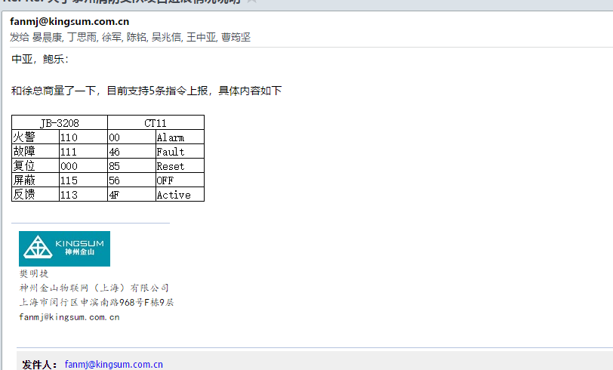

## 现场采集数据1

【2017-10-27 10:35:32:851】01 54 31 02 57 31 31 31 30 33 37 33 51 30 31 30 30 03 55 04 05

【2017-10-27 10:35:33:269】01 54 31 02 50 31 31 32 31 35 31 44 51 36 32 34 46 03 50 04

【2017-10-27 10:35:33:689】05

【2017-10-27 10:35:34:108】01 54 31 02 57 31 31 31 30 41 42 30 55 30 31 30 32 03 57 04 05

【2017-10-27 10:35:34:527】01 54 31 02 57 31 31 31 41 31 43 44 51 30 35 30 30 03 21 04

【2017-10-27 10:35:34:946】05 01 54 31 02 57 31 31 31 41 31 43 44 51 30 36 30 30 03 22

【2017-10-27 10:35:35:365】04 05

【2017-10-27 10:35:35:783】01 54 31 02 57 31 31 31 30 41 42 46 51 36 37 34 46 03 55 04

【2017-10-27 10:35:36:201】01 4C 30 02 03 7D

【2017-10-27 10:35:36:621】01 4C 30 02 03 7D

【2017-10-27 10:35:37:041】01 4C 30 02 03 7D

"1450";"2";"1894";"1605";"496";"0";"ZONE";"酒店地下一层手报";"西南话务员间门口手报";"A";"0AB0";"-";"LOG";"01:009:001:000";"0";"255"

【2017-10-27 10:35:37:459】01 4C 30 02 03 7D

### 数据分析

01 54 31 02 57 31 31 31 41 31 43 44 51 30 36 30 30 03 22 为火警信息 36 30才为火警标识

|  |  |
| --- | --- |
| Hex十六进制 | ASCii |
| 36 | 6 |
| 30 | 0 |

## 现场采集数据2

【2017-11-01 14:50:25:762】05 01 54 31 02 5A 31 31 31 30 30 30 30 4E 33 39 30 30 03 4B 04

【2017-11-01 14:50:26:197】01 4C 30 02 03 7D

【2017-11-01 14:50:26:633】01 4C 30 02 03 7D

【2017-11-01 14:50:27:066】01 4C 30 02 03 7D

【2017-11-01 14:50:27:501】01 4C 30 02 03 7D 05 01 54 31 02 57 31 31 32 31 31 42 46 4E 30 31 38 35 03 47

【2017-11-01 14:50:27:938】04 05

【2017-11-01 14:50:28:374】01 54 31 02 57 31 31 32 31 31 42 46 4E 36 34 33 43 03 39 04

【2017-11-01 14:50:28:810】05 01 54 31 02 57 31 31 32 41 31 43 44 4E 30 36 38 35 03 33 04

【2017-11-01 14:50:29:246】01

【2017-11-01 14:50:29:682】4C 30 02 03 7D 01 4C 30 02 03 7D

【2017-11-01 14:50:30:118】05 01 54 31 02 57 31 31 32 30 35 37 35 4E 30 31 38 35 03 44 04

【2017-11-01 14:50:30:554】01 4C 30 02 03 7D

【2017-11-01 14:50:30:993】01 4C 30 02 03 7D

【2017-11-01 14:50:31:427】01 4C 30 02 03 7D

【2017-11-01 14:50:31:864】05 01 54 31 02 50 31 31 31 31 33 42 36 4E 36 32 34 44 03 49 04

【2017-11-01 14:50:32:292】05 01 54 31 02 50 31 31 32 31 35 32 32 4E

【2017-11-01 14:50:32:723】36 32 34 44 03 38 04 05

【2017-11-01 14:50:33:153】01 54 31 02 57 31 31 32 31 32 30 31 4E 36 37 33 43 03 3C 04

### 协议分析

01 54 31 02 57 31 31 32 30 35 37 35 4E 30 31 38 35 03 44 04 为火警数据 火警标识38 35

|  |  |
| --- | --- |
| Hex十六进制 | ASCii |
| 38 | 8 |
| 35 | 5 |